Table of Contents

UNITED STATES

SECURITIES AND EXCHANGE COMMISSION

WASHINGTON, D.C. 20549

FORM 10-K

(Mark One)

x ANNUAL REPORT PURSUANT TO SECTION 13 OR 15(d) OF THE SECURITIES EXCHANGE ACT OF 1934

For the fiscal year ended December 31, 2024

or

o TRANSITION REPORT PURSUANT TO SECTION 13 OR 15(d) OF THE SECURITIES EXCHANGE ACT OF 1934

For the transition period from _________ to __________

 | COMMISSION FILE NUMBER 001-42023
 |  |  | SERVE ROBOTICS INC.
(Exact name of registrant as specified in its charter)
Delaware |  |  |  |  |  |  |  | 85-3844872
(State or other jurisdiction of |  |  |  |  |  |  |  | (I.R.S. Employer
incorporation or organization) |  |  |  |  |  |  |  | Identification No.)
730 Broadway |  |  |  |  |  |  |  | (818) 860-1352
Redwood City, CA 94063 |  |  |  |  |  |  |  | (818) 860-1352
(Address of principal executive offices) (Zip Code) |  |  |  |  |  |  | (Registrant’s telephone number, including area code)
Securities registered pursuant to Section 12(b) of the Act:
Title of each class |  |  | Trading Symbol(s) |  |  |  |  | Name of each exchange on which registered
Common Stock par value $0.0001 per share |  |  | SERV |  |  |  |  | The Nasdaq Capital Market

Securities registered pursuant to Section 12(g) of the Act:

Common Stock, $0.0001 par value per share

Indicate by check mark if the registrant is a well-known seasoned issuer, as defined in Rule 405 of the Securities Act. Yes o No x Indicate by check mark if the registrant is not required to file reports pursuant to Section 13 or 15(d) of the Act. Yes o No x

Indicate by check mark whether the registrant (1) has filed all reports required to be filed by Section 13 or 15(d) of the Securities Exchange Act of 1934 during the preceding 12 months (or for such shorter period that the registrant was required to file such reports), and (2) has been subject to such filing requirements for the past 90 days. Yes x No o

Indicate by check mark whether the registrant has submitted electronically every Interactive Data File required to be submitted pursuant to Rule 405 of Regulation S-T (§232.405 of this chapter) during the preceding 12 months (or for such shorter period that the registrant was required to submit such files). Yes x No o

Indicate by check mark whether the registrant is a large accelerated filer, an accelerated filer, a non-accelerated filer, a smaller reporting company, or an emerging growth company. See the definitions of “large accelerated filer,” “accelerated filer,” “smaller reporting company,” and “emerging growth company” in Rule 12b-2 of the Exchange Act.

Large accelerated filer | o | Accelerated filer | o
Non-accelerated filer | x | Smaller reporting company | x
 |  | Emerging growth company | x

If an emerging growth company, indicate by check mark if the registrant has elected not to use the extended transition period for complying with any new or revised financial accounting standards provided pursuant to Section 13(a) of the Exchange Act. o

Indicate by check mark whether the registrant has filed a report on and attestation to its management’s assessment of the effectiveness of its internal control over financial reporting under Section 404(b) of the Sarbanes-Oxley Act (15 U.S.C. 7262(b)) by the registered public accounting firm that prepared or issued its audit report. o

If securities are registered pursuant to Section 12(b) of the Act, indicate by check mark whether the financial statements of the registrant included in the filing reflect the correction of an error to previously issued financial statements. o

Indicate by check mark whether any of those error corrections are restatements that required a recovery analysis of incentive-based compensation received by any of the registrant’s executive officers during the relevant recovery period pursuant to § 240.10D-1(b). o

Indicate by check mark whether the registrant is a shell company (as defined in Rule 12b-2 of the Exchange Act) Yes o No x

The aggregate market value of the common stock held by non-affiliates of the registrant on June 30, 2024, the last business day of its most recently completed second fiscal quarter, was $65.3 million based on the closing price of the registrant’s common stock as reported by The Nasdaq Capital Market on that date.

As of March 4, 2025, the registrant had a total of 56,918,226 shares of its common stock, par value $0.0001 per share, issued and outstanding.

Table of Contents

 |  |  |  |  |  |  |  |  |  |  |  |  |  |  |  |  | TABLE OF CONTENTS
 |  |  |  |  |  |  |  |  |  |  |  |  |  |  |  |  |  |  |  |  |  |  |  |  |  |  |  |  |  | Page
 |  |  |  |  |  |  |  |  |  |  |  |  |  |  |  |  |  |  |  |  | PART I
Item 1. | Business |  |  |  |  |  |  |  |  |  |  |  |  |  |  |  |  |  |  |  |  |  |  |  |  |  |  |  |  | 1
Item 1A. | Risk Factors |  |  |  |  |  |  |  |  |  |  |  |  |  |  |  |  |  |  |  |  |  |  |  |  |  |  |  |  | 8
Item 1B. | Unresolved Staff Comments |  |  |  |  |  |  |  |  |  |  |  |  |  |  |  |  |  |  |  |  |  |  |  |  |  |  |  |  | 30
Item 1C. | Cybersecurity |  |  |  |  |  |  |  |  |  |  |  |  |  |  |  |  |  |  |  |  |  |  |  |  |  |  |  |  | 30
Item 2. | Properties |  |  |  |  |  |  |  |  |  |  |  |  |  |  |  |  |  |  |  |  |  |  |  |  |  |  |  |  | 31
Item 3. | Legal Proceedings |  |  |  |  |  |  |  |  |  |  |  |  |  |  |  |  |  |  |  |  |  |  |  |  |  |  |  |  | 31
Item 4. | Mine Safety Disclosures |  |  |  |  |  |  |  |  |  |  |  |  |  |  |  |  |  |  |  |  |  |  |  |  |  |  |  |  | 31
 |  |  |  |  |  |  |  |  |  |  |  |  |  |  |  |  |  |  | PART II
Item 5. | Market for Registrant’s Common Equity, Related Stockholder Matters and Issuer Purchases of Equity Securities |  |  |  |  |  |  |  |  |  |  |  |  |  |  |  |  |  |  |  |  |  |  |  |  |  |  |  |  | 32
Item 6. | [Reserved] |  |  |  |  |  |  |  |  |  |  |  |  |  |  |  |  |  |  |  |  |  |  |  |  |  |  |  |  | 33
Item 7. | Management’s Discussion and Analysis of Financial Condition and Results of Operation |  |  |  |  |  |  |  |  |  |  |  |  |  |  |  |  |  |  |  |  |  |  |  |  |  |  |  |  | 34
Item 7A. | Quantitative and Qualitative Disclosures about Market Risk |  |  |  |  |  |  |  |  |  |  |  |  |  |  |  |  |  |  |  |  |  |  |  |  |  |  |  |  | 43
Item 8. | Financial Statements and Supplementary Data |  |  |  |  |  |  |  |  |  |  |  |  |  |  |  |  |  |  |  |  |  |  |  |  |  |  |  |  | F-1
Item 9. | Changes in and Disagreements with Accountants on Accounting and Financial Disclosure |  |  |  |  |  |  |  |  |  |  |  |  |  |  |  |  |  |  |  |  |  |  |  |  |  |  |  |  | 58
Item 9A. | Controls and Procedures |  |  |  |  |  |  |  |  |  |  |  |  |  |  |  |  |  |  |  |  |  |  |  |  |  |  |  |  | 58
Item 9B. | Other Information |  |  |  |  |  |  |  |  |  |  |  |  |  |  |  |  |  |  |  |  |  |  |  |  |  |  |  |  | 59
Item 9C. | Disclosure Regarding Foreign Jurisdictions That Prevent Inspections |  |  |  |  |  |  |  |  |  |  |  |  |  |  |  |  |  |  |  |  |  |  |  |  |  |  |  |  | 59
 |  |  |  |  |  |  |  |  |  |  |  |  |  |  |  |  |  |  | PART III
Item 10. | Directors, Executive Officers and Corporate Governance |  |  |  |  |  |  |  |  |  |  |  |  |  |  |  |  |  |  |  |  |  |  |  |  |  |  |  |  | 60
Item 11. | Executive Compensation |  |  |  |  |  |  |  |  |  |  |  |  |  |  |  |  |  |  |  |  |  |  |  |  |  |  |  |  | 65
Item 12. | Security Ownership of Certain Beneficial Owners and Management and Related Stockholder Matters |  |  |  |  |  |  |  |  |  |  |  |  |  |  |  |  |  |  |  |  |  |  |  |  |  |  |  |  | 80
Item 13. | Certain Relationships and Related Transactions, and Director Independence |  |  |  |  |  |  |  |  |  |  |  |  |  |  |  |  |  |  |  |  |  |  |  |  |  |  |  |  | 82
Item 14. | Principal Accounting Fees and Services |  |  |  |  |  |  |  |  |  |  |  |  |  |  |  |  |  |  |  |  |  |  |  |  |  |  |  |  | 84
 |  |  |  |  |  |  |  |  |  |  |  |  |  |  |  |  |  |  | PART IV
Item 15. | Exhibits, Financial Statement Schedules |  |  |  |  |  |  |  |  |  |  |  |  |  |  |  |  |  |  |  |  |  |  |  |  |  |  |  |  | 86
Item 16. | Form 10-K Summary |  |  |  |  |  |  |  |  |  |  |  |  |  |  |  |  |  |  |  |  |  |  |  |  |  |  |  |  | 86
 | Exhibit Index |  |  |  |  |  |  |  |  |  |  |  |  |  |  |  |  |  |  |  |  |  |  |  |  |  |  |  |  | 87
 | Signatures |  |  |  |  |  |  |  |  |  |  |  |  |  |  |  |  |  |  |  |  |  |  |  |  |  |  |  |  | 90

i

Table of Contents

CAUTIONARY STATEMENT REGARDING FORWARD-LOOKING STATEMENTS

This Annual Report on Form 10-K contains “forward-looking statements” within the meaning of the Private Securities Litigation Reform Act of 1995, Section 27A of the Securities Act of 1933, as amended (the “Securities Act”), and Section 21E of the Securities Exchange Act of 1934, as amended (the “Exchange Act”). We have based these forward-looking statements largely on our current expectations and projections about future events and financial trends impacting the financial condition of our business. Forward-looking statements should not be read as a guarantee of future performance or results and will not necessarily be accurate indications of the times at, or by, which such performance or results will be achieved. Forward-looking statements are based on information available at the time those statements are made and/or management’s good faith belief as of that time with respect to future events and are subject to risks and uncertainties that could cause actual performance or results to differ materially from those expressed in or suggested by the forward-looking statements.

Forward-looking statements include all statements that are not historical facts. In some cases, you can identify forward-looking statements by terms such as “may,” “will,” “should,” “could,” “would,” “expect,” “intend,” “seek,” “plan,” “anticipate,” “believe,” “estimate,” “project,” “predict,” “potential,” “might,” “forecast,” “continue,” or the negative of those terms, and similar expressions and comparable terminology intended to reference future periods. Forward-looking statements include, but are not limited to, statements about:

- our ability to protect and enforce our intellectual property protection and the scope and duration of such protection;

- our reliance on third parties, including suppliers, delivery platforms, brand sponsors, software providers and service providers;

- our ability to operate in public spaces and any errors caused by human supervisors, network connectivity or automation;

- our robots’ reliance on sophisticated software technology that incorporates third-party components and networks to operate, and our ability to maintain licenses for this software technology;

- our ability to commercialize our products at a large scale;

- the competitive industry in which we operate which is subject to rapid technological change;

- our ability to raise additional capital to develop our technology and scale our operations;

- developments and projections relating to our competitors and our industry;

- our ability to adequately control the costs associated with our operations;

- the impact of current and future laws and regulations, especially those related to personal delivery devices;

- potential cybersecurity risks to our operational systems, infrastructure, and integrated software by us or third-party vendors; and

- other risks and uncertainties, including those listed under Item 1A. Risk Factors.

Should one or more of these risks or uncertainties materialize, or should the underlying assumptions prove incorrect, actual results may differ significantly from those anticipated, believed, estimated, expected, intended or planned.

Factors or events that could cause our actual results to differ may emerge from time to time, and it is not possible for us to predict all of them. We cannot guarantee future results, levels of activity, performance or achievements. Accordingly, the forward-looking statements in this Annual Report on Form 10-K should not be regarded as representations that the results or conditions described in such statements will occur or that our objectives and plans will be achieved, and we do not assume any responsibility for the accuracy or completeness of any of these forward-looking statements.

ii

Table of Contents

PART I

Item 1. Business

All references to “Serve” refer to Serve Operating Co. (formerly known as Serve Robotics Inc.), a privately held Delaware corporation and our direct, wholly-owned subsidiary. Unless otherwise stated or the context otherwise indicates, references to the “Company,” “we,” “our,” “us” or similar terms refer to Serve Robotics Inc. (formerly named Patricia Acquisition Corp.) together with its wholly-owned subsidiary, Serve. Serve holds all material assets and conducts all business activities and operations of Serve Robotics Inc.

Corporate History

We were incorporated in the State of Delaware as Patricia Acquisition Corp. on November 9, 2020. On July 31, 2023, our wholly-owned merger sub merged with and into Serve (the “Merger”). Following the Merger, Serve was the surviving entity and became our wholly-owned subsidiary, and all of the outstanding stock of Serve was converted into shares of our Common Stock. The business of Serve became our business as a result of the Merger. Following the consummation of the Merger, Serve changed its name to “Serve Operating Co.” and we changed our name to “Serve Robotics Inc.”

Prior to the Merger, Patricia Acquisition Corp. was a “shell” company registered under the Exchange Act, with no specific business plan or purpose until it began operating the business of Serve following the closing of the Merger.

Glossary of Terms and Abbreviations

The following is a glossary of technical terms used in this annual report:

AI — Artificial Intelligence

AV — Autonomous Vehicle

GPS — Global Positioning System

GPU — Graphical Processing Unit

IMU — Inertial Measurement Unit

LIDAR — A digital sensor for measuring distance to objects which uses the principle of radar, but uses light from a laser

ODD — Operating Design Domain describes the specific operating conditions in which the automated driving system is designed to properly operate, including but not limited to roadway types, speed range, and environmental conditions

Reverse Logistics — A type of supply chain management that moves goods from customers back to the sellers or manufacturers Company Overview
We are shaping the future of sustainable, self-driving delivery. We design, develop and operate low-emissions robots on our AI-powered robotics mobility platform, that serve people in public spaces, starting with food delivery. Starting in 2017, our core technology was developed by our co-founders and a majority of our product and engineering team in San Francisco, California as a special project within Postmates Inc. (“Postmates”), one of the pioneering food delivery startups in the United States. By the end of 2020, the team had developed a fleet of sidewalk robots that had successfully performed over 10,000 commercial deliveries for Postmates in California, augmenting Postmates’ fleet of human couriers. Postmates was acquired by Uber Technologies, Inc. (“Uber”) in 2020, and in February of 2021, Uber’s leadership team agreed to contribute the intellectual property developed by the team and assets relating to this project. In return for this contribution and an investment of cash into the Company, Uber acquired a minority equity interest in our business.

As of December 31, 2024, Serve’s fleet consisted of over 100 robots. We plan to deploy 2,000 robots by the end of 2025. We have platform-level integrations with Uber Eats, which means Serve robots can provide real-time presence and status updates on those platforms and receive requests to perform deliveries with respect to customer orders placed on those platforms as needed.

1

Table of Contents

Because Serve started within a food delivery company, our team comes with a depth of expertise in food delivery. Additionally, the engineering team has extensive experience in AI, automation and robotics. Our leadership team includes veterans from Uber, Instacart, Postmates, Waymo, Apple Inc., Blue Origin, LLC, GoPro, Inc., GoDaddy Inc., and Anki, Inc. We believe our expertise positions us to service the ever-growing on-demand delivery market, including food delivery.

Based on our proprietary historical delivery data, approximately half of all delivery distances in the United States are less than 2.5 miles and well-suited to delivery by sidewalk robots. We provide a robotic delivery experience that delights customers, improves reliability for merchants and reduces traffic congestion and vehicle emissions. Moreover, at scale we expect our robots will complete deliveries at lower cost than human couriers, making on-demand delivery more affordable and accessible in the areas in which we operate. By eliminating unnecessary car traffic, and by reducing the cost of last-mile transportation, Serve aims to reshape cities into sustainable, safe, and people-friendly environments, with thriving local economies.

Tailwinds for Automation

Despite technological innovations of the past few decades as well as growing adoption of online commerce and home delivery, last-mile delivery has remained costly. While an ever-growing share of consumers is shopping online and demanding faster deliveries, a number of factors have contributed to keeping last-mile costs high:

- Labor shortages caused by the aging population and the COVID-19 pandemic have led to wage inflation.

- On-demand delivery companies in many jurisdictions are battling regulatory pressures to classify gig workers as employees, which would in turn increase labor costs.

- More recently, cities across the United States have introduced maximum limits on how much delivery platforms can charge restaurants and merchants, highlighting the need to lower underlying delivery costs.

Labor cost inflation and regulatory pressures serve as tailwinds that are expected to accelerate the adoption of automated robotic last-mile delivery. While labor costs typically increase over time, hardware and technology costs typically decrease. We expect the cost of cameras, GPU processors, electric motors, batteries, and advanced sensors such as LIDAR to continue to decrease, while mobile networks will become faster and more reliable with higher bandwidth and geographic coverage, which will lead to a downward trend in the cost of building and operating robots.

Delivery Robot Operations

Our sidewalk delivery robots start each day at a central depot located near their operating area. While most robots deploy to and return from their operating area automatically and without further vehicular assistance, some robots may be transported to and from operating areas that are further away in a human-driven vehicle. They are supervised through mobile connectivity and video streaming by remote human operators who can assist robots when necessary, such as at intersection crossings or when robots are unable to navigate certain conditions. In less frequent occasions, if a robot requires physical assistance, such as when a robot is too low on battery to return home or if it has been damaged, a nearby employee is dispatched to repair or return the robot.

Throughout the day, each robot receives a series of delivery orders from partnered merchants and delivery platforms. Upon acceptance of any such order, the robot navigates to the pick-up location, waits outside, and notifies merchant staff, often through their existing delivery tablets or point-of-sale devices. Once the merchant staff load the package into the robot, it navigates to its drop-off destination. A similar sequence of events results in customers meeting the robot at the curb, unlocking its cargo using their delivery app or on-screen instructions, and retrieving their package.

At night, robots return to their central depot to be recharged, maintained, upgraded when necessary, and prepared for next morning’s deployment.

Serve’s third-generation robots are designed to carry more goods, enable more deliveries, and further reduce the cost of delivery. They can move roughly twice as fast, travel approximately twice as far on a single charge, and spend 6 more hours in the field each day compared to our prior generation. The third-generation robots also enjoy an expanded cargo bin that holds four large 16-inch pizzas or 15% more volume than the previous robots. Their new drivetrain is equipped with suspension to drive smoother and faster while protecting food quality, and their improved water resistance expands the robots’ ability to maneuver confidently in a wider range of weather conditions.

2

Table of Contents

Importantly, these hardware and software enhancements combine to extend Serve’s commitment to safety on the sidewalk. In addition to market-leading safety capabilities, including fail-safe mechanical braking and autonomous collision avoidance, the third-generation robots introduce enhanced emergency braking — stopping 40% more quickly.

Furthermore, our robots are equipped with a number of security features to prevent their cargo and their associated data and IP from unauthorized access. The robots’ secure cargo compartment can only be unlocked through the delivery app’s interface or using a security code entered on the touch screen. Moreover, using encrypted communication protocols and data storage as well as secure authentication methods, the data and software onboard each robot is protected from unauthorized access. Finally, robots are equipped with redundant real-time location tracking systems as well as alarm and communication features to deter attempts at vandalism and enable quick recovery of assets in the unlikely event of theft.

Impact of Robotic Delivery

As automation decreases the cost of last-mile delivery and leads to increased adoption, we anticipate opportunities for impact over the long term:

- Reduced Greenhouse Gas Emissions: We believe robots and drones can reduce emissions caused by large vehicles used today for moving small packages.

- Lower Delivery Costs: While all automated delivery vehicles still require a certain amount of human involvement (e.g., loading & unloading, maintenance, remote supervision), we believe labor is leveraged more efficiently resulting in more deliveries per unit of human effort. Just as automation has done in the past, it is expected that this will reduce delivery costs.

- Increased On-Demand Adoption: On-demand services are largely luxuries afforded by affluent consumers today. We believe reducing delivery costs could make home delivery services affordable to more people.

- Easier Reverse Logistics: We believe reducing the cost for last-mile transportation is likely to increase adoption of reverse logistics applications as well (e.g., more convenient package returns).

- More Local Commerce: We believe that the increased adoption of home delivery will result in more commerce for local businesses.

- Increased Local Jobs: We believe increased delivery and local commerce activities resulting from reduction in cost of delivery could lead to more local jobs, ranging from increased staffing of local businesses, logistics operators who enable automated delivery networks to function, and human couriers who perform deliveries that automated services cannot perform.

- Higher Delivery Quality: Like most automated systems, robots are less prone to error. For example, customers of food delivery platforms often experience missing items, mistaken orders, and lost or missed deliveries altogether. Robots promise to reduce such errors, creating a better experience for customers and merchants alike.

- Safer Roads: According to a study by the National Highway Traffic Safety Administration (the “NHTSA”) from December 2023, there were 7,388 pedestrians and 966 cyclists killed in

motor vehicle crashes in 2021 in the United States. There are many factors that contribute to pedestrian and bicyclist fatalities and injuries, including: speeding, distracted driving, drunk driving, and aggressive driving.

Delivery robots weigh significantly less and move at lower speeds than cars; as a result, on average, a single car carries over a thousand times more kinetic energy than a single robot.

We anticipate that replacing cars with delivery robots could result in safer cities for pedestrians and cyclists.

Serve Technology

Our robotic technology has been developed based on the following key principles:

- Humans and Machines: We believe that the most effective way to quickly unleash the benefits of AI and autonomy in our lives is by designing solutions that leverage both human and machine intelligence in ways that collaborate and complement each other. Creating fully autonomous machines that are safe and reliable without any human intervention requires substantially more time and capital investment than creating

3

Table of Contents

machines that are mostly automated but can rely on occasional human support, especially when it comes to high consequence safety-critical decisions.

- Labor-Optimized: We believe the cost of advanced sensors and hardware will continue to decrease over the coming years, and optimizing against such costs can be premature and an investment with diminishing long-term returns. Instead, we have continued to innovate by designing highly capable hardware and software solutions for robotic last-mile delivery that optimize against the largest cost of delivery: labor.

- Robots Among People: We believe that building world-class hardware, software, AI and autonomy for robots to share spaces with people is how we are positioned to build market value and create a lasting legacy.

- Robotic Platform: Our mission is to build a superior robotic platform that can accelerate the adoption of robotic solutions beyond last-mile delivery.

The following are key highlights of our approach to technology development:

Artificial Intelligence — AI empowers Serve robots to navigate city sidewalks and interact with their environment safely and efficiently. We use the latest AI methodologies to design, train and deploy a host of models on Serve robots. Currently, our AI models are used to perform a variety of tasks, including identification of sidewalk surfaces, intersections, traffic signals, obstacles, pedestrians and vehicles, and projecting the trajectory of other dynamic agents.

For the last seven years of development, we have continued to create AI models with new capabilities, while improving the performance of existing models. We expect to continue developing increasingly more capable AI models to improve robots’ performance and differentiate Serve from alternative products and solutions. As the broader field of Artificial Intelligence advances, we expect to benefit from such advances by increasing efficiency and effectiveness of our robots.

Level 4 Autonomy — In January 2022, we announced the deployment of a new generation of delivery robots capable of operating at Level 4 autonomy.

Level 4 autonomous robots can drive without humans in the loop for periods of time while they are operating in their intended operating environments (also known as “ODDs”). Specifically, Serve robots are capable of driving autonomously on certain sidewalks without a remote human supervisor having to oversee their movement. This capability makes it possible to operate our robots at lower cost than remotely operated robots used by our competitors, because it enables a single remote operator to simultaneously perform multiple deliveries.

Through frequent software updates, Serve’s AI models are continuously improved. We believe that over the coming years, we can steadily increase our robots’ autonomous capabilities using new and improved AI models and more training data including new edge cases encountered every day by our operating fleet.

Safety — Achieving Level 4 autonomy required Serve robots to maintain safety even when operating without supervision. As such, we have designed robust onboard safety systems that rely heavily on Serve’s advanced sensors and AI capabilities. This significantly reduces the possibility of collisions even when the robots are being supervised.

In fact, we believe robots that rely heavily on humans for safety are not sufficiently safe, because without automated onboard safety features, humans are prone to error. Also, data networks used for remote supervision frequently fail, slow down or get interrupted. Therefore, over-reliance on error-prone humans and failure-prone data networks makes human-in-the-loop safety inadequate.

In contrast, current Serve robots are equipped with an extensive array of onboard technologies that ensure safe and reliable operation without over-reliance on humans. Serve robots utilize multiple layers of redundant systems for critical navigation functions, including multiple sensor modalities—active sensors such as LIDAR and ultrasonics, as well as passive sensors such as cameras—to navigate safely on busy city sidewalks. Our robots have a wide range of capabilities, such as:

- Automatic emergency braking: If a remote supervisor mistakenly puts a robot at risk of collision, the robot will automatically override the remote supervisor and come to a stop.

- Vehicle collision avoidance: While Serve robots and their remote supervisors are trained to ensure legal and safe crossing of intersections and driveways, drivers of vehicles can still cause vehicle-to-robot collisions. Similar driver errors cause thousands of fatalities and injuries to pedestrians and cyclists every year. As such, Serve robots are equipped with AI features that assess the risk of collision with nearby vehicles and minimize such risks by taking necessary actions such as stopping prior to a collision.

4

Table of Contents

- Fail-safe mechanical braking: We believe another unique and innovative capability of Serve robots is their fail-safe emergency braking. No matter how reliable and well tested, batteries, electronics and computer systems occasionally fail. During any such failures, Serve robots automatically come to a full stop through a mechanically designed fail safe braking system. Some robots used by competitors solely rely on electronic braking, which can become ineffective during power or computer failures.

Manufacturing — Our robots are designed by Serve’s internal team of mechanical, electrical, and system engineers to not only meet product requirements but also supply availability of components and manufacturing and assembly for scalability.

Most components are widely available in supply and/or fabricated from raw materials using common manufacturing processes including machining, molding, stamping, and additive manufacturing from multiple sources. However, certain highly complex components are obtained from single or limited sources that we may have to compete for with other participants in the robotics, consumer electronics, and automotive markets. Therefore, these components can be at times subject to industry-wide shortages, resulting in long lead times and significant pricing fluctuations. Under these circumstances and to maintain production schedules, it may be necessary to temporarily source alternate higher-priced compatible components. Key suppliers of single and limited source components include NVIDIA and Ouster, Inc., in addition to vendors providing cameras, ultrasonic sensors, electronic motors, and modems. To mitigate such supply risks, we routinely search for more available alternatives and/or enter into strategic partnerships and agreements to secure pricing and supply of components.

Manufacturing and assembly of robots take place by a third-party contract manufacturer after component supply has been secured. The most recent delivery of Serve robots were final assembled by Magna International, our contract manufacturer in the United States. We engage an outsourced contract manufacturing firm for various subassembly components. In addition to Manga International supporting our manufacturing efforts, the Company has also entered into commercial relationships including software services and licensing arrangements, which resulted in the Company recognizing revenue for the year ended December 31, 2024.

Business Strategy

After seven years of research and development investment in AI, autonomy, safety, and efficiency of our robots, we are in a leading position to partner with the world’s largest food delivery platforms, restaurants, retailers, and convenience brands to augment their last-mile human delivery capabilities. Our business strategy relies on providing partners with a complete end-to-end delivery solution and charging a fee per delivery—or per hour depending on the type of partnership.

Additionally, robots can perform other value-add tasks while in operation and capture additional revenues, such as out-of-home (“OOH”) branding on transit vehicles. Similar to billboards and buses today, brands are placing ads on Serve robots’ exteriors.

In 2021, we signed a commercial agreement with Uber. Pilot deliveries began in early 2022, which successfully led to the execution of an additional agreement in June 2022 to enable the commercial expansion of our service with up to 2,000 robots across multiple markets. Currently, this is our only large-scale commercial contract.

We plan to continue growing our delivery operations and establish Serve as the global leader in automated last-mile delivery. Our growth will be facilitated by continued investment in our hardware, software and AI developments that increase the performance and efficiency of our fleet.

Competition

The worldwide sidewalk robotic market is highly competitive and we expect it will become even more competitive in the future as a significant and growing number of established and new companies enter the space. We also compete with human delivery drivers for market share in the delivery space.

Environmental Impact

Based on our internal data, we estimate that over 95% of deliveries completed by Serve robots over the last year would otherwise be performed by personal vehicles.

According to the International Energy Agency, 3.16 billion metric tons of CO2 were emitted by passenger vehicles in 2023. Assuming the 2022 estimate by the Bureau of Transportation Statistics that 16.2% of car trips were taken for

5

Table of Contents

shopping and errands, and our proprietary delivery data indicating half of all shopping trips can be completed by delivery robots, this suggests that the scaled use of robotic delivery could reduce global passenger car emissions of such trips from approximately 256 megatons to less than 10 megatons per year, which is a reduction of over 96% as estimated by a study published in Transportation Research Part D: Transport and Environment (Volume 85, August 2020, 102443).

Government Regulations

In the United States, delivery robots are generally allowed to operate on most sidewalks by default. Over twenty states and a number of cities have put in place legal frameworks to explicitly permit the use of delivery robots. The instances of cities welcoming delivery robots far exceed the few examples in which their operations were banned. This positive regulatory momentum for delivery robots may be due to a number of factors:

- Robots Inherently Safer: Cars carry over 1,000 times more kinetic energy than robots. As a result of having much lower kinetic energy, robots do not pose the same risk for injury or fatality that cars do. Meanwhile, cars injure and kill thousands of pedestrians and cyclists each year. Removing unnecessary car trips can make cities safer for pedestrians and cyclists.

- Robots Reduce Emissions: Many cities have established targets for reducing carbon emissions, and robots can help advance their environmental initiatives.

- Robots Reduce Congestion: Deliveries often originate in high traffic regions where restaurants and shops tend to be located. As a result, removing delivery car traffic can reduce congestion and parking issues in cities.

- Robots Reduce Delivery Cost for Local Merchants: Recently, a number of cities have implemented restrictions on how much delivery platforms can charge restaurants for their services. Robots can offer a cheaper alternative to help local restaurants and merchants reduce their delivery costs.

We are subject to various federal, state and local laws and regulations that govern aspects of our business operations. While costs associated with compliance with laws and regulations have increased as the number and scope of regulations have increased, the total costs incurred have not had, and are not expected to have, a material effect on our capital expenditures, results of operations or competitive position. See “Risk Factors” in Item 1A for discussion of risks relating to federal, state, local and international laws and regulations applicable to our business.

Intellectual Property

Our success and ability to compete are significantly dependent on our core technology and intellectual property. We currently have 18 active patent matters in various jurisdictions: China (1 patent), the United States (12 patents), and Canada (5 patents).

We have thus far been granted 11 of the 18 patents for which we have applied — 6 in the United States, 4 in Canada and 1 in China. Our granted patents will expire between May 2029 and June 2039, assuming that all maintenance fees are paid, no portion of the patent has been terminally disclaimed and the patent has not been invalidated. In certain jurisdictions, and in certain circumstances, patent terms can be extended or shortened.

We seek to protect our intellectual property and proprietary rights, including our proprietary technology and software, by relying on a combination of federal, state, and common law rights in the United States and other countries, as well as on contractual measures. However, these laws, agreements, and procedures provide only limited protection. Legal protections afford only limited protection for our technology. Although we currently primarily operate within the United States, the laws of some foreign countries do not protect our proprietary rights to as great an extent as domestic laws, and many foreign countries do not enforce these laws as diligently as government agencies and private parties in the United States.

We encourage our employees to continue to invent and develop new technologies so as to maintain our competitiveness in the marketplace. We generally enter into confidentiality and non-disclosure agreements with our employees, consultants, vendors and customers, and generally limit access to and distribution of our proprietary information. We also enter into invention assignment agreements with our employees and consultants, which give us the rights to their inventions during the term of the agreements.

Despite our best efforts, our means of protecting our proprietary rights may be inadequate. It is possible that our current patents, or patents we later acquire, may be successfully challenged or invalidated in whole or in part. It is also possible

6

Table of Contents

that we may not obtain issued patents for our pending patent applications or other inventions we seek to protect. In that regard, we sometimes permit certain intellectual property to lapse or go abandoned under appropriate circumstances and due to uncertainties inherent in prosecuting patent applications, sometimes patent applications are rejected and we subsequently abandon them. It is also possible that any patent issued to us may not provide us with any competitive advantages, or that the patents of others will harm or altogether preclude our ability to do business. Moreover, unauthorized parties and our competitors may either attempt to copy aspects of our products or obtain and use information that we regard as proprietary, or independently develop technology that is similar to ours thereby rendering our protected products less valuable, if the design is favorably received in the marketplace.

Employees and Human Capital Resources

Our employees are our greatest assets. We value and support hiring exceptional talent to develop our core technology and drive our business growth. We strive to meet these objectives by offering competitive pay and benefits in a diverse, inclusive, and safe workplace. In addition, we provide opportunities for our employees to grow and develop their careers.

As of December 31, 2024, we have 110 employees in the United States and 11 employees in Canada through our wholly-owned Canadian subsidiary, 120 of which are full-time employees. By primary job function, about 45% of our employees have engineering or product roles, 45% are in operations and 10% have business development or other administrative roles. None of our employees are represented by a labor union or covered by a collective bargaining agreement. We consider our relationship with our employees to be good.

Competitive Pay and Benefits

We provide compensation and benefits packages that we believe are competitive within our industry. We use a combination of cash and equity compensation and other benefits to attract, motivate and retain our employees, including equity awards, retirement programs, flexible or paid time off based on department, and health and wellness benefits. In addition, we benchmark our compensation and benefits packages periodically to remain competitive with our peers and attract and retain talent throughout our organization.

Employee Recruitment, Retention, and Development

We believe our corporate culture, competitive compensation and benefits programs, and career growth and development opportunities promote longer employee tenure and reduce turnover. We have enjoyed high employee retention since becoming an independent company in 2021 and monitor employee turnover rates as our success depends upon retaining and investing in our highly skilled technical staff.

Diversity, Equity, and Inclusion

We value the uniqueness that an inclusive and diverse team brings to our company. Therefore, we are focused on creating an environment that leverages the perspectives and contributions of each employee.

Safety, Health, and Wellness

We prioritize safe working conditions. We are committed to an injury-free workplace and provide comprehensive workplace training and support to reduce or eliminate health and safety risks.

Available Information

We are a public company, and our Annual Reports on Form 10-K, Quarterly Reports on Form 10-Q, Current Reports on Form 8-K and any amendments to such reports are filed with the SEC. We are subject to the informational requirements of the Exchange Act and file or furnish reports, proxy statements, and other information with the Securities and Exchange Commission (the “SEC"). Such reports and other information filed by us with the SEC will be available free of charge on our website at www.serverobotics.com when such reports are available on the SEC’s website. The SEC maintains a website that contains reports, proxy and information statements, and other information that issuers file electronically with the SEC at www.sec.gov. Our website is www.serverobotics.com, and we can be contacted at investor.relations@serverobotics.com.

The contents of the websites referred to above are not incorporated into this filing. Further, our references to the URLs for these websites are intended to be inactive textual references only.

7

Table of Contents

Item 1A. Risk Factors

Investment in our stock involves a high degree of risk. You should consider carefully the risks described below, together with other information in this Annual Report on Form 10-K and our other filings with the SEC, before making investment decisions regarding our stock. If any of the following risks and uncertainties, or if any other risks and uncertainties, actually occurs, our business, financial condition, or operating results could differ materially from the plans, projections, and other forward-looking statements included in Part II, Item 7. Management’s Discussion and Analysis of Financial Condition and Results of Operations” and elsewhere in this Annual Report on Form 10-K and in our other public filings. In addition, if any of the following risks and uncertainties, or if any other risks and uncertainties, actually occurs, our business, financial condition, or operating results could be harmed substantially, which could cause the market price of our stock to decline, perhaps significantly. Moreover, the risks described below are not the only ones that we face. Additional risks not presently known to us or that we currently deem immaterial may also affect our business, operating results, prospects or financial condition.

Risks Related to Our Business and Industry

Because we are an early-stage company with minimal revenue and a history of losses and we expect to continue to incur substantial losses for the foreseeable future, we cannot assure you that we can or will be able to operate profitably.

We are an early-stage company. We were formed and commenced operations in January 2021. We face all the risks faced by newer companies, including significant competition from existing and emerging competitors, some of which are established and have better access to capital. In addition, as a new business, we may encounter unforeseen expenses, difficulties, complications, delays, and other known and unknown factors. We will need to transition from an early-stage company to a company capable of supporting larger scale commercial activities. If we are not successful in such a transition, our business, results, and financial condition will be harmed.

We have not been profitable to date, and we expect operating losses for the near future. During the years ended December 31, 2024 and 2023, we generated revenue of $1.81 million and $0.21 million, respectively, and incurred a net loss of $39.19 million and $24.81 million, respectively. There can be no assurance that we will not continue to incur net losses in the future. We may not succeed in expanding our customer base and product offerings and even if we do, may never generate revenue that is significant enough to achieve profitability. Even if we do achieve profitability, we may not be able to sustain or increase profitability on a quarterly or annual basis. Furthermore, we may not be able to control overhead expenses even where our operations successfully expand. Our failure to become and remain profitable would depress our value and could impair our ability to raise capital, expand our business, diversify our product offerings, or even continue our operations.

We have a limited operating history, which may make it difficult to evaluate our business and prospects.

We face the risks associated with businesses in their early stages, with limited operating histories and whose prospects are hard to evaluate. Any evaluation of our business and our prospects must be considered in light of the uncertainties, delays, difficulties and expenses commonly experienced by companies at this stage, which generally include unanticipated problems and additional costs relating to the development and testing of products, product approval or clearance, regulatory compliance, production, product introduction and marketing, and competition. For example, we have incurred losses for each of the past few years, driven mainly by our investments in research and development costs. Many of these factors are beyond the control of our management. In addition, our performance will be subject to other factors beyond our control, including general economic conditions and conditions in the robotics industry. Accordingly, our business and success face risks from uncertainties faced by developing companies in a competitive environment. There can be no assurance that our efforts will be successful or that we will ultimately be able to attain profitability.

If we fail to effectively manage our growth, we may not be able to design, develop, manufacture, market, and launch new generations of our robotic systems successfully.

We intend to invest significantly in order to expand our business. Any failure to manage our growth effectively could materially and adversely affect our business, prospects, financial condition, and operating results. We intend to expand our operations significantly. We expect our expansion to include:

- expanding the management, engineering, and product teams;

- identifying and recruiting individuals with the appropriate relevant experience;

8

Table of Contents

- hiring and training new personnel;

- launching commercialization of new products and services;

- forecasting production and revenue;

- entering into relationships with one or more third-party design for manufacturing partners and third-party contract manufacturers and/or expanding our internal manufacturing capabilities;

- controlling expenses and investments in anticipation of expanded operations;

- carrying out acquisitions and entering into collaborations, in-licensing arrangements, joint ventures, strategic alliances or partnerships;

- expanding and enhancing internal information technology, safety, and security systems;

- conducting demonstrations;

- expanding into new markets and geographies;

- expanding our ODD into new environments;

- entering into agreements with suppliers and service providers; and

- implementing and enhancing administrative infrastructure, systems, and processes.

Should achieved market penetration warrant, we intend to continue to hire a significant number of additional personnel, including engineers, design, production, and operations personnel and service technicians for our robotic systems and services. Because of the innovative nature of our technology, individuals with the necessary experience may not be available to hire, and as a result, we will need to expend significant time and expense to recruit and retain experienced employees and appropriately train any newly hired employees. Competition for individuals with experience designing, producing, and servicing robots and their software is intense, and we may not be able to attract, integrate, train, motivate or retain additional highly qualified personnel. The failure to attract, integrate, train, motivate and retain these additional employees could seriously harm our business, prospects, financial condition and operating results.

Our revenues and profits are subject to fluctuations.

It is difficult to accurately forecast our revenues and operating results, and these could fluctuate in the future due to a number of factors. These factors may include adverse changes in companies’ interests in our robotic delivery and branding services, companies’ available dollars to invest on our services, general economic conditions, our ability to market our company to companies, headcount and other operating costs, and general industry and regulatory conditions and requirements. The Company’s operating results may fluctuate from year to year due to the factors listed above and others not listed. At times, these fluctuations may be significant and could impact our ability to operate our business.

A significant portion of our revenue is concentrated with two customers.

A significant portion of our revenue is concentrated with two customers, Magna and Uber. For the years ended December 31, 2024 and 2023, sales to Magna and Uber accounted for 91% and 71% of our total revenue, respectively. There are inherent risks whenever a large percentage of total revenues are concentrated with a limited number of customers. If Uber were to breach, cancel or amend our agreement, it may have an outsized effect on our revenue, cash on hand, and profitability. In addition, we may have an increased interest in accepting less favorable terms of any amendment as a result.

We are dependent on general economic conditions.

Our business model is dependent on companies purchasing our robotic delivery and branding services. Our business model is thus dependent on national and international economic conditions. Uncertain economic conditions have created volatility in the U.S. Such adverse national and international economic conditions may reduce the future availability of dollars companies have to spend on our services, which would negatively impact our revenues and possibly our ability to continue operations. For example, rising labor costs in recent years have led to increased interest in last-mile automation, while higher interest rates have resulted in a decrease in investment activity and overall capital allocation to hardware startups.

9

Table of Contents

The worsening of global economic conditions has in the past adversely affected, and could in the future, adversely affect our business, financial condition or results of operations, and the worsening of economic conditions in certain specific regions of the country could impact the expansion and success of our businesses in such areas.

Our directors may be engaged in a range of business activities that could result in conflicts of interest.

We may be subject to various potential conflicts of interest because some of our officers and directors may be engaged in a range of business activities. In addition, our executive officers and directors may devote time to their outside business interests, so long as such activities do not materially or adversely interfere with their duties owed to us. In some cases, our executive officers and directors may have fiduciary obligations associated with these business interests that interfere with their ability to devote time to our business and affairs and that could adversely affect our operations. These business interests could require significant time and attention of our executive officers and directors. In addition, we may also become involved in other transactions which conflict with the interests of our directors and the officers who may from time-to-time deal with persons, firms, institutions or companies with which we may be dealing, or which may be seeking investments similar to those desired by us. The interests of these persons could conflict with our interests.

Unfavorable changes in interest rates and foreign currency exchange rates may adversely affect our financial condition, liquidity, and results of operations.

Fluctuations in interest rates and foreign exchange rates may negatively impact our business. These rates are highly sensitive to many factors beyond our control, including general economic conditions, both domestic and foreign, and the monetary and fiscal policies of various governmental and regulatory authorities. Any of such widespread economic conditions could negatively impact our supply chain partners and the industry as a whole, which could materially decrease our profits and cash flow. We have experienced increased costs in acquiring parts for our robots as a result of the global semiconductor industry facing shortages in supply as well as inflation and increased interest rates. We, or our supply chain partners, could continue to increase prices as a result of other adverse macroeconomic conditions.

The inability of our supply chain to deliver certain key electrical components, such as semiconductors, could materially adversely affect our business, financial condition and results of operations.

Certain highly complex components used to manufacture our robots are obtained from single or limited sources that we may have to compete for with other participants in the robotics, consumer electronics, and automotive markets. If our supply chain fails to deliver products to us in sufficient quality and quantity on a timely basis, we will be challenged to meet our target production and development timelines and could incur significant additional expenses for expedited freight and other related costs. Our supply chain may also be adversely impacted by events outside of our control, including macroeconomic events, trade restrictions and economic recessions. For example, throughout 2022, we experienced delays in supply chain deliveries, extended lead times and shortages of key components. Supply chain disruptions may delay the timing of production and maintenance of our robots, which in turn could negatively impact our business, results of operations and financial condition.

Our robots are reliant on semiconductors. In recent years, there has been an ongoing shortage of semiconductors. The semiconductor supply chain is complex, with capacity constraints occurring throughout. We have and will continue to work closely with our suppliers to minimize any potential adverse impacts of the global semiconductor chip shortage and monitor the availability of semiconductor chips and other key components and any other supply chain inefficiencies that may arise. In an effort to mitigate these risks, in some cases, we may have to incur higher costs due to investment in supply chain resiliency and to secure available inventory or make non-cancelable purchase commitments with semiconductor suppliers, which introduce inventory risk if our forecasts and assumptions prove inaccurate. Furthermore, if we are not able to mitigate the impact of the semiconductor chip shortage, any direct or indirect supply chain disruptions may have a material adverse impact on our business, financial condition and results of operations.

Our failure to attract and retain highly qualified personnel in the future could harm our business.

We are an innovative technology company. We may not be able to locate or attract qualified individuals for important positions, such as software engineers, robotics engineers, machine vision and machine learning experts and others, which could affect our ability to grow and expand our business. We may also face intense competition for qualified individuals from numerous other companies, including other similarly situated technology companies, many of whom have greater financial and other resources than we do.

In addition, new hires often require significant training and, in many cases, take significant time before they achieve full productivity. We may incur significant costs to attract and retain qualified personnel, including significant expenditures

10

Table of Contents

related to salaries and benefits and compensation expenses related to equity awards, and we may lose new employees to our competitors or other companies before we realize the benefit of our investment in recruiting and training them. Moreover, new employees may not be or become as productive as we expect, as we may face challenges in adequately or appropriately integrating them into our workforce and culture. If we are unable to attract, integrate and retain suitably qualified individuals who can meet our technical, operational and managerial requirements, on a timely basis or at all, our business, results of operation and financial condition could be adversely affected.

Litigation or legal proceedings could expose us to significant liabilities, occupy a considerable amount of our management’s time and attention, and damage our reputation.

We may, from time to time, be a party to various litigation claims and legal proceedings. We will evaluate these claims and proceedings to assess the likelihood of unfavorable outcomes and estimate, if possible, the amount of potential losses. Claims made or threatened by our suppliers, distributors, customers, competitors, or current or former employees could adversely affect our relationships, damage our reputation or otherwise adversely affect our business, financial condition, or results of operations. The costs associated with defending legal claims and paying damages could be substantial. Our reputation could also be adversely affected by such claims, whether or not successful.

Our future revenue plans rely on partnering with third-party delivery platforms, brand sponsors and/or direct sales to merchants.

Our largest stream of projected revenue comes from maximizing utilization of our robots to perform deliveries. We may be unable to maximize utilization due to a variety of reasons, including insufficient merchant participation, platform partner matching algorithms, failure to deliver a commercial grade product, and a lack of product acceptance by merchants and/or delivery recipients. To date, we have been able to continually increase our robot utilization in our partnership with Uber driven by the continued improvement in our integration, high merchant participation, and widespread product acceptance by users of the Uber platform. We have not yet achieved such levels of utilization with our other partners because those integrations are less complete. To achieve profitability, we would need to continue to improve our utilization targets with Uber above current levels and maintain those levels with other partners as well. As this requires cooperation by third parties, there is no guarantee that it will be achieved within a specific timeframe.

Our financial projections also anticipate generating revenues from brand sponsors who would pay to place their branding on our robots as a form of OOH branding. OOH branding on robots is a new phenomenon and as such, an unproven model. To date, for our limited number of robots, we have been able to run periodic OOH advertising campaigns with several brands in varying sectors including real estate, fashion and entertainment, with 16% and 22% of our revenues for the years ended December 31, 2024 and 2023, respectively, coming from OOH advertising. In the future, if we are unable to realize these sales, our business model and go-to-market strategy will be jeopardized.

Failure of our service providers or disruptions to our outsourcing relationships may negatively impact our ability to conduct our business.

Certain of our remote piloting services are currently provided by third-party vendors, and from service centers outside of the United States. Services provided pursuant to arrangements with these third-party vendors could be disrupted due to events outside of their control such as power failures, cybersecurity incidents, internet traffic congestion or increased latency, natural disasters, or deterioration in their economic condition. Similarly, the expiration of agreements associated with such arrangements or the transition of services between providers could lead to loss of institutional knowledge or service disruptions. While we have not experienced material impact of such disruptions to date, our reliance on others as service providers could have a material adverse effect on our business, financial condition, results of operations and cash flows in the future.

Our robots operate in public spaces and any errors caused by human supervisors, network connectivity issues, third-party software, or automation may adversely affect our commercial relationships.

Our ability to attract and retain customers (including merchants, platform partners, and brand sponsors) is heavily dependent on our ability to provide a safe and reliable service. Our safety and security track record have been instrumental in helping us attract and retain our existing customers. Because we operate on public sidewalks, the performance of our robots is highly visible and we have to maintain the highest standards for public safety. Our operating procedures and automated systems are designed to ensure that our robots yield the right of way to vehicles, pedestrians, and other sidewalk and road users. Examples include policies to only crossing controlled intersections during a pedestrian “walk” signal and slowing down or stopping if a pedestrian approaches the robot from any direction. Our partners, such as Uber, require timely reporting of any material safety incidents, and if they are not able to ascertain our ability to maintain safe operations,

11

Table of Contents

our commercial relationships may be jeopardized. To date, we have not experienced material safety incidents nor have our partners raised any concerns about our safety standards and track record. However, any actual or perceived public safety incidents that may be caused by our human supervisors, network connectivity issues, third-party software, or automation may put our commercial relationships and financial viability at risk.

Our robots rely on sophisticated software technology that incorporate third-party components and networks to operate, and the inability to maintain licenses for software technology, errors in the software we license or the terms of open-source licenses could result in increased costs or reduced service levels, which would adversely affect our business.

Our robots require certain third-party software and networks to function safely and effectively, and our business relies on certain third-party software obtained under licenses from other companies. We anticipate that we will continue to rely on such third-party software in the future. Although we believe that there are commercially reasonable alternatives to the third-party software we currently license, this may not always be the case, or it may be difficult or costly to replace. In addition, integration of new third-party software may require significant work and require substantial investment of our time and resources. Our use of additional or alternative third-party software would require us to enter into license agreements with third parties, which may not be available on commercially reasonable terms or at all. Many of the risks associated with the use of third-party software cannot be eliminated, and these risks could negatively affect our business. Furthermore, performance degradation or lack of access to such software and networks can result in poor delivery performance or even grounding of our entire fleet until it is resolved, which can adversely impact our ability to continue our operations.

Additionally, the software powering our technology systems incorporates software covered by open-source licenses. The terms of many open-source licenses have not been interpreted by U.S. courts, and there is a risk that the licenses could be construed in a manner that imposes unanticipated conditions or restrictions on our ability to operate our systems. In the event that portions of our proprietary software are determined to be subject to an open-source license, we could be required to publicly release the affected portions of our source code or re-engineer all or a portion of our technology systems, each of which could reduce or eliminate the value of our technology systems. Such risk could be difficult or impossible to eliminate and could adversely affect our business, financial condition, and results of operations.

The benefits to customers of our products could be supplanted by other technologies or solutions or competitors’ products that utilize similar technology to ours in a more effective way.

The benefits to customers of our products could be supplanted by other technologies or solutions or competitors’ products that utilize similar technology to ours in a more effective way. We cannot be sure that alternative technologies or improvements to artificial intelligence, industrial automation or other technologies, processes or industries will not match or exceed the benefits of our products or be more cost effective than our products. The development of any alternative technology that can compete with or supplant our products may materially and adversely affect our business, prospects, financial condition and operating results, including in ways we do not currently anticipate. Any failure by us to develop new or enhanced technologies or processes, or to react to changes in existing technologies, could materially delay our development and introduction of new and enhanced products, which could result in the loss of competitiveness of our robotic systems and solutions, decreased revenue and a loss of market share to competitors. Our research and development efforts may not be sufficient to adapt to new or changing technologies. While we plan to upgrade and adapt our robotic systems and solutions as we or others develop new technology, our robotic systems and solutions may not compete effectively with alternative products if we are not able to source and integrate the latest technology into our systems and solutions.

We have limited experience commercializing our products at a large scale and may not be able to do so efficiently or effectively.

We have limited experience commercializing robotic systems at a large scale and may not be able to do so efficiently or effectively. A key element of our long-term business strategy is the continued growth in sales, marketing, training, customer service and maintenance and servicing operations, including hiring personnel with the necessary experience. Managing and maintaining these operations is expensive and time consuming, and an inability to leverage such an organization effectively or at all could inhibit potential sales or subscriptions and the penetration and adoption of our products into new markets. In addition, certain decisions we make regarding staffing in these areas in our efforts to maintain an adequate spending level could have unintended negative effects on our revenues, such as by weakening the sales, marketing and maintenance and servicing infrastructures or lowering the quality of customer service.

We are substantially reliant on our relationships with suppliers and service providers for the parts and components in our robots, as well as for the manufacture of our robots. If any of these suppliers or service partners choose to not do

12

Table of Contents

business with us, then we would have significant difficulty in procuring and producing our robots and our business prospects would be significantly harmed.

Our robots contain hundreds of components which are assembled by third-party manufacturing partners. Collaboration with third parties for the manufacturing of robots is subject to risks with respect to operations that are outside our control. Global supply chain problems directly impact our ability to obtain these components cost-effectively. We could experience delays to the extent our current or future partners do not continue doing business with us, meet agreed upon timelines, experience capacity constraints or otherwise are unable to deliver components or manufacture robots as expected. For example, we have had to delay increasing the number of robots in our fleet due to previous third-party supply restraints. Serve has an agreement with a leading LIDAR vendor to purchase LIDARs at highly competitive prices for a defined quantity. Failure to leverage this agreement, or secure similar supplier agreements for components that may face availability constraints due to supply chain disruptions can result in higher prices for those components, which in turn increases the cost of manufacturing robots and result in an adverse financial impact to our delivery economics.

There is risk of potential disputes with partners, and we could be affected by adverse publicity related to our partners whether or not such publicity is related to their collaboration with us. Our ability to successfully build a premium brand could also be adversely affected by perceptions about the quality of our partner manufacturers’ robots or other robots manufactured by the same partner. In addition, although we intend to be involved in material decisions in the supply chain and manufacturing process, given that we also rely on our partners to meet our quality standards, there can be no assurance that we will be able to maintain high quality standards.

We may in the future enter into strategic alliances, including joint ventures or minority equity investments, with various third parties to further our business purpose. These alliances could subject us to a number of risks, including risks associated with sharing proprietary information, non-performance by the third party, and increased expenses in establishing new strategic alliances, any of which may materially and adversely affect our business.

Tariffs imposed by the United States and other countries, as well as changing trade relations, regional and international conflicts, and political conditions could have a material adverse effect on our business and results of operations.

Changes in United States and foreign governments’ trade policies, as well as volatility caused by regional and international conflicts, and the political climate in the United States, have resulted in, and may continue to result in, tariffs on imports into and exports from the United States. Tariffs on certain products can increase our costs of doing business. If we are unable to recover these costs, our business may be adversely impacted. Diminished trade relations, conflicts between the United States and other countries, and any escalation of tariffs could have a material adverse effect on our financial performance and results of operations.

The evolving regulations around personal delivery devices ("PDDs") could materially impact our business and growth prospects in new markets.

Sidewalk robots, as opposed to autonomous vehicles operating on public streets, are not by default prohibited from operations in most jurisdictions. But there is no guarantee that the current permissive environment will not change in the future, especially as more sidewalk robots get deployed. While we currently have the requisite permits and support from local municipalities in areas we operate, any change in regulations or permit requirements could adversely impact our business. Therefore, we proactively engage with lawmakers, academics, standards-setting organizations, urban planning nonprofits, disability rights advocates, senior citizen organizations, and regional bicycle coalitions to anticipate and mitigate potential regulatory challenges.

Over a dozen states across the United States have enacted legislation regulating PDDs, using a definition that includes sidewalk robots such as ours. While these regulations have been largely industry-friendly and intended to streamline the rollout of PDDs in those jurisdictions, they are not yet uniform and may present some challenges as we seek to deploy in new markets. For example, the City of Chicago, Washington State and the District of Columbia have unladen weight restrictions between 90 and 135 lbs, and the City of Santa Monica and New York State both prohibit the operation of autonomous devices on sidewalks. These ordinances and statutes require amendments in order for us to expand into those jurisdictions.

Furthermore, the cellular network and radio systems contained in our robots are regulated by the Federal Communications Commission (the “FCC”), which allocates cellular and wireless bandwidth to ensure minimal conflict between operators. And the battery packs within our robots use custom lithium-ion cells. The transportation and effective storage of lithium-ion batteries is tightly regulated by the U.S. Department of Transportation and other regulatory bodies. Any failure to comply with the Department of Transportation’s storage and transport requirements or the FCC’s regulations on wireless

13

Table of Contents

communications could result in fines, loss of permits and licenses or other regulatory consequences, which could limit our ability to manufacture and deliver our robotic systems and negatively affect our business, prospects, financial condition, results of operations, and cash flows.

Defects, glitches, or malfunctions in our products or the software that operates them, failure of our products to perform as expected, connectivity issues or operator errors may result in product recalls, lower than expected return on investment for customers and cause significant safety concerns, each of which could adversely affect our results of operations, financial condition and our reputation.

The design, manufacture, and marketing of our products involve certain inherent risks. Manufacturing or design defects, glitches, malfunctions, connectivity issues between the central processing unit and peripheral vehicle subsystems, operator errors, unanticipated use of our robotic systems, inadequate disclosure of risks relating to the use of sidewalk robots, among others, can lead to injury, property damage or other adverse events. We conduct extensive testing of our units, in some instances in collaboration with our customers, to ensure that any such issues can be identified and addressed in advance of commercial launch of the products. However, there can be no assurance that we will be able to identify all such issues or that, if identified, efforts to address them will be effective in all cases.

In addition, if the manufacturing of our products is outsourced, we may not be aware of manufacturing defects that could occur. Such adverse events could lead to unexpected failures in our products and could result, in certain cases, in the removal of our products from the market. A product recall could result in significant costs. To the extent any manufacturing defect occurs, our agreement with the third-party manufacturer may contain a limitation on the third-party manufacturer’s liability, and therefore we could be required to incur the majority of related costs. Product defects or recalls could also result in negative publicity, damage to our reputation or, in the event of regulatory developments, delays in new product acceptance.

Our products incorporate sophisticated computer software. Complex software frequently contains errors, especially when first introduced. Our software may experience errors or performance problems in the future. If any part of our products’ hardware or software were to fail, the service mission could be compromised. Additionally, users may not use our products in accordance with safety protocols and training, which could amplify the risk of failure. Any such occurrence could cause delay in market acceptance of our products, damage to our reputation, product recalls, increased service and warranty costs, product liability claims and loss of revenue relating to such hardware or software defects.

We anticipate that as part of our ordinary course of business we may be subject to product liability claims alleging defects in the design or manufacture of our products. A product liability claim, regardless of our merit or eventual outcome, could result in significant legal defense costs and high punitive damage payments. Although we maintain product liability insurance, the coverage is subject to deductibles and limitations, and may not be adequate to cover future claims. Additionally, we may be unable to maintain our existing product liability insurance in the future at satisfactory rates or adequate amounts.

Even if our products perform properly and are used as intended, if operators sustain any injuries while using our products, we could be exposed to liability and our results of operations, financial condition, and our reputation may be adversely affected.

Our products contain complex technology and must be used as designed and intended in order to operate safely and effectively. While we expect to develop a training, customer service and maintenance and servicing infrastructure to ensure users are equipped to operate our products in a safe manner, we cannot be sure that the products will ultimately be used as designed and intended. In addition, we cannot be sure that we will be able to predict all the ways in which use or misuse of the products can lead to injury or damage to property, and our training resources may not be successful at preventing all incidents. If operators were to cause any injuries or damage to property while using our products, in a manner consistent with our training and instructions or otherwise, we could be exposed to liability and our results of operations, financial condition and our reputation may be adversely affected.

We operate in a competitive industry that is subject to rapid technological change, and competitors may have or attain more resources and/or greater market recognition than we do.

Our competitor base may change or expand as we continue to develop and commercialize our robotic systems in the future. Some of these companies are direct competitors, while others provide adjacent services such as delivery with autonomous vehicles on streets that could impact our market. A number of these companies may have, or may attain, more resources and/or greater market recognition than we do. These or other competitors may develop new technologies or products that

14

Table of Contents

provide superior results to customers or are less expensive than our products. Our technologies and products could have reduced competitiveness by such developments.

Our competitors may respond more quickly to new or emerging technologies, undertake more extensive marketing campaigns, have greater financial, marketing, manufacturing and other resources than we do, or may be more successful in attracting potential customers, employees and strategic partners. In addition, potential customers could have long-standing or contractual relationships with competitors. Potential customers may be reluctant to adopt our products, particularly if they compete with or have the potential to compete with or diminish the need/utilization of products or technologies supported through these existing relationships. If we are not able to compete effectively, our business, prospects, financial condition, and operating results will be negatively impacted.

In addition, because we operate in a new market, the actions of our competitors could adversely affect our business. Adverse events such as product defects or legal claims with respect to competing or similar products could cause reputational harm to the robotics market on the whole and, accordingly, our business.

If we cannot protect, maintain and, if necessary, enforce our intellectual property rights, our ability to develop and commercialize products may be adversely impacted.

Our success, in large part, depends on our ability to protect and maintain the proprietary nature of our technology. We must prosecute and maintain our existing patents and obtain new patents. Some of our proprietary information may not be patentable, and there can be no assurance that others will not utilize similar or superior solutions to compete with us. We cannot guarantee that we will develop proprietary products that are patentable, and that, if issued, any patent will give us a competitive advantage or that such patent will not be challenged by third parties. The process of obtaining patents can be time consuming with no certainty of success, as a patent may not issue or may not have sufficient scope or strength to protect the intellectual property it was intended to protect. We cannot assure you that our means of protecting our proprietary rights will suffice or that others will not independently develop competitive technology or design around patents or other intellectual property rights issued to us. If any of our products or the technology underlying our products is covered by third-party patents or other intellectual property rights, we could be subject to various legal actions. Even if a patent is issued, it does not guarantee that it is valid or enforceable. Any patents that we or our licensors have obtained or obtain in the future may be challenged, invalidated, or unenforceable. If necessary, we intend to initiate actions to protect our intellectual property, which will be costly and time consuming, and could have an adverse impact on our business, results of operation and financial condition.

We may be subject to claims of infringement of third-party intellectual property rights.

Our operating results may be adversely affected if third parties claim that our products infringed their patent, copyright, or other intellectual property rights. We cannot assure that our products do not, or will not in the future, infringe patents held by others. Although there have been no allegations made to this effect, we cannot assure that we will not receive such correspondence from third parties or competitors in the future. Such assertions could lead to expensive and unpredictable litigation, diverting the attention of management and technical personnel. Litigation may be necessary to enforce our intellectual property rights, to protect our trade secrets, to determine the validity and scope of the proprietary rights of others, or to defend against claims of infringement or invalidity, misappropriation, or other claims. Any such litigation could result in substantial costs and diversion of our resources. Moreover, any settlement of or adverse judgment resulting from such litigation could require us to obtain a license to continue to use the technology that is the subject of the claim, or otherwise restrict or prohibit our use of the technology. Any required licenses may not be available to us on acceptable terms, if at all. An unsuccessful result in such litigation could adversely affect our business, including injunctions, exclusion orders, and royalty payments to third parties.

Security breaches and other disruptions could compromise our proprietary information and expose us to liability, which would cause our business and reputation to suffer.

We rely on trade secrets, technical know-how, and other unpatented proprietary information relating to our product development and manufacturing activities to provide us with competitive advantages. We protect this information by entering into confidentiality agreements with our employees, consultants, strategic partners, and other third parties. We also design our computer systems and networks and implement various procedures to restrict unauthorized access to the dissemination of our proprietary information.

We face internal and external data security threats. For example, current, departing, or former employees or third parties could attempt to improperly use or access our computer systems and networks to copy, obtain, or misappropriate our proprietary information or otherwise interrupt our business. Like others, we are also subject to significant system or

15

Table of Contents

network disruptions from numerous causes, including computer viruses and other cyber-attacks, facility access issues, new system implementations, and energy blackouts.

Security breaches, computer malware, phishing, spoofing, and other cyber-attacks have become more prevalent and sophisticated in recent years. We do not believe that such attacks have caused us any material damage to date, but because the techniques used by computer hackers and others to access or sabotage networks constantly evolve and generally are not recognized until launched against a target, we may be unable to anticipate, counter or ameliorate all these techniques. As a result, our and our customers’ proprietary information may be misappropriated, and we cannot predict the impact of any future incident. Any loss of such information could harm our competitive position, result in a loss of customer confidence in the adequacy of our threat mitigation and detection processes and procedures, cause us to incur significant costs to remedy the damages caused by the incident, and divert management and other resources. We routinely implement improvements to our network security safeguards, and we are devoting increasing resources to the security of our information technology systems. However, we cannot assure that such system improvements will be sufficient to prevent or limit the damage from any future cyber-attack or network disruptions.

The costs related to cyber-attacks or other security threats or computer systems disruptions typically would not be fully insured or indemnified by others. As a result, the occurrence of any of the events described above could result in the loss of competitive advantages derived from our intellectual property. Moreover, these events may result in the diversion of the attention of management and critical information technology and other resources, or otherwise adversely affect our internal operations and reputation or degrade our financial results and stock price.

We may be subject to theft, loss, or misuse of personal data by or about our employees, customers, or other third parties, which could increase our expenses, damage our reputation, or result in legal or regulatory proceedings.

In the ordinary course of our business, we have access to sensitive, confidential, or personal data or information regarding our employees and others that is subject to privacy and security laws and regulations. Therefore, the theft, loss, or misuse of personal data collected, used, stored, or transferred by us to run our business, or by our third-party service providers, including business process software applications providers and other vendors that have access to sensitive data, could result in damage to our reputation, disruption of our business activities, significantly increased business and security costs or costs related to defending legal claims. For example, in July 2023, third-party actors attempted to steal one of our robots. We are not aware that any data was obtained during any incident of vandalism or attempted theft. We are also aware of certain media reports relating to the use of our robots as elements in law enforcement surveillance efforts. As a general policy, we do not share data with law enforcement, except in certain narrow circumstances where (1) we are required to share data when served with a warrant or subpoena, or (2) there are insurance claims, active incident investigations, or acts of armed violence or theft attempts involving the Company’s personnel or property.

Global privacy legislation, enforcement, and policy activity in this area are rapidly expanding and creating a complex regulatory compliance environment. For example, the European Union has adopted the General Data Protection Regulation (“GDPR”), which requires companies to comply with rules regarding the handling of personal data, including its use, protection, and the ability of persons whose data is stored to correct or delete such data about themselves. Failure to meet GDPR requirements could result in penalties of up to 4% of worldwide revenue. In addition, the interpretation and application of consumer and data protection laws in the U.S., Europe, and elsewhere are often uncertain and fluid and may be interpreted and applied in a manner that is inconsistent with our data practices. As a result, complying with these changing laws has caused, and could continue to cause, us to incur substantial costs, which could harm our business and results of operations. Further, failure to comply with existing or new rules may result in significant penalties or orders to stop the alleged non-compliant activity. Finally, even our inadvertent failure to comply with federal, state, or international privacy-related or data protection laws and regulations could result in audits, regulatory inquiries, or proceedings against us by governmental entities or others.

Our business plans require a significant amount of capital. Our future capital needs may require us to sell additional equity or debt securities that may dilute our stockholders or contain terms unfavorable to us or our investors.

We will require significant capital to operate our business and fund our capital expenditures for the next several years. The level and timing of future expenditure will depend on a number of factors, many of which are outside our control. While we expect that we will have sufficient capital to fund our currently planned operations, it is possible that we will need to raise additional capital to fund our business, including to finance ongoing research and development costs, manufacturing, any significant unplanned or accelerated expenses, and new strategic alliances or acquisitions. The fact that we have limited experience commercializing our delivery robotic systems on a large scale, coupled with the fact that our products represent a new product category in the commercial and delivery robotic market, means we have limited historical data on

16

Table of Contents

the demand for our robotic systems. In addition, we expect our capital expenditures to continue to be significant in the foreseeable future as we continue generational improvements for our commercial products, and that our level of capital expenditures will be significantly affected by customer demand for our robotic systems. As a result, our future capital requirements may be uncertain and actual capital requirements may be different from those we currently anticipate. We may need to seek equity or debt financing to finance a portion of our capital expenditures. Such financing might not be available to us in a timely manner or on terms that are acceptable, or at all, or that such funds, if raised, would be sufficient.

Our ability to obtain the necessary financing to carry out our business plan is subject to a number of factors, including general market conditions and investor acceptance of our business model. These factors may make the timing, amount, terms, and conditions of such financing unattractive or unavailable to us. If we are unable to raise sufficient funds, we will have to significantly reduce our spending, delay or cancel our planned activities or substantially change our corporate structure. We might not be able to obtain any funding, and we might not have sufficient resources to conduct business as projected, both of which could mean that we would be forced to curtail or discontinue our operations.

In addition, our future capital needs and other business reasons could require us to sell additional equity or debt securities or obtain a credit facility. The sale of additional equity or equity-linked securities could dilute our stockholders. The incurrence of indebtedness would result in increased debt service obligations and could result in operating and financing covenants that would restrict our operations.

If we cannot raise additional funds when we need or want them, we may be forced to curtail or abandon our growth plans, which could adversely impact the Company, its business, development, financial condition, operating results or prospects.

We will be required to raise additional capital in order to develop our technology and scale our commercial delivery operations. However, we may be unable to raise additional capital needed to fund and grow our business.

We will need additional capital to develop future versions of the Serve robots and scale our commercial delivery operations. We will not be able to continue product development and our commercial deliveries if we cannot raise additional debt and/or equity financing.

We may not be able to increase our capital resources by engaging in additional debt or equity financings. Even if we complete such financings, they may result in dilution to our existing investors and include additional rights or terms that may be unfavorable to our existing investor base. These circumstances could materially and adversely affect our financial results and impair our ability to achieve our business objectives. Additionally, we may be required to accept terms that restrict our ability to incur additional indebtedness or take other actions (including terms that require us to maintain specified liquidity or other ratios) that would otherwise be in the best interests of our stockholders.

Adverse developments affecting the financial services industry, such as actual events or concerns involving liquidity, defaults, or non-performance by domestic and international financial institutions or transactional counterparties, could adversely affect our business, financial condition, and results of operations.

Actual events involving reduced or limited liquidity, defaults, non-performance or other adverse developments that affect domestic and international financial institutions or other companies in the financial services industry or the financial services industry generally, or concerns or rumors about any events of these kinds, have in the past and may in the future lead to market-wide liquidity problems. For example, on March 10, 2023, Silicon Valley Bank was closed by the California Department of Financial Protection and Innovation, which appointed the Federal Deposit Insurance Corporation as receiver. We maintain a banking relationship with Silicon Valley Bank and during the year, we were required to keep deposits with Silicon Valley Bank pursuant to our Loan and Security Agreement with them. This Loan and Security Agreement was fully repaid during 2024. Although we had debt with Silicon Valley Bank at the time of its closure, following the closure, the debt was subsequently assumed by First Citizens Bank & Trust and we have experienced no impacts from the closure. However, investor concerns regarding the U.S. or international financial systems could result in less favorable commercial financing terms, including higher interest rates or costs and tighter financial and operating covenants, or systemic limitations on access to credit and liquidity sources, thereby making it more difficult for us to acquire financing on acceptable terms or at all. Any decline in available funding or access to our cash and liquidity resources could, among other risks, adversely impact our ability to meet our operating expenses, financial obligations or fulfill our other obligations, or result in breaches of our financial and/or contractual obligations. Any of these impacts, or any other impacts resulting from the factors described above or other related or similar factors not described above, could have material adverse impacts on our liquidity and our current and/or projected business operations, financial condition and results of operations.

17

Table of Contents

If use of the internet via websites, mobile devices and other platforms, particularly with respect to online food ordering, does not continue, our business and growth prospects will be harmed.

Our business and growth prospects are substantially dependent upon the continued use of the internet as an effective medium of transactions by diners. Internet use may not continue to develop at historical rates, and diners may not continue to use the internet and other online services to order their food at current or increased growth rates or at all, which could adversely impact our business, results of operation and financial condition. In addition, the internet and mobile applications may not continue to be accepted as a viable platform or resource for a number of reasons, including:

- actual or perceived lack of security of information or privacy protection;

- possible disruptions, computer viruses or other damage to internet servers, users’ computers or mobile applications;

- excessive governmental regulation; and

- unacceptable delays due to actual or perceived limitations of wireless networks.

Our business depends on discretionary spending patterns in the areas in which the restaurants on our partners’ platforms operate and in the economy at large. Economic downturns or other events (like coronavirus variants or similar widespread health/pandemic outbreaks) impacting the United States and global economy could materially adversely affect our results of operations.

Purchases at restaurants and food and beverage hospitality services locations are discretionary for consumers and we are therefore susceptible to changes in discretionary spending patterns or economic slowdowns in the geographic areas in which restaurants on our partners’ platforms operate and in the economy at large. Discretionary consumer spending can be impacted by general economic conditions, unemployment, consumer debt, inflation, rising gasoline prices, interest rates, consumer confidence, and other macroeconomic factors. We believe that consumers generally are more willing to make discretionary purchases, including delivery, dine-in or carryout of restaurant meals, during favorable economic conditions. Disruptions in the overall economy (including disruptions due to coronavirus or similar health/pandemic events), including high unemployment, inflation, rising gasoline prices, financial market volatility and unpredictability, and the related reduction in consumer confidence, could negatively affect food and beverage sales throughout the restaurant industry, including orders through our partners’ platforms. Additionally, merchants on our partners’ platforms may be negatively impacted by general economic conditions, supply chain issues, labor shortages, inflation, or other macroeconomic factors, which could negatively impact their ability to fulfill orders. There is also a risk that if uncertain economic conditions persist for an extended period of time or worsen, consumers might make long-lasting changes to their discretionary spending behavior, including ordering food for delivery, dine-in or carryout less frequently. The ability of the U.S. economy to handle this uncertainty is likely to be affected by many national and international factors that are beyond our control. These factors, including national, regional and local politics and economic conditions, continued impact of the COVID-19 pandemic, disposable consumer income and consumer confidence, also affect discretionary consumer spending. If any of these factors cause restaurants to cease operations or cease using our partners’ platforms, it could also significantly harm our financial results, for the reasons set forth elsewhere in these risk factors. Continued uncertainty in or a worsening of the economy, generally or in a number of our markets, and diners’ reactions to these trends could adversely affect our business and cause us to, among other things, reduce the number and frequency of new market openings or cease operations in existing markets.

Moreover, inflation also increases the cost of labor and materials needed to build and operate robots. For example, we have observed an increase in cost of labor for managing and maintaining robots in the field in the past year. However, over a longer time horizon, technological improvements continue to reduce the cost of our key components such as sensors, batteries and computers. While the unit cost of labor for operating robots will increase over time with inflation, robotic delivery leverages labor more efficiently than manual courier delivery. As such, we believe labor inflation increases the cost of manual courier delivery and similar alternatives to robotic delivery more than it increases robotic delivery cost. However, we believe improvements in robot autonomy will continue to reduce the rate of labor usage.

Our products and services are disruptive to the delivery services industries, and important assumptions about the market demand, pricing, adoption rates and sales cycle, for our current and future products and services may be inaccurate.

The market demand for and adoption of our delivery robots is unproven, and important assumptions about the characteristics of targeted markets, pricing, and sales cycles may be inaccurate. Although we have engaged in ongoing dialogue with potential customers, we have no binding commitments to purchase products and services. Existing or new

18

Table of Contents

regulatory or safety standards, or resistance by customer employees and labor unions, all of which are outside of our control, could cause delays or otherwise impair adoption of these new technologies, which will adversely affect our growth, financial position, and prospects. Given the evolving nature of the markets in which we operate, it is difficult to predict customer demand or adoption rates for our products or the future growth of the markets we expect to target. If one or more of the targeted markets experience a shift in customer or prospective customer demand, our products may not compete as effectively, if at all, and they may not be fully developed into commercial products. As a result, the financial projections in this report necessarily reflect various estimates and assumptions that may not prove accurate and these projections could differ materially from actual results because of the risks included in this “Risk Factors” section, among others. If demand does not develop as expected or if we cannot accurately forecast pricing, adoption rates and sales cycle for our products, our business, results of operations and financial condition will be adversely affected.

The benefits of our products to customers and projected return on investment have not been substantiated through long-term trials or use.

Our core products’ benefits to customers and projected return on investment have not been substantiated through long-term trials or use. We currently have a limited frame of reference by which to evaluate the performance of our delivery robotic systems upon which our business prospects depend. There can be no assurance that such robotic systems will provide their expected benefit to customers. Our robotic systems may not perform consistently with customers’ expectations or effectively compete with other robotics products which may become available. Any failure of our robotic systems and software to perform as expected could harm our reputation and result in adverse publicity, lost revenue, delivery delays, product recalls, product liability claims and significant warranty and other expenses and could have a material adverse impact on our business, prospects, financial condition and operating results. Additionally, problems and defects experienced by competitors or others in the delivery robotics market could, by association, have a negative impact on perception and customer demand for our delivery robotic systems.

Even if we successfully market our robotic systems, the purchase or subscription, adoption and use of these systems may be materially and negatively impacted if our customers resist their use and adoption.

We have designed and developed our robotic systems with the goal of reducing operating costs and greenhouse gases. Even if we successfully market our products and services to customers, the purchase, adoption and the use of the products may be materially and negatively impacted if our customers resist or delay the use and adoption of these new technology products and services. Customers may resist or delay the adoption of our products and services for several reasons, including lack of confidence in autonomous and semi-autonomous delivery vehicles. If our customers resist or delay adoption of our robotic delivery services, our business, prospects, financial condition and operating results will be materially and adversely affected.

Our systems, products, technologies and services and related equipment may have shorter useful lives than we anticipate.

Our growth strategy depends in part on developing systems, products, technologies, and services. These reusable systems, products, technologies and services and systems will have a limited useful life. While we intend to design our products and technologies for a certain lifespan, which corresponds to a number of cycles, there can be no assurance as to the actual operational life of a product or that the operational life of individual components will be consistent with its design life. A number of factors will impact the useful lives of our products and systems, including, among other things, the quality of their design and construction, the durability of their component parts and availability of any replacement components, and the occurrence of any anomaly or series of anomalies or other risks affecting the technology during launch and in orbit. In addition, any improvements in technology may make our existing products, designs, or any component of our products prior to the end of its life obsolete. If our systems, products, technologies and services and related equipment have shorter useful lives than we currently anticipate, this may lead to delays in increasing the rate of our follow on work and new business, which would have a material adverse effect on our business, financial condition, and results of operations. In addition, we are continually learning, and as our engineering and manufacturing expertise and efficiency increases, we aim to leverage this learning to be able to manufacture our products and equipment using less of our currently installed equipment, which could render our existing inventory obsolete.

Any acquisitions, partnerships, or joint ventures that we enter into could disrupt our operations and have a material adverse effect on our business, financial condition and results of operations.

From time to time, we may evaluate potential strategic acquisitions of businesses, including partnerships or joint ventures with third parties. We may not be successful in identifying acquisition, partnership, and joint venture candidates. In addition, we may not be able to continue the operational success of such businesses or successfully finance or integrate any

19

Table of Contents

businesses that we acquire or with which we form a partnership or joint venture. We may have potential write-offs of acquired assets and/or an impairment of any goodwill recorded as a result of acquisitions. Furthermore, the integration of any acquisition may divert management’s time and resources from our core business and disrupt our operations or may result in conflicts with our business. Any acquisition, partnership or joint venture may not be successful, may reduce our cash reserves, may negatively affect our earnings and financial performance and, to the extent financed with the proceeds of debt, may increase our indebtedness. Further, depending on market conditions, investor perceptions of us and other factors, we might not be able to obtain financing on acceptable terms, or at all, to implement any such transaction. We cannot ensure that any acquisition, partnership, or joint venture we make will not have a material adverse effect on our business, financial condition, and results of operations.

As part of growing our business, we may make acquisitions. If we fail to successfully select, execute, or integrate our acquisitions, then our business, results of operations and financial condition could be materially adversely affected, and our stock price could decline.

Failure to successfully identify, complete, manage and integrate acquisitions could materially and adversely affect our business, financial condition and results of operations and could cause our stock price to decline.

From time to time, we may undertake acquisitions to add new products and technologies, acquire talent, gain new sales channels, or enter into new markets or sales territories. In addition to possible stockholder approval, we may need approvals and licenses from relevant government authorities for the acquisitions and to comply with any applicable laws and regulations, and a failure to obtain such approvals and licenses could result in delays and increased costs and may disrupt our business strategy. Furthermore, acquisitions and the subsequent integration of new assets, businesses, key personnel, customers, vendors, and suppliers require significant attention from our management and could result in a diversion of resources from our existing business, which in turn could have an adverse effect on our operations. Acquired assets or businesses may not generate the financial results we expect. Acquisitions could result in the use of substantial amounts of cash, potentially dilutive issuances of equity securities and exposure to potential unknown liabilities of the acquired business. Moreover, the costs of identifying and consummating acquisitions may be significant.

Our management team will have broad discretion in making strategic decisions to execute their growth plans, and there can be no assurance that our management’s decisions will result in successful achievement of our business objectives or will not have unintended consequences that negatively impact our growth prospects.

Our management will have broad discretion in making strategic decisions to execute their growth plans and may devote time and company resources to new or expanded solution offerings, potential acquisitions, prospective customers or other initiatives that do not necessarily improve our operating results or contribute to our growth. Management’s failure to make strategic decisions that are ultimately accretive to our growth may result in unfavorable returns and uncertainty about our prospects, each of which could cause the price of the common stock to decline.

We face risks related to natural disasters, health epidemics and other outbreaks, which could significantly disrupt our operations.

Our facilities or operations or those of any third-party manufacturers or suppliers could be adversely affected by events outside of our or their control, such as natural disasters, wars, health epidemics, and other calamities. Our robots are charged overnight and rely on broadband internet connectivity to operate; therefore, power outages and broadband connectivity disruptions would adversely impact our operations. Furthermore, as hardware, our robots can be damaged or irreparably destroyed by the effects of fire, floods, typhoons, earthquakes, power loss, telecommunications failures, break-ins, war, riots, terrorist or malicious attacks or similar events.

We, any manufacturing partners, and suppliers may rely on complex machinery for production, which involves a significant degree of risk and uncertainty in terms of operational performance and costs.

We, any third-party manufacturing partners, and suppliers may rely on complex machinery for the production, assembly, repair, and maintenance of our robotic systems, which will involve a significant degree of uncertainty and risk in terms of operational performance and costs. Our operational facilities, and those of any third-party manufacturing partners and suppliers consist or are expected to consist of large-scale machinery combining many components. These components may suffer unexpected malfunctions from time to time and will depend on repairs and spare parts to resume operations, which may not be available when needed. Unexpected malfunctions of these components may significantly affect the intended operational efficiency. Operational performance and costs can be difficult to predict and are often influenced by factors outside of our or any third-party manufacturing partners’ and suppliers’ control, such as, but not limited to, scarcity of natural resources, environmental hazards and remediation, costs associated with decommissioning of machines, labor

20

Table of Contents

disputes and strikes, difficulty or delays in obtaining governmental permits, damages or defects in electronic systems, industrial accidents, fire, seismic activity and natural disasters. Should operational risks materialize, they may result in the personal injury to or death of workers, the loss of production equipment, damage to production facilities, monetary losses, delays and unanticipated fluctuations in production, environmental damage, administrative fines, increased insurance costs and potential legal liabilities, all which could have a material adverse effect on our business, prospects, financial condition and operating results.

We may be unable to adequately control the costs associated with our operations.

We will require significant capital to develop and grow our business, including developing and producing our commercial robotic systems and other products, establishing or expanding design, research and development, production, operations and maintenance and service facilities and building our brand and partnerships. We have incurred and expects to continue incurring significant expenses which will impact our profitability, including research and development expenses, procurement costs, business development, operation and integration expenses as we build and deploy our robotic fleet, and general and administrative expenses as we scale our operations, identify and commit resources to investigate new areas of demand and incur costs as a public company. In addition, we may incur significant costs servicing, maintaining and refurbishing our robots, and we expect that the cost to repair and service our robots will increase over time as they age. Our ability to become profitable in the future will not only depend on our ability to complete the design and development of our robots to meet projected performance metrics, identify and investigate new areas of demand and successfully market our robotic services, but also to sell, whether outright or through subscriptions, our systems at prices needed to achieve our expected margins and control our costs, including the risks and costs associated with operating, maintaining and financing our robots. If we are unable to efficiently design, develop, manufacture, market, deploy, distribute and service our robots in a cost-effective manner, our margins, profitability and prospects would be materially and adversely affected.

Our ability to manufacture products of sufficient quality on schedule in the future is uncertain, and delays in the design, production and launch of our products could harm our business, prospects, financial condition and operating results.

Our future business depends in large part on our ability to execute our plans to design, develop, manufacture, market, deploy and service our products. We intend to outsource the manufacturing of our robotic systems to a third-party manufacturing partner. While this arrangement may lower operating costs, it may have an adverse effect on our flexibility to respond to changing conditions.

We also plan to retain third-party vendors and service providers to engineer, design and test some of the critical systems and components of our units. While this allows us to draw from such third parties’ industry knowledge and expertise, there can be no assurance such systems and components will be successfully developed to our specifications or delivered in a timely manner to meet our program timing requirements.

Laws, regulations, and other legislative efforts related to climate change, environmental concerns, and health and safety could result in increased operating costs, reduced demand for our products and services, or the loss of future business.

Concerns over environmental pollution and climate change have produced significant legislative and regulatory efforts on a global basis, and we believe this will continue both in scope and in the number of countries participating. These changes could directly increase the cost of energy, which may have an effect on the way we manufacture products or utilize energy to produce our products. In addition, any new regulations or laws in the environmental area might increase the cost of raw materials or key components we use in our products. Environmental regulations may require us to reduce product energy usage and to participate in compulsory recovery and recycling of our products or components. We are unable to predict how any future changes will impact us and if such impacts will be material to our business.

Further, climate change laws, environmental regulations, and other similar measures may have an effect on the operating activities of our customers, which may, in turn, reduce the demand for our products and services. To the extent increasing concentrations of greenhouse gases in the Earth’s atmosphere may produce climate changes that have significant physical effects, such as increased frequency and severity of storms, droughts, floods and other climatic events, such events could have a material adverse effect on the Company and potentially subject the Company to further regulation.

We may become subject to new or changing governmental regulations relating to the design, manufacturing, marketing, distribution, servicing, or use of our products, including as a result of climate change, and a failure to comply with such

21

Table of Contents

regulations could lead to withdrawal or recall of our products from the market, delay our projected revenues, increase cost, or make our business unviable if we are unable to modify our products to comply.

We may become subject to new or changing international, federal, state and local regulations, including laws relating to the design, manufacturing, marketing, distribution, servicing or use of our products. Such laws and regulations may require us to pause sales and modify our products, which could result in a material adverse effect on our revenues and financial condition. Such laws and regulations can also give rise to liability such as fines and penalties, property damage, bodily injury and cleanup costs. Capital and operating expenses needed to comply with laws and regulations can be significant, and violations may result in substantial fines and penalties, third-party damages, suspension of production or a cessation of our operations. Any failure to comply with such laws or regulations could lead to withdrawal or recall of our products from the market.

Severe weather conditions and climate change could have a material adverse impact on our business by reducing the operating hours of our robots.

Our robots are designed to operate in common environmental conditions. Currently we operate our robots in warm and dry climates, and we do not operate robots under rare or extreme conditions such as strong storms or unusually high or low temperatures. While with each new generation of robots we plan to continually expand their operating ability (e.g., introducing the ability to manage ice and snow), which in turn would expand our geographic reach, there is no guarantee that our efforts will successfully overcome all severe weather conditions.

We are subject to cybersecurity risks to our operational systems, security systems, infrastructure, integrated software in our products and data processed by us or third-party vendors.

Our business and operations involve the collection, storage, processing, and transmission of personal data and certain other sensitive and proprietary data of collaborators, customers, and others. Additionally, we maintain sensitive and proprietary information relating to our business, such as our own proprietary information and personal data relating to our employees. An increasing number of organizations have disclosed breaches of their information security systems and other information security incidents, some of which have involved sophisticated and highly targeted attacks. We may be a target for attacks by state-sponsored actors and others designed to disrupt our operations or to attempt to gain access to our systems or data that is processed or maintained in our business. Additionally, we are subject to increased security risks due to many personnel working remotely.

We are at risk for interruptions, outages and breaches of our: (a) operational systems, including business, financial, accounting, product development, data processing or production processes, owned by us or our third-party vendors or suppliers; (b) facility security systems, owned by us or our third-party vendors or suppliers; (c) transmission control modules or other in-product technology, owned by us or our third-party vendors or suppliers; (d) the integrated software in our units; or (e) customer data that we processes or that our third-party vendors or suppliers process on our behalf. Because techniques used to obtain unauthorized access to or to sabotage information systems change frequently and may not be known until launched against a target, we may be unable to anticipate or prevent these attacks, react in a timely manner, or implement adequate preventive measures, and may face delays in our detection or remediation of, or other responses to, security breaches and other privacy-and security-related incidents. Such incidents could: materially disrupt our operational systems; result in loss of intellectual property, trade secrets or other proprietary or competitively sensitive information; compromise certain information of customers, employees, suppliers, or others; jeopardize the security of our facilities; or affect the performance of in-product technology and the integrated software in our units. Certain efforts may be state-sponsored or supported by significant financial and technological resources, making them even more difficult to detect, remediate, and otherwise respond to.

We plan to include product services and functionality that utilize data connectivity to monitor performance and timely capture opportunities to enhance performance and for safety and cost-saving preventative maintenance. The availability and effectiveness of our services depend on the continued operation of information technology and communications systems. Our systems will be vulnerable to damage or interruption from, among others, physical theft, fire, terrorist attacks, natural disasters, power loss, war, telecommunications failures, viruses, denial or degradation of service attacks, ransomware, social engineering schemes, insider theft or misuse or other attempts to harm our systems. We intend to use our product services and functionality to log information about each unit’s use in order to aid us in diagnostics and servicing. Our customers may object to the use of this data, which may require us to implement new or modified data handling policies and mechanisms, increase our unit maintenance costs and costs associated with data processing and handling, and harm our business prospects.

22

Table of Contents

Although we are in the process of implementing certain systems and processes that are designed to protect our data and systems within our control, prevent data loss, and prevent other security breaches and security incidents, these security measures cannot guarantee security. The IT and infrastructure used in our business may be vulnerable to cyberattacks or security breaches, and third parties may be able to access data, including personal data and other sensitive and proprietary data of us and our customers, collaborators and partners, our employees’ personal data, or other sensitive and proprietary data, accessible through those systems. Employee error, malfeasance, or other errors in the storage, use, or transmission of any of these types of data could result in an actual or perceived privacy or security breach or other security incident.

Moreover, there are inherent risks associated with developing, improving, expanding and updating our current systems, such as the disruption of our data management, procurement, production execution, finance, supply chain and sales and service processes. These risks may affect our ability to manage our data and inventory, procure parts or supplies or manufacture, deploy, deliver and service our units, adequately protect our intellectual property or achieve and maintain compliance with, or realize available benefits under, applicable laws, regulations and contracts. We cannot be sure that these systems upon which we rely, including those of our third-party vendors or suppliers, will be effectively implemented, maintained or expanded as planned. If we do not successfully implement, maintain or expand these systems as planned, our operations may be disrupted, our ability to accurately and timely report our financial results could be impaired, and deficiencies may arise in our internal control over financial reporting, which may impact our ability to certify our financial results. Moreover, our proprietary information or intellectual property could be compromised or misappropriated, and our reputation may be adversely affected. If these systems do not operate as we expect them to, we may be required to expend significant resources to make corrections or find alternative sources for performing these functions.

Any actual or perceived security breach or security incident, or any systems outages or other disruption to systems used in our business, could interrupt our operations, result in loss or improper access to, or acquisition or disclosure of, data or a loss of intellectual property protection, harm our reputation and competitive position, reduce demand for our products, damage our relationships with customers, partners, collaborators, or others, or result in claims, regulatory investigations, and proceedings and significant legal, regulatory, and financial exposure, and any such incidents or any perception that our security measures are inadequate could lead to loss of confidence in us and harm to our reputation, any of which could adversely affect our business, financial condition, and results of operations. Any actual or perceived breach of privacy or security, or other security incident, impacting any entities with which we share or disclose data (including, for example, our third-party technology providers) could have similar effects. We expect to incur significant costs in an effort to detect and prevent privacy and security breaches and other privacy- and security-related incidents and may face increased costs and requirements to expend substantial resources in the event of an actual or perceived privacy or security breach or other incident.

We are subject to evolving laws, regulations, standards, policies, and contractual obligations related to data privacy and security laws and regulations, and our actual or perceived failure to comply with such obligations could harm our reputation, subject us to significant fines and liability, or otherwise adversely affect our business, prospects, financial condition and operating results.

We are subject to or affected by a number of federal, state and local laws and regulations, as well as contractual obligations and industry standards, that impose certain obligations and restrictions with respect to data privacy and security, and govern our collection, storage, retention, protection, use, processing, transmission, sharing and disclosure of personal information, including that of our employees, customers and others. Most jurisdictions have enacted laws requiring companies to notify individuals, regulatory authorities and others of security breaches involving certain types of data. Such laws may be inconsistent or may change or additional laws may be adopted. In addition, our agreements with certain customers may require us to notify them in the event of a security breach. Such mandatory disclosures are costly, could lead to negative publicity, result in penalties or fines, result in litigation, may cause our customers to lose confidence in the effectiveness of our security measures and require us to expend significant capital and other resources to respond to and/or alleviate problems caused by the actual or perceived security breach.

The global data protection landscape is rapidly evolving, and implementation standards and enforcement practices are likely to remain uncertain for the foreseeable future. We may not be able to monitor and react to all developments in a timely manner. For example, California adopted the California Consumer Privacy Act (“CCPA”), which became effective in January 2020. The CCPA establishes a privacy framework for covered businesses, including an expansive definition of personal information and data privacy rights for California residents. The CCPA includes a framework with potentially severe statutory damages and private rights of action. The CCPA requires covered businesses to provide new disclosures to California residents, provide them new ways to opt-out of certain disclosures of personal information, and allow for a new cause of action for data breaches. Additionally, a new privacy law, the California Privacy Rights Act (“CPRA”), was approved by California voters in the November 3, 2020 election. The CPRA creates obligations relating to consumer data

23

Table of Contents

beginning on January 1, 2022, with implementing regulations expected on or before July 1, 2022, and enforcement beginning July 1, 2023. The CPRA significantly modifies the CCPA, potentially resulting in further uncertainty. Some observers have noted that the CCPA could mark the beginning of a trend toward more stringent privacy legislation in the United States. Other states have begun to propose and enact similar laws. For example, Virginia has enacted the Virginia Consumer Data Protection Act, which provides for obligations similar to the CCPA, and which will go into effect January 1, 2023. As we expand our operations, the CCPA, CPRA, and other laws and regulations relating to privacy and data security may increase our compliance costs and potential liability. Compliance with any applicable privacy and data security laws and regulations is a rigorous and time-intensive process, and we may be required to put in place additional mechanisms to comply with such laws and regulations.

Additionally, as our international presence expands, we may become subject to or face increasing obligations under laws and regulations in countries outside the United States, many of which, such as the GDPR and national laws supplementing the GDPR, as well as legislation substantially implementing the GDPR in the United Kingdom, are significantly more stringent than those currently enforced in the United States. The GDPR requires companies to meet stringent requirements regarding the handling of personal data of individuals located in the European Economic Area (“EEA”). The GDPR also includes significant penalties for noncompliance, which may result in monetary penalties of up to the higher of €20 million or 4% of a group’s worldwide turnover for the preceding financial year for the most serious violations. The United Kingdom’s version of the GDPR, the UK GDPR, which it maintains along with its Data Protection Act (collectively, the “UK GDPR”), also provides for substantial penalties that, for the most serious violations, can go up to the greater of £17.5 million or 4% of a group’s worldwide turnover for the preceding financial year. Many other jurisdictions globally are considering or have enacted legislation providing for local storage of data or otherwise imposing privacy, data protection and data security obligations in connection with the collection, use and other processing of personal data.

We publish privacy policies and other documentation regarding our collection, processing, use and disclosure of personal information and/or other confidential information. Although we endeavor to comply with our published policies and other documentation, we may at times fail to do so or may be perceived to have failed to do so. Moreover, despite our efforts, we may not be successful in achieving compliance, including if our employees, contractors, service providers or vendors fail to comply with our published policies and documentation. Such failures can subject us to potential action by governmental or regulatory authorities if they are found to be deceptive, unfair, or misrepresentative of our actual practices. We are also aware of certain media reports relating to the use of our robots as elements in law enforcement surveillance efforts. As a general policy, we do not share data with law enforcement, except in certain narrow circumstances where (1) we are required to share data when served with a warrant or subpoena, or (2) there are insurance claims, active incident investigations, or acts of armed violence or theft attempts involving our personnel or property. Public perception of our involvement in such surveillance activities could harm our reputation, and consequently, our business prospects and financial condition. Any actual or perceived inability of us to adequately address privacy and security concerns or comply with applicable laws, rules and regulations relating to privacy, data protection or data security, or applicable privacy notices, could lead to investigations, claims, and proceedings by governmental entities and private parties, damages for contract breach, and other significant costs, penalties, and other liabilities. Any such claims or other proceedings could be expensive and time-consuming to defend and could result in adverse publicity. Any of the foregoing may have an adverse effect on our business, prospects, results of operations, and financial condition.

We are subject to U.S. and foreign anti-corruption and anti-money laundering laws and regulations. We can face criminal liability and other serious consequences for violations, which can harm our business, prospects, financial condition and operating results.

We are subject to the U.S. Foreign Corrupt Practices Act of 1977, as amended (the “FCPA”), the U.S. domestic bribery statute contained in 18 U.S.C. § 201, the U.S. Travel Act, and other anti-corruption, anti-bribery and anti-money laundering laws in countries in which we conduct activities. Anti-corruption laws are interpreted broadly and prohibit companies and their employees, business partners, third-party intermediaries, representatives, and agents from authorizing, promising, offering or providing, directly or indirectly, improper payments or anything else of value to government officials, political candidates, political parties, or commercial partners for the purpose of obtaining or retaining business or securing an improper business advantage.

We have direct and indirect interactions with foreign officials, including in furtherance of sales to governmental entities in non-U.S. countries. We sometimes leverage third parties to conduct our business abroad, and our third-party business partners, representatives, and agents may have direct or indirect interactions with officials and employees of government agencies or state-owned or affiliated entities. We can be held liable for the corrupt or other illegal activities of our employees or these third parties, even if we do not explicitly authorize or have actual knowledge of such activities. The FCPA and other applicable laws and regulations also require that we keep accurate books and records and maintain internal

24

Table of Contents

controls and compliance procedures designed to prevent any such actions. While we have policies and procedures to address compliance with such laws, there can be no assurance that all of our employees, business partners, third-party intermediaries, representatives, and agents will not take actions in violation of our policies and applicable law, for which we may be ultimately held responsible. Our exposure for violating these laws increases as our international presence expands and as we increase sales and operations in foreign jurisdictions.

Any violations of the laws and regulations described above may result in whistleblower complaints, adverse media coverage, investigations, substantial civil and criminal fines and penalties, damages, settlements, prosecution, enforcement actions, imprisonment, the loss of export or import privileges, suspension or debarment from government contracts, tax reassessments, breach of contract and fraud litigation, reputational harm and other consequences, any of which could adversely affect our business, prospects, financial condition and operating results. In addition, responding to any investigation or action will likely result in a significant diversion of management’s attention and resources and significant defense costs and other professional fees.

Being a public company can be administratively burdensome and will significantly increase our legal and financial compliance costs.

As a public reporting company, we are subject to the information and reporting requirements of the Securities Act, the Exchange Act and other federal securities laws, rules and regulations related thereto, including compliance with the Sarbanes-Oxley Act of 2002 (the “Sarbanes-Oxley Act”), and the Dodd-Frank Wall Street Reform and Consumer Protection Act (the “Dodd-Frank Act”). In addition, the listing requirements of any national securities exchange or other exchange and other applicable securities rules and regulations impose various requirements on public companies. Our management and other personnel will need to devote a substantial amount of time to these compliance initiatives. Moreover, these rules and regulations will significantly increase our legal and financial compliance costs and will make some activities more time-consuming and costly. Among other things, we are required to:

- maintain and evaluate a system of internal controls over financial reporting in compliance with the requirements of Section 404 of the Sarbanes-Oxley Act and the related rules and regulations of the SEC and the Public Company Accounting Oversight Board;

- maintain policies relating to disclosure controls and procedures;

- prepare and distribute periodic reports in compliance with our obligations under federal securities laws;

- institute a more comprehensive compliance function, including with respect to corporate governance; and

- involve, to a greater degree, our outside legal counsel and accountants in the above activities.

The costs of preparing and filing annual and quarterly reports, proxy statements and other information with the SEC and furnishing audited reports to stockholders is expensive and much greater than that of a privately-held company, and compliance with these rules and regulations will require us to hire additional financial reporting, internal controls and other finance personnel, and will involve a material increase in regulatory, legal and accounting expenses and the attention of our board of directors (the “Board”) and management. In addition, being a public company makes it more expensive for us to obtain director and officer liability insurance. In the future, we may be required to accept reduced coverage or incur substantially higher costs to obtain this coverage. These factors could also make it more difficult for us to attract and retain qualified executives and members of our Board.

Although the Jumpstart Our Business Startups Act of 2012 (the “JOBS Act”) may for a limited period of time somewhat lessen the cost of complying with these additional regulatory and other requirements, we nonetheless expect a substantial increase in legal, accounting, insurance and certain other expenses in the future, which will negatively impact our business, results of operations and financial condition.

Our management as a group has limited experience in operating a publicly traded company.

Our management team may not successfully or effectively manage operating as a public company subject to significant regulatory oversight and reporting obligations under U.S. securities laws. Our executive officers as a group have limited experience in the management of a publicly traded company. Their limited experience in dealing with the increasingly complex laws pertaining to public companies could be a significant disadvantage in that it is likely that an increasing amount of their time may be devoted to these activities which will result in less time being devoted to the management and growth of our company. We may not have adequate personnel with the appropriate level of knowledge, experience and

25

Table of Contents

training in the accounting policies, practices or internal control over financial reporting required of public companies. Any failure by us to effectively and efficiently meet our obligations as a publicly traded company could have a material adverse effect on our business, prospects, financial condition and operating results and/or result in legal liability or other negative consequences.

Risks Related to Ownership of Our Common Stock

The market price and trading volume of our common stock may be volatile and could decline significantly.

Stock exchanges and quotation systems, including The Nasdaq Capital Market ("Nasdaq"), on which our common stock is listed or may be listed or quoted on in the future have from time to time experienced significant price and volume fluctuations. Even if an active, liquid and orderly trading market develops and is sustained for our common stock, the market price of our common stock may be volatile and could decline significantly. In addition, the trading volume in our common stock may fluctuate and cause significant price variations to occur. If the market price of our common stock declines significantly, you may be unable to resell your shares at or above the market price of our common stock as of the date of purchase. We cannot assure you that the market price of common stock will not fluctuate widely or decline significantly in the future in response to a number of factors, including, among others, the following:

- the realization of any of the risk factors presented in this annual report;

- actual or anticipated differences in our estimates, or in the estimates of analysts, for our revenues, results of operations, level of indebtedness, liquidity or financial condition;

- additions and departures of key personnel;

- our ability to maintain the listing of our common stock on Nasdaq;

- failure to comply with the Sarbanes-Oxley Act or other laws or regulations;

- future issuances, sales, resales or repurchases or anticipated issuances, sales, resales or repurchases, of our common stock;

- publication of research reports about us, or our industry;

- the performance and market valuations of other similar companies;

- broad disruptions in the financial markets, including sudden disruptions in the credit markets;

- speculation in the press or investment community;

- actual, potential or perceived control, accounting or reporting problems; and

- changes in accounting principles, policies and guidelines.

In the past, securities class-action litigation has often been instituted against companies following periods of volatility in the market price of their shares. This type of litigation could result in substantial costs and divert our management’s attention and resources, which could have a material adverse effect on us.

We are obligated to develop and maintain proper and effective internal control over financial reporting. If we fail to develop and maintain an effective system of disclosure controls and internal control over financial reporting, our ability to produce timely and accurate financial statements or comply with applicable laws and regulations could be impaired. In addition, the presence of a material weakness increases the risk of material misstatement of the consolidated financial statements.

We are a public company and are required, pursuant to Section 404(a) of the Sarbanes-Oxley Act, to furnish a report by management on, among other things, the effectiveness of its internal control over financial reporting on our annual report on Form 10-K. Effective internal control over financial reporting is necessary for reliable financial reports and, together with adequate disclosure controls and procedures, such internal controls are designed to prevent fraud. Any failure to implement required new or improved controls, or difficulties encountered in their implementation, could cause us to fail to meet its reporting obligations. Ineffective internal controls could also cause investors to lose confidence in reported financial information, which could have a negative effect on the trading price of our common stock.

26

Table of Contents

The report by management is required to include disclosure of any material weaknesses identified in internal control over financial reporting. However, for as long as we are an “emerging growth company” under the JOBS Act, our independent registered public accounting firm will not be required to attest to the effectiveness of internal control over financial reporting pursuant to Section 404(b) of the Sarbanes-Oxley Act. Management’s assessment of internal controls, when implemented, could detect problems with internal controls, and an independent assessment of the effectiveness of internal controls by our auditors could detect further problems that management’s assessment might not, and could result in the identification of material weaknesses that were not otherwise identified. Undetected material weaknesses in internal controls could lead to financial statement restatements and require us to incur the expense of remediation. We are required to disclose changes made in internal control and procedures on a quarterly basis. To comply with the public company requirements, we may need to undertake various actions, such as implementing new internal controls and procedures and hiring accounting or internal audit staff.

We are in the early stages of developing the system and processing documentation necessary to perform the evaluation needed to comply with Section 404. We may not be able to complete its evaluation, testing, and any required remediation in a timely fashion. During the evaluation and testing process, if we identify material weaknesses in internal control over financial reporting, we will be unable to assert that internal control over financial reporting is effective.

As discussed elsewhere in this Annual Report on Form 10-K, we completed the Merger on July 31, 2023. Prior to the Merger, Serve was a private company and, therefore, its controls were not required to be designed or maintained in accordance with Rules 13a-15 and 15d-15 under the Exchange Act. The design and implementation of internal control over financial reporting post-Merger has required and will continue to require significant time and resources from management and other personnel. Because of this, the design and ongoing development of our framework for implementation and evaluation of internal control over financial reporting is in its preliminary stages. As a result, management was unable, without incurring unreasonable effort or expense to conduct a comprehensive assessment of our internal control over financial reporting as of December 31, 2024. Accordingly, we are excluding management's report on internal control over financial reporting pursuant to Section 215.02 of the SEC Division of Corporation Finance's Regulation S-K Compliance & Disclosure Interpretations. However, management concluded that as of December 31, 2024, we had material weaknesses in our internal controls over financial reporting.

A “material weakness” is a deficiency, or combination of deficiencies, in internal control over financial reporting, such that there is more than a reasonable possibility that a material misstatement of our annual or interim financial statements will not be prevented or detected on a timely basis. Management concluded that we did not have a comprehensive and formalized accounting and financial reporting policies and procedures manual which details the information needed for our financial reporting process and that we did not have a robust review process by which management could monitor for potential errors or technical accounting requirements.

If we are unable to assert that our internal control over financial reporting is effective, or if our independent registered public accounting firm is unable to express an opinion on the effectiveness of its internal control, including as a result of the material weaknesses described above, we could lose investor confidence in the accuracy and completeness of financial reports, which would cause the price of our common stock to decline, and we may be subject to investigation or sanctions by the SEC. In addition, if we are unable to continue to meet these requirements, we may not be able to remain quoted on any over-the-counter trading system, or following any potential listing, listed on any securities exchange.

We are an emerging growth company and a smaller reporting company, and any decision on our part to comply only with certain reduced reporting and disclosure requirements applicable to emerging growth companies and smaller reporting companies could make our common stock less attractive to investors.

We are an “emerging growth company,” as defined in the JOBS Act, and, for as long as we continue to be an emerging growth company, we may choose to take advantage of exemptions from various reporting requirements applicable to other public companies but not to emerging growth companies, including:

- not being required to have our independent registered public accounting firm audit our internal control over financial reporting under Section 404 of the Sarbanes-Oxley Act;

- reduced disclosure obligations regarding executive compensation in our periodic reports and annual report on Form 10-K; and

- exemptions from the requirements of holding non-binding advisory votes on executive compensation and stockholder approval of any golden parachute payments not previously approved.

27

Table of Contents

We could be an emerging growth company for up to five years following the completion of our initial public offering. Our status as an emerging growth company will end as soon as any of the following takes place:

- the last day of the fiscal year in which we have more than $1.235 billion in annual revenues;

- the date we qualify as a “large accelerated filer,” with at least $700 million of equity securities held by non-affiliates;

- the date on which we have issued, in any three-year period, more than $1.00 billion in non-convertible debt securities; or

- the last day of the fiscal year ending after the fifth anniversary of the completion of our initial public offering.

We cannot predict if investors will find our common stock less attractive if we choose to rely on any of the exemptions afforded emerging growth companies. If some investors find our common stock less attractive because we rely on any of these exemptions, there may be a less active trading market for our common stock and the market price of our common stock may be more volatile.

Under the JOBS Act, emerging growth companies can also delay adopting new or revised accounting standards until such time as those standards apply to private companies. We have elected to avail ourselves of this provision of the JOBS Act. As a result, we will not be subject to new or revised accounting standards at the same time as other public companies that are not emerging growth companies. Therefore, our consolidated financial statements may not be comparable to those of companies that comply with new or revised accounting pronouncements as of public company effective dates.

We are also a “smaller reporting company” as defined in the Exchange Act. We may continue to be a “smaller reporting company” even after we are no longer an emerging growth company. We may take advantage of certain of the scaled disclosures available to smaller reporting companies and will be able to take advantage of these scaled disclosures for so long as our voting and non-voting common stock held by non-affiliates is less than $250.0 million measured on the last business day of our second fiscal quarter, or our annual revenues is less than $100.0 million during the most recently completed fiscal year and our voting and non-voting common stock held by non-affiliates is less than $700.0 million measured on the last business day of our second fiscal quarter.

Anti-takeover provisions in our charter documents and under Delaware law could make an acquisition of us, which may be beneficial to our stockholders, more difficult and may prevent attempts by our stockholders to replace or remove our current management.

Our amended and restated certificate of incorporation and our amended and restated bylaws that became effective upon completion of the Merger contain provisions that could delay or prevent a change in control of our company. These provisions could also make it difficult for stockholders to elect directors who are not nominated by current members of our Board or take other corporate actions, including effecting changes in our management. These provisions:

- establish a classified Board so that not all members of our board are elected at one time;

- permit only the Board to establish the number of directors and fill vacancies on the board;

- provide that directors may only be removed “for cause” and only with the approval of two-thirds of our stockholders;

- require super-majority voting to amend some provisions in our amended and restated certificate of incorporation and amended and restated bylaws;

- authorize the issuance of “blank check” preferred stock that our board could use to implement a stockholder rights plan;

- eliminate the ability of our stockholders to call special meetings of stockholders;

- prohibit stockholder action by written consent, which requires all stockholder actions to be taken at a meeting of our stockholders;

- prohibit cumulative voting; and

28

Table of Contents

- establish advance notice requirements for nominations for election to our board or for proposing matters that can be acted upon by stockholders at annual stockholder meetings.

In addition, our amended and restated certificate of incorporation provides that the Court of Chancery of the State of Delaware will be the exclusive forum for: any derivative action or proceeding brought on our behalf; any action asserting a breach of fiduciary duty; any action asserting a claim against us arising pursuant to the Delaware General Corporation Law (the “DGCL”), our amended and restated certificate of incorporation, or our amended and restated bylaws; or any action asserting a claim against us that is governed by the internal affairs doctrine.

Section 22 of the Securities Act creates concurrent jurisdiction for federal and state courts over all claims brought to enforce any duty or liability created by the Securities Act or the rules and regulations thereunder. Our amended and restated certificate of incorporation provides that the federal district courts of the United States of America will, unless we consent in writing to an alternative forum, be the exclusive forum for resolving any complaint asserting a cause of action arising under the Securities Act (“Federal Forum Provision”). Our decision to adopt a Federal Forum Provision followed a decision by the Supreme Court of the State of Delaware holding that such provisions are facially valid under Delaware law. While there can be no assurance that federal courts or state courts will follow the holding of the Delaware Supreme Court or determine that the Federal Forum Provision should be enforced in a particular case, application of the Federal Forum Provision means that suits brought by our stockholders to enforce any duty or liability created by the Securities Act must be brought in federal court and cannot be brought in state court. While neither the exclusive forum provision nor the Federal Forum Provision applies to suits brought to enforce any duty or liability created by the Exchange Act creates exclusive federal jurisdiction over all claims brought to enforce any duty or liability created by the Exchange Act or the rules and regulations thereunder. Accordingly, actions by our stockholders to enforce any duty or liability created by the Exchange Act or the rules and regulations thereunder also must be brought in federal court. Our stockholders will not be deemed to have waived our compliance with the federal securities laws and the regulations promulgated thereunder.

Any person or entity purchasing or otherwise acquiring or holding any interest in any of our securities shall be deemed to have notice of and consented to our exclusive forum provisions, including the Federal Forum Provision. These provisions may limit a stockholder’s ability to bring a claim in a judicial forum of their choosing for disputes with us or our directors, officers or other employees, which may discourage lawsuits against us and our directors, officers, and other employees.

In addition, Section 203 of the DGCL may discourage, delay or prevent a change in control of our company. Section 203 imposes certain restrictions on mergers, business combinations and other transactions between us and holders of 15% or more of our common stock.

General Risk Factors

We may face risks related to securities litigation that could result in significant legal expenses and settlement or damage awards.

We may in the future become subject to claims and litigation alleging violations of the securities laws or other related claims, which could harm our business and require us to incur significant costs. Significant litigation costs could impact our ability to comply with certain financial covenants under our credit agreement. We are generally obliged, to the extent permitted by law, to indemnify our current and former directors and officers who are named as defendants in these types of lawsuits. Regardless of the outcome, litigation may require significant attention from management and could result in significant legal expenses, settlement costs or damage awards that could have a material impact on our business, results of operation and financial condition.

We do not intend to pay dividends for the foreseeable future and, as a result, your ability to achieve a return on your investment will depend on appreciation in the price of our common stock.

We have never declared or paid any cash dividends on our capital stock, and we do not intend to pay any cash dividends in the foreseeable future. Any determination to pay dividends in the future will be at the discretion of our Board. Accordingly, investors must rely on sales of their common stock after price appreciation, which may never occur, as the only way to realize any future gains on their investments.

If securities or industry analysts do not publish research or publish unfavorable or inaccurate research about our business, our stock price and trading volume could decline.

The trading market for our common stock will depend in part on the research and reports that securities or industry analysts publish about us or our business, as well as the way analysts and investors interpret our financial information and other

29

Table of Contents

disclosures. Securities and industry analysts do not currently, and may never, publish research on our business. If few, or no, securities or industry analysts commence coverage of us, our stock price could be negatively affected. If securities or industry analysts downgrade our common stock, or publish negative reports about our business, our stock price would likely decline. If one or more of these analysts cease coverage of us or fail to publish reports on us regularly, demand for our common stock could decrease, which might cause our stock price to decline and could decrease the trading volume of our common stock.

We are and may continue to be significantly impacted by the worldwide economic downturn due to pandemics, outbreaks of other contagious diseases, and other catastrophic events.

The extent to which any catastrophic event affects our business and financial results will depend on future developments, including the duration of such event and the global response to it, its impact on capital and financial markets, its impact on global supply chains, and whether the impacts may result in temporary or permanent changes in consumer behavior among others, which are highly uncertain and cannot be predicted.

Item 1B. Unresolved staff comments

None.

Item 1C. Cybersecurity

Cybersecurity Risk Management and Strategy

We recognize the importance of assessing, identifying, and managing material risks associated with cybersecurity threats, as such term is defined in Item 106(a) of Regulation S-K. These risks include, among other things, operational risks; intellectual property theft; fraud; extortion; harm to robots, employees or customers; violation of privacy or security laws and other litigation, legal and reputational risks. We have implemented several cybersecurity processes, technologies, and controls to aid in our efforts to assess, identify, and manage such material risks.

As part of these processes, and to ensure confidentiality, integrity and availability of critical data and systems, we have implemented various technologies that aid in the prevention, detection, investigation, response and remediation of vulnerabilities, cybersecurity incidents and risks. These technologies and processes include, but are not limited to, mobile device management, virtual private network security services, attack surface management services, cloud threat detection and response systems, cloud security posture management solutions, cloud-native security scanners and source code analysis tooling, continuous compliance monitoring and security awareness training solutions.

Evaluation and mitigation of Third-party risks are included within our broader overall risk assessment process. We perform diligence on third parties that have access to our systems, data or facilities that house such systems or data, and where necessary, we require those third parties that could introduce significant cybersecurity risk to us to agree by contract to manage their cybersecurity risks in specified ways, and to agree to be subject to cybersecurity audits, which we conduct as appropriate. Please see the risk factor entitled “We are subject to cybersecurity risks to our operational systems, security systems, infrastructure, integrated software in our products and data processed by us or third-party vendors..” in Part I, Item 1A. Risk Factors in this report for more information.

The security and infrastructure teams are responsible for the continuous monitoring, reporting and response to threats and vulnerabilities discovered through the deployment and operation of these tools. As part of our risk management strategy, our cybersecurity team conducts routine vulnerability and risk assessments within our product operations and service environments. The results of these reviews and any incidents identified by security tooling are reported to senior management and the internal steering committee as part of the quarterly reporting process. As part of routine security assessments, if any deficiencies relating to internal technology controls over financial reporting are discovered, the VP of Security is required to report them directly to the executive management team and internal steering committee without delay.

In the last three fiscal years, we are not aware of and have not experienced any material cybersecurity incidents and the expenses we have incurred from cybersecurity incidents were immaterial. We have not been faced with any penalties or settlements related to cybersecurity.

30

Table of Contents

Cybersecurity Governance

Our internal steering committee and board of directors oversees our risk management strategies and processes, regarding risk assessment and risk management as they relate to cybersecurity. Our security team is led by our VP of Security who has over 15 years of direct cybersecurity experience that includes incident response, security operations and management. The security and infrastructure teams are responsible for implementing and maintaining cybersecurity and data protection controls and practices for the protection of our robots, customer and company information, systems and data. The VP of Security in coordination with our internal steering committee, whose members include professionals from our executive team, general counsel, product and technology and finance teams, meet quarterly to review our Cybersecurity risk exposure, discuss internal and external threat actors and prioritize remediation strategies. The internal steering committee makes decisions on the avoidance, transference, acceptance and mitigation of our overall cybersecurity risk exposure.

Our steering committee, typically in joint session with the full board of directors, meets quarterly with Serve executive leadership to receive reports regarding our overall security posture. These reports include updates on the implementation of cybersecurity controls, data security, risk assessments, the status of internal cybersecurity projects, technology compliance, employee awareness training and any notable incidents and remediation that have occurred within the quarter.

Item 2. Properties

Our current headquarters are located in Redwood City, California, where we lease 4,200 square feet of office and industrial space pursuant to a lease that expires in 2028. Our headquarters contain research and development, operations and selling, general and administrative functions as well as test tracks for our robots. We also lease four other offices throughout the United States. We believe our facilities are adequate and suitable for our current needs and that, should it be needed, suitable additional or alternative space will be available to accommodate our operations.

Item 3. Legal Proceedings

We are from time to time subject to various claims, lawsuits and other legal and administrative proceedings arising in the ordinary course of business. However, we do not consider any such claims, lawsuits or proceedings that are currently pending, individually or in the aggregate, to be material to our business or likely to result in a material adverse effect on our future operating results, financial condition or cash flows.

Item 4. Mine Safety Disclosures

Not applicable.

31

Table of Contents

Part II

Item 5. Market for Registrant’s Common Equity, Related Stockholder Matters and Issuer Purchases of Equity Securities

Market Information and Holders

The Company's common stock is quoted on Nasdaq under the symbol "SERV". As of December 31, 2024, there were approximately 135 stockholders of record of our common stock.

Dividends

We have never paid any cash dividends on our capital stock and do not anticipate paying any cash dividends on our common stock in the foreseeable future. We intend to retain future earnings to fund ongoing operations and future capital requirements. Any future determination to pay cash dividends will be at the discretion of our Board and will be dependent upon financial condition, results of operations, capital requirements and such other factors as the Board deems relevant.

Recent Sales of Unregistered Securities

August PIPE

On August 27, 2024, we entered into a Securities Purchase Agreement (the “August Purchase Agreement”) with a certain accredited and institutional investor for a private placement offering of pre-funded warrants (the “August Pre-Funded Warrants”) to purchase shares of our common stock and warrants exercisable for shares of our common stock (the “Common Warrants”). Pursuant to the August Purchase Agreement, on August 28, 2024, we sold 555,555 August Pre-Funded Warrants, with each August Pre-Funded Warrant exercisable for one share of our common stock, together with Common Warrants to purchase up to 555,555 shares of our common stock. Each August Pre-Funded Warrant and accompanying Common Warrant were sold together at a combined offering price of $8.9999, for aggregate consideration of $5 million.

The August Pre-Funded Warrants are immediately exercisable, at a nominal exercise price of $0.0001, and may be exercised at any time until all of the August Pre-Funded Warrants are exercised in full. The Common Warrants have an exercise price of $10.00 per share (subject to adjustment as set forth in the Common Warrant), are exercisable upon issuance and will expire five and a half years from the date of issuance.

In addition, pursuant to the August Purchase Agreement, we agreed with the investor to exercise the Investor Warrants (as defined below) to purchase an aggregate of 2,500,000 shares of our common stock (the “Warrant Exchange”). The Investor Warrants were exercised at their exercise price of $6.00 per share. In consideration for the immediate exercise in full of the Investor Warrants for gross cash proceeds of approximately $15.0 million, the exercising holder received in a private placement new unregistered warrants (the “Exchange Warrants”) to purchase up to an aggregate of 2,200,000 shares of Common Stock with an exercise price of $10.00 per share. The Exchange Warrants are exercisable upon issuance and will expire five and a half years from the date of issuance.

These transactions were exempt from registration under Section 4(a)(2) of the Securities Act as not involving any public offering or Regulation D promulgated thereunder.

July PIPE

On July 23, 2024, we entered into a Securities Purchase Agreement (the “July Purchase Agreement”) with a certain accredited and institutional investor for a private placement offering of pre-funded warrants (the “July Pre-Funded Warrants”) to purchase shares of our common stock and warrants exercisable for our common stock (the “Investor Warrants”). Pursuant to the July Purchase Agreement, on July 24, 2024, we sold 2,500,000 July Pre-Funded Warrants, with each July Pre-Funded Warrant exercisable for one share of our common stock, together with Investor Warrants to purchase up to 2,500,000 shares of our common stock. Each July Pre-Funded Warrant and accompanying Investor Warrant were sold together at a combined offering price of $5.9999, for aggregate consideration of $15 million.

The July Pre-Funded Warrants are immediately exercisable, at a nominal exercise price of $0.0001, and may be exercised at any time until all of the July Pre-Funded Warrants are exercised in full. The Investor Warrants have an exercise price of

32

Table of Contents

$6.00 per share (subject to adjustment as set forth in the Investor Warrant), are exercisable upon issuance and will expire five and a half years from the date of issuance.

These transactions were exempt from registration under Section 4(a)(2) of the Securities Act as not involving any public offering or Regulation D promulgated thereunder.

Representative’s Warrant

On April 17, 2024, we entered into an underwriting agreement (the “Underwriting Agreement”) with Aegis Capital Corp. (“Aegis”) in connection with the public offering of 10,000,000 shares of our common stock at a public offering price of $4.00 per share (the “Offering”). Pursuant to the Underwriting Agreement, at the closing of the Offering on April 22, 2024, we issued to Aegis a warrant to purchase 500,000 shares of our common stock (the “Representative’s Warrant”). The Representative’s Warrant is exercisable at a per share exercise price equal to $5.00 and is exercisable at any time and from time to time, in whole or in part, commencing October 14, 2024. The Representative’s Warrant expires on April 17, 2029.

The issuance of the Representative’s Warrant was exempt from registration under the Securities Act pursuant to Section 4(a)(2) of the Securities Act.

Placement Agent’s Warrant

Pursuant to a placement agent’s agreement, Network 1 Financial Securities, Inc. (“Network 1”) served as the exclusive placement agent in connection with the Convertible Promissory Notes Offering (as defined below). In connection with the Convertible Promissory Notes Offering, we agreed to issue Network 1 (or its designated affiliates) warrants (the “Placement Agent’s Warrant”) to purchase 10% of the shares of the common stock issued upon conversion of the Convertible Promissory Notes that were issued to investors that Network 1 introduced to us.

In connection with the Offering, the Convertible Promissory Notes converted to shares of common stock, and on April 22, 2024, we issued Network 1 the Placement Agent’s Warrant to purchase up to 63,479 shares of common stock at an exercise price of $2.42 per share. The Placement Agent’s Warrant expires on April 17, 2029.

The issuance of the Placement Agent’s Warrant was exempt from registration under the Securities Act pursuant to Section 4(a)(2) of the Securities Act.

Magna Warrant

In connection with the strategic partnership with Magna New Mobility USA, Inc. (“Magna”), on February 7, 2024, the Company issued to Magna a warrant (the “Magna Warrant”) to purchase up to 2,145,000 shares of the Company’s common stock, par value $0.0001 per share (the “Magna Warrant Shares”), subject to adjustments as provided therein, at an exercise price per share of $0.01.

The Magna Warrant is exercisable in two equal tranches: (i) the first tranche became exercisable no later than May 15, 2024, subject to certain conditions; and (ii) the second tranche became exercisable upon the achievement by Magna of a certain manufacturing milestone as set forth in a production and purchase agreement to be entered into with respect to the contract manufacturing of the Company’s autonomous delivery robots by Magna or one of its affiliates. As of December 31, 2024, the manufacturing milestone has been met and the second tranche is fully exercisable.

The Magna Warrant Shares that may be issued pursuant to the exercise of the Magna Warrant were offered and sold in a transaction exempt from registration under the Securities Act in reliance on Section 4(a)(2) of the Securities Act.

Convertible Promissory Notes Offering

At an initial closing on January 2, 2024 and subsequent closings on January 12, 2024, January 22, 2024 and January 26, 2024, we issued an aggregate of $5.0 million in convertible promissory notes (the “Convertible Promissory Notes”) to accredited investors (the “Convertible Promissory Notes Offering”). These transactions were exempt from registration under Section 4(a)(2) of the Securities Act as not involving any public offering or Regulation D promulgated thereunder.

Item 6. [Reserved]

33

Table of Contents

Item 7. Management’s Discussion and Analysis of Financial Condition and Results of Operations

The following discussion of the financial condition and results of operations of the Company should be read in conjunction with the financial statements and the notes to those statements included in this Annual Report on Form 10-K for the fiscal year ended December 31, 2024. Some of the information contained in this discussion and analysis including information with respect to our plans and strategy for our business, includes forward-looking statements that involve risk, uncertainties and assumptions. You should read Part I, Item 1A. Risk Factors of this report for a discussion of important factors that could cause actual results to differ materially from the results described in or implied by the forward-looking statements contained in the following discussion and analysis.

Note about Forward-Looking Statements

This Annual Report on Form 10-K includes statements that constitute “forward-looking statements.” These forward-looking statements are often characterized by the terms “may,” “believes,” “projects,” “intends,” “plans,” “expects,” or “anticipates,” and do not reflect historical facts.

Specific forward-looking statements contained in this portion of the report include, but are not limited to: (i) statements that are based on current projections and expectations about the markets in which we operate, (ii) statements about current projections and expectations of general economic conditions, (iii) statements about specific industry projections and expectations of economic activity,

- statements relating to our future operations, prospects, results, and performance, and (v) statements that the cash on hand and additional cash generated from operations together with potential sources of cash through issuance of debt or equity will provide the Company with sufficient liquidity for the next 12 months.

Forward-looking statements involve risks, uncertainties, and other factors, which may cause our actual results, performance, or achievements to be materially different from those expressed or implied by such forward-looking statements. Factors and risks that could affect our results, future performance and capital requirements and cause them to materially differ from those contained in the forward-looking statements include those identified in the “Cautionary Note Regarding Forward-Looking Statements” and the Part 1, Item 1A. Risk Factors in this report, as well as other factors that we are currently unable to identify or quantify, but that may exist in the future.

In addition, the foregoing factors may generally affect our business, results of operations and financial position. Forward-looking statements speak only as of the date the statements were made. We do not undertake and specifically decline any obligation to update any forward-looking statements. Any information contained on our website www.serverobotics.com or any other websites referenced in this report are not part of this report.

Our Company

We are on a mission to deliver a sustainable future by transforming how goods move among people. Serve has developed an advanced, AI-powered robotics mobility platform, with last-mile delivery in cities as its first application. We are an operating company which has experienced losses since our inception. Our sources of cash to date have been capital investments by stockholders.

The following discussion contains forward-looking statements, as discussed above. Please see the sections entitled “Cautionary Note Regarding Forward-Looking Statements” and Part I, Item 1A.

Risk Factors in this report for a discussion of the uncertainties, risks and assumptions associated with these forward-looking statements.

Our principal offices are located at 730 Broadway, Redwood City, CA 94063, our telephone number is (818) 860-1352 and our corporate website (which does not form part of this report) is located at www.serverobotics.com.

Overview

On July 31, 2023, Patricia Acquisition Corp., Acquisition Sub, and Serve entered into a Merger Agreement. Pursuant to the terms of the Merger Agreement, on the Closing Date, Acquisition Sub merged with and into Serve, with Serve continuing as the surviving corporation and our wholly owned subsidiary. As a result of the Merger, we acquired the business of Serve and will continue the existing business operations of Serve as a public reporting company under the name Serve Robotics Inc. On the Closing Date, Serve’s predecessor was renamed Serve Operating Co.

The Merger was treated as a recapitalization and reverse acquisition for us for financial reporting purposes, and Serve is considered the acquirer for accounting purposes. As a result of the Merger and the change in our business and operations, a discussion of the past financial results of Patricia Acquisition Corp. is not pertinent, and under applicable accounting

34

Table of Contents

principles, the historical financial results of Serve, the accounting acquirer, prior to the Merger are considered our historical financial results.

Our discussion and analysis are organized as follows:

- Executive Summary – Summary analysis of financial and other highlights to provide context for the discussion and analysis.

- Results of Operations – An analysis of our financial results.

- Liquidity, and Capital Resources – An analysis of changes in our balance sheets and cash flows and a discussion of our financial condition and potential sources of liquidity.

- Critical Accounting Estimates – Accounting estimates that management believes are the most important to understanding the assumptions and judgments incorporated in our financial results and forecasts and involve a significant level of estimation uncertainty.

Serve Robotics

Serve is shaping the future of sustainable, self-driving delivery. We design, develop, and operate low-emissions robots that serve people in public spaces, starting with food delivery. Starting in 2017, our core technology was developed by our co-founders and a majority of our product and engineering team in San Francisco, California as a special project within Postmates, one of the pioneering food delivery startups in the United States.

Because we started this project within a food delivery company, our team comes with a depth of combined expertise in food delivery, automation, and robotics.

Our expertise positions us to service the growing on-demand delivery market, including food delivery, where approximately half of all deliveries are less than 2.5 miles and well-suited to delivery by sidewalk robots. We provide a robotic delivery experience that delights customers, improves reliability for merchants, and reduces traffic congestion and eliminates vehicle emissions. At scale, our delivery robots can complete deliveries at lower cost than human couriers, making on-demand delivery more affordable and accessible in areas we operate.

Recent Developments

Securities Purchase Agreement

On January 7, 2025, the Company entered into a securities purchase agreement with a certain institutional investor pursuant to which the Company agreed to issue and sell, in a registered direct offering an aggregate of 4,210,525 shares of the Company’s common stock, $0.0001 par value per share at a price of $19.00 per Share. The gross proceeds to the Company from the Registered Direct Offering were approximately $80 million, before deducting the placement agents’ fees and other offering expenses payable by the Company.

Public Offering and Uplisting to Nasdaq

On April 17, 2024, we entered into an underwriting agreement with Aegis Capital Corp. (“Aegis”) in connection with the public offering of 10,000,000 shares of our common stock, par value $0.0001, at a public offering price of $4.00 per share (the “Offering”). The Company’s net proceeds from the Offering, after deducting the underwriting discount and other estimated offering expenses payable by the Company, were approximately $35.8 million. As a result of the Offering, the Company’s common stock was approved for listing on The Nasdaq Capital Market and commenced trading under the ticker symbol “SERV” beginning on April 18, 2024.

License and Services Agreement

On February 20, 2024, Serve entered into a License and Services Agreement (the “LSA”) with Magna as a part of a strategic partnership with Magna. Pursuant to the LSA, Serve, as an independent contractor of Magna, agreed to (i) grant a non-exclusive royalty-free license to the Serve AMR Technology in the Licensed Fields of Use (each as defined in the LSA) to Magna and its affiliates and

- provide all reasonable engineering, technical and related support services that Magna may request from time to time in writing and in furtherance of commercialization of the Serve AMR Technology and products (including software) using, practicing, or incorporating the Serve AMR Technology, and manufactured using,

35

Table of Contents

practicing or incorporating the Serve AMR Technology (such services and support, the “Development Services”). Except as expressly set forth in the LSA, any Development Services shall be provided under the MSA (as defined below) and, if expired or terminated, under terms and conditions that are consistent with the terms therein. The term of the LSA will continue unless terminated by either party pursuant to and in accordance with the terms and conditions set forth in the LSA.

Master Services Agreement

On February 1, 2024, Serve entered into a Master Services Agreement (the “MSA”) with Magna, retroactively effective as of January 15, 2024 (the “Effective Date”). Pursuant to the MSA, Serve agreed to provide certain services to Magna as described in one or more statements of work (“SOWs”). Such SOWs will contain a description of the scope, the time to be spent on performance, the fees to be paid to Serve, the functional requirements and technical specifications and, to the extent applicable, the timetable, schedule or milestones for the performance of the requested services. Serve and Magna entered into the first SOW on the Effective Date. The term of the MSA commenced on the Effective Date and will continue for a term of three months, unless terminated earlier or mutually extended in accordance with its terms.

In connection with the strategic partnership with Magna, on February 7, 2024, we issued the Magna Warrant to purchase up to 2,145,000 shares of our common stock, subject to adjustments as provided therein, at an exercise price of $0.01 per share. The Magna Warrant was issued pursuant to a production agreement executed in connection with the MSA between the parties in April 2024 whereby Magna will assist the Company in assembly of robotic delivery vehicles.

The Magna Warrant is exercisable in two equal tranches: (i) the first tranche became exercisable on in May 2024; and (ii) the second tranche became exercisable in December 2024.

The Magna Warrant Shares that may be issued pursuant to the exercise of the Magna Warrant were offered and sold in a transaction exempt from registration under the Securities Act in reliance on Section 4(a)(2) of the Securities Act.

Convertible Promissory Notes Offering

At an initial closing on January 2, 2024 and subsequent closings on January 12, 2024, January 22, 2024 and January 26, 2024, we issued to certain accredited investors convertible promissory notes, for which the Company received an aggregate of $5 million in proceeds. The convertible promissory notes bear interest at a rate of 6% per year, compounded annually, due and payable upon request by each investor on or after the 12-month anniversary of the original issuance date of each note. The Company may not prepay or repay the notes in cash without the consent of the investors.

Outlook And Challenges Facing Our Business

There are a number of industry factors that affect our business which include, among others:

Overall Demand for Last-mile Delivery on Partner Platforms.

Our potential for growth depends significantly on continued demand for last-mile delivery of food and other items on our partner platforms. This demand can fluctuate based on various market cycles and weather and local community health conditions, as well as evolving competitive dynamics. Our largest stream of projected revenue comes from maximizing utilization of our robots to perform deliveries on our partner platforms. Matching algorithms on these platforms as well as the extent of their merchant and end-customer participation in robotic delivery directly impacts the utilization rate of our robots, both of which can be challenging to predict. These uncertainties make demand difficult to forecast for us and our partners.

Customer Concentration.

We currently have a limited number of customers. Sales to Magna and Uber represented 65% and 26% of our revenues for the year ended December 31, 2024, respectively. If Magna or Uber were to breach, cancel, or amend our agreements, it may have an outsized effect on our revenue, cash on hand, and profitability. Our business development team is actively pursuing new delivery and branding customers to diversify our customer base.

Inflation and Market Considerations; Availability of Materials, Labor & Services.

We consider most on-demand purchases as discretionary spending for consumers, and we are therefore susceptible to changes in discretionary spending patterns and economic slowdowns in the geographic areas in which merchants on our partners’ platforms operate and in the economy at large. Discretionary consumer spending can be impacted by general

36

Table of Contents

economic conditions, unemployment, consumer debt, inflation, rising gasoline prices, interest rates, consumer confidence, and other macroeconomic factors. Inflation can lead to increased cost of material and labor for restaurants and merchants who may in turn raise prices on the item they sell and result in a reduction in demand for those items. To the extent inflation reduces economic activity and consumer demand for items we deliver, it could negatively impact our financial results. Continued uncertainty in or a worsening of the economy, generally or in a number of our markets, and consumers’ reactions to these trends could adversely affect our business and cause us to, among other things, reduce the number and frequency of new market openings or cease operations in existing markets. It is important to note, however, that inflation can also serve as a tailwind that would accelerate the adoption of automated robotic last-mile delivery as labor becomes more expensive and drives up the cost of delivery by humans.

Intellectual Property.

We rely on patented and non-patented proprietary information relating to product development, manufacturing capabilities, and other core competencies of our business. Protection of intellectual property is critical. Therefore, steps such as additional patent applications, confidentiality, and non-disclosure agreements, as well as other security measures are important. While we believe we have a strong patent portfolio and there is no actual or, to our knowledge, threatened litigation against us for patent-related matters, litigation or threatened litigation is a common method to effectively enforce or protect intellectual property rights. Such action may be initiated by or against us and would require significant management time and expenses.

Supply Chain Constraints.

We cannot be sure whether global supply chain shortages will impact our future robot build plans. In order to mitigate supply chain risks, we may need to incur higher costs to secure available inventory and place non-cancelable purchase commitments with our suppliers, which could introduce inventory risk if our forecasts and assumptions prove inaccurate. Higher costs of components would impact our cash runway and delays in the manufacturing of our robots would push out our revenue forecasts.

Governmental and Regulatory Conditions.

Our potential for growth depends on continued permission and acceptance by local governments and municipalities where our robots perform deliveries. Changes in regulations such as the imposition of a cap on the number of robots or technical requirements such as robot size and weight restrictions or limitations on autonomy within a certain geographic area could reduce or limit our ability to generate revenues and/or impact our unit economics in those markets.

Components of Results of Operations

Revenue

Revenue currently consists of (1) delivery revenues, (2) branding revenues and (3) software services revenues.

Cost of Revenue and Operating Expenses

Cost of revenue. Cost of revenue consists primarily of allocations of depreciation on robot assets used for revenue producing activities, personnel time related to revenue activities and costs related to data, software and similar costs that allow the robots to function as intended and for the Company to communicate with its robots while in service.

Operations. Operations expenses primarily consist of costs for field operations personnel.

Research and Development. Costs incurred in the research and development of the Company’s products are expensed as incurred. Research and development costs include product design, hardware and software costs.

Sales and Marketing. Sales and marketing expenses include personnel costs and public relations expenses. Advertising costs are expensed as incurred and included in sales and marketing expenses.

General and Administrative. General and administrative expenses primarily consist of personnel-related expenses for executive management and administrative functions, including finance and accounting, legal and human resources, as well as general corporate expenses and general insurance. General and administrative expenses also include depreciation on property and equipment as well as amortization of right of use assets.

37

Table of Contents

Interest Income (Expense), Net

Interest expense consists of stated rates of interest on financing instruments, fees incurred related to financing instruments or accretion of debt discounts.

Changes in Fair Value of future equity obligations

Changes in the fair value of the simple agreements for future equity (“SAFEs”) relate to updated assumptions and estimates are recognized within the statements of operations.

Other Income, Net

Other income, net of other expenses, consists primarily of income generated from our interest-bearing deposit account.

Financial Overview

For the year ended December 31, 2024 and 2023, we generated revenues of $1.81 million and $0.21 million, respectively, and reported net loss of $39.19 million and $24.81 million, respectively.

As noted in our consolidated financial statements, as of December 31, 2024, we had an accumulated deficit of $107.53 million.

38

Table of Contents

Results of Operations

Comparison of Results of Operations for the Year ended December 31, 2024 and 2023

The following table summarizes our operating results as reflected in our statements of operations during the year ended December 31, 2024 and 2023, respectively, and provides information regarding the dollar and percentage increase (or decrease) during such periods.

 |  | Year Ended
 |  | December 31,
 |  | 2024 |  |  | 2023 |  |  | Change
Revenues | $ | 1,812,483 |  | $ | 207,545 |  | $ | 1,604,938
Cost of revenues |  | 1,887,639 |  |  | 1,730,262 |  |  | 157,377
Gross profit (loss) |  | (75,156) |  |  | (1,522,717) |  |  | 1,447,561
Operating expenses:
General and administrative |  | 10,092,911 |  |  | 4,618,499 |  |  | 5,474,412
Operations |  | 3,288,779 |  |  | 2,564,930 |  |  | 723,849
Research and development |  | 24,255,023 |  |  | 9,947,258 |  |  | 14,307,765
Sales and marketing |  | 577,075 |  |  | 605,205 |  |  | (28,130)
Impairment of long-lived assets |  | - |  |  | 1,468,995 |  |  | (1,468,995)
Total operating expenses |  | 38,213,788 |  |  | 19,204,887 |  |  | 19,008,901
Loss from operations |  | (38,288,944) |  |  | (20,727,604) |  |  | (17,561,340)
Other income (expense), net:
Interest income (expense), net |  | (680,548) |  |  | (2,264,426) |  |  | 1,583,878
Change in fair value of derivative liability |  | (221,560) |  |  | (149,000) |  |  | (72,560)
Change in fair value of simple agreements for future equity |  | - |  |  | (1,672,706) |  |  | 1,672,706
Total other income (expense), net |  | (902,108) |  |  | (4,086,132) |  |  | 3,184,024
Provision for income taxes |  | - |  |  | - |  |  | -
Net loss | $ | (39,191,052) |  | $ | (24,813,736) |  | $ | (14,377,316)
Weighted average common shares outstanding - basic and diluted |  | 36,658,834 |  |  | 14,204,078 |  |  | 22,454,756
Net loss per common share - basic and diluted | $ | (1.07) |  | $ | (1.75) |  | $ | (0.64)

Revenues increased $1.60 million to $1.81 million for the year ended December 31, 2024 from $0.21 million for the year ended December 31, 2023. The increase is due primarily to the $1.19 million in revenues generated from software services. The Company also recognized an increase in delivery and branding revenues of $0.44 million to $0.63 million for the year ended December 31, 2024, compared to $0.19 million for the same period in 2023.

Cost of revenues increased $0.16 million to $1.89 million for the year ended December 31, 2024, compared with $1.73 million for the year ended December 31, 2023, due primarily to an increase in headcount, partially offset by depreciation on robot assets in the prior year.

General and administrative expense increased $5.47 million to $10.09 million for the year ended December 31, 2024, compared with $4.62 million for the year ended December 31, 2023, due primarily to an increase in headcount of $0.85

39

Table of Contents

million, stock-based compensation expense of $2.77 million, legal fees of $0.97 million and increased investor relations expenses of $0.39 million .

Operations expense increased $0.72 million to $3.29 million for the year ended December 31, 2024, compared with $2.56 million for the year ended December 31, 2023, due primarily to an increase in headcount of $0.20 million and additional facility costs of $0.11 million.

Research and development expense increased $14.31 million to $24.26 million for the year ended December 31, 2024, compared with $9.95 million for the year ended December 31, 2023, due primarily to an increase in stock-based compensation expense of $11.07 million and headcount of $2.21 million.

Sales and marketing expenses decreased $0.03 million to $0.58 million for the year ended December 31, 2024, compared with $0.61 million for the year ended December 31, 2023, due primarily to a decrease in public relations expense offset by an increase in headcount and stock-based compensation.

During the prior year ended December 31, 2023, an impairment of long-lived asset expense of $1.47 million was recognized due to the carrying value being greater than the undiscounted flows over the remaining depreciable life.

Interest expense, net increased $1.58 million to $0.68 million for the year ended December 31, 2024, compared with $2.26 million for the year ended December 31, 2023, due primarily to interest earned on bank deposits of $1.22 million and by the decrease of interest expense from the repayment of the outstanding notes.

The change in fair value of derivative liability increased by $0.07 million to $0.22 million for the year ended December 31, 2024 compared to $0.15 million for the year ended December 31, 2023.

The increase in expense was due to the valuation of of the derivatives associated with the 2024 Notes, which were converted into common shares upon the Offering..

There was no change in fair value of the simple agreements for future equity (“SAFEs”) for the year ended December 31, 2024, compared with $1.67 million for the same period in 2023. The decrease in expense is related to the SAFE agreements converting to common stock as a part of the merger.

Key metrics

We regularly review the following key business metrics to evaluate our business, measure our performance, identify trends affecting our business, formulate business plans, and make strategic decisions:

 |  |  |  |  |  |  | Twelve Months Ended
 | Three Months Ended December 31, |  |  |  |  |  | December 31,
 | 2024 |  |  | 2023 |  |  | 2024 |  |  | 2023
Key Metrics | (Unaudited) |  |  | (Unaudited) |  |  | (Unaudited) |  |  | (Unaudited)
Daily Active Robots |  | 57 |  |  | 30 |  | 52 |  |  | 29
Daily Supply Hours |  | 455 |  |  | 224 |  | 401 |  |  | 206

Daily Active Robots: We define daily active robots as the average number of robots performing daily deliveries during the period. Daily active robots reflect our operation team’s capacity to have active robots in the field performing deliveries and/or generating branding revenues. We closely monitor and strive to increase our daily active robots efficiently as we improve our autonomy and resultant human-to-robot ratios and increase the number of merchants and brand advertisers on our platform.

Daily Supply Hours: We define daily supply hours as the average number of hours our robots are ready to accept offers and perform daily deliveries during the period. Supply hours represent the aggregate number of robot hours per day during which we can utilize our robots for delivery. Supply hours increase as we add active robots and increase the operating window of those robots in a day. We closely monitor and strive to efficiently increase our fleet’s daily supply hours.

Liquidity and Capital Resources

As of December 31, 2024, we had current assets of $125.25 million and current liabilities of $6.81 million, which included $123.27 million in cash and cash equivalents. Cash and cash equivalents consisted of cash on deposit with banks as well as an institutional money market account.

40

Table of Contents

We have generated significant operating losses from our operations as reflected in our accumulated deficit of $107.53 million as of December 31, 2024. We have historically funded our operations from issuance of equity and debt securities, including our initial public offering in April 2024. To execute on our strategic initiatives to continue to grow our business, we may incur operating losses and generate negative cash flows from operations in the future, and as a result, we may require additional capital resources. We believe our existing cash and cash equivalents will be sufficient to meet our working capital and capital expenditures needs for at least the next 12 months.

Our future capital expenditures will depend on many factors, including, but not limited to our growth, our ability to attract and retain customers, the continuing market acceptance of our offerings, the time and extent of spending to support our efforts to develop our platform, and the expansion of sales and marketing activities, the timing and extent of spending for policy initiatives. Further, we may in the future enter into arrangements to acquire or invest in businesses, products, services, and technologies. We may be required to seek additional equity or debt financing. In the event that additional financing is required from outside sources, we may not be able to raise it on terms acceptable to us or at all. If we are unable to raise additional capital when desired, our business, financial condition, and results of operations could be adversely affected.

Cash Flows
The following table summarizes our cash flows for the periods indicated:
 |  | Twelve Months Ended
 |  | December 31, 2024
 |  | 2024 |  |  | 2023 |  |  | Change
Net cash (used in) provided by:
Operating activities | $ | (21,542,229) |  | $ | (15,970,878) |  | $ | (5,571,351)
Investing activities |  | (10,317,987) |  |  | (4,914) |  |  | (10,313,073)
Financing activities |  | 155,119,897 |  |  | 13,266,829 |  |  | 141,853,068
(Decrease) increase in cash and cash equivalents | $ | 123,259,681 |  | $ | (2,708,963) |  | $ | 125,968,644

Operating Activities

Net cash used in operating activities was $21.54 million and $15.97 million for the years ended December 31, 2024 and 2023, respectively. The increase of $5.57 million primarily consisted of a net loss of $39.19 million, adjusted for certain non-cash items, which primarily includes $14.55 million of non-cash stock-based compensation expense, $0.31 million of depreciation expense, and $1.68 million of amortization of debt discount. The increase in cash used for 2024 compared to 2023 was mainly due to the increase in net loss and increased stock based compensation.

Investing Activities

Net cash used in investing activities was $10.32 million and $0.00 million for the years ended December 31, 2024 and 2023, respectively. The increase of $10.31 million was mainly due to robot build construction in-process.

Financing Activities

Net cash provided by financing activities was $155.12 million and $13.27 million for the years ended December 31, 2024 and 2023, respectively. The increase of $141.85 million was due to $77.60 million from Proceeds from issuance of common stock under the sales agreement and equity distribution agreement, net of offering costs, $35.85 million from proceeds of issuance of common stock pursuant to public offering, net of issuance costs, $17.12 million from proceeds from issuance of prefunded warrants to purchase common stock in connection with private placement, net of issuance costs, $22.45 million from proceeds from the exercise of warrants, partially offset by repayments of note payable and financinglease liability (as more fully described below).

Indebtedness

In March 2022, we entered into a term loan with Silicon Valley Bank for gross proceeds of $2.50 million with a maturity date of March 1, 2025. The loan accrues interest at the greater of 3.25% per annum or prime rate. Principal payments commenced on October 1, 2022, and the loan was repaid in full as of September 30, 2024.

41

Table of Contents

In June 2022, we entered into an equipment financing lease agreement with Farnam Street commencing November 2022, for the cost of building robots, calling for 24 monthly payments of approximately $0.19 million based on an expected total cost of $4.46 million of robot parts and manufacturing costs. In December 2023, the agreement was modified to require three monthly repayments of approximately $0.03 million each and 12 monthly repayments of approximately $0.19 million each, subject to certain terms and effective in January 2024.

Critical Accounting Policies and Estimates

Our consolidated financial statements and the related notes thereto included in this report are prepared in accordance with United States generally accepted accounting principles. The preparation of consolidated financial statements also requires us to make estimates and assumptions that affect the reported amounts of assets, liabilities, revenue, costs and expenses, and related disclosures. Our most critical accounting estimates relate to impairment of long-lived assets and stock-based compensation. These estimates are critical as they require management judgment for inputs that are not observable. These estimates are developed based on historical experience and various other assumptions that we believe to be reasonable under the circumstances. Actual results could differ significantly from the estimates made by management. To the extent that there are differences between our estimates and actual results, our future financial statement presentation, financial condition, results of operation, and cash flows will be affected. We believe that the accounting policies described below involve a greater degree of judgment and complexity. Accordingly, these are the policies we believe are most critical to aid in fully understanding and evaluating our consolidated financial condition and results of operations.

Revenue Recognition

We account for revenue in accordance with ASC 606 – Revenue from Contracts with Customers (“ASC 606”). We determine revenue recognition through the following steps:

- Identification of a contract with a customer;

- Identification of the performance obligations in the contract;

- Determination of the transaction price;

- Allocation of the transaction price to the performance obligations in the contract; and

- Recognition of revenue when or as the performance obligations are satisfied.

Revenue is recognized when control of the promised goods or services is transferred to customers, in an amount that reflects the consideration we expect to be entitled to in exchange for those goods or services. As a practical expedient, we do not adjust the transaction price for the effects of a significant financing component if, at contract inception, the period between customer payment and the transfer of goods or services is expected to be one year or less.

To date, we have generated initial revenues from our delivery services as well as branding fees. For delivery services, we satisfy our performance obligation when the delivery is complete, which is the point in time control of the delivered product transfers to the customer. We recognize branding fees over time as performance obligations are completed over the term of the agreement.

The Company recognizes revenue on its software services over time. The Company utilizes labor hours as a measure of progress to estimate the percentage of completion of the performance obligation at each reporting period. Service fees that have been invoiced or paid but performance obligations have not been met are recorded as deferred revenue.

Stock-Based Compensation

We account for stock-based compensation in accordance with ASC 718, Compensation - Stock Compensation. We measure all stock-based awards granted to employees, directors and non-employee consultants based on the fair value on the date of the grant and recognizes compensation expense for those awards, net of estimated forfeitures, over the requisite service period, which is generally the vesting period of the respective award. For awards with service-based vesting conditions, we record the expense for using the straight-line method. For awards with performance-based vesting conditions, we record the expense if and when we conclude that it is probable that the performance condition will be achieved.

42

Table of Contents

We classify stock-based compensation expenses in our statement of operations in the same manner in which the award recipient’s payroll costs are classified or in which the award recipient’s service payments are classified.

The fair value of each stock option grant is estimated on the date of grant using the Black-Scholes option-pricing model. We historically have been a private company and lacks company-specific historical and implied volatility information for our stock. Therefore, we estimate our expected stock price volatility based on the historical volatility of publicly traded peer companies and expect to continue to do so until such time as we have adequate historical data regarding the volatility of our own traded stock price. The expected term of our stock options has been determined utilizing the “simplified” method for awards that qualify as “plain-vanilla” options. The risk-free interest rate is determined by reference to the U.S. Treasury yield curve in effect at the time of grant of the award for time periods approximately equal to the expected term of the award. Expected dividend yield is based on the fact that we have never paid cash dividends on common stock and do not expect to pay any cash dividends in the foreseeable future. Determining the appropriate fair value of stock-based awards requires the input of subjective assumptions. The assumptions used in calculating the fair value of stock-based awards represent management’s best estimates and involve inherent uncertainties and the application of management’s judgment. As a result, if factors change and management uses different assumptions, stock-based compensation expenses could be materially different for future awards.

Emerging Growth Company and Smaller Reporting Company Status

We are an “emerging growth company,” as defined in the JOBS Act. The JOBS Act provides that an emerging growth company can take advantage of an extended transition period for complying with new or revised accounting standards. This provision allows an emerging growth company to either early adopt or delay the adoption of some accounting standards until those standards would otherwise apply to private companies. We have elected to use the extended transition period under the JOBS Act until the earlier of the date we (i) are no longer an emerging growth company or (ii) affirmatively and irrevocably opt out of the extended transition period provided in the JOBS Act. As a result, our financial statements may not be comparable to companies that comply with new or revised accounting pronouncements as of public company effective dates.

We are also a “smaller reporting company” meaning that the market value of our stock held by non-affiliates is less than $700 million and our annual revenue was less than $100 million during the most recently completed fiscal year. We may continue to be a smaller reporting company if either (i) the market value of our stock held by non-affiliates is less than $250 million or (ii) our annual revenue was less than $100 million during the most recently completed fiscal year and the market value of our stock held by non-affiliates is less than $700 million. If we are a smaller reporting company at the time we cease to be an emerging growth company, we may continue to rely on exemptions from certain disclosure requirements that are available to smaller reporting companies. Specifically, as a smaller reporting company we may choose to present only the two most recent fiscal years of audited financial statements in our Annual Report on Form 10-K and, similar to emerging growth companies, smaller reporting companies have reduced disclosure obligations regarding executive compensation.

Item 7A. Quantitative and Qualitative Disclosures about Market Risk

We are a smaller reporting company, as defined in Rule 12b-2 under the Exchange Act, for this reporting period and are not required to provide the information required under this item.

43

Table of Contents
Item 8. Financial Statements and Supplementary Data
 |  |  |  |  |  | INDEX TO CONSOLIDATED FINANCIAL STATEMENTS
 |  |  |  |  |  |  |  | Page
 | Report of Independent Registered Public Accounting Firm (PCAOB ID: #3501) |  |  |  |  |  |  | F-2
 | Consolidated Balance Sheets |  |  |  |  |  |  | F-3
 | Consolidated Statements of Operations |  |  |  |  |  |  | F-4
 | Consolidated Statements of Stockholders’ Equity (Deficit) |  |  |  |  |  |  | F-5
 | Consolidated Statements of Cash Flows |  |  |  |  |  |  | F-6
 | Notes to Consolidated Financial Statements |  |  |  |  |  |  | F-7
 |  |  |  |  |  |  | F-1

Table of Contents

REPORT OF INDEPENDENT REGISTERED PUBLIC ACCOUNTING FIRM

To the Board of Directors and

Stockholders of Serve Robotics Inc.

Opinion on the Financial Statements

We have audited the accompanying consolidated balance sheets of Serve Robotics Inc. (the “Company”) as of December 31, 2024 and 2023, the related consolidated statements of operations, stockholders’ equity (deficit), and cash flows for the years then ended, and the related notes (collectively referred to as the “financial statements”). In our opinion, the financial statements present fairly, in all material respects, the financial position of the Company as of December 31, 2024 and 2023,

and the results of its operations and its cash flows for the years then ended, in conformity with accounting principles generally accepted in the United States of America.

Basis for Opinion

These financial statements are the responsibility of the Company’s management. Our responsibility is to express an opinion on the Company’s financial statements based on our audits. We are a public accounting firm registered with the Public Company Accounting Oversight Board (United States) (PCAOB) and are required to be independent with respect to the Company in accordance with the U.S. federal securities laws and the applicable rules and regulations of the Securities and Exchange Commission and the PCAOB.

We conducted our audits in accordance with the standards of the PCAOB. Those standards require that we plan and perform the audit to obtain reasonable assurance about whether the financial statements are free of material misstatement, whether due to error or fraud. The Company is not required to have, nor were we engaged to perform, an audit of its internal control over financial reporting. As part of our audits, we are required to obtain an understanding of internal control over financial reporting, but not for the purpose of expressing an opinion on the effectiveness of the Company’s internal control over financial reporting. Accordingly, we express no such opinion.

Our audits included performing procedures to assess the risks of material misstatement of the financial statements, whether due to error or fraud, and performing procedures that respond to those risks. Such procedures included examining, on a test basis, evidence regarding the amounts and disclosures in the financial statements. Our audits also included evaluating the accounting principles used and significant estimates made by management, as well as evaluating the overall presentation of the financial statements. We believe that our audits provide a reasonable basis for our opinion.

/s/ dbbmckennon

Newport Beach, California

March 6, 2025
We have served as the Company’s auditor since 2022

F-2

Table of Contents
 | Serve Robotics Inc.
 | Consolidated Balance Sheets
 |  |  | Year Ended December 31,
 |  |  | 2024 |  |  | 2023
ASSETS
Current assets:
Cash and cash equivalents |  | $ | 123,266,437 |  | $ | 6,756
Accounts receivable |  |  | 86,805 |  |  | 2,955
Inventory |  |  | 309,711 |  |  | 774,349
Prepaid expenses |  |  | 1,396,874 |  |  | 676,969
Other receivables |  |  | 191,643 |  |  | —
Total current assets |  |  | 125,251,470 |  |  | 1,461,029
Property and equipment, net |  |  | 11,963,461 |  |  | 48,422
Operating lease right-of-use assets |  |  | 1,807,705 |  |  | 782,439
Security deposits |  |  | 578,237 |  |  | 512,659
Total assets |  | $ | 139,600,873 |  | $ | 2,804,549
LIABILITIES AND STOCKHOLDERS’ EQUITY (DEFICIT)
Current liabilities:
Accounts payable |  | $ | 4,901,665 |  | $ | 2,050,605
Accrued liabilities |  |  | 654,466 |  |  | 255,849
Deferred revenue |  |  | 20,097 |  |  | —
Note payable, current |  |  | — |  |  | 1,000,000
Note payable - related party |  |  | — |  |  | 70,000
Operating lease liabilities, current |  |  | 666,136 |  |  | 496,963
Financing lease liabilities, current |  |  | 564,383 |  |  | 2,363,807
Total current liabilities |  |  | 6,806,747 |  |  | 6,237,224
Note payable, net of current portion |  |  | — |  |  | 230,933
Restricted stock award liability |  |  | — |  |  | 158,617
Operating lease liabilities, non-current |  |  | 1,113,212 |  |  | 211,181
Total liabilities |  |  | 7,919,959 |  |  | 6,837,955
Commitments and contingencies (Note 9)
Stockholders’ equity (deficit):
Preferred stock, $0.0001 par value, 10,000,000 shares authorized, no shares issued or outstanding as of December 31, 2024 and 2023 |  |  | — |  |  | —
Common stock, $0.0001 par value; 300,000,000 shares authorized, 51,396,574 and 24,832,814 shares issued and 51,288,566 and 24,508,795
shares outstanding as of December 31, 2024 and 2023, respectively |  |  | 5,127 |  |  | 2,450
Additional paid-in capital |  |  | 239,201,220 |  |  | 64,468,141
Subscription receivable |  |  | — |  |  | (169,616)
Accumulated deficit |  |  | (107,525,433) |  |  | (68,334,381)
Total stockholders’ equity (deficit) |  |  | 131,680,914 |  |  | (4,033,406)
Total liabilities and stockholders’ equity (deficit) |  | $ | 139,600,873 |  | $ | 2,804,549
 | See accompanying notes to these consolidated financial statements.
 | F-3

Table of Contents
 |  | Serve Robotics Inc.
 |  | Consolidated Statements of Operations
 |  |  |  | Year Ended
 |  |  |  | December 31,
 |  |  |  | 2024 |  |  | 2023
Revenues |  | $ |  | 1,812,483 |  | $ | 207,545
Cost of revenues |  |  |  | 1,887,639 |  |  | 1,730,262
Gross loss |  |  |  | (75,156) |  |  | (1,522,717)
Operating expenses:
General and administrative |  |  |  | 10,092,911 |  |  | 4,618,499
Operations |  |  |  | 3,288,779 |  |  | 2,564,930
Research and development |  |  |  | 24,255,023 |  |  | 9,947,258
Sales and marketing |  |  |  | 577,075 |  |  | 605,205
Impairment of long-lived assets |  |  |  | — |  |  | 1,468,995
Total operating expenses |  |  |  | 38,213,788 |  |  | 19,204,887
Loss from operations |  |  |  | (38,288,944) |  |  | (20,727,604)
Other income (expense), net:
Interest income (expense), net |  |  |  | (680,548) |  |  | (2,264,426)
Change in fair value of derivative liability |  |  |  | (221,560) |  |  | (149,000)
Change in fair value of simple agreements for future equity |  |  |  | — |  |  | (1,672,706)
Total other income (expense), net |  |  |  | (902,108) |  |  | (4,086,132)
Provision for income taxes |  |  |  | — |  |  | —
Net loss |  | $ |  | (39,191,052) |  | $ | (24,813,736)
Weighted average common shares outstanding - basic and diluted |  |  |  | 36,658,834 |  |  | 14,204,078
Net loss per common share - basic and diluted |  | $ |  | (1.07) |  | $ | (1.75)

See accompanying notes to these consolidated financial statements.

F-4

Table of Contents

Serve Robotics Inc.

Consolidated Statements of Stockholders’ Equity (Deficit)

 | Series Seed |  |  |  |  | Series Seed-1 |  |  |  |  | Series Seed-2 |  |  |  |  | Series Seed-3 |  |  |  |  | Common Stock
 | Preferred Stock |  |  |  |  | Preferred Stock |  |  |  |  | Preferred Stock |  |  |  |  | Preferred Stock |  |  |  |  |  |  |  |  |  |  | Additional Paid-in |  |  | Subscription |  |  | Accumulated |  |  | Total Stockholders’
 | Shares |  | Amount |  |  | Shares |  |  | Amount |  | Shares |  |  | Amount |  | Shares |  |  | Amount |  | Shares |  |  | Amount |  |  | Capital |  |  | Receivable |  |  | Deficit |  |  | Equity (Deficit)
Balances at December 31, 2022 | 3,091,672 |  | $ | 309 |  | 2,440,411 |  | $ | 244 |  | 2,088,696 |  | $ | 209 |  | 357,836 |  | $ | 36 |  | 6,826,352 |  | $ | 683 |  | $ | 31,232,737 |  | $ | (165,719) |  | $ | (43,520,645) |  | $ | (12,452,146)
Issuance of common stock pursuant to private
placement | - |  |  | - |  | - |  |  | - |  | - |  |  | - |  | - |  |  | - |  | 3,040,140 |  |  | 304 |  |  | 12,160,256 |  |  | - |  |  | - |  |  | 12,160,560
Conversion of convertible note and derivative
into common stock in connection with
Merger | - |  |  | - |  | - |  |  | - |  | - |  |  | - |  | - |  |  | - |  | 937,961 |  |  | 94 |  |  | 3,751,781 |  |  | - |  |  | - |  |  | 3,751,875
Conversion of SAFEs into common stock in
connection with Merger | - |  |  | - |  | - |  |  | - |  | - |  |  | - |  | - |  |  | - |  | 4,372,601 |  |  | 437 |  |  | 17,489,967 |  |  | - |  |  | - |  |  | 17,490,404
Conversion of preferred stock into common
stock in connection with Merger | (3,091,672) |  |  | (309) |  | (2,440,411) |  |  | (244) |  | (2,088,696) |  |  | (209) |  | (357,836) |  |  | (36) |  | 7,978,616 |  |  | 798 |  |  | - |  |  | - |  |  | - |  |  | -
Patricia shares converted into common stock
upon the Merger | - |  |  | - |  | - |  |  | - |  | - |  |  | - |  | - |  |  | - |  | 1,500,000 |  |  | 150 |  |  | (150) |  |  | - |  |  | - |  |  | -
Issuance of common stock pursuant to private
placement offering, net of offering costs | - |  |  | - |  | - |  |  | - |  | - |  |  | - |  | - |  |  | - |  | 143,531 |  |  | 14 |  |  | 574,110 |  |  | - |  |  | - |  |  | 574,124
Vested restricted stock purchased with
recourse notes | - |  |  | - |  | - |  |  | - |  | - |  |  | - |  | - |  |  | - |  | 11,194 |  |  | - |  |  | 13,735 |  |  | (3,897) |  |  | - |  |  | 9,838
Restricted stock awards repurchased | - |  |  | - |  | - |  |  | - |  | - |  |  | - |  | - |  |  | - |  | (319,118) |  |  | (32) |  |  | 29 |  |  | - |  |  | - |  |  | (3)
Warrants issued with convertible note | - |  |  | - |  | - |  |  | - |  | - |  |  | - |  | - |  |  | - |  | - |  |  | - |  |  | 991,000 |  |  | - |  |  | - |  |  | 991,000
Exercise of warrants upon the Merger | - |  |  | - |  | - |  |  | - |  | - |  |  | - |  | - |  |  | - |  | 17,518 |  |  | 2 |  |  | (2) |  |  | - |  |  | - |  |  | -
Stock-based compensation | - |  |  | - |  | - |  |  | - |  | - |  |  | - |  | - |  |  | - |  | - |  |  | - |  |  | 544,375 |  |  | - |  |  | - |  |  | 544,375
Offering costs consists in connection with
issuance of common stock pursuant to
Merger | - |  |  | - |  | - |  |  | - |  | - |  |  | - |  | - |  |  | - |  | - |  |  | - |  |  | (2,289,697) |  |  | - |  |  | - |  |  | (2,289,697)
Net loss | - |  |  | - |  | - |  |  | - |  | - |  |  | - |  | - |  |  | - |  | - |  |  | - |  |  | - |  |  | - |  |  | (24,813,736) |  |  | (24,813,736)
Balances at December 31, 2023 | - |  | $ | - |  | - |  | $ | - |  | - |  | $ | - |  | - |  | $ | - |  | 24,508,795 |  | $ | 2,450 |  | $ | 64,468,141 |  | $ | (169,616) |  | $ | (68,334,381) |  | $ | (4,033,406)
Issuance of common stock pursuant to
offering | - |  |  | - |  | - |  |  | - |  | - |  |  | - |  | - |  |  | - |  | 10,000,000 |  |  | 1,000 |  |  | 39,999,000 |  |  | - |  |  | - |  |  | 40,000,000
Offering costs | - |  |  | - |  | - |  |  | - |  | - |  |  | - |  | - |  |  | - |  | - |  |  | - |  |  | (4,150,864) |  |  | - |  |  | - |  |  | (4,150,864)
Conversion of convertible note and derivative
liability into common stock | - |  |  | - |  | - |  |  | - |  | - |  |  | - |  | - |  |  | - |  | 2,104,562 |  |  | 210 |  |  | 6,803,390 |  |  | - |  |  | - |  |  | 6,803,600
Issuance of common stock under the Sales
Agreement and Equity Distribution
Agreement, net of offering costs |  |  |  |  |  |  |  |  |  |  |  |  |  |  |  |  |  |  |  |  | 5,698,992 |  |  | 570 |  |  | 77,595,423 |  |  |  |  |  |  |  |  | 77,595,993
Restricted stock awards repurchased | - |  |  | - |  | - |  |  | - |  | - |  |  | - |  | - |  |  | - |  | (233,208) |  |  | (24) |  |  | 24 |  |  | - |  |  | - |  |  | -
Interest on recourse loan | - |  |  | - |  | - |  |  | - |  | - |  |  | - |  | - |  |  | - |  | - |  |  | - |  |  | - |  |  | 3,987 |  |  | - |  |  | 3,987
Interest and forgiveness on recourse loans | - |  |  | - |  | - |  |  | - |  | - |  |  | - |  | - |  |  |  |  | - |  |  | - |  |  | - |  |  | 165,629 |  |  | - |  |  | 165,629
Issuance of pre-funded warrants to purchase
common stock in connection with private
placement, net of issuance costs | - |  |  | - |  | - |  |  | - |  | - |  |  | - |  | - |  |  | - |  | 3,055,555 |  |  | 306 |  |  | 17,115,657 |  |  | - |  |  | - |  |  | 17,115,963
Vested restricted stock units | - |  |  | - |  | - |  |  | - |  | - |  |  | - |  | - |  |  | - |  | 377,284 |  |  | 38 |  |  | (38) |  |  | - |  |  | - |  |  | -
Exercise of warrants | - |  |  | - |  | - |  |  | - |  | - |  |  | - |  | - |  |  | - |  | 5,264,799 |  |  | 526 |  |  | 22,448,315 |  |  | - |  |  | - |  |  | 22,448,841
Exercise of options | - |  |  | - |  | - |  |  | - |  | - |  |  | - |  | - |  |  | - |  | 511,787 |  |  | 51 |  |  | 367,246 |  |  | - |  |  | - |  |  | 367,297
Stock-based compensation | - |  |  | - |  | - |  |  | - |  | - |  |  | - |  | - |  |  | - |  | - |  |  | - |  |  | 14,554,926 |  |  | - |  |  | - |  |  | 14,554,926
Net loss | - |  |  | - |  | - |  |  | - |  | - |  |  | - |  | - |  |  | - |  | - |  |  | - |  |  | - |  |  | - |  |  | (39,191,052) |  |  | (39,191,052)
Balances at December 31, 2024 | - |  | $ | - |  | - |  | $ | - |  | - |  | $ | - |  | - |  | $ | - |  | 51,288,566 |  | $ | 5,127 |  | $ | 239,201,220 |  | $ | - |  | $ | (107,525,433) |  | $ | 131,680,914

See accompanying notes to theseF -consolidated5 financial statements.

Table of Contents
 | Serve Robotics Inc.
 | Consolidated Statements of Cash Flows
 |  |  | Year Ended
 |  |  | December 31
 |  |  | 2024 |  |  | 2023
Cash flows from operating activities:
Net loss |  | $ | (39,191,052) |  | $ | (24,813,736)
Adjustments to reconcile net loss to net cash used in operating activities:
Depreciation |  |  | 309,712 |  |  | 1,863,924
Stock-based compensation |  |  | 14,554,926 |  |  | 544,375
Amortization of debt discount |  |  | 1,677,942 |  |  | 1,811,798
Change in fair value of derivative liability |  |  | 221,560 |  |  | 149,000
Change in fair value of simple agreements for future equity |  |  | — |  |  | 1,672,706
Impairment of long-lived assets |  |  | — |  |  | 1,468,995
Interest on recourse loan |  |  | — |  |  | (3,897)
Changes in operating assets and liabilities:
Accounts receivable |  |  | (83,850) |  |  | 20,742
Inventory |  |  | 464,638 |  |  | (156,087)
Prepaid expenses |  |  | (719,905) |  |  | (595,630)
Other receivables |  |  | (191,643) |  |  | —
Accounts payable |  |  | 872,251 |  |  | 1,888,568
Accrued liabilities |  |  | 477,157 |  |  | 228,020
Deferred revenue |  |  | 20,097 |  |  | -
Operating lease liabilities, net |  |  | 45,938 |  |  | (49,656)
Net cash used in operating activities |  |  | (21,542,229) |  |  | (15,970,878)
Cash flows from investing activities:
Purchase of property and equipment |  |  | (10,252,409) |  |  | (4,914)
Security deposits |  |  | (65,578) |  |  | —
Net cash used in investing activities |  |  | (10,317,987) |  |  | (4,914)
Cash flows from financing activities:
Proceeds from issuance of common stock pursuant to public offering, net of offering costs |  |  | 35,849,136 |  |  | —
Proceeds from issuance of prefunded warrants to purchase common stock in connection with private placement, net of issuance costs |  |  | 17,115,963 |  |  | —
Proceeds from issuance of common stock under the Sales Agreement and Equity Distribution Agreement, net of offering costs |  |  | 77,595,993 |  |  | —
Proceeds from exercise of warrants |  |  | 22,448,841 |  |  | —
Proceeds from convertible notes payable, net of offering costs |  |  | 4,844,625 |  |  | 2,798,410
Proceeds from exercise of options |  |  | 367,297 |  |  | —
Proceeds from note payable |  |  | — |  |  | 750,000
Repayments of note payable |  |  | (1,250,000) |  |  | (1,750,000)
Proceeds from note payable, related party |  |  | — |  |  | 519,000
Repayments of notes payable, related party |  |  | (70,000) |  |  | (449,000)
Issuance of restricted common stock, net of repurchases |  |  | — |  |  | (3)
Issuance of common stock pursuant to Merger and private placement, net of offering cost |  |  | — |  |  | 10,444,987
Proceeds from simple agreement for future equity |  |  | — |  |  | 2,666,953
Repayment of financing lease liability |  |  | (1,781,958) |  |  | (1,713,518)
Net cash provided by financing activities |  |  | 155,119,897 |  |  | 13,266,829
Net change in cash and cash equivalents |  |  | 123,259,681 |  |  | (2,708,963)
Cash and cash equivalents at beginning of year |  |  | 6,756 |  |  | 2,715,719
Cash and cash equivalents at end of year |  | $ | 123,266,437 |  | $ | 6,756
Supplemental disclosure of cash flow information:
Cash paid for income taxes |  | $ | — |  | $ | —
Cash paid for interest |  | $ | 202,785 |  | $ | 507,193
Supplemental disclosure of non-cash investing and financing activities:
Conversion of convertible notes and derivative into common stock |  | $ | 6,803,600 |  | $ | 3,751,875
Purchases of property and equipment, accrued but not paid |  | $ | 1,972,341 |  | $ | —
Operating lease right-of-use assets obtained for lease obligations |  | $ | 1,577,867 |  | $ | —
Derivative liability in connection with convertible note |  | $ | — |  | $ | 601,000
Debt discount issued as accrued liability |  | $ | — |  | $ | 63,840
Conversion of simple agreement for future equity into common stock |  | $ | — |  | $ | 17,490,404
Warrants issued in connection with note payable |  | $ | — |  | $ | 991,000

See accompanying notes to these consolidated financial statements.

F-6

Table of Contents

Serve Robotics Inc.

Notes to the Consolidated Financial Statements

NATURE OF OPERATIONS, HISTORY, ORGANIZATION AND BUSINESS

Serve Operating Co. (formerly known as Serve Robotics Inc.) (the “Serve”) is a corporation formed on January 15, 2021 under the laws of the State of Delaware. The Company is developing next generation robots for last-mile delivery services. The Company is headquartered in Redwood City, California.

On July 31, 2023, a wholly-owned subsidiary of Patricia Acquisition Corp., a Delaware corporation incorporated on November 9, 2020 (“Patricia”), Serve Acquisition Corp., a corporation formed in the State of Delaware on July 10, 2023 (“Acquisition Sub”), merged with and into the Company. Pursuant to this transaction (the “Merger”), the Company was the surviving corporation and became Patricia’s wholly owned subsidiary, and all of the outstanding stock of Serve was converted into shares of Patricia’s common stock. All of Serve’s outstanding warrants and options were assumed by Patricia. In addition, on July 31, 2023, the board of directors of Patricia and all of its pre-Merger stockholders approved a restated certificate of incorporation, which was effective upon its filing with the Secretary of State of the State of Delaware on July 31, 2023, and through which Patricia changed its name to “Serve Robotics Inc.” (the "Company") Following the consummation of the Merger, Serve changed its name to “Serve Operating Co.”

As a result of the Merger, Patricia acquired the business of Serve and will continue the existing business operations of Serve as a public reporting company under the name Serve Robotics Inc. In accordance with “reverse merger” or “reverse acquisition” accounting treatment, the Company was determined the accounting acquirer. Patricia’s historical financial statements before the Merger has been replaced with the historical financial statements of Serve before the Merger in filings with the SEC since the Merger unless otherwise noted.

Public Offering and Uplisting

On April 17, 2024, the Company entered into an underwriting agreement (the “Underwriting Agreement”) with Aegis Capital Corp. (“Aegis”) in connection with the public offering of 10,000,000 shares of the Company’s common stock, par value $0.0001, at a public offering price of $4.00 per share (the “Offering”). The Company’s net proceeds from the Offering, after deducting the underwriting discount and other estimated offering expenses payable by the Company, were approximately $35.8 million. As a result of the Offering, the Company’s common stock was approved for listing on The Nasdaq Capital Market and commenced trading under the ticker symbol “SERV” beginning on April 18, 2024. See Note 6.

SUMMARY OF SIGNIFICANT ACCOUNTING POLICIES

Basis of Presentation

The accompanying consolidated financial statements include the accounts of the Company and its wholly-owned subsidiaries have been prepared in accordance with accounting principles generally accepted in the United States of America (“GAAP”). The Company’s fiscal year is December 31.

Principles of Consolidation

These consolidated financial statements include the accounts of the Company and its wholly-owned subsidiaries, Serve Operating Co. and Serve Robotics Canada Inc. All inter-company transactions and balances have been eliminated on consolidation.

Liquidity and Going Concern

Total unrestricted cash and cash equivalents on hand as of December 31, 2024 was $123.27 million. Although the Company has incurred recurring losses each year since its inception, the Company expects it will be able to fund its operations for at least the next twelve months. We believe we will meet longer term expected future cash requirements and obligations through a combination of cash flows from operating activities and available cash balances. However, our projections of future cash needs and cash flows may differ from historical results. If current cash on hand, cash equivalents, and cash that may be generated from our business operations are insufficient to continue to operate our business, or if we elect to invest in or acquire a company or companies or new technology or technologies that are synergistic with or complementary to our technologies, we may be required to obtain more working capital. We may seek to obtain working capital during our fiscal year 2025 or thereafter through sales of our equity securities or through bank credit facilities or public or private debt from various financial institutions where possible, though the availability of such funding, and applicable terms, will be dependent on prevailing market conditions.

F-7

Table of Contents

Serve Robotics Inc.

Notes to the Consolidated Financial Statements

If we do identify sources for additional funding, the sale of additional equity securities or convertible debt will result in dilution to our stockholders. We can give no assurance that we will generate sufficient cash flows in the future to satisfy our liquidity requirements or sustain future operations, or that other sources of funding, such as sales of equity or debt, would be available or would be approved by our security holders, if needed, on favorable terms or at all. If we fail to obtain additional working capital as and when needed, such failure could have a material adverse impact on our business, results of operations and financial condition. Furthermore, such lack of funds may inhibit our ability to respond to competitive pressures or unanticipated capital needs, or may force us to reduce operating expenses, which would significantly harm the business and development of operations.

The Company's consolidated financial statements have been prepared assuming the Company will continue as a going concern, which contemplates, among other things, the realization of assets and satisfaction of liabilities in the normal course of business.

Use of Estimates

The preparation of the Company’s consolidated financial statements in conformity with GAAP requires management to make estimates and assumptions that affect the reported amounts of assets and liabilities, the disclosure of contingent assets and liabilities at the date of the financial statements, and the reported amounts of revenues and expenses during the reporting period. Significant estimates and assumptions reflected in these financial statements include, but are not limited to, impairment of long-lived assets and stock-based compensation. The Company bases its estimates on historical experience, known trends and other market-specific or other relevant factors that it believes to be reasonable under the circumstances. On an ongoing basis, management evaluates its estimates when there are changes in circumstances, facts and experience. Changes in estimates are recorded in the period in which they become known. Actual results could differ from those estimates.

Concentrations of Credit Risk

Financial instruments that potentially subject the Company to concentrations of credit risk consist principally of cash and cash equivalents. The Company generally maintains balances in various operating accounts at financial institutions that management believes to be credit worthy, in amounts that may exceed federally insured limits. The Company has not experienced any losses related to its cash and cash equivalents and does not believe that it is subject to unusual credit risk beyond the normal credit risk associated with commercial banking relationships.

Concentrations

A significant portion of our revenue is concentrated with two customers, Magna and Uber. For the years ended December 31, 2024 and 2023, sales to Magna and Uber accounted for 91% and 71% of our total revenue, respectively. There are inherent risks whenever a large percentage of total revenues are concentrated with a limited number of customers. The loss of one or either of these customers could have a negative impact on our planned operations.

In addition to Manga International supporting our manufacturing efforts, the Company has also entered into commercial relationships including software services and licensing arrangements, which resulted in the Company recognizing revenue for the year ended December 31, 2024.

Cash and Cash Equivalents

The Company considers all highly liquid investments with maturities of three months or less at the date of purchase to be cash equivalents.

Fair Value Measurements

Certain assets and liabilities of the Company are carried at fair value under GAAP. Fair value is defined as the exchange price that would be received for an asset or paid to transfer a liability (an exit price) in the principal or most advantageous market for the asset or liability in an orderly transaction between market participants on the measurement date. Valuation techniques used to measure fair value must maximize the use of observable inputs and minimize the use of unobservable inputs. Financial assets and liabilities carried at fair value are to be classified and disclosed in one of the following three levels of the fair value hierarchy, of which the first two are considered observable and the last is considered unobservable:

Level 1—Quoted prices in active markets for identical assets or liabilities.

F-8

Table of Contents

Serve Robotics Inc.

Notes to the Consolidated Financial Statements

Level 2—Observable inputs (other than Level 1 quoted prices), such as quoted prices in active markets for similar assets or liabilities, quoted prices in markets that are not active for identical or similar assets or liabilities, or other inputs that are observable or can be corroborated by observable market data.

Level 3—Unobservable inputs that are supported by little or no market activity that are significant to determining the fair value of the assets or liabilities, including pricing models, discounted cash flow methodologies and similar techniques.

The carrying values of the Company’s accounts receivable, prepaid expenses and accounts payable and accrued expenses approximate their fair values due to the short-term nature of these assets and liabilities.

See Note 3 for fair value measurements.

Accounts Receivable

Accounts receivable are derived from services delivered to customers and are stated at their net realizable value. Each month, the Company reviews its receivables on a customer-by-customer basis and evaluates whether an allowance for doubtful accounts is necessary based on any known or perceived collection issues. Any balances that are eventually deemed uncollectible are written off against the allowance after all means of collection have been exhausted and the potential for recovery is considered remote. As of December 31, 2024 and 2023, the Company determined there was no allowance for doubtful accounts necessary.

Inventory

Inventory is stated at the lower of cost or market value and accounted for using the specific identification cost method. As of December 31, 2024 and 2023, inventory primarily consists of robotic component parts from the Company’s suppliers. Management reviews its inventory for obsolescence and impairment annually and did not record a reserve for obsolete inventory for the years ended December 31, 2024 and 2023.

Property and Equipment

Property and equipment are stated at cost less accumulated depreciation. Depreciation expense is recognized using the straight-line method over the estimated useful life of the asset, which is three

- to five (5) years for office equipment and two (2) to four (4) years for the Company’s robot assets. Estimated useful lives are periodically assessed to determine if changes are appropriate. Maintenance and repairs are charged to expense as incurred. When assets are retired or otherwise disposed of, the cost of these assets and related accumulated depreciation or amortization are eliminated from the balance sheets and any resulting gains or losses are included in the statement of operations in the period of disposal.

Impairment of Long-Lived Assets

The Company accounts for long-lived assets in accordance with the provisions of ASC 360-10-35, Property, Plant and Equipment, Impairment or Disposal of Long-lived Assets. The Company continually monitors events and changes in circumstances that could indicate carrying amounts of long-lived assets may not be recoverable. When such events or changes in circumstances are present, the Company assesses the recoverability of long-lived assets by determining whether the carrying value of such assets will be recovered through undiscounted expected future cash flows. If the total of the future cash flows is less than the carrying amount of those assets, the Company recognizes an impairment loss based on the excess of the carrying amount over the fair value of the assets. Assets to be disposed of are reported at the lower of the carrying amount or the fair value less costs to sell.

At December 31, 2023, management determined that certain events and circumstances occurred that indicated that the carrying value of the Company’s original fleet of robot assets may not be recoverable. Based on the undiscounted cash flows over the remaining depreciable life, management determined an impairment of the remaining carrying value was necessary.

Deferred Offering Costs

The Company complies with the requirements of ASC 340-10-S99-1 with regards to offering costs. Prior to the completion of an offering, offering costs are capitalized. The deferred offering costs are charged to additional paid-in capital or as a

F-9

Table of Contents

Serve Robotics Inc.

Notes to the Consolidated Financial Statements

discount to debt, as applicable, upon the completion of an offering or to expense if the offering is not completed. As of December 31, 2024 and 2023, there were no deferred offering costs.

Convertible Instruments

GAAP requires companies to bifurcate conversion options from their host instruments and account for them as free-standing derivative financial instruments according to certain criteria. The criteria include circumstances in which (a) the economic characteristics and risks of the embedded derivative instrument are not clearly and closely related to the economic characteristics and risks of the host contract, (b) the hybrid instrument that embodies both the embedded derivative instrument and the host contract is not re-measured at fair value under otherwise applicable generally accepted accounting principles with changes in fair value reported in earnings as they occur and (c) a separate instrument with the same terms as the embedded derivative instrument would be considered a derivative instrument. An exception to this rule is when the host instrument is deemed to be conventional as that term is described under applicable GAAP.

Subscription Receivable

The Company records stock issuances at the effective date. If the subscription is not funded upon issuance, the Company records a subscription receivable as an asset on a balance sheet, except when subscription receivable is not received prior to the issuance of financial statements at a reporting date in satisfaction of the requirements under ASC 505-10-45-2, in which case, the subscription is reclassified as a contra account to stockholders’ equity (deficit) on the consolidated balance sheet.

Accounting for Preferred Stock

ASC 480, Distinguishing Liabilities from Equity, includes standards for how an issuer of equity (including equity shares issued by consolidated entities) classifies and measures on its consolidated balance sheet certain financial instruments with characteristics of both liabilities and equity.

Management is required to determine the presentation for the preferred stock as a result of the redemption and conversion provisions, among other provisions in the agreement. Specifically, management is required to determine whether the embedded conversion feature in the preferred stock is clearly and closely related to the host instrument, and whether the bifurcation of the conversion feature is required and whether the conversion feature should be accounted for as a derivative instrument. If the host instrument and conversion feature are determined to be clearly and closely related (both more akin to equity), derivative liability accounting under ASC 815, Derivatives and Hedging, is not required. Management determined that the host contract of the preferred stock is more akin to equity, and accordingly, liability accounting is not required by the Company. The Company has presented preferred stock within stockholders’ equity.

Costs incurred directly for the issuance of the preferred stock are recorded as a reduction of gross proceeds received by the Company, resulting in a discount to the preferred stock. The discount is not amortized.

Stock-Based Compensation

The Company accounts for stock-based compensation in accordance with ASC 718, Compensation - Stock Compensation (“ASC 718”). The Company measures all stock-based awards granted to employees, directors and non-employee consultants based on the fair value on the date of the grant and recognizes compensation expense for those awards over the requisite service period, which is generally the vesting period of the respective award. For awards with service-based vesting conditions, the Company records the expense for using the straight-line method. For awards with performance-based vesting conditions, the Company records the expense if and when the Company concludes that it is probable that the performance condition will be achieved.

The Company classifies stock-based compensation expense in its statement of operations in the same manner in which the award recipient’s payroll costs are classified or in which the award recipient’s service payments are classified.

The fair value of each stock option grant is estimated on the date of grant using the Black-Scholes option-pricing model. The Company historically has been a private company and lacks company-specific historical and implied volatility information for its stock. Therefore, it estimates its expected stock price volatility based on the historical volatility of publicly traded peer companies and expects to continue to do so until such time as it has adequate historical data regarding the volatility of its own traded stock price. The expected term of the Company’s stock options has been determined utilizing the “simplified” method for awards that qualify as “plain-vanilla” options. The risk-free interest rate is determined

F-10

Table of Contents

Serve Robotics Inc.

Notes to the Consolidated Financial Statements

by reference to the U.S. Treasury yield curve in effect at the time of grant of the award for time periods approximately equal to the expected term of the award. Expected dividend yield is based on the fact that the Company has never paid cash dividends on common stock and does not expect to pay any cash dividends in the foreseeable future. Forfeitures are recognized as incurred. Determining the appropriate fair value of stock-based awards requires the input of subjective assumptions. The assumptions used in calculating the fair value of stock-based awards represent management’s best estimates and involve inherent uncertainties and the application of management’s judgment. As a result, if factors change and management uses different assumptions, stock-based compensation expense could be materially different for future awards.

Revenue Recognition

The Company accounts for revenue under ASC 606, Revenue from Contracts with Customers. The Company determines revenue recognition through the following steps:

- Identification of a contract with a customer;

- Identification of the performance obligations in the contract;

- Determination of the transaction price;

- Allocation of the transaction price to the performance obligations in the contract; and

- Recognition of revenue when or as the performance obligations are satisfied.

Revenue is recognized when control of the promised goods or services is transferred to customers, in an amount that reflects the consideration the Company expects to be entitled to in exchange for those goods or services. As a practical expedient, the Company does not adjust the transaction price for the effects of a significant financing component if, at contract inception, the period between customer payment and the transfer of goods or services is expected to be one year or less.

The Company recognizes revenue on its software services over time. The Company utilizes labor hours as a measure of progress to estimate the percentage of completion of the performance obligation at each reporting period. Service fees that have been invoiced or paid but performance obligations have not been met are recorded as deferred revenue. As of December 31, 2024, the Company had $20,097 in deferred revenue pertaining to software services.

For delivery services, the Company satisfies its performance obligation when the delivery is complete, which is the point in time control of the delivered product transfers to the customer.

The Company recognizes branding fees over time as performance obligations are completed over the term of the agreement.

Disaggregation of Revenue

The disaggregation of revenue is as follows:

F-11

Table of Contents

Serve Robotics Inc.

Notes to the Consolidated Financial Statements

 |  | Twelve months ended December 31,
 |  | 2024 |  |  | 2023
Software services | $ | 1,185,903 |  | $ | —
Delivery services |  | 332,180 |  |  | 146,462
Branding fees |  | 294,400 |  |  | 45,250
Other revenue |  | — |  |  | 15,833
 | $ | 1,812,483 |  | $ | 207,545

Cost of Revenue

Cost of revenue consists primarily of allocations of depreciation on robot assets used for revenue-producing activities, personnel time related to revenue-producing activities, and costs related to data, software and similar costs that allow the robots to function as intended and for the Company to communicate with the robots while in service.

Sales and Marketing

Sales and marketing expenses include personnel costs. Advertising costs are expensed as incurred and included in sales and marketing expenses. Advertising expense were approximately $0.39 million and $0.18 million for the years ended December 31, 2024 and 2023, respectively.

Operations

Operations expenses primarily consist of costs for field operations personnel and the lease expense associated with the facilities to operate our robot fleets.

General and Administrative Expenses

General and administrative expenses primarily consist of personnel-related expenses for executive management and administrative functions, including finance and accounting, legal, and human resources, as well as general corporate expenses and general insurance. General and administrative expenses also include depreciation on property and equipment as well as allocated facility costs. These costs are expensed as incurred.

Research and Development Costs

Costs incurred in the research and development of the Company’s products are expensed as incurred. Research and development costs include product design, hardware and software costs.

Leases

The Company accounts for leases under ASC 842 – Leases. The company does not apply the recognition requirements for leases with a term of twelve months or less.

The Company determines if an arrangement is a lease, or includes an embedded lease, at inception for each contract or agreement. A contract is or contains an embedded lease if the contract meets all of the below criteria:

- there is an identified asset

- the Company obtains substantially all of the economic benefits of the asset

- the Company has the right to direct the use of the asset

The Company’s operating lease agreements include office and warehouse space, and cargo vans. ROU assets represent the right to use an underlying asset for the lease term and operating lease liabilities represent the obligation to make payments arising from the lease or embedded lease. Operating lease ROU assets and operating lease liabilities are recognized at commencement date based on the present value of the future minimum lease payments over the lease term. As most leases

F-12

Table of Contents

Serve Robotics Inc.

Notes to the Consolidated Financial Statements

do not provide an implicit rate, the Company uses an incremental borrowing rate that is based on the estimated rate of interest for a collateralized borrowing of a similar asset, using a similar term as the lease payments at the commencement date. Indirect capital costs are capitalized and included in the ROU assets at commencement.

The operating lease ROU assets and operating lease liabilities include any lease payments made, including any variable amounts that are based on an index or rate, and exclude lease incentives.

Variability that is not due to an index or rate, such as payments made based on hourly rates, are excluded from the lease liability. Lease terms may include options to extend or terminate the lease.

Renewal option periods are included within the lease term and the associated payments are recognized in the measurement of the operating ROU asset and operating lease liability when they are at our discretion and considered reasonably certain of being exercised. Over the lease term, the Company uses the effective interest rate method to account for the lease liability as lease payments are made and the ROU asset is amortized in a manner that results in straight-line expense recognition.

Income Taxes

The Company uses the liability method of accounting for income taxes as set forth in ASC 740, Income Taxes. Under the liability method, deferred taxes are determined based on the temporary differences between the financial statement and tax basis of assets and liabilities using tax rates expected to be in effect during the years in which the basis differences reverse. A valuation allowance is recorded when it is unlikely that the deferred tax assets will not be realized. We assess our income tax positions and record tax benefits for all years subject to examination based upon our evaluation of the facts, circumstances and information available at the reporting date. In accordance with ASC 740-10, for those tax positions where there is a greater than 50% likelihood that a tax benefit will be sustained, the Company’s policy will be to record the largest amount of tax benefit that is more likely than not to be realized upon ultimate settlement with a taxing authority that has full knowledge of all relevant information. For those income tax positions where there is less than 50% likelihood that a tax benefit will be sustained, no tax benefit will be recognized in the financial statements.

Net Loss per Share

Net earnings or loss per share is computed by dividing net income or loss by the weighted-average number of common shares outstanding during the period, excluding shares subject to redemption or forfeiture. The Company presents basic and diluted net earnings or loss per share. Diluted net earnings or loss per share reflect the actual weighted average of common shares issued and outstanding during the period, adjusted for potentially dilutive securities outstanding. Potentially dilutive securities are excluded from the computation of the diluted net loss per share if their inclusion would be anti-dilutive. As all potentially dilutive securities are anti-dilutive as of December 31, 2024 and 2023, diluted net loss per share is the same as basic net loss per share for each year. Potentially dilutive items outstanding as of December 31, 2024 and 2023 is as follows:

December 31,

 | 2024 |  |  | 2023
Common stock warrants |  | 3,340,011 |  | 1,090,272
Stock options |  | 1,022,291 |  | 1,515,386
Unvested restricted stock awards subject to recourse and nonrecourse loans |  | 108,008 |  | 324,019
Unvested restricted stock units |  | 5,362,326 |  | -
Total potentially dilutive shares |  | 9,832,636 |  | 2,929,677

Recently Adopted Accounting Pronouncements

Changes to U.S. GAAP are established by the Financial Accounting Standards Board (the “FASB”), in the form of Accounting Standards Updates (“ASUs”), to the FASB’s ASC. The Company will adopt these changes according to the

F-13

Table of Contents

Serve Robotics Inc.

Notes to the Consolidated Financial Statements

various timetables the FASB specifies. There were no recently adopted accounting standards which had a material impact on the Company’s consolidated financial position, results of operations, changes in stockholders’ equity and cash flows.

Recent Accounting Pronouncements Adopted

In November 2023, the FASB issued ASU 2023-07, Segment Reporting (Topic 280) - Improvements to Reportable Segment Disclosures, which requires disclosure of incremental segment information on an annual and interim basis, primarily disclosure of significant segment expense categories and amounts for each reportable segment. The new standard is effective for annual periods beginning after December 15, 2023, and interim periods within fiscal years beginning after December 15, 2024. The Company adopted ASU 2023-07 in the annual financial statements for the twelve months ended December 31, 2024, and for interim periods beginning in 2025. The Company believes the amendments of ASU 2023-07 will not have a significant impact on the Company’s consolidated financial statements and will include all required disclosures upon adoption.

New Accounting Pronouncements Not Yet Adopted

In December 2023, the FASB issued ASU 2023-09, Income Taxes (Topic 740) - Improvements to Income Tax Disclosures, which requires greater disaggregation of income tax disclosures related to the income tax reconciliation and income taxes paid. The amendments improve the transparency of income tax disclosures by requiring (1) consistent categories and greater disaggregation of information in the rate reconciliation and (2) income taxes paid disaggregated by jurisdiction. The new standard is effective for annual periods beginning after December 15, 2024, and early adoption is permitted. The Company believes the amendments of ASU 2023-09 will not have a significant impact on the Company’s consolidated financial statements and will include all required disclosures upon adoption.

FAIR VALUE MEASUREMENTS

The Company’s financial assets and liabilities subject to fair value measurements on a recurring basis and the level of inputs used for such measurements were as follows:

There were no Level 1, 2 or 3 assets or liabilities as of December 31, 2024 or 2023.

Simple Agreements for Future Equity

The Company measures the simple agreements for future equity (“SAFE” or “SAFEs”) at fair value based on significant inputs not observable in the market, which causes it to be classified as a Level 3 measurement within the fair value hierarchy. The valuation of the future equity obligations uses assumptions and estimates the Company believes would be made by a market participant in making the same valuation. The Company assesses these assumptions and estimates on an on-going basis as additional data impacting the assumptions and estimates are obtained. Changes in the fair value of the simple agreements for future equity related to updated assumptions and estimates are recognized within the statements of operations.

The simple agreements for future equity may change significantly as additional data is obtained, impacting the Company’s assumptions regarding probabilities of outcomes used to estimate the fair value of the liability. In evaluating this information, considerable judgment is required to interpret the data used to develop the assumptions and estimates. The estimates of fair value may not be indicative of the amounts that could be realized in a current market exchange. Accordingly, the use of different market assumptions and/or different valuation techniques may have a material effect on the estimated fair value amounts, and such changes could materially impact the Company’s results of operations in future periods.

The Company utilized a probability-weighted average approach based on the estimated market value of the underlying securities and the potential settlement outcomes of the simple agreements for future equity, including a liquidity event or future equity financing as well as other settlement alternatives. Both the market value of the underlying securities and the probability of settlement outcomes include unobservable Level 3 inputs.

As of December 31, 2022, the Company assumed a 85% probability of a liquidity and/or equity financing events as the primary ultimate settlement outcomes of the future equity obligations. Immediately prior to the Merger, the Company revalued the remaining outstanding SAFEs using a 100% probability of an equity financing and $4.00 as the fair value of

F-14

Table of Contents

Serve Robotics Inc.

Notes to the Consolidated Financial Statements

the underlying common stock (see Note 6). Upon the Merger, the SAFEs converted into 4,372,601 shares of common stock at a fair value of $17,490,404.

Derivative Liability

In connection with the Company’s convertible notes, the Company recorded a derivative liability (see Note 5). The estimated fair value of the derivative liability is recorded using significant unobservable measures and other fair value inputs and is therefore classified as a Level 3 financial instrument.

The fair value of the derivative liability is valued using a with-or-without analysis utilizing the terms of the notes and assumptions regarding cash settlement or conversion to equity.

The following table sets forth a summary of changes in the fair value of our Level 3 financial instrument liabilities for the years ended December 31, 2024 and 2023:

 |  | Simple |  |  | Embedded
 |  | Agreement For |  |  | Derivative
 |  | Future Equity |  |  | Liability |  |  |  | Total
Outstanding as of December 31, 2022 | $ | 13,150,745 |  | $ | - |  |  | $ | 13,150,745
Issuance of simple agreements for future equity |  | 2,666,953 |  |  | - |  |  |  | 2,666,953
Issuance of embedded derivative liability |  | - |  |  | 601,000 |  |  |  | 601,000
Change in fair value |  | 1,672,706 |  |  | 149,000 |  |  |  | 1,821,706
Conversion to common stock upon Merger |  | (17,490,404) |  |  | (750,000) |  |  |  | (18,240,404)
Outstanding as of December 31, 2023 |  | - |  |  | - |  |  |  | -
Issuance of embedded derivative liability |  | - |  |  | 1,489,000 |  |  |  | 1,489,000
Change in fair value |  | - |  |  | 221,560 |  |  |  | 221,560
Conversion to common stock upon Merger |  | - |  |  | (1,710,560) |  |  |  | (1,710,560)
Outstanding as of December 31, 2024 | $ | - |  | $ | - |  |  | $ | -
PROPERTY AND EQUIPMENT, NET
The following is a summary of property and equipment:
 |  |  |  |  | December 31,
 |  |  |  |  | 2024 |  |  |  | 2023
Office equipment |  |  |  | $ | 332,310 |  |  | $ | 250,661
Robot assets |  |  |  |  | 4,609,886 |  |  |  | 2,092,293
Construction in progress |  |  |  |  | 7,826,476 |  |  |  | -
Tooling |  |  |  |  | 1,799,033 |  |  |  | -
Total |  |  |  |  | 14,567,705 |  |  |  | 2,342,954
Less: Accumulated depreciation |  |  |  |  | (2,604,244) |  |  |  | (2,294,532)
Property and equipment, net |  |  |  | $ | 11,963,461 |  |  | $ | 48,422

Depreciation expense was $309,712 and $1,863,924 for the years ended December 31, 2024 and 2023, respectively.

During the year ended December 31, 2023, the Company fully impaired the carrying amount of the former fleet of robot assets pursuant to its annual impairment assessment. The Company recorded an impairment expense of $1,468,995.

F-15

Table of Contents

Serve Robotics Inc.

Notes to the Consolidated Financial Statements

NOTES PAYABLE

Silicon Valley Bank

As of December 31, 2024, note payable, net of unamortized discounts was zero, compared to $1,230,933 at December 31, 2023. As of December 31, 2024 and 2023, the company made repayments of $1,250,000 and $750,000, respectively. During the years ending December 31, 2024 and 2023, amortization of debt discount was $19,067 and $16,333, respectively.

Note Payable – Related Party

In June and July 2023, the Company issued senior secured promissory notes with its Chief Executive Officer for which the Company received $449,000 in proceeds. The notes bore interest at 7.67% per annum.

In connection with these notes, the Company agreed to pay an exit fee upon repayment of the note equal to 16% of the principal, less the total interest that accrued until repayment. Upon the Merger, the Company fully repaid the notes and exit fee for a total of $520,840.

In December 2023, the Company issued a senior secured promissory note to its Chief Executive Officer for which Serve received $70,000 in proceeds. The note bore interest at 7.67% per annum. The note was outstanding as of December 31, 2023 and fully repaid on January 3, 2024.

April 2023 Convertible Note Payable

In April 2023, the Company entered into bridge financing totaling $3,001,500 in principal for which the Company received $2,798,410 in net proceeds (the “April Notes”), after deducting offering costs of $203,090. The April Notes bore interest at 10% per annum and were payable six months from the date of the bridge financing, subject to conversion. The April Notes were convertible into shares of common stock at a conversion price equal to 80% of the price per the PIPE offering (the “Private Placement”), which initially closed simultaneously with the Merger on July 31, 2023 (see Note 6). Upon the closing of the Merger and the initial closing of the Private Placement, the outstanding principal amount of the Bridge Notes was automatically converted into 937,961 shares of common stock at a conversion price of $3.20 per share. Furthermore, accrued interest on the April Notes were forgiven; therefore, no interest was recognized as of the closing of the Merger.

The Company evaluated the terms of the conversion features of the April Notes as noted above in accordance with ASC Topic No. 815 – 40, Derivatives and Hedging – Contracts in Entity’s Own Stock, and determined they are not indexed to the Company’s common stock and that the conversion feature, which is akin to a redemption feature, meet the definition of a liability. Therefore, the Company bifurcated the conversion feature and accounted for it as a separate derivative liability. Upon issuance of the April Notes, the Company recognized a derivative liability at a fair value of $601,000 (see Note 3), which was recorded as a debt discount and was amortized over the life of the notes. Upon the Merger and the Private Placement, the derivative liability had a fair value of $750,000, which was recorded to additional paid-in capital in connection with the conversion of the underlying notes.

January 2024 Convertible Note Payable

At various dates in January 2024, the Company issued to certain accredited investors convertible promissory notes in an aggregate amount of $5,014,500, for which the Company received $4,844,625 in net proceeds (the “January Notes”). As a result, the Company incurred fees of $169,875 which was recorded as a debt discount. The January Notes bore interest at a rate of 6.00% per year, compounded annually, and were due and payable upon request by each investor on or after the 12-month anniversary of the original issuance date of each note. The Company may not prepay or repay the January Notes in cash without the consent of the investors. The January Notes were to convert upon a qualified offering into common stock at the lesser of the price paid per share multiplied by 75% or the quotient resulting from dividing $80,000,000 by the outstanding shares of common stock on a fully diluted basis prior to the financing (the “Conversion Price”). Upon the closing of the Offering in April 2024, the January Notes, including accrued interest, were converted into 2,104,562 shares of common stock at a conversion price of $2.42 per share.

The Company evaluated the terms of the conversion features of the January Notes as noted above in accordance with ASC Topic No. 815 - 40, Derivatives and Hedging - Contracts in Entity’s Own Stock, and determined they are not indexed to the Company’s common stock and that the conversion feature, which is akin to a redemption feature, meets the definition of a liability. The January Notes contain an indeterminate number of shares to settle with conversion options outside of the

F-16

Table of Contents

Serve Robotics Inc.

Notes to the Consolidated Financial Statements

Company’s control. Therefore, the Company bifurcated the conversion feature and accounted for it as a separate derivative liability. Upon issuance of the January Notes, the Company recognized a derivative liability at a fair value of $1,489,000, which is recorded as a debt discount and was amortized over the life of the January Notes. Upon the closing of the Offering, the derivative liability had a fair value of $1,710,560, which was reclassified to additional paid-in capital in connection with the conversion of the underlying the January Notes.

As a result of the January Notes, the Company recognized an aggregate debt discount of $1,658,875 through December 31, 2024, amortized to interest expense.

As of December 31, 2024, the Company incurred interest expense pertaining to the January Notes of $78,540, all of which were converted into common stock in April 2024.

Upon the closing of the Offering in April 2024, the outstanding principal and accrued interest of the January Notes converted into 2,104,562 shares of common stock. Accordingly, the related derivative liability was recorded into additional paid-in capital. See Note 6.

In connection with the issuance of the January Notes, the Company granted the placement agent warrants to purchase (the “Convertible Promissory Notes Offering Warrants”) to purchase common stock equal to 10% of the number of shares of common stock into which the January Notes sold to investors introduced by the placement agent are initially convertible. The Convertible Promissory Notes Offering Warrants are exercisable at the same price as the Conversion Price. Upon closing of the Offering, the Company issued the Convertible Promissory Notes Offering Warrants to purchase up to 63,479 shares of common stock at an exercise price of $2.42 per share. The Convertible Promissory Notes Offering Warrants expire on April 17, 2029. The Convertible Promissory Notes Offering Warrants include customary anti-dilution provisions. As of December 31, 2024, 62,388 of 63,479 warrants exercised into shares of common stock.

STOCKHOLDERS’ EQUITY (DEFICIT)

Each share of common stock entitles the holder to one vote on all matters submitted to a vote of the Company’s stockholders. Common stockholders are not entitled to receive dividends, unless declared by the Company’s board of directors.

The Company is authorized to issue 10,000,000 and 300,000,000 shares of preferred stock and common stock, par value $0.0001 per share.

Dividend Rights

Subject to applicable law and the rights and preferences, if any, of any holders of any outstanding series of preferred stock, the holders of our common stock are entitled to receive dividends if our Board, in its discretion, determines to issue dividends and then only at the times and in the amounts that our Board may determine, payable either in cash, in property or in shares of capital stock.

Transactions

In April 2024, the Company issued 10,000,000 shares of common stock for gross proceeds of $40,000,000, or $4.00 per share, pursuant to the Offering. In connection with the Offering, the Company incurred $4,150,864 in offering costs. In connection with the Offering, the Company issued warrants to purchase 500,000 shares of common stock (the “Representative’s Warrant”). The Representative’s Warrant is exercisable at a per share exercise price equal to $5.00 and became exercisable at any time and from time to time, in whole or in part, on October 14, 2024. The Representative’s Warrant expire on April 17, 2029.

Upon closing of the Offering, the January Notes converted into 2,104,562 shares of common stock based upon a conversion price of $2.42 per share.

On July 23, 2024, the Company entered into a Securities Purchase Agreement (the "July Purchase Agreement") with a certain accredited and institutional investor for a private placement offering of pre-funded warrants (the "July Pre-Funded Warrants") to purchase shares of the Company’s common stock and warrants exercisable for common stock (the "July Investor Warrants"). Pursuant to the July Purchase Agreement, the Company sold 2,500,000 July Pre-Funded Warrants with each July Pre-Funded Warrant exercisable for one share of common stock, together with July Investor Warrants to purchase up to 2,500,000 shares of common stock. Each July Prefunded Warrant and accompanying July Investor Warrant

F-17

Table of Contents

Serve Robotics Inc.

Notes to the Consolidated Financial Statements

were sold together at a combined offering price of $5.9999. The Company received net proceeds of $13.7 million pursuant to the July Purchase Agreement.

On August 27, 2024, the Company entered into a Securities Purchase Agreement (the "August Purchase Agreement") with a certain accredited and institutional investor for a private placement offering of pre-funded warrants (the "August Pre-Funded Warrants") to purchase shares of the Company’s common stock and warrants exercisable for shares of Common Stock (the "August Investor Warrants"). Pursuant to the August Purchase Agreement, the company sold 555,555 August Prefunded Warrants exercisable for one share of common stock, together with the August Investor Warrants to purchase up to 555,555 shares. Each August Prefunded Warrant and accompanying August Investor Warrants were sold together at a combined offering price of $8.9999. The July Investor Warrants were exercised in full for 2,500,000 shares of common stock. In consideration for the immediate exercise in full of the existing warrants, the exercise holder received new warrants (the "August Exchange Warrants") to purchase 2,200,000 shares of common stock with and exercise price of $10.00 per share. The August Exchange Warrants became exercisable immediately upon issuance and will expire five and a half years from the date of issuance. The Company received net proceeds of $18.6 million pursuant to the August Purchase Agreement.

Immediately following the Merger, the Company issued 2,782,378 shares of common stock pursuant to a private placement offering for gross proceeds of $11,129,512, or at a purchase price of $4.00 per share. On August 31, 2023, the Company issued an additional 257,762 shares of common stock pursuant to the private placement offering for gross proceeds of $1,031,048, or $4.00 per share.

Upon consummation of the Merger, Patricia’s predecessor shares converted into 1,500,000 shares of common stock of the newly merged entity.

Upon consummation of the Merger, all outstanding SAFEs were converted into 4,372,601 shares of common stock.

Upon consummation of the Merger, the outstanding convertible note was converted into 937,961 shares of common stock (see Note 5).

Upon consummation of the Merger, all shares of Serve Preferred Stock were converted into 7,978,616 shares of common stock.

On October 26, 2023, the Company completed a subsequent closing of the Private Placement and issued 143,531 shares of common stock for gross proceeds of $547,123, or $4.00 per share. The Company received $529,127 in net proceeds.

Restricted Common Stock and Restricted Stock Units

During 2023, the Company issued 338,121 shares of restricted common stock for recourse notes totaling $164,116. The shares were issued with a corresponding note receivable, a recourse loan that was collateralized by the underlying shares. The Company planned to enforce the recourse terms for the holders. As such, in accordance with ASC 505-10-45-2, the Company recognized a subscription receivable of $165,719, inclusive of interest on the note, which was included as a contra-equity on the consolidated balance sheets. The Company recorded a corresponding restricted stock award liability of $162,747 for the potential settlement if the call right for the shares of restricted common stock is exercised and unvested shares repurchased. The Company reduced the liability and increased additional paid-in capital for the value of the note associated with vested shares no longer subject to the call right. In June 2024, the Company forgave one recourse loan, and due to the lack of enforcement, the remaining loans were deemed nonrecourse. Accordingly, the Company extinguished restricted stock award liability and the related subscription receivable related to loans previously classified as recourse loans. In accordance with ASC 718, these actions were deemed award modifications. The Company recognized $204,272 in stock based compensation related to the incremental value of the award and an additional $11,503 related to the change in classification; all of which was included in general and administrative expense in the consolidated statements of operations.

As of December 31, 2024, there were 108,008 shares of common stock issued, that are subject to the non-recourse notes and deemed not outstanding.

As of December 31, 2024 and 2023, the Company repurchased restricted stock awards of 233,208 and 319,118 shares of common stock, respectively, for nominal value.

F-18

Table of Contents

Serve Robotics Inc.

Notes to the Consolidated Financial Statements

During 2024, the Company issued 5,759,948 of restricted stock units ("RSUs") with vesting periods ranging 1 month to 4 years.

As of December 31, 2024, 377,284 RSUs vested and 5,362,326 RSUs remained outstanding and will vest over approximately 2.94 years.

During 2024 and 2023, the Company recorded stock-based compensation pertaining to vesting of restricted common stock and RSUs of $5,505,883 and $263,893, respectively.

The following table summarizes restricted common stock and RSU activity for the year ended December 31, 2024:

 | Restricted Common Stock |  |  |  |  | Restricted Stock Units
 | Number of Shares |  | Weighted Average |  |  | Number of Shares |  |  | Weighted Average
 | Number of Shares |  | Fair Value |  |  |  |  |  | Fair Value
Nonvested as of December 31, 2023 | 2,877,761 | $ | 0.22 |  |  |  |  | - | $ | -
Granted | - |  | - |  |  | 5,759,948 |  |  |  | 7.28
Vested | (1,647,754) |  | - |  |  | (377,284) |  |  |  | 2.28
Forfeited | (233,208) |  | - |  |  | (20,338) |  |  |  | 7.51
Nonvested as of December 31, 2024 | 996,799 | $ | 0.38 |  |  | 5,362,326 |  |  | $ | 7.49
Warrants
The following is a summary of warrants as of December 31, 2024:
 |  |  |  | Warrants |  |  |  |  | Weighted Average
 |  |  |  |  |  |  |  |  | Exercise Price
Outstanding as of December 31, 2023 |  |  |  |  |  | 1,090,272 |  | $ |  | 2.67
Granted |  |  |  |  |  | 11,019,589 |  |  |  | 5.92
Exercised |  |  |  |  |  | (8,755,939) |  |  |  | 5.27
Forfeited |  |  |  |  |  | (13,911) |  |  |  | 3.89
Outstanding as of December 31, 2024 |  |  |  |  |  | 3,340,011 |  | $ |  | 6.56
Exercisable as of December 31, 2024 |  |  |  |  |  | 3,340,011 |  | $ |  | 6.56

The weighted-average remaining term of the warrants outstanding was 6.3 years as of December 31, 2024.

Magna Warrant

On February 1, 2024, Serve entered into a Master Services Agreement (the “MSA”) with Magna New Mobility USA, Inc. (“Magna”), retroactively effective as of January 15, 2024.

In connection with the strategic partnership with Magna, on February 7, 2024, the Company issued to Magna a warrant (the “Magna Warrant”) to purchase up to 2,145,000 shares of its common stock (the “Magna Warrant Shares”), subject to at an exercise price of $0.01 per share. The Magna Warrant was issued pursuant to a production agreement executed in connection with the MSA between the parties in April 2024 whereby Magna will assist the Company in assembly of robotic delivery vehicles.

The Magna Warrant is exercisable in two equal tranches: (i) the first tranche became exercisable on May 2024; and (ii) the second tranche became exercisable in December 2024. As of December 31, 2024, all Magna Warrants were fully vested.

F-19

Table of Contents

Serve Robotics Inc.

Notes to the Consolidated Financial Statements

The fair value of the Magna Warrant was $8,566,184, which was valued using the Black-Scholes pricing model using the range of inputs as indicated below:

Risk-free interest rate

Expected term (in years)

Expected volatility

Expected dividend yield

4.09 %

10.0

75.0 %

— %

The Company recognized 8,566,184 in stock-based compensation expense pertaining to these warrants as of December 31, 2024, based on the vesting conditions noted above and the Company’s estimations of when the services will be completed. The Company recorded the expense to research and development expense in the consolidated statements of operations.

Equity Distribution Agreement

On November 7, 2024, the Company entered into a equity distribution agreement (the “Distribution Agreement”) with Northland Securities, Inc., B. Riley Securities, Inc. and Ladenburg Thalmann & Co. Inc. under which the Company may offer and sell, from time to time in its sole discretion, shares of the Company’s common stock, par value $0.0001 per share (the “Common Stock”), with aggregate gross sales proceeds of up to $100,000,000 through an “at the market” equity offering program. Under the Distribution Agreement, the Company will set the parameters for the sale of shares. Subject to the terms and conditions of the Distribution Agreement, the Agents may sell the shares by methods deemed to be an “at the market” offering as defined in Rule 415 promulgated under the Securities Act of 1933, as amended. The Distribution Agreement provides that the Company will pay the Agents a commission of up to 3% of the gross proceeds of any shares of Common Stock sold through the Agents under the Distribution Agreement.

During the twelve months ended December 31, 2024, the Company sold a total of 5,698,992 shares of our common stock under the Equity Distribution Agreement, at a weighted-average price of $14.04 per share, respectively, and raised $80.0 million of gross proceeds. After deducting approximately $2.4 million of commissions and offering costs incurred by the Company, the net proceeds from sales of common stock was $77.6 million during the twelve months ended December 31, 2024. As of December 31, 2024, the Company had approximately $20.0 million of remaining capacity to sell the Company's common stock under the Equity Distribution Agreement. On March 5, 2025 the Company terminated the Equity Distribution Agreement.

STOCK-BASED COMPENSATION

2023 Equity Incentive Plan

The 2023 Equity Incentive Plan (the “2023 Plan”) permits the grant of incentive stock options, nonstatutory stock options, stock appreciation rights (“SARs”), restricted stock, restricted stock units (“RSUs”) and stock bonus awards (all such types of awards, collectively, “stock awards”).

Subject to adjustments as set forth in the 2023 Plan, the maximum aggregate number of shares of common stock that may be issued under the 2023 Plan will not exceed 7,487,029 shares.

The shares may be authorized, but unissued, or reacquired common stock. Furthermore, subject to adjustments as set forth in the 2023 Plan, in no event shall the maximum aggregate number of shares that may be issued under the 2023 Plan pursuant to Incentive Stock Options exceed the number set forth above plus, to the extent allowable under Section 422 of the Code and the regulations promulgated thereunder, any shares that again become available for issuance pursuant to the 2023 Plan.

The number of shares available for issuance under the 2023 Plan may, at the discretion of the Plan Administrator (as defined below), be increased on October 1st of each fiscal year beginning with the 2023 fiscal year until the 2023 Plan terminates, in each case, in an amount equal to the lesser of (i) at the discretion of our Board, 4% of the shares of common stock issued and outstanding on the last day of the immediately preceding month on a fully-diluted and as-converted basis and (ii) such other number of shares determined by our Board.

To the extent, stock awards or awards or shares issued under the 2021 Plan that are assumed by the Company pursuant to the Merger Agreement (“Existing Plan Awards”) expire or are forfeited or becomes unexerciseable for any reason without

F-20

Table of Contents

Serve Robotics Inc.

Notes to the Consolidated Financial Statements

having been exercised in full, or are surrendered pursuant to an exchange program (as defined in the 2023 Plan), the unissued shares that were subject thereto shall continue to be available under the 2023 Plan for issuance pursuant to future stock awards. In addition, any shares which are retained by us upon exercise of a stock award or Existing Plan Award in order to satisfy the exercise or purchase price for such stock award or Existing Plan Award or any withholding taxes due with respect to such stock award or Existing Plan Award shall be treated as not issued and shall continue to be available under the 2023 Plan for issuance pursuant to future stock awards. Shares issued under the 2023 Plan or an Existing Plan Award and later forfeited to us due to the failure to vest or repurchased by us at the original purchase price paid to us for the shares (including without limitation upon forfeiture to or repurchase by us in connection with a participant ceasing to be a service provider) shall again be available for future grant under the 2023 Plan. To the extent a stock award under the 2023 Plan or Existing Plan Award is paid out in cash rather than shares, such cash payment will not result in reducing the number of shares available for issuance under the 2023 Plan.

Serve Robotics 2021 Equity Incentive Plan

The Company has adopted the Serve Robotics 2021 Equity Incentive Plan (“2021 Plan”), as amended and restated, which provides for the grant of shares of stock options and stock appreciation rights (“SARs”) and restricted common shares to employees, non-employee directors, and non-employee consultants. The number of shares authorized by the 2021 Plan was 4,870,663 shares as of December 31, 2024. The option exercise price generally may not be less than the underlying stock’s fair market value at the date of the grant and generally have a term of ten years. The amounts granted each calendar year to an employee or non-employee is limited depending on the type of award. Stock options granted under the 2021 Plan typically vest over a four-year period, with a one-year cliff as well as via specified milestones.

As of December 31, 2024, there were approximately 1,590,603 shares available to be issued, including forfeited shares from predecessor plans.

A summary of information related to stock options for the years ended December 31, 2024 and 2023 is as follows:
 |  |  |  | Weighted Average
 | Options |  |  | Exercise Price |  |  | Intrinsic Value
Outstanding as of December 31, 2022 | 861,309 | $ |  | 0.49 |  | $ | -
Granted | 765,477 | $ |  | 0.75
Exercised | - |  |  | -
Forfeited | (111,400) | $ |  | 0.60
Outstanding as of December 31, 2023 | 1,515,386 | $ |  | 0.61 |  | $ | 5,111,928
Granted | 110,374 | $ |  | 4.05
Exercised | (511,787) |  |  | 0.71 |  | $ | 6,543,993
Forfeited | (91,682) | $ |  | 0.77
Outstanding as of December 31, 2024 | 1,022,291 | $ |  | 0.94 |  | $ | 12,842,790
Exercisable as of December 31, 2024 | 554,200 | $ |  | 0.95 |  | $ | 6,956,792
Exercisable and expected to vest at December 31, 2024 | 1,022,291 | $ |  | 0.94 |  | $ | 12,842,790

As of December 31, 2024, the weighted average duration to expiration of outstanding options was 7.55 years.

Stock-based compensation expense for stock options of $360,558 and $280,482 was recognized for the years ended December 31, 2024 and 2023, respectively. Total unrecognized compensation cost related to non-vested stock option awards amounted to approximately $208,126 as of December 31, 2024, which will be recognized over a weighted average period of 1.63 years.

F-21

Table of Contents

Serve Robotics Inc.

Notes to the Consolidated Financial Statements

The stock options were valued using the Black-Scholes pricing model using the range of inputs as indicated below:
 | Years Ended
 | December 31,
 | 2024 |  |  | 2023
Risk-free interest rate | 3.82% - 4.50% |  |  | 3.58% - 3.91%
Expected term (in years) | 5.00-6.27 |  |  | 5.52-6.27
Expected volatility | 75.0 % |  |  | 75.0 %
Expected dividend yield | 0 % |  |  | 0 %

The weighted average grant date fair value of options granted during 2024 and 2023 were $2.64 and $0.41, respectively.

Classification

Stock-based compensation expense for stock options and restricted common stock (Note 6) was classified in the statements of operations as follows:

Years Ended

December 31,

 |  | 2024 |  |  | 2023
General and administrative | $ | 2,833,862 |  | $ | 59,002
Operations |  | 146,152 |  |  | 49,139
Research and development |  | 11,491,617 |  |  | 416,838
Sales and marketing |  | 83,295 |  |  | 19,396
 | $ | 14,554,926 |  | $ | 544,375

INCOME TAXES

Deferred taxes are recognized for temporary differences between the basis of assets and liabilities for financial statement and income tax purposes. The differences relate primarily to net operating loss carryforwards and temporary differences from capitalized research and development costs under tax purposes. As of December 31, 2024 and 2023, the Company had net deferred tax assets before valuation allowance of $21,403,134 and $14,412,164, respectively. The following table presents the deferred tax assets and liabilities by source:

 |  | December 31,
 |  | 2024 |  |  | 2023
Deferred tax assets:
Net operating loss carryforwards | $ | 15,003,632 |  | $ | 11,896,550
Capitalized research and development costs |  | 5,988,286 |  |  | 2,516,557
Other temporary differences |  | 411,216 |  |  | (943)
Valuation allowance |  | (21,403,134) |  |  | (14,412,164)
Net deferred tax assets | $ | - |  | $ | -

The Company recognizes deferred tax assets to the extent that it believes that these assets are more likely than not to be realized. In making such a determination, the Company considers all available positive and negative evidence, including future reversals of existing taxable temporary differences, projected future taxable income, tax-planning strategies, and results of recent operations. The Company assessed the need for a valuation allowance against its net deferred tax assets and determined a full valuation allowance is required due to taxable losses for the periods ended 2024 and 2023, cumulative losses through December 31, 2024, and no history of generating taxable income. Therefore, valuation allowances of $21,403,134 and $14,412,164 were recorded as of December 31, 2024 and 2023, respectively. Valuation allowance increased by $6,990,970 and $5,385,725 during the periods ended December 31, 2024 and 2023, respectively.

F-22

Table of Contents

Serve Robotics Inc.

Notes to the Consolidated Financial Statements

Deferred tax assets were calculated using the Company’s combined effective tax rate, which it estimated to be 28.0%. The effective rate is reduced to 0% due to the full valuation allowance on its net deferred tax assets.

The Company’s ability to utilize net operating loss carryforwards will depend on its ability to generate adequate future taxable income. At December 31, 2024 and 2023, the Company had net operating loss carryforwards available to offset future taxable income in the amount of $53,535,239 and $42,321,416, respectively, and net operating loss carryforwards do not expire under current tax regulations.

The Company has evaluated its income tax positions and has determined that it does not have any uncertain tax positions. The Company will recognize interest and penalties related to any uncertain tax positions through its income tax expense.

The Company may in the future become subject to federal, state and local income taxation though it has not been since its inception, other than minimum state tax. The Company is not presently subject to any income tax audit in any taxing jurisdiction, though its 2021-2024 tax years remain open to examination.

COMMITMENTS AND CONTINGENCIES

Operating Leases – Right of Use Asset and Liability

The Company has leases for office and warehouse space with monthly payments ranging from $9,514 to $18,937, and terms expiring through March 2028. The Company also has leases for cargo vans, each with a monthly payment of $1,450, and terms expiring through December 2026.

The components of lease costs are as follows:
 |  |  |  |  |  | Years Ended
 |  | Financial Statement |  |  |  | December 31,
Type |  | Line Item |  |  |  | 2024 |  |  |  |  | 2023
Operating lease |  | General and administrative |  |  | $ | 55,978 |  |  |  | $ | 49,810
Operating lease |  | Operations |  |  |  | 719,253 |  |  |  |  | 665,961
Operating lease |  | Research and development |  |  |  | 241,630 |  |  |  |  | 217,890
Total lease costs |  |  |  |  | $ | 1,016,861 |  |  |  | $ | 933,661
Supplemental cash flow information related to leases are as follows:
 |  |  |  |  |  | Years Ended
 |  |  |  |  |  | December 31,
 |  |  |  |  |  | 2024 |  |  |  |  | 2023
Operating cash flows paid for operating leases |  |  |  |  | $ | 593,184 |  |  |  | $ | 550,470
Right-of-use assets obtained in exchange for operating lease obligations |  |  |  |  | $ | 1,577,867 |  |  |  | $ | -
Supplemental information related to leases are as follows:
 |  |  |  |  |  | December 31,
 |  |  |  |  |  | 2024 |  |  |  |  | 2023
Weighted-average remaining lease term (in years) |  |  |  |  |  | 2.65 |  |  |  |  | 1.30
Weighted-average discount rate |  |  |  |  |  | 7.24 % |  |  |  |  | 7.25 %
 |  | F-23

Table of Contents
 | Serve Robotics Inc.
 | Notes to the Consolidated Financial Statements
Future annual minimum payments under operating leases as of December 31, 2024, are as follows:
2025 |  | $ | 811,919
2026 |  |  | 658,770
2027 |  |  | 462,028
2028 |  |  | 68,054
Total undiscounted future cash flows |  |  | 2,000,771
Less: imputed interest |  |  | (221,423)
Total |  | $ | 1,779,348

Finance Lease – Failed Sales-Leaseback

In November 2022, the Company entered into a lease agreement with Farnam Capital for its robot assets. As per ASC 842-40-25-1, the transaction was considered a failed sales-leaseback and therefore the lease was accounted for as a financing agreement. The equipment, subject to the lease agreement, is held as collateral. The net book value of such collateral is zero. The outstanding liability at December 31, 2024 was $564,383. The Company has the option to purchase the assets at the end of the lease for 45% of the original equipment cost.

Non-Cancellable Purchase Commitments

The Company has non-cancelable purchase commitments, which primarily relate to the manufacturing of robot assets and software and storage services. These purchase commitments are not recorded as liabilities on the consolidated balance sheet as of December 31, 2024 as the Company has not yet received the related services.

As of December 31, 2024, the future annual minimum payments under the Company's non-cancelable purchase commitments were as follows:
Year Ending December 31, | Amount
2025 | $ | 3,310,484
2026 |  | 146,631
2027 |  | 87,472
Total future minimum payments | $ | 3,544,587

On December 31, 2021, the Company entered into a strategic non-cancellable supply agreement with a manufacturer of component parts used for the Company’s robot assets. The agreement was amended in January 2024, and increased the total purchase commitment of $6.83 million in purchases over a two-year period ending December 2025. As of December 31, 2024, the Company has $3.25 million in remaining commitment under this supply contract. The vendor has the right to invoice the Company for any shortfall at December 31, 2025 met. The Company has minimum spend agreements related to simulation software and storage services. The purchase commitments extend for a period of two to three years.

Contingencies

The Company may be subject to pending legal proceedings and regulatory actions in the ordinary course of business. The results of such proceedings cannot be predicted with certainty, but the Company does not anticipate that the final outcome arising out of any such matters will have a material adverse effect on its business, financial condition or results of operations.

SUBSEQUENT EVENTS

On January 7, 2025, the Company entered into a securities purchase agreement with a certain institutional investor pursuant to which the Company agreed to issue and sell, in a registered direct offering an aggregate of 4,210,525 shares of the Company’s common stock, $0.0001 par value per share at a price of $19.00 per Share. The gross proceeds to the Company

F-24

Table of Contents

Serve Robotics Inc.

Notes to the Consolidated Financial Statements

from the Registered Direct Offering were approximately $80 million, before deducting the placement agents’ fees and other offering expenses payable by the Company.

A total of 573,574 warrant were exercised on January 3, 2025, and an additional 573,574 warrants were exercised on January 6, 2025. Total proceeds from both exercises were approximately $11.5 million.

F-25

Table of Contents

Item 9. Changes in and Disagreements with Accountants on Accounting and Financial Disclosure

Not applicable.

Item 9A. Controls and Procedures

Disclosure Controls and Procedures

Under the supervision of and with the participation of our management, including our principal executive officer and our principal financial officer, we conducted an evaluation of the effectiveness of our disclosure controls and procedures as of December 31, 2024, the end of the period covered by this report on Form 10-K. The term “disclosure controls and procedures,” as set forth in Rules 13a-15(e) and 15d-15(e) under the Exchange Act, means controls and other procedures of a company that are designed to provide reasonable assurance that information required to be disclosed by a company in the reports that it files or submits under the Exchange Act is recorded, processed, summarized and reported, within the time periods specified in the rules and forms promulgated by the SEC. Disclosure controls and procedures include, without limitation, controls and procedures designed to ensure that information required to be disclosed by a company in the reports that it files or submits under the Exchange Act is accumulated and communicated to the Company’s management, including its principal executive and principal financial officers, as appropriate to allow timely decisions regarding required disclosure.

In designing and evaluating our disclosure controls and procedures, management recognizes that disclosure controls and procedures, no matter how well conceived and operated, can provide only reasonable, not absolute, assurance that the objectives of the disclosure controls and procedures are met. Additionally, in designing disclosure controls and procedures, our management necessarily was required to apply its judgment in evaluating the cost-benefit relationship of possible disclosure controls and procedures. The design of any system of controls also is based in part upon certain assumptions about the likelihood of future events, and there can be no assurance that any design will succeed in achieving its stated goals under all potential future conditions; over time, controls may become inadequate because of changes in conditions, or the degree of compliance with policies or procedures may deteriorate. Because of the inherent limitations in a control system, misstatements due to error or fraud may occur and not be detected.

As of December 31, 2024, we carried out an evaluation, under the supervision and with the participation of our management, including our Chief Executive Officer and Chief Financial Officer, of the effectiveness of the design and operation of our disclosure controls and procedures (as defined in Exchange Act Rule 13a-15(e)) pursuant to Rule 13a-15 of the Exchange Act. Based upon that evaluation, our Chief Executive Officer and Chief Financial Officer concluded that our disclosure controls and procedures are not effective.

Management’s Report on Internal Control Over Financial Reporting

This report does not include a report of management’s assessment regarding our internal control over financial reporting (as defined in Rule 13a-15(f) and 15d-15(f) under the Exchange Act) as allowed by the SEC for reverse acquisitions between an issuer and a private operating company when it is not possible to conduct an assessment of the private operating company’s internal control over financial reporting in the period between the consummation date of the reverse acquisition and the date of management’s assessment of internal control over financial reporting (pursuant to Section 215.02 of the SEC Division of Corporation Finance’s Regulation S-K Compliance & Disclosure Interpretations).

As discussed elsewhere in this report, we consummated the Merger on July 31, 2023, pursuant to which we acquired Serve and its subsidiary. Prior to the Merger, we were a “shell company” (as defined in Rule 12b-2 under the Exchange Act). As a result, previously existing internal controls are no longer applicable or comprehensive enough as of the assessment date as our operations prior to the Merger were insignificant compared to those of the consolidated entity post-Merger. The design of our internal control over financial reporting following the Merger has required and will continue to require significant time and resources from management and other personnel. Because of this, the design and ongoing development of our framework for implementation and evaluation of internal control over financial reporting is in its preliminary stages. If management were to conduct an assessment regarding our internal control over financial reporting, however, its scope would include the criteria set forth by the Internal Control Integrated Framework (2013) issued by the Committee of Sponsoring Organizations of the Treadway Commission. Based on an initial assessment, we concluded that our internal control over financial reporting was not effective as of December 31, 2024, because of the material weakness described below.

58

Table of Contents

Material Weaknesses in Internal Control Over Financial Reporting

Although management did not conduct a formal assessment of internal control over financial reporting, in connection with the audits of our consolidated financial statements for the years ended December 31, 2024, and 2023, management has identified material weaknesses in internal control over financial reporting. Our size has prevented us from being able to employ sufficient resources to enable us to have an adequate level of supervision and segregation of duties. Therefore, management concluded that we did not have a comprehensive and formalized accounting and financial reporting policies and procedures manual which details the information needed for our financial reporting process and that we did not have a robust review process by which management could monitor for potential errors or technical accounting requirements, which have resulted in material weaknesses in internal control over financial reporting as of December 31, 2024.

The material weaknesses above did not result in a misstatement to the consolidated financial statements.

In response, our management team has established a remediation plan to address the previously disclosed material weaknesses. During 2024, we hired more qualified personnel including a Chief Financial Officer, Corporate Controller, and VP of Security. Our plan during 2025 will include establishing more robust processes to support our internal control over financial reporting, which includes designing and implementing controls and processes to facilitate effective financial reporting, along with accurate documentation and timely support.

The Company is committed to remediating the material weaknesses and the actions the Company is taking are subject to ongoing senior management review, as well as oversight from the Company’s Board of Directors. The Company will not be able to fully remediate these material weaknesses until these steps have been completed and operate effectively for a sufficient period of time. The Company may also identify additional measures that may be required to remediate the material weaknesses in the Company’s internal control over financial reporting, necessitating further action.

Changes in Internal Controls over Financial Reporting

During the quarter ended December 31, 2024, there have been no changes in our internal control over financial reporting, as such term is defined in Rules 13a-15(f) and 15(d)-15(f) promulgated under the Exchange Act, that have materially affected, or are reasonably likely to materially affect, our internal control over financial reporting.

Item 9B. Other Information

During the fiscal quarter ended December 31, 2024, no director or officer of the Company adopted or terminated a “Rule 10b5-1 trading arrangement” or a “non-Rule 10b5-1 trading arrangement” (in each case, as defined in Item 408 of Regulation S-K).

Item 9C. Disclosure Regarding Foreign Jurisdictions That Prevent Inspections

Not applicable.

59

Table of Contents

PART III

Item 10. Directors, Executive Officers and Corporate Governance

Executive Officers and Directors

The following table provides information regarding our executive officers and directors as of December 31, 2024:

Name |  |  |  |  |  |  | Age |  | Positions
Executive Officers
Ali Kashani |  |  |  |  |  |  | 40 |  | Chief Executive Officer and Chairman of the Board
Touraj Parang |  |  |  |  |  |  | 52 |  | President, Chief Operating Officer and Director
Brian Read |  |  |  |  |  |  | 35 |  | Chief Financial Officer
Non-Employee Directors
 | David Goldberg |  |  | (1)(2) |  |  | 43 |  | Director
Sarfraz Maredia |  |  |  |  |  |  | 41 |  | Director
 | Lily Sarafan |  | (2)(3) |  |  |  | 42 |  | Director
Olivier Vincent⁽²⁾⁽³⁾ |  |  |  |  |  |  | 60 |  | Director
(1) |  | Member of the nominating and governance committee.
(2) |  | Member of the audit committee.
(3) |  | Member of the compensation committee.

Executive Officers

Ali Kashani co-founded Serve Robotics Inc. in January 2021 and has served as its Chief Executive Officer and a member of the board of directors of Serve since then. Prior to co-founding Serve, he served as Vice President of Postmates Inc., an on-demand food delivery platform, from July 2017 to January 2021. Dr. Kashani received both his Bachelor of Science in Computer Engineering and his Doctorate in Robotics from the University of British Columbia. Dr. Kashani has served on the Board since the Company’s formation, and we believe he is qualified to remain on the Board due to the institutional knowledge he brings as Co-Founder and Chief Executive Officer of the Company and his business and robotics experience.

Touraj Parang has served as Serve’s Chief Operating Officer and as a member of the Board since March 2021, and was appointed President of Serve in July 2022. Prior to joining Serve, Mr. Parang worked at GoDaddy Inc. (NYSE: GDDY) from May 2014 to March 2021, where he began as Senior Director of Corporate Development and most recently served as Vice President of Corporate Development. Mr. Parang received his Bachelor of Arts in Philosophy and Economics from Stanford University and his Juris Doctorate from Yale Law School. We believe that Mr. Parang is qualified to serve on the Serve’s Board due to his extensive experience with early-stage startups and prior leadership role at a publicly traded company.

Brian Read has served as Serve’s Chief Financial Officer since April 2024. Prior to Serve, Mr. Read served as a Controller for Apptronik Inc. from April 2023 to April 2024, as a Global Controller at REE Automotive Ltd. (Nasdaq: REE) from February 2021 to March 2023 and as an Assistant Global Controller at Coherent Corp. (NYSE: COHR) from January 2019 to January 2021. Mr. Read was also an associate and senior associate at PricewaterhouseCoopers LLP from July 2011 to January 2017. Mr. Read holds a Bachelor of Science in Business Administration (Accounting) from Duquesne University and is a Certified Public Accountant (Pennsylvania).

Non-Employee Directors

David Goldberg has served as a member of Serve's Board since July 2024. Mr. Goldberg most recently served as a consultant to our Company from September 2023 to March of 2024. He is currently a Vice President at Magna International. Prior to that, he was the Chief Financial Officer of REE Automotive, Ltd. (Nasdaq: REE), an electric vehicle developer and manufacturer, from February 2022 to March 2023. Before joining REE Automotive, Mr. Goldberg had various roles at Magna International, including SVP – Corporate Development from January 2021 to January 2022 and VP – Finance and Corporate Development from May 2018 to December 2020. Mr. Goldberg has a degree in Business

60

Table of Contents

Administration from the Ivey Business School at Western University. We believe that Mr. Goldberg is qualified to serve on our board of directors due to his experience and expertise in the automotive and mobility industries.

Sarfraz Maredia has served as a member of Serve's Board since July 2023. Since September 2014, Mr. Maredia has been employed at Uber, most recently as Vice President for Delivery and Head of Americas at Uber, where he leads the largest segment of Uber Eats’ marketplace business across the United States, Canada, and Latin America as well as overseeing Postmates. In September 2011, Mr. Maredia joined IQVIA (formerly IMS Health), a global information and technology services company focused on healthcare, where he was promoted to and served as Vice President of Corporate Development until September 2014. He previously advised technology clients as a management consultant at Bain & Company and worked as a private equity and public markets investor at TPG and Dodge & Cox, respectively. Mr. Maredia received his Bachelor’s Degree in Finance from the University of Texas at Austin. We believe that Mr. Maredia’s unique position leading one of the world’s largest on-demand delivery platforms, and his experience in leadership, operations, finance, and technology qualify him to serve on the Board.

Lily Sarafan has served as a member of Serve's Board since December 2024. In 2005, Ms. Sarafan co-founded TheKey, one of the largest and most trusted in-home care provider networks, where she served as chief executive through December 2020, and since then has served as executive chair. She has been recognized as an EY Entrepreneur of the Year, a Fortune 40 Under 40, Women Health Care Executives' Woman of the Year, and a Henry Crown Fellow of the Aspen Institute. Ms. Sarafan currently serves on the boards of Instacart (Nasdaq: CART), Thumbtack and Kyo, as well as on the board of trustees of Stanford University. Ms. Sarafan holds an M.S. in Management Science and Engineering and a B.S. in Science, Technology, and Society from Stanford University.

Olivier Vincent has served as a member of our Board since July 2023. Mr. Vincent co-founded and has served as Chief Executive Officer of Autozen Technology Ltd., a marketplace start-up in the automobile world since March 2020. Prior to joining Autozen, Mr. Vincent served as Chief Executive Officer of Spliqs, an AI technology company from January 2019 until March 2020. From December 2016 until January 2019, Mr. Vincent served as President of WeatherBug, a weather application. Mr. Vincent has served on the board of directors of Wishpond Technologies Ltd., a Canadian public company traded on the TSX (OTCMKTS: WPNDF), since December 2020. Mr. Vincent holds a Masters of Engineering in Computer Science from Ecole Nationale Superieure de Techniques Avancées (ENSTA) Paris and a Masters of Business, Entrepreneurship from Hautes Etudes Commerciales (HEC) Paris. We believe that Mr. Vincent is qualified to serve on our Board due to his experience growing and managing technology companies.

Corporate Governance

Appointment of Officers

Our executive officers are appointed by, and serve at the discretion of, our Board provided, however, that the Board may empower the Chief Executive Officer of the Company to appoint any officer other than the Chief Executive Officer, the President, the Chief Financial Officer or the Treasurer.

Board Composition

Our Board currently consists of six members: David Goldberg, Ali Kashani, Sarfraz Maredia, Touraj Parang, Lily Sarafan and Olivier Vincent.

Each of our current directors will continue to serve until the election and qualification of his or her successor, or his or her earlier death, resignation, disqualification or removal.

Classified Board of Directors

Our Board consists of six members, divided into three classes of directors, designated Class I, Class II and Class III, with staggered three-year terms. At each annual meeting of stockholders, a class of directors will be elected for a three-year term to succeed the same class whose term is then expiring. As a result, only one class of directors will be elected at each annual meeting of our stockholders, with the other classes continuing for the remainder of their respective three-year terms. Our current directors are divided among the three classes as follows:

- the Class I directors are Sarfraz Maredia and David Goldberg, and their terms will expire at the 2027 annual meeting of stockholders;

61

Table of Contents

- the Class II directors are Lily Sarafan and Olivier Vincent, and their terms will expire at the 2025 annual meeting of stockholders; and

- the Class III directors are Ali Kashani and Touraj Parang, and their terms will expire at the 2026 annual meeting of stockholders.

Each director’s term continues until the election and qualification of his or her successor, or his or her earlier death, resignation, disqualification or removal. Our amended and restated certificate of incorporation and amended and amended and restated bylaws authorize, subject to the special rights of the holders of any series of preferred stock to elect directors, only our Board to fill vacancies on the Board. Any increase or decrease in the number of directors will be distributed among the three classes so that, as nearly as possible, each class will consist of one-third of the directors. This classification of our Board may have the effect of delaying or preventing changes in control of our Company.

Director Independence

We evaluate independence by the standards for director independence set forth in Nasdaq’s listing requirements. The Nasdaq independence definition includes a series of objective tests, including that the director is not, and has not been for at least three years, one of our employees and that neither the director nor any of his or her family members has engaged in various types of business dealings with us. Under such rules, our Board has determined that all members of the Board except Ali Kashani and Touraj Parang are independent directors. In making such independence determination, our Board considered the relationships that each non-employee director has with us and all other facts and circumstances that our Board deemed relevant in determining their independence, including the beneficial ownership of our capital stock by each non-employee director.

Under the rules of Nasdaq, independent directors must comprise a majority of a listed company’s board of directors within a specified period of listing. In addition, rules require that, subject to specified exceptions, each member of a listed company’s audit, compensation, and nominating, governance, and corporate responsibility committees be independent. Under such rules, a director will only qualify as an “independent director” if, in the opinion of that company’s board of directors, that person does not have a relationship that would interfere with the exercise of independent judgment in carrying out the responsibilities of a director.

Audit committee members must also satisfy the independence criteria set forth in Rule 10A-3 under the Exchange Act. In order to be considered independent for purposes of Rule 10A-3, a member of an audit committee of a listed company may not, other than in his or her capacity as a member of the audit committee, the board of directors, or any other board committee: (1) accept, directly or indirectly, any consulting, advisory, or other compensatory fee from the listed company or any of its subsidiaries; or (2) be an affiliated person of the listed company or any of its subsidiaries.

Our Board has undertaken a review of the independence of each director and considered whether each director has a material relationship with us that could compromise his or her ability to exercise independent judgment in carrying out his or her responsibilities. As a result of this review, our Board determined that Messrs. Jordan, Maredia, Pourdad and Vincent are “independent directors” as defined under the applicable rules and regulations of the SEC and the listing requirements and rules of Nasdaq. In making these determinations, our Board reviewed and discussed information provided by the directors and us with regard to each director’s business and personal activities and current and prior relationships as they may relate to us and our management, including the beneficial ownership of our capital stock by each non-employee director and the transactions involving them described in Part III, Item 13. Certain Relationships and Related Transactions, and Director Independence of this report.

Family Relationships

There are no family relationships by between or among the members of the Board or other executive officers of the Company.

Committees of the Board of Directors

Our Board has an audit committee, a compensation committee, and a nominating and governance committee, each of which, pursuant to its respective charter, have the composition and responsibilities described below. Members serve on these committees until their resignation or until otherwise determined by our Board.

62

Table of Contents

Audit Committee

Our audit committee is composed of Mr. Goldberg, Ms. Sarafan and Mr. Vincent. Mr. Goldberg is the chair of our audit committee. Each member of our audit committee is financially literate. Our Board has determined that each member of our audit committee is independent within the meaning of the Nasdaq director independence standards and applicable rules of the SEC for audit committee members. Our Board has also determined that Mr. Goldberg qualifies as an “audit committee financial expert” under the rules of the SEC.

The primary purpose of our audit committee is to discharge the responsibilities of the Board with respect to our corporate accounting and financial reporting processes, systems of internal control and financial statement audits and to oversee our independent registered public accounting firm. The principal functions of our audit committee include, among other things:

- helping the Board oversee our corporate accounting and financial reporting processes;

- managing the selection, engagement, qualifications, independence, and performance of a qualified firm to serve as the independent registered public accounting firm to audit our financial statements;

- reviewing and discussing the scope and results of the audit with the independent registered public accounting firm, and reviewing, with management and the independent accountants, our interim and year-end operating results;

- obtaining and reviewing a report by the independent registered public accounting firm at least annually that describes our internal quality control procedures, any material issues with such procedures and any steps taken to deal with such issues when required by applicable law;

- establishing procedures for employees to submit concerns anonymously about questionable accounting or audit matters;

- overseeing our policies on risk assessment and risk management;

- overseeing compliance with our code of business conduct and ethics;

- reviewing related person transactions; and

- approving or, as required, pre-approving audit and permissible non-audit services to be performed by the independent registered public accounting firm.

Compensation Committee

Our compensation committee is composed of Ms. Sarafan and Mr. Vincent. Mr. Vincent is the chair of our compensation committee. The primary purpose of our compensation committee is to discharge the responsibilities of the Board in overseeing our compensation policies, plans and programs and to review and determine the compensation to be paid to our executive officers, directors and other senior management, as appropriate. The principal functions of our compensation committee include, among other things:

- reviewing, approving and determining, or making recommendations to the Board regarding, the compensation of our chief executive officer, other executive officers and senior management;

- reviewing, evaluating and recommending to the Board succession plans for our executive officers;

- reviewing and recommending to the Board the compensation paid to our non-employee directors;

- administering our equity incentive plans and other benefit programs;

- reviewing, adopting, amending and terminating incentive compensation and equity plans, severance agreements, profit sharing plans, bonus plans, change-of-control protections and any other compensatory arrangements for our executive officers and other senior management; and

- reviewing and establishing general policies relating to compensation and benefits of our employees, including our overall compensation philosophy.

63

Table of Contents

Each member of our compensation committee is a non-employee director as defined in Rule 16b-3 of the Exchange Act. Our Board has also determined that each member of our compensation committee is also an independent director within the meanings of Nasdaq’s director independence standards and applicable SEC rules.

Nominating and Governance Committee

Our nominating and governance committee is composed of David Goldberg who also serves as the chair of our nominating and governance committee. Our nominating and governance committee’s principal functions include, among other things:

- identifying and evaluating candidates, including the nomination of incumbent directors for reelection and nominees recommended by stockholders, to serve on the Board;

- considering and making recommendations to the Board regarding the composition and chairmanship of the committees of the Board;

- instituting plans or programs for the continuing education of the Board and the orientation of new directors;

- developing and making recommendations to the Board regarding corporate governance guidelines and matters;

- overseeing our corporate governance practices;

- overseeing periodic evaluations of the Board’s performance, including committees of the Board; and

- contributing to succession planning.

Compensation Committee Interlocks and Insider Participation

None of the members of the compensation committee is currently, or has been at any time, one of our officers or employees. In addition, none of our executive officers has served as a member of the board of directors, or as a member of the compensation or similar committee, of any entity that has one or more executive officers who served on our Board.

Code of Business Conduct and Ethics

The Board has adopted a Code of Business Conduct and Ethics that applies to all of our directors, officers and employees, including our principal executive officer, principal financial officer, principal accounting officer or controller, or persons performing similar functions. The Code of Business Conduct and Ethics is available under the “Investors” tab of our website at https://www.serverobotics.com/investors. In addition, we intend to post under the “Investors” tab on our website all disclosures that are required by law relating to any amendments to, or waivers from, any provision of the Code of Business Conduct and Ethics.

Delinquent Section 16(a) Reports

Section 16(a) of the Exchange Act requires our directors and executive officers, and persons who own more than 10% of a registered class of our equity securities, to file with the SEC initial reports of ownership and reports of changes in ownership of our common stock and other equity securities.

To our knowledge, based solely upon a review of Forms 3, 4, and 5 filed with the SEC during the fiscal year ended December 31, 2024, we believe that our directors, executive officers, and greater than 10% beneficial owners have complied with all applicable filing requirements during the fiscal year ended December 31, 2024, except for the following.

Name of Reporting Person | Type of Report Filed Late | Number of Transactions Reported Late
NVIDIA Corporation | Form 3 | ₁(1)
NVIDIA Corporation | Form 4 | ₁(2)
Ali Kashani | Form 4 | ₁(3)
Touraj Parang | Form 4 | ₁(4)
Euan Abraham | Form 4 | ₁(5)
James Buckly Jordan | Form 4 | ₂(6)
 | 64

Table of Contents

Olivier Vincent | Form 4 | 1
Ali Pourdad | Form 4 | 1

- Form 3 filed on July 18, 2024.

- Form 4 filed on July 18, 2024.

- Form 4 filed on September 6, 2024.

- Form 4 filed on September 6, 2024.

- Form 4 filed on September 6, 2024.

- Form 4 filed on December 6, 2024.

Item 11. Executive Compensation

Information with respect to the Company’s directors and executive officers after the closing of the Merger is described in the Part III, Item 10. Directors, Executive Officers and Corporate Governance of this report.

Non-Employee Director Compensation Policy

On November 22, 2024, we adopted our Amended and Restated Outside Director Compensation Policy (the “Director Compensation Policy”), effective as of November 22, 2024, pursuant to which we pay each non-employee director annual cash retainers and equity awards, as further described below.

Pursuant to the Director Compensation Policy, each non-employee director is entitled to receive an annual cash retainer for service on the Board and an additional annual cash retainer for service on each committee on which the non-employee director is a member. All annual cash retainers are paid quarterly in arrears. In addition, James Buckly Jordan, Ali Pourdad and Olivier Vincent each received an initial cash compensation in the amount of $11,250 on March 31, 2024. No compensation had previously been paid to our non-employee directors.

The fees paid to non-employee directors for service on the Board and for service on each committee of the Board of which the non-employee director is a member are as follows:

Annual Board Member Service Retainer

- All non-employee directors: $20,000

Annual Committee Member Service Retainer

- Member of the Audit Committee: $5,000

- Member of the Compensation Committee: $5,000

- Member of the Nominating and Corporate Governance Committee: $5,000

The Director Compensation Policy provides that at each annual stockholder meeting following a non-employee director’s appointment to the Board and subject to such non-employee director’s service on the Board since December 31st of the calendar year prior to such annual meeting, each non-employee director will be granted an award of 20,000 restricted stock units under the 2023 Plan, which will vest in full upon the earlier of the first anniversary of the date of grant or the next annual stockholder meeting, subject to the applicable non-employee director’s continuous service through the applicable vesting date; provided that if we do not have an effective Form S-8 registration statement on file with the SEC with sufficient shares available to cover the applicable equity award as of the date such award is granted (an “Effective S-8”), the grant of such equity award shall be delayed until such time there is an Effective S-8.

Notwithstanding the foregoing, for each non-employee director who remains in continuous service as a member of our Board until immediately prior to the consummation of a change in control, any unvested portion of an equity award granted in consideration of such non-employee director’s service as a member of our Board will vest in full immediately prior to, and contingent upon, the consummation of a change in control.

65

Table of Contents

The non-employee director compensation program is intended to provide a total compensation package that enables us to attract and retain qualified and experienced individuals to serve as directors and to align our directors’ interests with those of our stockholders.

Director Compensation Table

The following table sets forth certain information concerning compensation earned by the Company’s non-employee directors for services rendered as a director during the year ended December 31, 2024:

 |  |  |  |  |  |  |  |  | Nonqualified deferred
 |  | Fees earned or paid |  | Stock Awards ($) |  | Option Awards ($) |  | Non-equity incentive | compensation earnings All other compensation
 | Name | in cash ($) |  | (1) |  | (2) |  | plan compensation ($) | ($) | ($) | Total ($)
David Goldberg |  | 188,225 | (8) | 433,100 | (3) | — |  | — | — | — | 621,325
Sarfraz Maredia |  | — |  | — |  | — |  | — | — | — | —
Lily Sarafan |  | 2,201 |  | 173,600 | (4) | — |  | — | — | — | 175,801
Olivier Vincent |  | 30,000 |  | — |  | 41,200 | (5) | — | — | — | 71,200
James Buckly Jordan |  | 27,799 |  | — |  | 41,200 | (6) | — | — | — | 68,999
Ali Pourdad |  | 16,775 |  | — |  | 41,200 | (7) | — | — | — | 57,975

- Amounts reflected in this column represent the grant date fair value of restricted stock units. The grant date fair value is measured based on the closing price of our common stock on the date of grant in accordance with FASB ASC Topic 718. The valuation methodology and assumptions used in determining such amounts are described in Note 7 of the Company’s financial statements for the year ended December 31, 2024.

- Amounts reflected in this column represent the grant date fair value of options to purchase common stock computed in accordance with FASB ASC Topic 718. The valuation methodology and assumptions used in determining such amounts are described in Note 7 of the Company’s financial statements for the year ended December 31, 2024.

- The grant date fair value of Mr. Goldberg's Stock Awards of $433,100 consists of amounts granted for his services as follows: $257,500 attributable to 50,000 restricted stock units granted in connection with his role as a consultant and $175,600 attributable to 20,000 restricted stock units granted to Mr. Goldberg as a member of the Board of Directors.

- The amount represents the grant date fair value of 20,000 restricted stock units award granted on December 4, 2024, which is scheduled to vest in full on the earlier to occur of (i) the Company's next annual shareholder meeting or (ii) December 4, 2025.

- The amount represents the grant date fair value of an option to purchase 20,000 shares of common stock granted on April 18, 2024, all of which were outstanding as of December 31, 2024. The option is scheduled to vest in full on April 18, 2025.

- The amount represents the grant date fair value of an option to purchase 20,000 shares of common stock granted on April 18, 2024, which was scheduled to vest in full on April 18, 2025. Upon Mr. Jordan's resignation in December 2024, the options were forfeited.

- The amount represents the grant date fair value of an option to purchase 20,000 shares of common stock granted on April 18, 2024, all of which were outstanding as of December 31, 2024. The vesting of the option was fully accelerated upon Mr. Pourdad's resignation on July 22, 2024.

- Mr. Goldberg's fees earned or paid in cash amount consists of (i) $175,000 in consulting fees paid to Mr. Goldberg for services provided to the Company as a consultant and (ii) $13,225 of fees paid to Mr. Goldberg in connection with his role as a member of the Board of Directors.

Executive Compensation

Throughout this section, unless otherwise noted, “we,” “us,” “our,” “Company” and similar terms refer to Serve prior to the closing of the Merger, and to the Company and its subsidiaries after the closing of the Merger.

66

Table of Contents

This section discusses the material components of the executive compensation program for the Company’s named executive officers who appear in the “2024 Summary Compensation Table” below.

In 2024, the “named executive officers” and their positions with the Company were as follows:

- Ali Kashani: Chief Executive Officer

- Touraj Parang: President & Chief Operating Officer

- Brian Read: Chief Financial Officer

This discussion may contain forward-looking statements that are based on our current plans, considerations, expectations and determinations regarding future compensation programs. Actual compensation programs that we adopt may differ materially from the currently planned programs summarized in this discussion.

2024 Summary Compensation Table

The following table sets forth the portion of compensation paid to the named executive officers for the fiscal years ended December 31 2024 and 2023.

 |  |  |  |  |  |  |  | Stock |  | Option |  | Non-Equity
 |  |  |  |  |  |  |  |  |  |  |  | Incentive Plan |  |  |  | All Other
 |  |  |  | Salary |  | Bonus |  | Awards |  | Awards |  |  |  | Nonqualified Deferred |  |  |  | Total
 |  |  |  |  |  |  |  |  |  |  |  | Compensation |  |  |  | Compensation |  | Total
Name and Principal Position |  | Year |  | ($) |  | ($) |  | ($)⁽¹⁾ |  | _{($)}(2) |  | ($) |  | Compensation Earnings ($) |  | ($) |  | ($)
Ali Kashani |  | 2024 |  | 236,667 |  | — |  | 8,445,000 |  | — |  | — |  | — |  | — |  | 8,681,667
Chief Executive Officer | 2023 |  |  | 105,738 |  | — |  | — |  | 36,984 |  | — |  | — |  | — |  | 142,722
Touraj Parang | 2024 |  |  | 328,333 |  | — |  | 3,009,064 |  | — |  | — |  | — |  | — |  | 3,337,397
President & Chief Operating Officer | 2023 |  |  | 238,500 |  | — |  | — |  | 11,655 |  | — |  | — |  | — |  | 250,155
Brian Read | 2024 |  |  | 168,561 |  | 25,000 |  | 1,461,900 |  | — |  | — |  | — |  | — |  | 1,655,461
Chief Financial Officer

- Amounts reflected in this column represent the grant date fair value of restricted stock units. The grant date fair value is measured based on the closing price of our common stock on the date of grant in accordance with FASB ASC Topic 718. The valuation methodology and assumptions used in determining such amounts are described in Note 7 of the Company’s financial statements for the year ended December 31, 2024.

- Amounts reflected in this column represent the grant date fair value of options to purchase common stock computed in accordance with FASB ASC Topic 718. The valuation methodology and assumptions used in determining such amounts are described in Note 7 of the Company’s financial statements for the year ended December 31, 2024.

Salaries

In fiscal year 2024, Dr. Kashani, Mr. Parang, and Mr. Read received an annual salary of $236,667, $328,333, and $168,561, respectively, to compensate them for services rendered to Serve. In fiscal year 2023, Dr. Kashani and Mr. Parang received an annual base salary of $105,738 and $238,500, respectively, to compensate them for services rendered to Serve. The salary payable to each of Dr. Kashani and Mr. Parang was intended to provide a fixed component of compensation reflecting the executive’s skill set, experience, role and responsibilities.

Equity Awards

On June 6, 2023, Dr. Kashani and Mr. Parang were each granted an option to purchase 45,182 and 11,403 shares of Serve common stock, which fully vested on the one-month anniversary of the closing of the Merger, subject to the executive’s continued employment through the vesting date. In addition, on June 6, 2023, Dr. Kashani and Mr. Parang were each granted an option to purchase 19,373 and 8,451 shares of Serve common stock, which are scheduled to vest as to 1/48th of the option shares on July 1, 2023 and monthly thereafter, subject to the executive’s continued employment through each vesting date.

On April 3, 2024, Mr. Read was awarded a restricted stock unit grant of 240,000 shares of Serve common stock scheduled to vest as to 25% of the shares on April 29, 2025 and as to 1/48th of the shares monthly over the 36 month-period thereafter, subject to the executive’s continued employment through each vesting date. On June 11, 2024, Dr. Kashani and Mr. Parang

67

Table of Contents

were each awarded a restricted stock unit grant of 60,000 and 12,857 shares of Serve common stock, scheduled to vest on a monthly basis through May 1, 2025.

On September 5, 2024, Dr. Kashani, Mr. Parang and Mr. Read were each awarded a restricted stock unit grant of 1,100,000, 395,000, and 30,000 shares of Serve common stock, scheduled to vest as to 33% of the shares on September 5, 2025 and as to 1/36th of the shares monthly over the remaining 24-month period thereafter.

Description of the 2021 Stock Plan

General. Serve’s board of directors originally adopted, and Serve’s stockholders approved, the Serve Robotics Inc. 2021 Stock Plan (the “2021 Stock Plan”) in 2021. The 2021 Stock Plan provided for the grant of incentive stock options to Serve employees (and employees of any parent or subsidiary of Serve) and for the grant of non-statutory stock options, restricted stock and restricted stock purchase rights to Serve employees, directors and consultants (and employees and consultants of any parent, subsidiary or affiliate of Serve). The Serve board of directors terminated the 2021 Stock Plan, effective as of and contingent upon the closing of the Merger. Following termination of the 2021 Stock Plan, no new awards will be granted under such plan, but previously granted awards will continue to be subject to the terms and conditions of the 2021 Stock Plan and the stock award agreements pursuant to which such awards were granted.

Plan Administration. The Serve board of directors has administered the 2021 Stock Plan.

Types of Awards. The 2021 Stock Plan provides for the grant of incentive stock options, non-statutory stock options, restricted stock and restricted stock purchase rights.

Stock Options. The Serve board of directors granted stock options under the 2021 Stock Plan. The exercise price per share applicable to such options was equal to at least the fair market value per share of Serve common stock on the date of grant. The term of options granted under the 2021 Stock Plan did not exceed 10 years; provided, however, that any incentive stock option granted to a participant who owned more than 10% of the total combined voting power of all classes of Serve stock, or of certain of Serve’s subsidiary corporations, did not have a term in excess of five years and had an exercise price per share of at least 110% of the fair market value per share of Serve common stock on the grant date. Subject to the provisions of the 2021 Stock Plan, the Serve board of directors determined the remaining terms of the options (e.g., vesting). After the termination of service of an employee, director or consultant, the participant may exercise his or her option, to the extent vested, for the period of time stated in his or her option agreement. Generally, if termination is due to death or disability, the option will remain exercisable for 12 months. In all other cases except for a termination for cause, the option will generally remain exercisable for three months following the termination of service. In the event of a termination for cause, the option will immediately terminate. However, in no event may an option be exercised later than the expiration of its term.

Restricted Stock. The Serve board of directors granted stock options under the 2021 Stock Plan. Subject to the provisions of the 2021 Stock Plan, the Serve board of directors determined the terms of the restricted stock, including the number of shares that the participant will be entitled to purchase, the price to be paid, if any, the time within which such participant must accept the offer to purchase the restricted stock, and the other terms applicable to the award. Unless the Serve board of directors determines otherwise, the restricted stock purchase agreement evidencing the award grants Serve a repurchase option exercisable upon the voluntary or involuntary termination of the participant’s service for any reason at a purchase price equal the original purchase price paid by the participant. The Serve board of directors determines the rate at which the repurchase option lapses. Once the restricted stock is purchased by the participant, the participant will have the rights equivalent to those of a holder of Serve capital stock, and shall be a record holder when his or her purchase and the issuance of the shares is entered upon the records of the duly authorized transfer agent of the Company.

Non-transferability of Awards. Unless the Serve board of directors provided otherwise, the 2021 Stock Plan generally did not allow for the transfer of awards or shares acquired pursuant to an award and only the recipient of an option may exercise such an award during his or her lifetime.

Certain Adjustments. In the event of certain corporate events or changes in Serve’s capitalization, to prevent diminution or enlargement of the benefits or potential benefits available under the 2021 Stock Plan, the Serve board of directors will make adjustments to the number of shares reserved for issuance under the 2021 Stock Plan, the exercise prices of and number of shares subject to each outstanding stock option and the purchase prices of and number of shares subject to each other outstanding stock award.

Corporate Transaction. The 2021 Stock Plan provides that in the event of certain significant corporate transactions, including: (i) a transfer of all or substantially all of Serve’s assets, (ii) a merger, consolidation or other capital

68

Table of Contents

reorganization or business combination transaction of Serve with or into another corporation, entity or person, or (iii) the consummation of a transaction, or series of related transactions, in which any person becomes the beneficial owner, directly or indirectly, of more than 50% of Serve’s then outstanding capital stock, each outstanding award will be treated as the Serve board of directors determines.

Amendment or Termination. Serve’s board of directors may amend or terminate the 2021 Stock Plan at any time, provided such action does not materially and adversely affect the rights of any participant without his or her consent. In addition, stockholder approval must be obtained to the extent necessary and desirable to comply with applicable laws. The Serve board of directors terminated the 2021 Stock Plan, effective as of and contingent upon the closing of the Merger. Following termination of the 2021 Stock Plan, no new awards will be granted under such plan, but previously granted awards will continue to be subject to the terms and conditions of the 2021 Stock Plan and the stock award agreements pursuant to which such awards were granted.

Benefits

In 2024 and 2023, the Company provided benefits to its named executive officers on the same basis as provided to all of its employees, including medical, dental, vision, life and AD&D, and short-and long-term disability insurance, flexible spending accounts, vacation and paid holidays. The named executive officers are also eligible to participate in the Company’s 401(k) plan.

Outstanding Equity Awards at 2024 Fiscal Year-End

The following table sets forth information regarding each unexercised stock option or unvested stock award held by each named executive officer as of December 31, 2024.

Option Awards⁽¹⁾ Stock Awards⁽²⁾

 |  |  |  | Equity
 |  |  |  | incentive
 |  |  |  | plan awards:
 |  | Number of | Number of | Number of |  |  | Number | Market
 |  | securities | securities | securities |  |  | Number | value of
 |  | underlying | underlying | underlying | Option |  | of shares | shares that
 |  | unexercised | unexercised | unexercised | Option | Option | that have | shares that
 |  | unexercised | unexercised | unexercised | exercise | Option | that have | have not
 |  | options | options | unearned | exercise | expiration | not | have not
 |  | options | options | unearned | price | expiration | not | vested
Name | Grant Date | exercisable | unexercisable | options | price | date | vested | vested
Name | Grant Date | (#) | (#) | (#) | ($)⁽³⁾ | ($) | (#) | ($)⁽⁴⁾

Equity | Equity incentive
incentive | plan awards:
plan awards: | market or
Number of | payout value of
unearned | unearned shares,
shares, units or | units or other
other rights that | rights that have
have not vested | not vested
(#) | ($)

Ali Kashani | 6/7/2023 (11) |  | — | 12,109 |  | — | 0.9447 | 6/6/2028 | — |  |  | — | — | —
 | 4/7/2021 |  | — | — |  | — | — | — | 281,225 | (6) | $ | 3,796,538 | — | —
 | 4/7/2021 |  | — | — |  | — | — | — | 58,143 | (5) | $ | 784,931 | — | —
 | 6/11/2024 |  | — | — |  | — | — | — | 25,000 | (7) | $ | 337,500 | — | —
 | 9/5/2024 |  | — | — |  | — | — | — | 1,100,000 | (8) | $ | 14,850,000 | — | —
Touraj Parang | 6/7/2023 | (11) | 176 | 5,282 |  | — | 0.8588 | 6/6/2033 | — |  |  | — | — | —
 | 4/7/2021 |  | — | — |  | — | — | — | 100,343 | (6) |  | 1,354,631 | — | —
 | 4/7/2021 |  | — | — |  | — | — | — | 32,946 | (9) |  | 444,771 | — | —
 | 6/11/2024 |  | — | — |  | — | — | — | 5,358 | (7) |  | 72,333 | — | —
 | 9/5/2024 |  | — | — |  | — | — | — | 395,000 | (8) |  | 5,332,500 | — | —
Brian Read | 9/5/2024 |  | — | — |  | — | — | — | 30,000 | (8) |  | 405,000 | — | —
 | 4/3/2024 |  | — | — |  | — | — | — | 240,000 | (10) |  | 3,240,000 | — | —

- All stock options above cover shares of our common stock following the closing of the Merger and were granted under the 2021 Stock Plan.

- All restricted shares listed above cover shares of our common stock following the closing of the Merger and were granted under the 2021 or 2023 Stock Plan.

- This column represents the fair market value of a share of Serve common stock on the date of grant, as determined by the Serve board of directors.

69

Table of Contents

- This column represents the total value of the number of unvested restricted shares outstanding as of December 31, 2024, multiplied by $13.50, which is the per share value of Serve common stock as of December 31, 2024.

- The restricted shares are subject to a 4-year vesting schedule, with 25% of the shares vesting on February 18, 2022 and 1/48th of the shares vesting monthly over the remaining 36 month-period thereafter.

- The restricted shares are subject to a 4-year vesting schedule running from the date the Board retroactively determined that vesting should run regardless of Milestone achievement, with 1/48th of the shares vesting on July 15, 2022 and monthly thereafter.

- The restricted stock units vest as to 1/12th of the total number of shares on June 1, 2024, and an additional 1/12th of the total number of shares will vest on the same day of each month thereafter.

- The restricted stock units will vest as to 1/3rd of the total number of shares on September 5, 2025 and 1/36th of the total number of shares on the same day of each month thereafter.

- The restricted shares are subject to a 4-year vesting schedule, with 25% of the shares vesting on March 22, 2022 and 1/48th of the shares vesting monthly over the remaining 36 month-period thereafter.

- The restricted stock units are subject to a 4-year vesting schedule, with 25% of the shares vesting on April 29, 2025 and 1/48th of the shares vesting monthly over the remaining 36 month-period thereafter.

- The options are subject to a 4-year vesting schedule, with 1/48th of the option shares vesting on July 1, 2023 and monthly thereafter.

Executive Compensation Arrangements

Touraj Parang Offer Letter

On March 1, 2021, Serve entered into an offer letter with the Company’s President and Chief Operating Officer, Touraj Parang, pursuant to which Mr. Parang is entitled to an annual base salary of $250,000 per year.

Mr. Parang is eligible to participate in the Company employee benefits plans maintained by the Company and generally made available to similarly situated employees. Mr. Parang’s employment is “at-will” and may be terminated by either party at any time.

Subject to the approval of the Board, Mr. Parang will be granted the Parang Time-Based Equity Award which consists of restricted stock award to purchase 666,040 shares of the Company’s common stock. The Parang Time-Based Equity Award will vest over 4 years at the rate of 25% of the total number of the Parang Time-Based Equity Award shares on the one-year anniversary of Mr. Parang’s start date and 1/48th of the total number of the Parang Time-Based Equity Award shares on each monthly anniversary thereafter, subject to his continuous service with the Company through each vesting date. In addition, subject to the approval of the Board, Mr. Parang will be granted the Parang Milestone-Based Equity Award which consists of restricted stock award to purchase 333,020 shares of the Company’s common stock. Once the milestone is achieved, the Parang Milestone-Based Equity Award will vest over 4 years thereafter at the rate of 1/48th of the total number of Parang Milestone-Based Equity Award shares on each monthly anniversary of the Parang Milestone Achievement Date, subject to his continuous service with the Company through each vesting date. For additional information regarding the Parang Time-Based Award and Parang Milestone-Based Award, please see the section below titled “Potential Payments Upon Termination or Change in Control — Time-Based Awards and Milestone-Based Awards.”

Mr. Parang will continue to be employed by the Company under the terms of his offer letter with the Company.

For additional information regarding a termination payment letter entered into with Mr. Parang in fiscal year 2021, please see the section below titled “Potential Payments Upon Termination or Change in Control — Parang Termination Payment Letter.”

Brian Read Offer Letter

On April 8, 2024, Serve entered into an offer letter whereby Brian Read agreed to serve as the Company’s Chief Financial Officer beginning April 29, 2024 pursuant to which Mr. Read is entitled to an annual base salary of $250,000 per year (the "Brian Read Offer Letter").

70

Table of Contents

Mr. Read is eligible to participate in the Company employee benefits plans maintained by the Company and generally made available to similarly situated employees. Mr. Read’s employment is “at-will” and may be terminated by either party at any time.

Mr. Read will continue to be employed by the Company under the terms of his offer letter with the Company. Potential Payments Upon Termination or Change in Control Time-Based Awards and Milestone-Based Awards

The Time-Based Awards and Milestone-Based Awards granted to Dr. Kashani and Mr. Parang will fully vest upon a termination of service by the Company without “cause” or upon the executive’s resignation for “good reason” (each, an “involuntary termination”). The acceleration of the Kashani Time-Based Award and the Kashani Milestone-Based Award is subject to Dr. Kashani’s return of all Company property in his possession within 10 business days following the date of involuntary termination and his execution of a general release of all claims that becomes effective no later than the 30th day after the date of involuntary termination.

In the event the applicable executive’s service with the Company terminates for any reason, any unvested shares subject to the Time-Based Awards and Milestone-Based Awards granted to Dr. Kashani and Mr. Parang may be repurchased by the Company within 3 months following the date of termination at the original purchase price paid for the shares. In addition, in the event the applicable executive’s service with the Company terminates for any reason on or prior to February 18, 2025, any vested shares subject to the Milestone-Based Awards granted to Dr. Kashani and Mr. Parang may be repurchased by the Company within 3 months following the date of termination at the lesser of (x) a purchase price per share of the Company’s common stock equal to $500 million divided by the then fully diluted capitalization of the Company or (y) the then current fair market value per share of the Company’s common stock (the “Award Call Option”).

For purposes of the Time-Based Awards and the Milestone-Based Awards granted to Dr. Kashani and Mr. Parang, “cause” means: (i) any material breach by the executive of any material written agreement between the executive and the Company and the executive’s failure to cure such breach within 30 days after receiving written notice thereof; (ii) any failure by the executive to comply with the Company’s material written policies or rules as they may be in effect from time to time; (iii) neglect or persistent unsatisfactory performance of the executive’s duties and the executive’s failure to cure such condition within 30 days after receiving written notice thereof; (iv) the executive’s repeated failure to follow reasonable and lawful instructions from the Board and the executive’s failure to cure such condition within 30 days after receiving written notice thereof; (v) the executive’s conviction of, or plea of guilty or nolo contendere to, any crime that results in, or is reasonably expected to result in, material harm to the business or reputation of the Company; (vi) the executive’s commission of or participation in an act of fraud against the Company; (vii) the executive’s intentional material damage to the Company’s business, property or reputation; or (viii) the executive’s unauthorized use or disclosure of any proprietary information or trade secrets of the Company or any other party to whom the executive owes an obligation of nondisclosure as a result of the executive’s relationship with the Company.

For purposes of the Kashani Time-Based Award and the Kashani Milestone-Based Award, “good reason” means the executive’s resignation due to the occurrence of any of the following conditions which occurs without the executive’s written consent, provided that the requirements regarding advance notice and an opportunity to cure set forth below are satisfied: (i) the executive’s then-current base salary is reduced by more than 10% (other than as part of an across-the-board salary reduction applicable to all similarly situated employees); (ii) a material reduction of the executive’s duties, authority, responsibilities or reporting relationship, relative to the executive’s duties, authority, responsibilities or reporting relationship as in effect immediately prior to such reduction; or (iii) the Company (or its successor) conditions the executive’s continued service on the executive being transferred to a site of employment that would increase the executive’s one-way commute by more than 50 miles from the executive’s then-principal residence. In order for the executive to resign for good reason, the executive must provide written notice to the Company of the existence of the good reason condition within 30 days of the initial existence of such condition. Upon receipt of such notice, the Company will have 30 days during which it may remedy the condition and not be required to provide for the acceleration described herein as a result of such proposed resignation. If the condition is not remedied within such 30-day period, the executive may resign based on the condition specified in the notice effective no later than 60 days following the expiration of the Company’s 30-day cure period.

For purposes of the Parang Time-Based Award and the Parang Milestone-Based Award, “good reason” means the executive’s resignation due to the occurrence of any of the following conditions which occurs without the executive’s written consent, provided that the requirements regarding advance notice and an opportunity to cure set forth below are satisfied: (i) a reduction of the executive’s then current base salary by 10% or more unless such reduction is part of a

71

Table of Contents

generalized salary reduction affecting similarly situated employees; (ii) a change in the executive’s position with the Company that materially reduces the executive’s duties, level of authority or responsibility; or (iii) the Company conditions the executive’s continued service with the Company on the executive’s being transferred to a site of employment that would increase the executive’s one-way commute by more than 35 miles from Purchaser’s then principal residence.

Parang Termination Payment Letter

On June 23, 2021, Serve entered into a termination payment letter agreement with Mr. Parang (the “Termination Payment Letter”), which provides that if (i) the Company terminates Mr. Parang’s service with the Company without cause on or prior to February 18, 2025 and (ii) the Company exercises its Award Call Option with respect to all or a portion of the Parang Milestone-Based Award, then the Company will pay Mr. Parang a termination payment equal to the product of (i) the shares repurchased by the Company pursuant to the Award Call Option, multiplied by (ii) the excess, if any, of (x) the purchase price per share of the Company’s common stock equal to $500 million divided by the Company’s then fully diluted capitalization as of the date of termination over (y) the per share fair market value of the Company’s common stock as of the date of termination. The termination payment will be paid in a lump sum on the first regularly scheduled payroll date after the 30th day following the date of termination. The termination payment is subject to Mr. Parang’s return of all Company property in his possession within 10 business days following the date of involuntary termination and his execution of a general release of all claims that becomes effective no later than the 30th day after the date of termination.

Kashani Termination Payment Letter

On September 27, 2021, Serve entered into a termination payment letter agreement with Dr. Kashani (the “Termination Payment Letter”), which provides that if (i) the Company terminates Dr. Kashani’s service with the Company without cause on or prior to February 18, 2025 and (ii) the Company exercises its Award Call Option with respect to all or a portion of the Kashani Milestone-Based Award, then the Company will pay Dr. Kashani a termination payment equal to the product of (i) the shares repurchased by the Company pursuant to the Award Call Option, multiplied by (ii) the excess, if any, of (x) the purchase price per share of the Company’s common stock equal to $500 million divided by the Company’s then fully diluted capitalization as of the date of termination over (y) the per share fair market value of the Company’s common stock as of the date of termination. The termination payment will be paid in a lump sum on the first regularly scheduled payroll date after the 30th day following the date of termination. The termination payment is subject to Dr. Kashani’s return of all Company property in his possession within 10 business days following the date of involuntary termination and his execution of a general release of all claims that becomes effective no later than the 30th day after the date of termination.

Brian Read Offer Letter

In the case of Mr. Read’s Involuntary Termination or Resignation for Good Reason (each as defined in the Brian Read Offer Letter) prior to April 29, 2025 he will be entitled to pro rata acceleration of his initial grant of restricted stock units representing 240,000 shares of the Common Stock (the “Equity Award”) based on the number of months of service he has provided to the Company. The Equity Award is subject to the terms of the Company’s 2023 Equity Incentive Plan (as amended from time to time), the Company’s standard award agreements, and the Company’s clawback policies.

Compensation Recovery Policy

In accordance with the final rules adopted by the SEC and Nasdaq implementing the incentive-based compensation recovery provisions of the Dodd-Frank Act, our Board approved the Serve Robotics Inc. Compensation Recovery Policy, effective as of October 2, 2023, which provides that in the event the Company is required to restate any of its financial statements that have been filed with the SEC, then the Compensation Committee will seek to recover any erroneously awarded performance-based incentive-based compensation (including any performance-based cash and equity awards and salary increases earned wholly or in part based on the attainment of financial performance goals) received by any person who is or was a Section 16 officer during the three-fiscal year recovery period.

Insider Trading Policy

We are committed to promoting high standards of ethical business conduct and compliance with applicable laws, rules and regulations. As part of this commitment, we have adopted our Insider Trading Policy governing the purchase, sale, and/or other dispositions of our securities by our directors, officers and employees that we believe is reasonably designed to promote compliance with insider trading laws, rules and regulations, and the exchange listing standards applicable to us. A

72

Table of Contents

copy of our Insider Trading Policy, including any amendments thereto, is filed as Exhibit 19.1 to this Annual Report on Form 10-K.

Policies and Practices Related to the Grant of Certain Equity Awards Close in Time to the Release of Material Nonpublic Information

Our policy is to not grant stock options or similar awards in anticipation of the release of material nonpublic information that is likely to result in changes to the price of our common stock, such as a significant positive or negative earnings announcement, and not time the public release of such information based on stock option grant dates. In addition, it is our policy to not grant stock options or similar awards during periods in which there is material nonpublic information about our company, including (i) during “blackout” periods or outside a “trading window” established in connection with the public release of earnings information under our insider trading policy (each, a “Blackout”) or (ii) at any time during the four business days prior to or the one business day following the filing of our periodic reports or the filing or furnishing of a Form 8-K that discloses material nonpublic information (each, a “Filing Window”). These restrictions do not apply to RSUs or other types of equity awards that do not include an exercise price related to the market price of our common stock on the date of grant.

Our executive officers are not permitted to choose the grant date for their individual stock option grants.

During the period covered by this report, we have not timed the disclosure of material nonpublic information for the purpose of affecting the value of executive compensation. Description of the 2023 Equity Incentive Plan

Set forth below is a summary of the material features of the 2023 Plan. The 2023 Plan is set forth in its entirety as an exhibit to this report, and all descriptions of the 2023 Plan contained in this section are qualified by reference to the complete text of the 2023 Plan.

Purpose

The 2023 Plan is intended to (i) attract and retain the best available personnel to ensure our success and accomplish our goals, (ii) incentivize employees, directors and independent contractors with long-term equity-based compensation to align their interests with our stockholders, and (iii) promote the success of our business.

Types of Stock Awards

The 2023 Plan permits the grant of incentive stock options, nonstatutory stock options, stock appreciation rights (“SARs”), restricted stock, restricted stock units (“RSUs”) and stock bonus awards (all such types of awards, collectively, “stock awards”).

Share Reserve

Number of Shares

Subject to adjustments as set forth in the 2023 Plan, the maximum aggregate number of shares of common stock that may be issued under the 2023 Plan will not exceed 1,594,800 shares. The shares may be authorized, but unissued, or reacquired common stock. Furthermore, subject to adjustments as set forth in the 2023 Plan, in no event shall the maximum aggregate number of shares that may be issued under the 2023 Plan pursuant to Incentive Stock Options exceed the number set forth above plus, to the extent allowable under Section 422 of the Code and the regulations promulgated thereunder, any shares that again become available for issuance pursuant to the 2023 Plan.

The number of shares available for issuance under the 2023 Plan may, at the discretion of the Plan Administrator (as defined below), be increased on October 1st of each fiscal year beginning with the 2023 fiscal year until the 2023 Plan terminates, in each case, in an amount equal to the lesser of (i) at the discretion of our Board, 4% of the shares of common stock issued and outstanding on the last day of the immediately preceding month on a fully-diluted and as-converted basis and (ii) such other number of shares determined by our Board.

73

Table of Contents

Lapsed Awards

To the extent, stock awards or awards or shares issued under the 2021 Plan that are assumed by the Company pursuant to the Merger Agreement (“Existing Plan Awards”) expire or are forfeited or become unexercisable for any reason without having been exercised in full, or are surrendered pursuant to an exchange program (as defined in the 2023 Plan), the unissued shares that were subject thereto shall continue to be available under the 2023 Plan for issuance pursuant to future stock awards. In addition, any shares which are retained by us upon exercise of a stock award or Existing Plan Award in order to satisfy the exercise or purchase price for such stock award or Existing Plan Award or any withholding taxes due with respect to such stock award or Existing Plan Award shall be treated as not issued and shall continue to be available under the 2023 Plan for issuance pursuant to future stock awards. Shares issued under the 2023 Plan or an Existing Plan Award and later forfeited to us due to the failure to vest or repurchased by us at the original purchase price paid to us for the shares (including without limitation upon forfeiture to or repurchase by us in connection with a participant ceasing to be a service provider) shall again be available for future grant under the 2023 Plan. To the extent a stock award under the 2023 Plan or Existing Plan Award is paid out in cash rather than shares, such cash payment will not result in reducing the number of shares available for issuance under the 2023 Plan.

Assumption or Substitution of Awards

The Plan Administrator (as defined below), from time to time, may determine to substitute or assume outstanding awards granted by another company, whether in connection with an acquisition of such other company or otherwise, by either: (a) assuming such award under the 2023 Plan or (b) granting a stock award under the 2023 Plan in substitution of such other company’s award. Such assumption or substitution will be permissible if the holder of the substituted or assumed award would have been eligible to be granted a stock award under the 2023 Plan if the other company had applied the rules of the 2023 Plan to such grant. In the event the Plan Administrator elects to assume an award granted by another company, subject to the requirements of Section 409A of the Code (“Section 409A”), the purchase price or the exercise price, as the case may be, and the number and nature of shares issuable upon exercise or settlement of any such stock award will be adjusted appropriately. In the event the Plan Administrator elects to grant a new option in substitution rather than assuming an existing option, such new option may be granted with a similarly adjusted exercise price. Any awards that are assumed or substituted under the 2023 Plan shall not reduce the number of shares authorized for grant under the 2023 Plan or authorized for grant to a participant in any fiscal year.

Eligibility

Employees, directors and independent contractors or our affiliates are all eligible to participate in the 2023 Plan. However, Incentive Stock Options may only be granted to employees.

Administration

The 2023 Plan is administered by our Board or a committee thereof, which committee will be constituted to satisfy applicable laws (the “Plan Administrator”). To the extent desirable to qualify transactions under the 2023 Plan as exempt under Rule 16b-3 of the Exchange Act, the transactions contemplated under the 2023 Plan will be structured to satisfy the requirements for exemption under Rule 16b-3.

Subject to the terms of the 2023 Plan, the Plan Administrator has the authority, in its discretion, to (i) determine the fair market value in accordance with the 2023 Plan; (ii) select the service providers to whom stock awards may be granted under the 2023 Plan; (iii) determine the number of shares to be covered by each stock award granted under the 2023 Plan; (iv) approve forms of stock award agreements for use under the 2023 Plan; (v) determine the terms and conditions, not inconsistent with the terms of the 2023 Plan, of any stock award granted thereunder; (vi) institute and determine the terms and conditions of an exchange program under the terms of the 2023 Plan (subject to stockholder approval); (vii) construe and interpret the terms of the 2023 Plan and stock awards granted pursuant to the 2023 Plan; (viii) correct any defect, supply any omission or reconcile any inconsistency in the 2023 Plan, any stock award or any award agreement; (ix) prescribe, amend and rescind rules and regulations relating to the 2023 Plan; (x) modify or amend each stock award (subject to the terms of the 2023 Plan); (xi) adjust performance goals to take into account changes in applicable laws or in accounting or tax rules, or such other extraordinary, unforeseeable, nonrecurring or infrequently occurring events or circumstances as the Plan Administrator deems necessary or appropriate to avoid windfalls or hardships; (xii) allow participants to satisfy tax withholding obligations in such manner as prescribed in the 2023 Plan; (xiii) authorize any person to execute on our behalf any instrument required to effect the grant of a stock award previously granted by the Plan Administrator; (xiv) allow a participant to defer the receipt of the payment of cash or the delivery of shares that would otherwise be due to such participant under a stock award; and (xv) make all other determinations deemed necessary or advisable for administering the 2023 Plan.

74

Table of Contents

To the extent permitted by applicable law, the Plan Administrator, in its sole discretion and on such terms and conditions as it may provide, may delegate all or any part of its authority and powers under the 2023 Plan to one or more of our directors or officers. To the extent permitted by applicable laws, the Plan Administrator may delegate to one or more officers who may be (but are not required to be) insiders subject to Section 16 of the Exchange Act, the authority to do any of the following (i) designate employees who are not insiders to be recipients of stock awards, (ii) determine the number of shares to be subject to such stock awards granted to such designated employees, and (iii) take any and all actions on behalf of the Plan Administrator other than any actions that affect the amount or form of compensation of Insiders or have material tax, accounting, financial, human resource or legal consequences to us or our affiliates; provided, however, that the Plan Administrator resolutions regarding any delegation with respect to (i) and (ii) will specify the total number of shares that may be subject to the stock awards granted by such officer and that such officer may not grant a stock award to himself or herself. Any stock awards will be granted on the form of award agreement most recently approved for use by the Plan Administrator, unless otherwise provided in the resolutions approving the delegation authority.

The Plan Administrator will, in its sole discretion, determine the performance goals, if any, applicable to any stock award (including any adjustment(s) thereto that will be applied in determining the achievement of such performance goals) on or prior to the Determination Date (as defined in the 2023 Plan). The performance goals may differ from participant to participant and from stock award to stock award. The Plan Administrator shall determine and approve the extent to which such performance goals have been timely achieved and the extent to which the shares subject to such stock award have thereby been earned. Please refer to the discussion below under “Performance Goals” for more information.

Stock awards granted to participants who are insiders subject to Section 16 of the Exchange Act must be approved by two or more “non-employee directors” of the Board (as defined in the regulations promulgated under Section 16 of the Exchange Act).

Stock Options

Each stock option will be designated in the stock award agreement as either an incentive stock option (which is entitled to potentially favorable tax treatment) or a nonstatutory stock option. However, notwithstanding such designation, to the extent that the aggregate fair market value of the shares with respect to which incentive stock options are exercisable for the first time by the participant during any calendar year exceeds $0.10 million, such stock options will be treated as nonstatutory stock options. Incentive stock options may only be granted to employees.

The term of each stock option will be stated in the stock award agreement. In the case of an incentive stock option, the term will be ten years from the date of grant or such shorter term as may be provided in the stock award agreement. Moreover, in the case of an incentive stock option granted to a participant who owns stock representing more than 10% of the total combined voting power of all classes of our stock or the stock of any subsidiary, the term of the incentive stock option will be five years from the date of grant or such shorter term as may be provided in the stock award agreement.

The per share exercise price for the shares to be issued pursuant to exercise of a stock option will be determined by the Plan Administrator, subject to the following: in the case of an incentive stock option (i) granted to an employee who, at the time the incentive stock option is granted, owns stock representing more than 10% of the voting power of all classes of our stock or the stock of any subsidiary, the per share exercise price will be no less than 110% of the fair market value per share on the date of grant; and (ii) granted to any other employee, the per share exercise price will be no less than 100% of the fair market value per share on the date of grant. In the case of a nonstatutory stock option, the per share exercise price will be no less than 100% of the fair market value per share on the date of grant. Notwithstanding the foregoing, stock options may be granted with a per share exercise price of less than 100% of the fair market value per share on the date of grant pursuant to a corporate reorganization, liquidation, etc., described in Section 424(a) of the Code.

At the time a stock option is granted, the Plan Administrator will fix the period within which the stock option may be exercised and will determine any conditions that must be satisfied before the stock option may be exercised. A stock option may become exercisable upon completion of a specified period of service with us or one of our affiliates and/or based on the achievement of performance goals during a performance period as set out in advance in the participant’s award agreement. If a stock option is exercisable based on the satisfaction of performance goals, then the Plan Administrator will: (x) determine the nature, length and starting date of any performance period for such stock option; (y) select the performance goals to be used to measure the performance; and (z) determine what additional vesting conditions, if any, should apply. Please refer to the discussion below under “Performance Goals” for more information. The Plan Administrator will also determine the acceptable form of consideration for exercising a stock option, including the method of payment.

75

Table of Contents

If a participant ceases to be a service provider other than for “Cause” (as defined in the 2023 Plan), the participant may exercise his or her stock option within such period of time as is specified in the stock award agreement to the extent that the stock option is vested on the date of termination (but in no event later than the expiration of the term of such stock option). In the absence of a specified time in the stock award agreement, to the extent vested as of a participant’s termination, the stock option will remain exercisable for 12 months following a termination for death or disability, and 3 months following a termination for any other reason. Any outstanding stock option (including any vested portion thereof) held by a participant shall immediately terminate in its entirety upon the participant being first notified of his or her termination for Cause.

Stock Appreciation Rights (SARs)

The Plan Administrator will determine the terms and conditions of each SAR, provided that the exercise price for each SAR will be no less than 100% of the fair market value of the underlying shares of common stock on the date of grant. An SAR may become exercisable upon completion of a specified period of service with us or one of our affiliates and/or based on the achievement of performance goals during a performance period as set out in advance in the participant’s award agreement. If an SAR is exercisable based on the satisfaction of performance goals, then the Plan Administrator will: (x) determine the nature, length and starting date of any performance period for such SAR; (y) select the performance goals to be used to measure the performance; and (z) determine what additional vesting conditions, if any, should apply. Please refer to the discussion below under “Performance Goals” for more information. Upon exercise of an SAR, a participant will receive payment from us in an amount determined by multiplying the difference between the fair market value of a share on the date of exercise over the exercise price by the number of shares with respect to which the SAR is exercised. SARs may be paid in cash or shares of common stock, as determined by the Plan Administrator. SARs are exercisable at the times and on the terms established by the Plan Administrator.

Restricted Stock and RSUs

Restricted stock awards are grants of shares of common stock that are subject to various restrictions, including restrictions on transferability and forfeiture provisions. Shares of restricted stock will vest and the restrictions on such shares will lapse in accordance with terms and conditions established by the Plan Administrator. Each RSU is a bookkeeping entry representing an amount equal to the fair market value of one share of common stock. Restrictions may lapse upon the completion of a specified period of service with us or one of our affiliates and/or based on the achievement of performance goals during a performance period as set out in advance in the participant’s award agreement. If the unvested shares of restricted stock or RSUs are being earned upon the satisfaction of performance goals, then the Plan Administrator will: (x) determine the nature, length and starting date of any performance period for each unvested share or RSU; (y) select the performance goals to be used to measure the performance; and (z) determine what additional vesting conditions, if any, should apply.

In determining whether restricted stock or RSUs should be granted, and/or the vesting schedule for such a stock award, the Plan Administrator may impose whatever conditions on vesting as it determines to be appropriate. For example, the Plan Administrator may determine to grant restricted stock or RSUs only if performance goals established by the Plan Administrator are satisfied. Any performance goals may be applied on a Company-wide or an individual business unit basis, as determined by the Plan Administrator. Please refer to the discussion below under “Performance Goals” for more information.

During the period of restriction, participants holding restricted stock may exercise full voting rights and will be entitled to receive all dividends and other distributions paid, in each case with respect to such shares unless the Plan Administrator determines otherwise. If any such dividends or distributions are paid in shares, the shares will be subject to the same restrictions, including without limitation restrictions on transferability and forfeitability, as the restricted stock with respect to which they were paid. During the period of restriction, such dividends or other distributions shall be subject to the same restrictions and risk of forfeiture as the shares of restricted stock with respect to which the dividends accrue and shall not be paid or distributed unless and until such related shares have vested and been earned.

During the vesting period, participants holding RSUs will hold no voting rights by virtue of such RSUs. The Plan Administrator may, in its sole discretion, award dividend equivalents in connection with the grant of RSUs that may be settled in cash, in shares of equivalent value, or in some combination thereof.

Stock Bonus Awards

A stock bonus award is an award of shares to an eligible person without a purchase price that is not subject to any restrictions. All stock bonus awards may but are not required to be made pursuant to an award agreement. The Plan

76

Table of Contents

Administrator will determine the number of shares to be awarded to the participant under a stock bonus award. Payment may be made in the form of cash, whole shares, or a combination thereof, based on the fair market value of the shares subject to the stock bonus award on the date of payment, as determined in the sole discretion of the Administrator.

Performance Goals

The Plan Administrator in its discretion may make performance goals applicable to a participant with respect to a stock award. In the Plan Administrator’s discretion, one or more of the following performance goals may apply: (1) sales or non-sales revenue; (2) return on revenues; (3) operating income; (4) income or earnings including operating income; (5) income or earnings before or after taxes, interest, depreciation and/or amortization; (6) income or earnings from continuing operations; (7) net income; (8) pre-tax income or after-tax income; (9) net income excluding amortization of intangible assets, depreciation and impairment of goodwill and intangible assets and/or excluding charges attributable to the adoption of new accounting pronouncements; (10) raising of financing or fundraising; (11) project financing; (12) revenue backlog; (13) gross margin; (14) operating margin or profit margin; (15) capital expenditures, cost targets, reductions and savings and expense management; (16) return on assets, return on investment, return on capital, or return on stockholder equity; (17) cash flow, free cash flow, cash flow return on investment, net cash provided by operations, or cash flow in excess of cost of capital; (18) performance warranty and/or guarantee claims; (19) stock price or total stockholder return; (20) earnings or book value per share; (21) economic value created; (22) pre-tax profit or after-tax profit; (23) strategic business criteria; (24) objective goals relating to divestitures, joint ventures, mergers, acquisitions and similar transactions;

- objective goals relating to staff management, results from staff attitude and/or opinion surveys, staff satisfaction scores, staff safety, staff accident and/or injury rates, compliance, headcount, performance management, completion of critical staff training initiatives; (26) objective goals relating to projects; and (27) enterprise resource planning. Stock awards issued to participants may take into account other criteria (including subjective criteria).

Outside Director Limitations

Stock awards granted during a single fiscal year under the 2023 Plan or otherwise, taken together with any cash fees paid during such fiscal year for services on the Board, shall not exceed $0.50 million in total value for any non-employee director (“Outside Director”) (calculating the value of any such stock awards, in each case, based on the grant date fair value of such stock awards for financial reporting purposes). Such applicable limit shall include the value of any stock awards that are received in lieu of all or a portion of any annual committee cash retainers or other similar cash based payments. Stock awards granted to an individual while he or she was serving in the capacity as an employee or while he or she was an independent contractor but not an Outside Director will not count for purposes of these limitations.

Leaves of Absence / Transfer Between Locations

The Plan Administrator has the discretion to determine at any time whether and to what extent the vesting of stock awards shall be suspended during any leave of absence; provided that in the absence of such determination, vesting of stock awards will continue during any paid leave and will be suspended during any unpaid leave (unless otherwise required by applicable laws). A participant will not cease to be an employee in the case of (i) any leave of absence approved by the participant’s employer or (ii) transfers between our locations or between us and any subsidiary. If an employee holds an incentive stock option and such leave exceeds 3 months then, for purposes of incentive stock option status only, such employee’s service as an employee shall be deemed terminated on the first day following such 3 month period and the incentive stock option shall thereafter automatically be treated for tax purposes as a nonstatutory stock option in accordance with applicable laws, unless reemployment upon the expiration of such leave is guaranteed by contract or statute, or unless provided otherwise pursuant to a written Company policy.

Change in Time Commitment

In the event a participant’s regular level of time commitment in the performance of his or her services for us or one of our affiliates is reduced (for example, and without limitation, if the participant is an employee and the employee has a change in status from full-time to part-time or takes an extended leave of absence) after the date of grant of any stock award, the Plan Administrator, in its sole discretion, may (x) make a corresponding reduction in the number of shares or cash amount subject to any portion of such stock award that is scheduled to vest or become payable after the date of such change in time commitment, and (y) in lieu of or in combination with such a reduction, extend the vesting schedule applicable to such stock award (in accordance with Section 409A, as applicable). In the event of any such reduction, the participant will have no right with respect to any portion of the stock award that is so amended.

77

Table of Contents

Nontransferability of Stock Awards

Unless determined otherwise by the Plan Administrator, a stock award may not be sold, pledged, assigned, hypothecated, transferred, or disposed of in any manner other than by will or by the laws of descent or distribution and may be exercised, during the lifetime of the participant, only by the participant. If the Plan Administrator makes a stock award transferable, such stock award will contain such additional terms and conditions as the Plan Administrator deems appropriate; provided, however, that in no event may any stock award be transferred for consideration to a third-party financial institution.

Recoupment Policy

The Plan Administrator may specify in an award agreement that the participant’s rights, payments, and/or benefits with respect to a stock award will be subject to reduction, cancellation, forfeiture, and/or recoupment upon the occurrence of certain specified events, in addition to any applicable vesting, performance or other conditions and restrictions of a stock award. Notwithstanding any provisions to the contrary under the 2023 Plan, a stock award granted under the 2023 Plan shall be subject to the Company’s clawback policy as may be established and/or amended from time to time, including the Compensation Recovery Policy. The Plan Administrator may require a participant to forfeit or return to and/or reimburse us for all or a portion of the stock award and/or shares issued under the stock award, any amounts paid under the stock award, and any payments or proceeds paid or provided upon disposition of the shares issued under the stock award, pursuant to the terms of such company policy or as necessary or appropriate to comply with applicable laws. For the avoidance of doubt, each participant will be subject to compliance with applicable laws, the Company’s Code of Business Conduct and Ethics, and the Company’s corporate policies, as applicable, including without limitation the Company’s Compensation Recovery Policy. Notwithstanding anything to the contrary herein, (i) compliance with applicable law, the Company’s Code of Business Conduct and Ethics, and the Company’s corporate policies, as applicable, will be a pre-condition to earning, or vesting in respect of, any award under the 2023 Plan and (ii) any awards under the 2023 Plan which are subject to the Company’s Compensation Recovery Policy will not be earned or vested, even if already granted, paid or settled, until the Company’s Compensation Recovery Policy ceases to apply to such awards and any other vesting conditions applicable to such awards are satisfied.

Adjustment

In the event of a stock split, reverse stock split, stock dividend, combination, consolidation, recapitalization or reclassification of the shares, subdivision of the shares, a rights offering, a reorganization, merger, spin-off, split-up, repurchase, or exchange of common stock or other securities of us or other significant corporate transaction, or other change affecting common stock occurs, the Plan Administrator, in order to prevent dilution, diminution or enlargement of the benefits or potential benefits intended to be made available under the 2023 Plan, will, in such manner as it may deem equitable, adjust the number, kind and class of securities that may be delivered under the 2023 Plan and/or the number, class, kind and price of securities covered by each outstanding stock award; provided that all such adjustment will be made in a manner that does not result in taxation under Section 409A.

Corporate Transaction

In the event of (i) a transfer of all or substantially all of our assets, (ii) a merger, consolidation or other capital reorganization or business combination transaction of us with or into another corporation, entity or person, (iii) the consummation of a transaction, or series of related transactions, in which any person becomes the beneficial owner directly or indirectly, of more than 50% of our then outstanding capital stock or (iv) a Change in Control (as defined in 2023 Plan), each outstanding stock award (vested or unvested) will be treated as the Plan Administrator determines, which determination may provide for one or more of the following: (a) the continuation of such outstanding stock awards (if we are the surviving corporation); (b) the assumption of such outstanding stock awards by the surviving corporation or its parent; (c) the substitution by the surviving corporation or its parent of new stock options or other equity awards for such stock awards; (d) the cancellation of such stock awards in exchange for a payment to the participants equal to the excess of (1) the fair market value of the shares subject to such stock awards as of the closing date of such corporate transaction over (2) the exercise price or purchase price paid or to be paid (if any) for the shares subject to the stock awards (which payment may be subject to the same conditions that apply to the consideration that will be paid to holders of shares in connection with the transaction, subject to applicable law); (e) the full or partial acceleration of exercisability or vesting and accelerated expiration of an outstanding stock award and lapse of our right to repurchase or re-acquire shares acquired under a stock award or lapse of forfeiture rights with respect to shares acquired under a stock award; (e) the opportunity for participants to exercise the stock options prior to the occurrence of the corporate transaction and the termination (for no consideration) upon the consummation of such corporate transaction of any stock options not exercised prior thereto; or (f) the cancellation of outstanding stock awards in exchange for no consideration.

78

Table of Contents

Change in Control

A stock award may be subject to additional acceleration of vesting and exercisability upon or after a “Change in Control” (as defined in the 2023 Plan) as may be provided in the award agreement for such stock award or as may be provided in any other written agreement between us or any affiliate and the participant, but in the absence of such provision, no such acceleration will occur.

Amendment, Termination and Duration of the 2023 Plan

The 2023 Plan will continue in effect for a term of 10 years measured from the date the 2023 Plan was approved by our Board, unless terminated earlier under the terms of the 2023 Plan. The Plan Administrator may at any time amend, alter, suspend or terminate the 2023 Plan.

U.S. Federal Tax Aspects

A participant who receives a stock option or SAR will not have taxable income upon the grant of the stock option or SAR. For nonstatutory stock options and SARs, the participant will recognize ordinary income upon exercise in an amount equal to the excess of the fair market value of the shares over the exercise price—the appreciation value—on the date of exercise. Any additional gain or loss recognized upon any later disposition of the shares generally will be long-term or short-term capital gain or loss, depending on whether the shares are held for more than one year.

The purchase of shares upon exercise of an incentive stock option will not result in any taxable income to the participant, except for purposes of the alternative minimum tax. Gain or loss recognized by the participant on a later sale or other disposition of the shares will be capital gain or loss and/or ordinary income depending upon whether the participant holds the shares transferred upon exercise for a specified period. If the shares are held for the specified period, any gain generally will be taxed at long-term capital-gain rates. If the shares are not held for the specified period, generally any gain up to the excess of the fair market value of the shares on the date of exercise over the exercise price will be treated as ordinary income. Any additional gain generally will be taxable at long-term or short-term capital-gain rates, depending on whether the participant held the shares for more than one year after the exercise date.

A participant who receives restricted stock will not have taxable income until vesting unless the participant timely files an election under Section 83(b) of the Code to be taxed at the time of grant (“Section 83(b) election”). The participant will recognize ordinary income equal to the fair market value of the shares at the time of vesting less the amount paid for such shares (if any) if no such election is made. Any additional gain or loss recognized upon any later disposition of the shares generally will be long-term or short-term capital gain or loss, depending on whether the shares are held for more than one year. If a participant timely files a Section 83(b) election, the participant will recognize ordinary income equal to the fair market value of the shares at the time of purchase or grant less the amount paid for such shares (if any).

A participant who receives RSUs, performance units or performance shares will not have taxable income upon grant of the stock award; instead the participant will be taxed upon settlement of the stock award. The participant will recognize ordinary income equal to the fair market value of the shares or the amount of cash received by the participant. In addition, Section 409A imposes certain restrictions on deferred compensation arrangements. Stock awards that are treated as deferred compensation under Section 409A are intended to meet the requirements of this section of the Code.

The Plan Administrator may, at its discretion and pursuant to such procedures as it may specify from time to time, permit a participant to satisfy such withholding or deduction obligations or any other tax-related items, in whole or in part by (without limitation) paying cash, electing to have us withhold otherwise deliverable cash or shares, or delivering to us already-owned shares; provided that, unless the Plan Administrator permits otherwise, any proceeds derived from a cashless exercise must be an approved broker-assisted cashless exercise or the cash or shares withheld or delivered must be limited to avoid financial accounting charges under applicable accounting guidance or shares must have been previously held for the minimum duration required to avoid financial accounting charges under applicable accounting guidance. The fair market value of the shares to be withheld or delivered will be determined based on such methodology that we deem to be reasonable and in accordance with applicable laws.

We will be entitled to a tax deduction in connection with a stock award under the 2023 Plan only in an amount equal to the ordinary income realized by the participant and at the time the participant recognizes the income. Section 162(m) of the Code places a limit of $1 million on the amount of compensation that we may deduct as a business expense in any year with respect to certain of our most highly paid executive officers. While the Plan Administrator considers the deductibility of compensation as one factor in determining executive compensation, the Plan Administrator retains the discretion to award and pay compensation that is not deductible as it believes that it is in the best interests of our stockholders to

79

Table of Contents

maintain flexibility in our approach to executive compensation and to structure a program that we consider to be the most effective in attracting, motivating and retaining key employees.

New Plan Benefits

The 2023 Plan does not provide for set benefits or amounts of awards and we have not approved any stock awards that are conditioned on stockholder approval of the 2023 Plan. We have not approved any stock awards under the 2023 Plan in connection with the Merger. All future awards to directors, executive officers, employees and consultants under the 2023 Plan are discretionary and cannot be determined at this time.

Item 12. Security Ownership of Certain Beneficial Owners and Management and Related Stockholder Matters

The following table sets forth certain information with respect to the beneficial ownership of our common stock as of February 24, 2025 by:

- each of our named executive officers;

- each of our directors;

- all of our current directors and executive officers as a group; and

- each person, or group of affiliated persons, who beneficially owned more than 5% of our common stock.

We have determined beneficial ownership in accordance with the rules of the SEC, and the information is not necessarily indicative of beneficial ownership for any other purpose. Except as indicated by the footnotes below, we believe, based on information furnished to us, that the persons and entities named in the table below have sole voting and sole investment power with respect to all shares of common stock that they beneficially owned, subject to applicable community property laws.

The percentage of shares beneficially owned is computed on the basis of 56,892,029 shares of common stock outstanding as of February 24, 2025. Unless otherwise indicated, the address of each beneficial owner in the table below is c/o Serve Robotics Inc., 730 Broadway, Redwood City, CA 94063.

 |  | Shares of Common Stock Beneficially Owned
Name |  | Number |  | Percentage
5% Stockholders
Postmates, LLC⁽¹⁾ |  | 5,298,833 |  | 9.3 %
Directors and Named Executive Officers
Ali Kashani⁽²⁾ |  | 2,150,894 |  | 3.8 %
Touraj Parang⁽³⁾ |  | 777,076 |  | 1.4 %
Olivier Vincent⁽⁴⁾ |  | 29,928 |  | *
David Goldberg⁽⁵⁾ |  | 21,425 |  | *
Lily Sarafan⁽⁵⁾ |  | 18,402 |  | *
Euan Abraham⁽⁶⁾ |  | 21,128 |  | *
Brian Read |  | — |  | —
Evan Dunn |  | — |  | —
Anthony Armenta |  | — |  | —
Sarfraz Maredia |  | — |  | —
All directors and executive officers as a group (six persons) |  | 3,018,853 |  | 5.3 %

- Represents beneficial ownership of less than 1% of the outstanding shares of common stock.

80

Table of Contents

- Postmates, LLC is the wholly-owned subsidiary of Uber. The address of Uber is 1725 3rd Street, San Francisco, California 94158. The foregoing information is solely from a Schedule 13D reflecting beneficial ownership of the Company's common stock filed on May 8, 2024.

- Consists of (i) 1,562,347 shares of common stock held directly by Ali Kashani, (ii) 16,070 shares of common stock held by Nikki Stoddart, the spouse of Dr. Kashani, (iii) 11,718 shares of common stock held by Salma Kashani, (iv) 1,172 shares of common stock held by Ali Sadeghi Hariri, (v) 1,562 shares underlying warrants to purchase common stock which are exercisable within 60 days of February 24, 2025, (vi) 807 shares of common stock underlying options which are or will become exercisable within 60 days of February 24, 2025 and (vii) 10,000 shares of restricted stock units which will become vested within 60 days of February 24, 2025. Dr. Kashani shares control of the shares of common stock held by Ms. Stoddart. 249,978 shares of common stock held by Dr. Kashani are subject to a repurchase option held by the Company in the event that Dr. Kashani’s service with the Company is terminated.

- Consists of (i) 608,178 shares of Common stock held by Touraj Parang, (ii) 352 shares of common stock underlying options which are or will become exercisable within 60 days of February 24, 2025 and (iii) 2,143 shares of restricted stock units which will become vested within 60 days of February 24, 2025. 100,176 shares of common stock held by Mr. Parang are subject to a repurchase option held by the Company in the event that Mr. Parang’s service with the Company is terminated.

- Consists of (i) 9,928 shares of common stock and (ii) 20,000 shares of of common stock underlying options which are or will become exercisable within 60 days of February 24, 2025.

- Consists of shares of common stock.

- Consists of (i) 6,231 shares of common stock, (ii) 12,754 shares of of common stock underlying options which are or will become exercisable within 60 days of February 24, 2025 and (iii) 2,143 shares of restricted stock units which will become vested within 60 days of February 24, 2025.

Securities Authorized for Issuance under Equity Compensation Plans

The following table sets forth information as of December 31, 2024 regarding shares of common stock that may be used under our equity compensation plans.

Plan Category

Equity compensation plans approved by security holders

Equity compensation plans not approved by security holders

Total

Number of securities to be issued upon |  | Weighted-average exercise |  |  | Number of securities remaining
 |  |  | price of outstanding |  | available for future issuance under
exercise of outstanding options, warrants |  |  | options, warrants and |  | equity compensation plans (excluding
and rights and vesting of restricted stock |  |  | rights |  | securities reflected in column (a))
(a) |  |  | (b) |  | (c)
6,913,325 | (1) | $ | 0.95 |  | 1,590,603 | (2)
-- |  |  | -- |  | --
6,913,325 (1) |  | $ | 0.95 |  | 1,590,603 (2)

- As of December 31, 2024, total number of securities (column (a)) consists of (i) 554,200 shares of common stock issuable upon exercise of options, (ii) 996,799 of restricted stock awards and (iii) 5,362,326 of restricted stock units granted under the 2021 Plan and under the 2023 Plan.

- Includes 1,590,603 shares of our common stock available for issuance under the 2023 Plan. The number of shares available for issuance under the 2023 Plan may, at the discretion of the Board or a committee thereof, be increased on October 1st of each fiscal year beginning with the 2023 fiscal year until the 2023 Plan terminates, in each case, in an amount equal to the lesser of (i) at the discretion of our Board, 4% of the shares of common stock issued and outstanding on the last day of the immediately preceding month on a fully-diluted and as-converted basis and (ii) such other number of shares determined by our Board.

81

Table of Contents

See “Description of the 2023 Equity Incentive Plan” under Part III, Item 11. Executive Compensation and Note 10 of Notes to Financial Statements included in Part II, Item 8. Financial Statements and Supplementary Data of this report for additional information about our equity compensation plans and arrangements.

Item 13. Certain Relationships and Related Transactions, and Director Independence

Below, we describe transactions since January 1, 2023, in which the amounts involved exceeded or will exceed the lesser of (i) $120,000 and (ii) 1% of the average total assets of the Company at year end for the last two completed fiscal years, between the Company and any of our directors, executive officers, or beneficial holders of more than 5% of our capital stock. Other than as described below, there have not been transactions to which we have been a party other than compensation arrangements, which are described under “Executive Compensation.”

Secured Subordinated Promissory Note with Ali Kashani

On December 27, 2023, Serve issued a Secured Subordinated Promissory Note (the “December 2023 Kashani Note”) to Ali Kashani, a holder of greater than 5% of the capital stock of Serve who serves as Chief Executive Officer and is a member of the Serve Board of Directors, in exchange for a loan with the aggregate principal amount of $70,000. Pursuant to the December 2023 Kashani Note, the loan accrued interest on the unpaid principal amount at a rate of 7.67% per annum, computed as simple interest. Serve repaid the December 2023 Kashani Note on January 3, 2024.

On June 28, 2023, Serve issued a Secured Subordinated Promissory Note (the “June 2023 Kashani Note”) to Dr. Kashani, in exchange for a loan with the aggregate principal amount of $449,000. Pursuant to the June 2023 Kashani Note, the loan accrued interest on the unpaid principal amount at a rate of 7.67% per annum, computed as simple interest. Dr. Kashani was entitled to an exit fee equal to 16% of the stated principal amount of the June 2023 Kashani Note, less the total amount of interest that accrued on the June 2023 Kashani Note prior to the closing of the Merger (the “Kashani Exit Fee”). Serve paid the Kashani Exit Fee and repaid the June 2023 Kashani Note upon the closing of the Merger. On August 4, 2023, payment of $520,840 was made to Dr. Kashani as repayment of the promissory note, which includes $449,000 in principal and $71,840 in interest. No additional fees were paid.

Related Party Transactions with Uber Technologies Inc.

As described elsewhere in this report, Serve is a spin-off of Uber. Serve was initially formed in 2017 as the X division of Postmates, which was acquired by Uber in 2020. Uber holds greater than 5% of our capital stock.

Convertible Promissory Note

On January 2, 2024, we issued a convertible promissory note (the “Postmates Convertible Promissory Note”) to Postmates. The Postmates Convertible Promissory Note bears interest at a rate of 6.00% per year, compounded annually, and is due and payable upon request by Postmates on or after the 12-month anniversary of the original issuance date of the Postmates Convertible Promissory Note. We may not prepay or repay the Postmates Convertible Promissory Note in cash without Postmates’ consent. The aggregate gross proceeds from the issuance of the Postmates Convertible Promissory Note was $500,000.

The issuance of the Postmates Convertible Promissory Note was exempt from registration under Section 4(a)(2) of the Securities Act and Rule 506 of Regulation D promulgated by the SEC thereunder.

Master Framework Agreement and Project Plan

Uber and the Company entered into the Master Framework Agreement, effective September 3, 2021 which was amended by Amendment No. 1 to the Master Framework Agreement, dated June 7, 2022, Amendment No. 2 to the Master Framework Agreement, dated January 12, 2023, and Amendment No. 3 to the Master Framework Agreement, dated September 6, 2023 (as amended, the “Master Framework Agreement”). The term of the Master Framework Agreement has been extended twice and is currently effective until February 24, 2027 and automatically renews for one-year periods unless terminated. Pursuant to the Master Framework Agreement, the Company agreed to provide delivery robots for Uber deliveries and Uber to pay delivery fees based on the services provided by the delivery robots. In addition, among other things, under the Master Framework Agreement, the Company is obligated to obtain and maintain the necessary regulatory approvals and licenses and certain types and levels of insurance for the robots.

The Company and Uber entered into separate Project Plans on February 3, 2022 (“Project Plan #1”) and May 26, 2022 (“Project Plan #2” and together with Project Plan #1, the “Project Plans”) for deployment of the Company’s robots to

82

Table of Contents

perform concurrent deliveries on Uber’s platform. Under Project Plan #1, Uber and the Company worked together to onboard 10 robots to perform concurrent deliveries on Uber’s platform in a mutually agreed upon operating area in Los Angeles, California. Entering into Project Plan #2 signified satisfactory completion of Project Plan #1. Under Project Plan #2, Uber and the Company are working together to deploy up to 2,000 robots on Uber’s platform in multiple cities in the U.S. Each of these Project Plans is governed by the terms of the Master Framework Agreement. Pursuant to the Project Plans, the Company and Uber have agreed to meet monthly to discuss completion dates and key milestones for the Master Framework Agreement and to establish operating areas.

The Master Framework Agreement provides for certain negotiated indemnification terms, including indemnification by the Company for damages resulting from third-party intellectual property rights claims. The Project Plans require the Company to maintain commercial insurance during the term of the Project Plans, including for general liability, auto liability and workers’ compensation.

Related Party Transactions with NVIDIA

Convertible Promissory Note

On January 2, 2024, we issued a convertible promissory note (“the NVIDIA Convertible Promissory Note”) to NVIDIA. The NVIDIA Convertible Promissory Note bears interest at a rate of 6.00% per year, compounded annually, and are due and payable upon request by NVIDIA on or after the 12-month anniversary of the original issuance date of the NVIDIA Convertible Promissory Note. We may not prepay or repay the NVIDIA Convertible Promissory Note in cash without NVIDIA’s consent. The aggregate gross proceeds from the issuance of the NVIDIA Convertible Promissory Note was $2,500,000.

Equity Financings

2022 SAFEs

Between February 4, 2022 and March 9, 2022, Serve issued SAFEs for an aggregate purchase amount of $10.59 million to investors of Serve (the “February 2022 SAFEs”). Between December 1, 2022 and January 18, 2023, Serve issued SAFEs for an aggregate purchase amount of $4.97 million to investors of Serve (the “December 2022 SAFEs” and, together with the February 2022 SAFEs, the “2022 SAFEs”). The following table summarizes the purchase of 2022 SAFEs by related persons:

 |  |  |  |  |  |  | Aggregate
 |  |  |  |  |  |  | Purchase
Purchaser |  |  |  |  |  |  | Price for
 |  |  |  |  |  |  | 2022 SAFEs
NEO 2.0, L.P. | (1) |  |  |  |  | $ | 987,483
NEO 2.0a, L.P.⁽¹⁾ |  |  |  |  |  | $ | 12,517
NVIDIA |  |  |  |  |  | $ | 9,000,000
Postmates, LLC⁽²⁾ |  |  |  |  |  | $ | 2,000,000
Wavemaker Pacific 4, L.P. |  |  | (3) |  |  | $ | 1,000,000

- The general partner of each of NEO 2.0., L.P. and NEO 2.0a, L.P. is NEO GP. NEO GP and its affiliates held greater than 5% of the pre-Merger capital stock of Serve.

- Postmates, LLC is a wholly-owned subsidiary of Uber, which held greater than 5% of the pre-Merger capital stock of Serve. Sarfraz Maredia is VP, Head of Americas, Delivery at Uber and serves as a member of the Serve Board of Directors.

- Wavemaker Pacific 4, L.P. held greater than 5% of Serve’s pre-Merger capital stock.

Registration Rights Agreement

In connection with the Merger and the Private Placement, on July 31, 2023, we entered into a registration rights agreement (the “Registration Rights Agreement”), pursuant to which we agreed that promptly, but no later than 60 calendar days from the final closing of the Private Placement, we would file, subject to customary exceptions, a registration statement with the SEC covering the registrable securities (the “Registration Statement”). All of our directors, executive officers and holders

83

Table of Contents

of more than 5% of our capital stock are parties to the Registration Rights Agreement. We must use commercially reasonable efforts to keep the Registration Statement effective for five years from the date it was declared effective by the SEC or until the date on which all registrable securities have been transferred other than to certain enumerated permitted assignees under the Registration Rights Agreement.

Participation in Private Placement

Certain of our existing investors, including investors affiliated with certain of our directors and officers, have purchased an aggregate of 1,258,221 shares of our common stock in the Private Placement, for an aggregate gross purchase price of $5.01 million. Such purchases were made on the same terms as the shares that were sold to other investors in the Private Placement and not pursuant to any pre-existing contractual rights or obligations. Each of NVIDIA, and Postmates, LLC, who hold more than 5% of our capital stock, and Olivier Vincent and Ali Kashani participated in the Private Placement.

Other Transactions

We have granted stock options to our executive officers and our directors. For a description of these stock options, see Part III, Item 11. Executive Compensation of this report. Indemnification Agreements
We maintain indemnification agreements with each of our current directors and executive officers. The indemnification agreements and our amended and restated bylaws require us to indemnify our directors to the fullest extent not prohibited by DGCL. Subject to very limited exceptions, our amended and restated bylaws also require us to advance expenses incurred by our directors and officers.

Policies and Procedures for Related Party Transactions

We did not have a formal review and approval policy for related party transactions at the time of any of the transactions described above. However, all of the transactions described above were entered into after presentation, consideration and approval by our Board. Subsequently, our audit committee adopted a charter which requires the audit committee to conduct appropriate review and oversight of related party transactions.

Item 14. Principal Accounting Fees and Services

The Company's Board engaged dbbmckennon (“dbbmckennon”) as the independent registered public accounting firm to audit the Company’s financial statements for the fiscal years ending December 31, 2024 and 2023. Set below are aggregate fees billed by dbbmckennon for professional services rendered for the years ended December 31, 2024 and 2023.

 |  |  |  | 2024 |  |  |  | 2023
Audit fees |  | (1) |  | $ | 302,928 |  | $ | 144,507
Audit-related fees ⁽²⁾ |  |  |  |  | - |  |  | -
Tax fees | (3) |  |  |  | - |  |  | -
All other fees ⁽⁴⁾ |  |  |  |  | - |  |  | -
Total fees |  |  |  | $ | 302,928 |  | $ | 144,507

- Audit fees consist of fees billed for professional services rendered by our independent registered public accounting firm for the audit of our annual consolidated financial statements and review of our interim consolidated financial statements or services that are normally provided by our independent registered public accounting firm in connection with statutory and regulatory filings or engagements. The fees for the audit services billed and to be billed dbbmckennon for the years ended December 31, 2024 and 2023 amounted to $302,928 and $144,507, respectively.

- Audit-related fees consist of fees billed for professional services rendered to provide consent for incorporation by reference of audit reports in certain registration statements and other forms filed with the SEC. here were no fees billed by dbbmckennon for audit-related services for the years ended December 31, 2024 and 2023.

- Tax fees consist of fees billed for professional services rendered by our independent registered public accounting firm for tax compliance, tax advice, and tax planning. There were no fees billed by dbbmckennon for tax services for the years ended December 31, 2024 and 2023.

84

Table of Contents

(4) All other fees consist of fees billed for all other services. There were no fees billed by dbbmckennon for other products and services for the years ended December 31, 2024 and 2023.

Audit Committee’s Pre-Approval Policy and Procedures

Under the Audit Committee’s charter, the Audit Committee is required to pre-approve all audit and permitted non-audit services performed by our independent registered public accountants to ensure that the provision of such services does not impair the public accountants’ independence. All audit and audit-related fees billed by dbbmckennon were approved by the Audit Committee in accordance with SEC requirements.

85

Table of Contents

PART IV

Item 15. Exhibits, Financial Statement Schedules

We have filed the following documents as part of this Form 10-K:

(1) Financial Statements

See “Index to the Consolidated Financial Statements” in Part II, Item 8. Financial Statements and Supplementary Data of this report.

(2) Financial Statement Schedules

All schedules have been omitted because they are not required, not applicable, not present in amounts sufficient to require submission of the schedule, or the required information is otherwise included.

(3) Exhibits

The exhibits filed in response to Item 601 of Regulation S-K are listed in the Exhibit Index.

Item 16. Form 10-K Summary

None.

86

Table of Contents
 |  |  |  |  |  | EXHIBIT INDEX
Exhibit No. |  |  | Description
 |  |  | Agreement and Plan of Merger and Reorganization among the Company, Serve Acquisition Corp. and Serve Robotics Inc. (incorporated by reference to Exhibit 2.1 to
2.1§ |  |  | the Current Report on Form 8-K filed with the SEC on August 4, 2023)
 |  |  | Certificate of Merger relating to the merger of Serve Acquisition Corp. with and into Serve Robotics Inc., filed with the Secretary of State of the State of Delaware on
3.1 |  |  | July 31, 2023 (incorporated by reference to Exhibit 3.1 to the Current Report on Form 8-K filed with the SEC on August 4, 2023).
 |  |  | Amended and Restated Certificate of Incorporation, filed with the Secretary of State of the State of Delaware on July 31, 2023 (incorporated by reference to Exhibit 3.2
3.2 |  |  | to the Current Report on Form 8-K filed with the SEC on August 4, 2023).
3.3 |  |  | Amended and Restated Bylaws (incorporated by reference to Exhibit 3.3 to the Current Report on Form 8-K filed with the SEC on August 4, 2023).
4.1 |  |  | Form of Bridge Warrant (incorporated by reference to Exhibit 4.1 to the Current Report on Form 8-K filed with the SEC on August 4, 2023).
4.2 |  |  | Form of Placement Agent A Warrant (incorporated by reference to Exhibit 4.3 to the Current Report on Form 8-K filed with the SEC on August 4, 2023).
 |  |  | Common Stock Warrant, dated February 7, 2024, issued by Serve Robotics Inc. to Magna New Mobility USA, Inc. (incorporated by reference to Exhibit 10.3 to the
4.3# |  |  | Current Report on Form 8-K filed with the SEC on February 7, 2024).
4.4 |  |  | Form of August Common Warrant (incorporated by reference to Exhibit 10.3 to the Current Report on Form 8-K filed with the SEC on August 28, 2024).
4.5 |  |  | Form of August Exchange Warrant (incorporated by reference to Exhibit 10.5 to the Current Report on Form 8-K filed with the SEC on August 28, 2024).
4.4 |  |  | Description of Securities (incorporated by reference to Exhibit 4.8 to the Annual Report on Form 10-K filed with the SEC on February 29, 2024).
 |  |  | Offer Letter, dated as of March 1, 2021, by and between Touraj Parang and the Company (incorporated by reference to Exhibit 10.1 to the Current Report on Form 8-K
10.1+§ |  |  | filed with the SEC on August 4, 2023).
 |  |  | Offer Letter, dated March 24, 2024, by and between Brian Read and Serve Operating Co. (incorporated by reference to Exhibit 10.1 to the Company’s Current Report on
10.2+§ |  |  | Form 8-K filed with the SEC on April 9, 2024).
 |  |  | Parang Termination Payment Letter, dated as of June 23, 2021, by and between Touraj Parang and the Company (incorporated by reference to Exhibit 10.4 to the Current
10.3+ |  |  | Report on Form 8-K filed with the SEC on August 4, 2023).
 |  |  | Kashani Termination Payment Letter, dated as of September 27, 2021, by and between Ali Kashani and the Company (incorporated by reference to Exhibit 10.5 to the
10.4+ |  |  | Current Report on Form 8-K filed with the SEC on August 4, 2023).
 |  |  | Master Framework Agreement, dated as of September 3, 2021 by and between Uber Technologies, Inc. and the Company (incorporated by reference to Exhibit 10.9 to
10.5# |  |  | Amendment No. 2 to the Registration Statement on Form S-1 filed with the SEC on November 28, 2023).
 |  |  | Amendment No. 1 to the Master Framework Agreement, dated as of May 26, 2022 by and between Uber Technologies, Inc. and the Company (incorporated by reference
10.6# |  |  | to Exhibit 10.10 to Amendment No. 2 to the Registration Statement on Form S-1 filed with the SEC on November 28, 2023).
 |  |  | Amendment No. 2 to the Master Framework Agreement, dated as of January 12, 2023 by and between Uber Technologies, Inc. and the Company (incorporated by
10.7# |  |  | reference to Exhibit 10.11 to Amendment No. 2 to the Registration Statement on Form S-1 filed with the SEC on November 28, 2023).
 |  |  | Amendment No. 3 to the Master Framework Agreement, dated as of September 6, 2023 by and between Uber Technologies, Inc. and the Company (incorporated by
10.8# |  |  | reference to Exhibit 10.12 to Amendment No. 2 to the Registration Statement on Form S-1 filed with the SEC on November 28, 2023).
 |  |  | Amendment No. 4 to the Master Framework Agreement; Amendment No. 2 to Project Plan 2, dated as of June 5, 2024 by and between Uber Technologies, Inc. and
10.9# |  |  | Serve (incorporated by reference to Exhibit 10.13 to the Company’s Registration Statement on Form S-1 filed with the SEC on June 7, 2024).
 |  | 87

Table of Contents

10.10#

10.11#

10.12#

10.13#§

10.14#§

10.15#§

10.16

10.17

10.18

10.19+

10.20+

10.21+

10.22#§

10.23#

10.24#

10.25*+

10.26

10.27

10.28

10.29

16.1

19.1*

Project Plan #1, dated as of February 3, 2022, by and between Uber Technologies, Inc. and the Company (incorporated by reference to Exhibit 10.13 to Amendment No.

2 to the Registration Statement on Form S-1 filed with the SEC on November 28, 2023).

Project Plan #2, dated as of May 26, 2022, by and between Uber Technologies, Inc. and the Company (incorporated by reference to Exhibit 10.14 to Amendment No. 2 to the Registration Statement on Form S-1 filed with the SEC on November 28, 2023).

Amendment No. 1 to Project Plan 2, dated April 25, 2024, by and between Uber Technologies, Inc. and the Company (incorporated by reference to Exhibit 10.5 to the Company’s Quarterly Report on Form 10-Q filed with the SEC on May 15, 2024).
Strategic Customer Agreement, dated as of December 31, 2021, by and between Ouster, Inc. and the Company (incorporated by reference to Exhibit 10.15 to the Current Report on Form 8-K filed with the SEC on August 4, 2023).

First Amendment to the Strategic Customer Agreement, dated as of June 11, 2024, by and between Ouster, Inc. and the Company (incorporated by reference to Exhibit 10.38 to Amendment No. 1 to the Company’s Registration Statement on Form S-1 filed with the SEC on June 28, 2024).
Second Amendment to the Strategic Customer Agreement, dated as of June 11, 2024, by and between Ouster, Inc. and the Company (incorporated by reference to Exhibit 10.38 to Amendment No. 1 to the Company’s Registration Statement on Form S-1 filed with the SEC on June 28, 2024).

Form of Pre-Merger Indemnification Agreement (incorporated by reference to Exhibit 10.21 to the Current Report on Form 8-K filed with the SEC on August 4, 2023).

Subscription Agreement, dated July 31, 2023, by and between the Company and the parties thereto (incorporated by reference to Exhibit 10.22 to the Current Report on Form 8-K filed with the SEC on August 4, 2023).

Form of Registration Rights Agreement, by and between the Company and the parties thereto (incorporated by reference to Exhibit 10.23 to the Current Report on Form 8-K filed with the SEC on August 4, 2023).
2021 Stock Plan and form of award agreements (incorporated by reference to Exhibit 10.24 to the Current Report on Form 8-K filed with the SEC on August 4, 2023).

2023 Equity Incentive Plan and form of award agreements (incorporated by reference to Exhibit 10.29 to the Company's report on Form 10-K filed with the SEC on February 29, 2024).
Amendment to Serve Robotics Inc.'s 2023 Equity Incentive Plan (incorporated by reference to the Company's Form DEF14A filed with the SEC on June 7, 2024)

Master Services Agreement, dated as of February 1, 2024 and effective as of January 15, 2024, by and between Magna New Mobility USA, Inc. and Serve Operating Co.

(incorporated by reference to Exhibit 10.1 to the Current Report on Form 8-K filed with the SEC on February 7, 2024).

Statement of Work, dated as of February 1, 2024 and effective as of January 15, 2024, by and between Magna New Mobility USA, Inc. and Serve Operating Co.

(incorporated by reference to Exhibit 10.2 to the Current Report on Form 8-K filed with the SEC on February 7, 2024).

License and Services Agreement, dated as of February 20, 2024, by and between Magna New Mobility USA, Inc. and Serve Operating Co. (incorporated by reference to Exhibit 10.1 to the Current Report on Form 8-K filed with the SEC on February 23, 2024).
Serve Robotics Inc. Amended and Restated Outside Director Compensation Policy.

Form of July Registration Rights Agreement (incorporated by reference to Exhibit 10.3 to the Current Report on Form 8-K filed with the SEC on July 23, 2024).

Form of July Securities Purchase Agreement (incorporated by reference to Exhibit 10.1 to the Current Report on Form 8-K filed with the SEC on July 23, 2024).

Form of August Registration Rights Agreement (incorporated by reference to Exhibit 10.2 to the Current Report on Form 8-K filed with the SEC on August 28, 2024).

Form of August Securities Purchase Agreement (incorporated by reference to Exhibit 10.1 to the Current Report on Form 8-K filed with the SEC on August 28, 2024).

Letter from Grassi & Co., CPAs, P.C. as to the change in certifying accountant, dated August 4, 2023 (incorporated by reference to Exhibit 16.1 to the Current Report on Form 8-K filed with the SEC on August 4, 2023).
Serve Robotics Inc. Insider Trading Policy

88

Table of Contents
21.1* |  | Subsidiaries of the Registrant
23.1* |  | Consent of dbbmckennon
31.1* |  | Certification of Principal Executive Officer, pursuant to Section 302 of the Sarbanes-Oxley Act of 2002
31.2* |  | Certification of Principal Financial Officer, pursuant to Section 302 of the Sarbanes-Oxley Act of 2002
 |  | Certification of Principal Executive Officer, pursuant to Section 906 of the Sarbanes-Oxley Act of 2002 (Subsections (a) and (b) of Section 1350, Chapter 63 of Title 18,
32.1** |  | United States Code)
 |  | Certification of Principal Financial Officer, pursuant to Section 906 of the Sarbanes-Oxley Act of 2002 (Subsections (a) and (b) of Section 1350, Chapter 63 of Title 18,
32.2** |  | United States Code)
 |  | Serve Robotics Inc. Compensation Recovery Policy (incorporated by reference to Exhibit 97.1 to the Annual Report on Form 10-K filed with the SEC on February 29,
97.1 |  | 2024)
101.INS |  | Inline XBRL Instance Document.
101.SCH |  | Inline XBRL Taxonomy Extension Schema Document.
101.CAL |  | Inline XBRL Taxonomy Extension Calculation Linkbase Document.
101.DEF |  | Inline XBRL Taxonomy Extension Definition Linkbase Document.
101.LAB |  | Inline XBRL Taxonomy Extension Label Linkbase Document.
101.PRE |  | Inline XBRL Taxonomy Extension Presentation Linkbase Document.
104 |  | Cover Page Interactive Data File (formatted as Inline XBRL and contained in Exhibit 101).

- Filed herewith.

- This document is being furnished in accordance with Item 601(b)(32)(ii) of Regulation S-K. + Indicates a management contract or any compensatory plan, contract or arrangement.

- Portions of this exhibit (indicated by asterisks) have been omitted in accordance with Item 601(b)(10) of Regulation S-K. The registrant has furnished supplementally copies of the omitted portions of this exhibit to the SEC upon its request.

- Certain exhibits or schedules to this exhibit have been omitted in accordance with Item 601(a)(5) of Regulation S-K. The registrant hereby agrees to furnish supplementally a copy of any omitted exhibit or schedule to the SEC upon its request.

89

Table of Contents

SIGNATURES

Pursuant to the requirements of Section 13 or 15(d) of the Securities Exchange Act of 1934, the registrant has duly caused this report to be signed on its behalf by the undersigned thereunto duly authorized.

 | SERVE ROBOTICS INC.
Dated: March 6, 2025 | By:/s/ Ali Kashani
 |  | Chief Executive Officer
 |  | (Principal Executive Officer)

Pursuant to the requirements of the Securities Exchange Act of 1934, as amended, this Annual Report on Form 10-K has been signed by the following persons in the capacities indicated on the date indicated.

Signature |  | Title |  | Date
/s/ Ali Kashani |  | Chief Executive Officer, and Chairman of the Board of Directors |  | March 6, 2025
/s/ Ali Kashani |  | (Principal Executive Officer)
Ali Kashani
/s/ Brian Read |  | Chief Financial Officer |  | March 6, 2025
/s/ Brian Read |  | (Principal Financial and Accounting Officer)
Brian Read
/s/ Touraj Parang |  | President and Chief Operating Officer and Director |  | March 6, 2025
Touraj Parang
/s/ David Goldberg |  | Director |  | March 6, 2025
David Goldberg
/s/ Sarfraz Maredia |  | Director |  | March 6, 2025
Sarfraz Maredia
/s/ Lily Sarafan |  | Director |  | March 6, 2025
Lily Sarafan
/s/ Olivier Vincent |  | Director |  | March 6, 2025
Olivier Vincent
 | 90

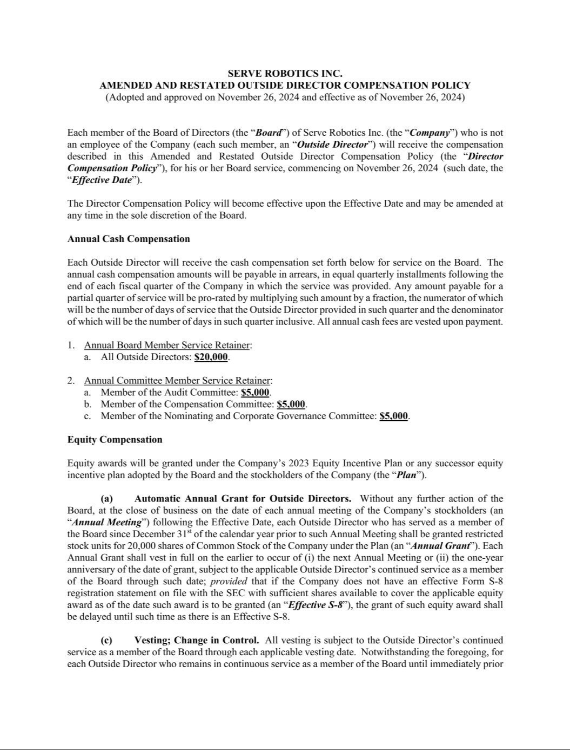

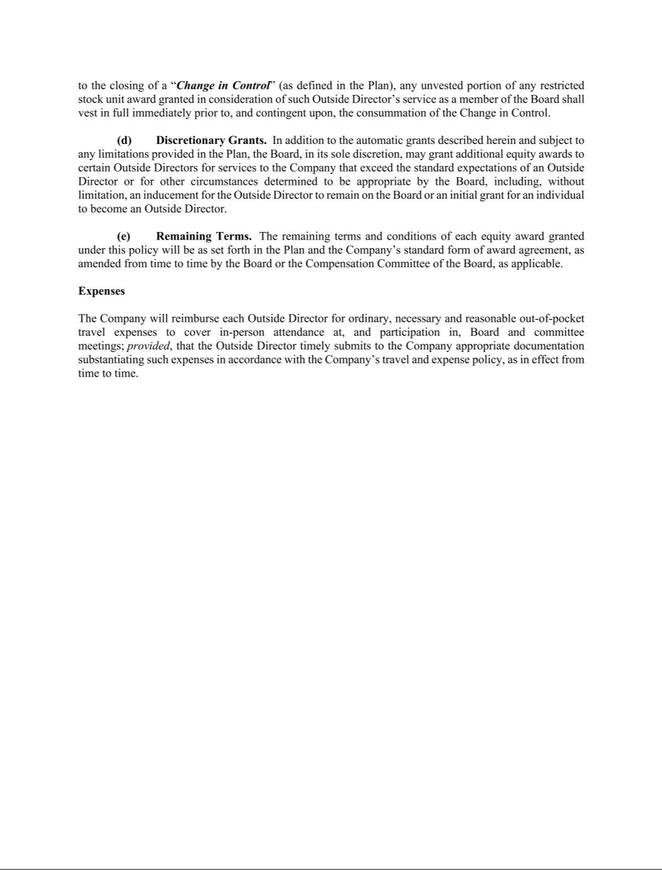

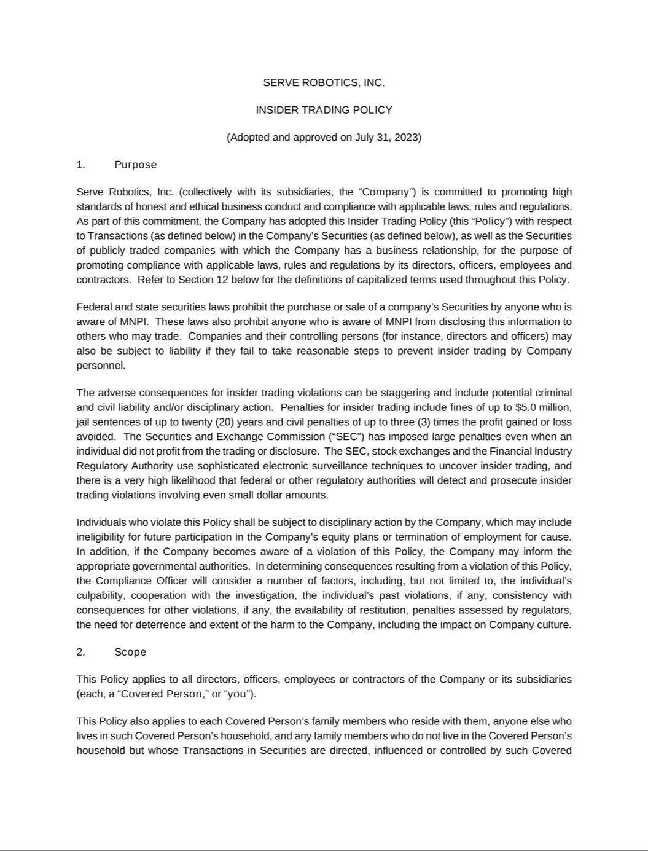

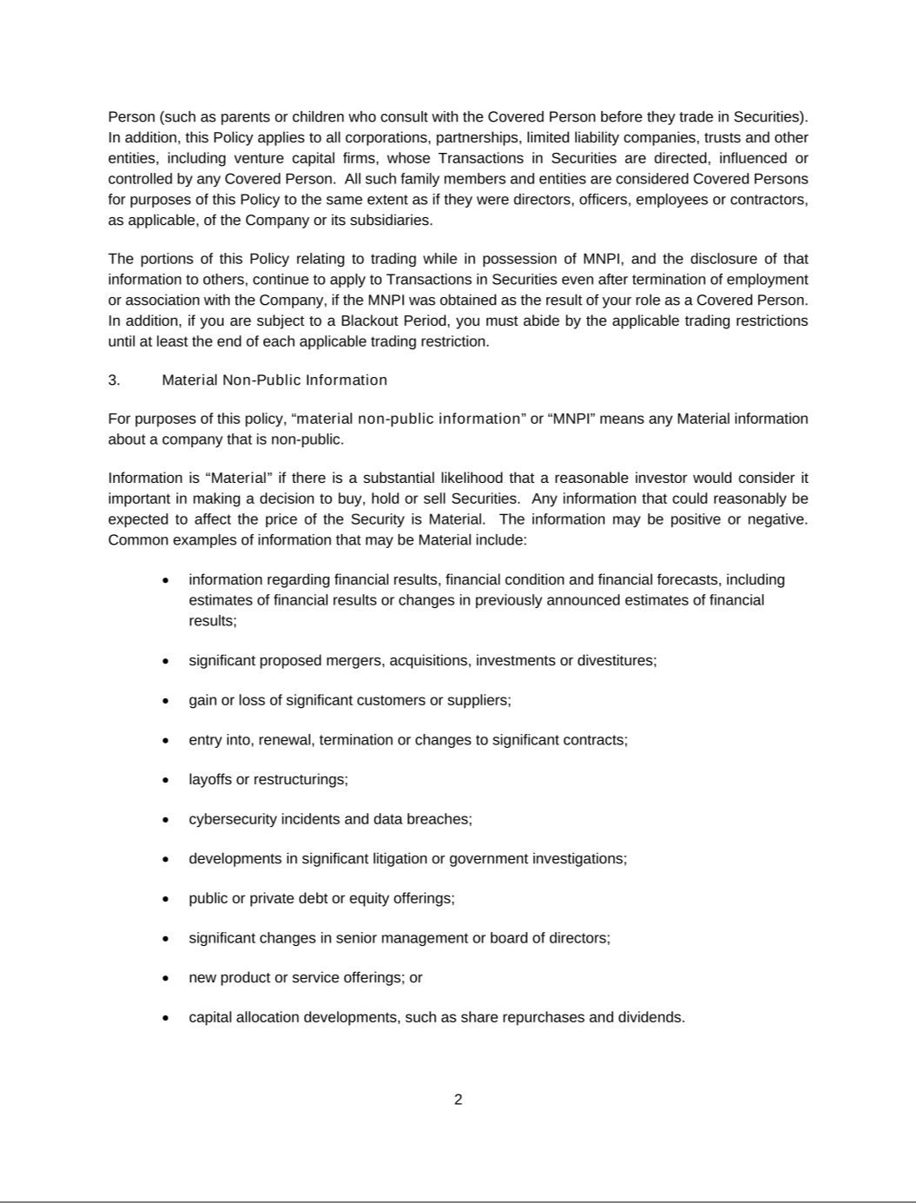

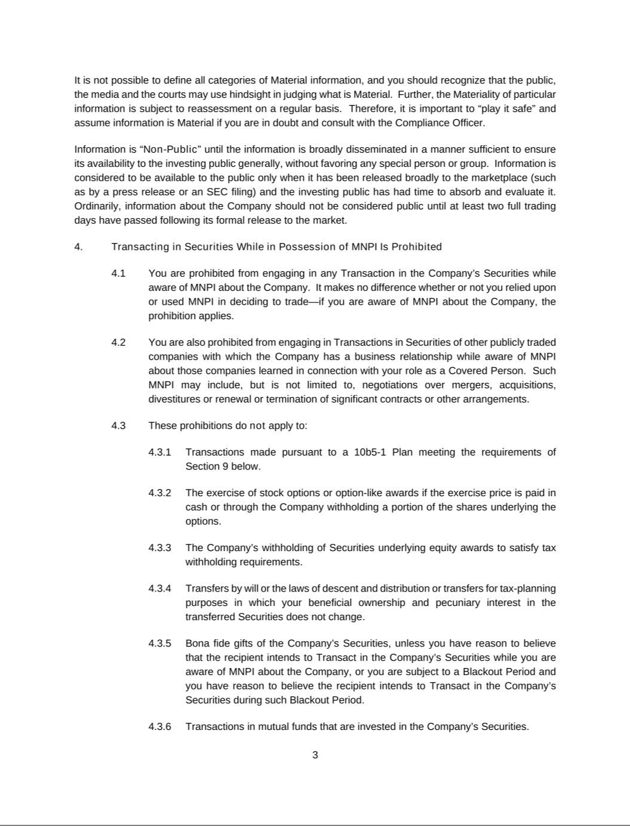

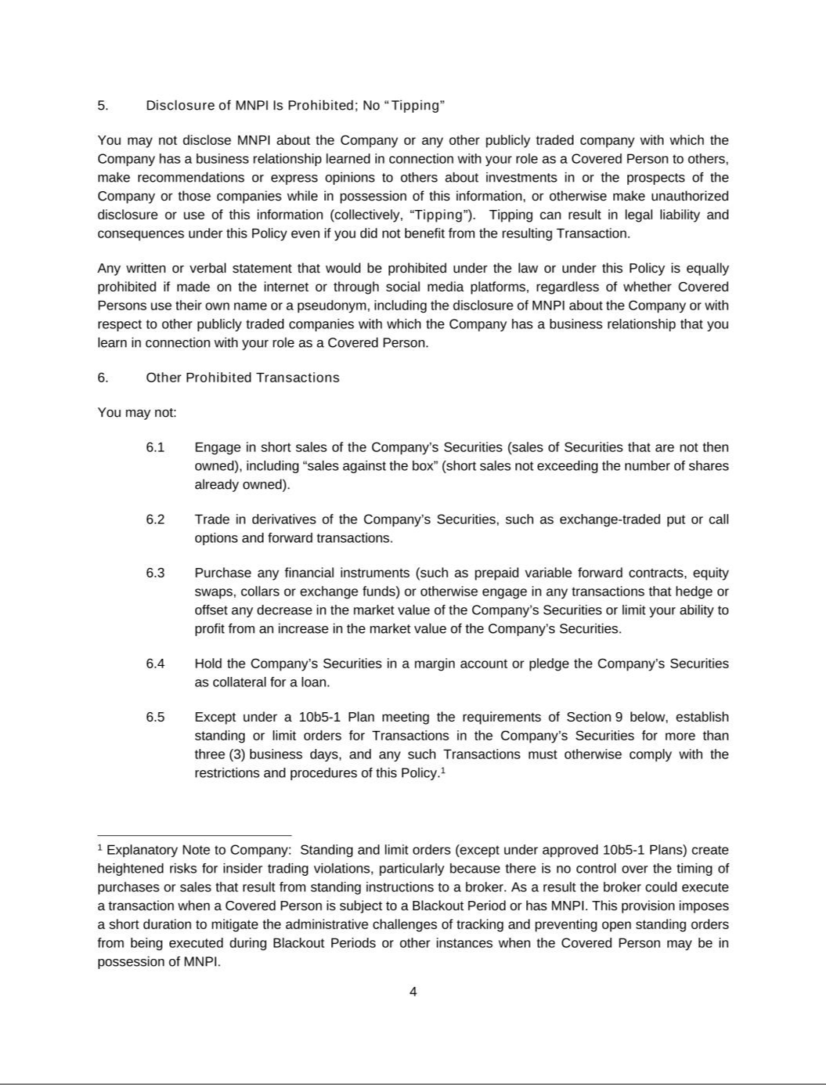

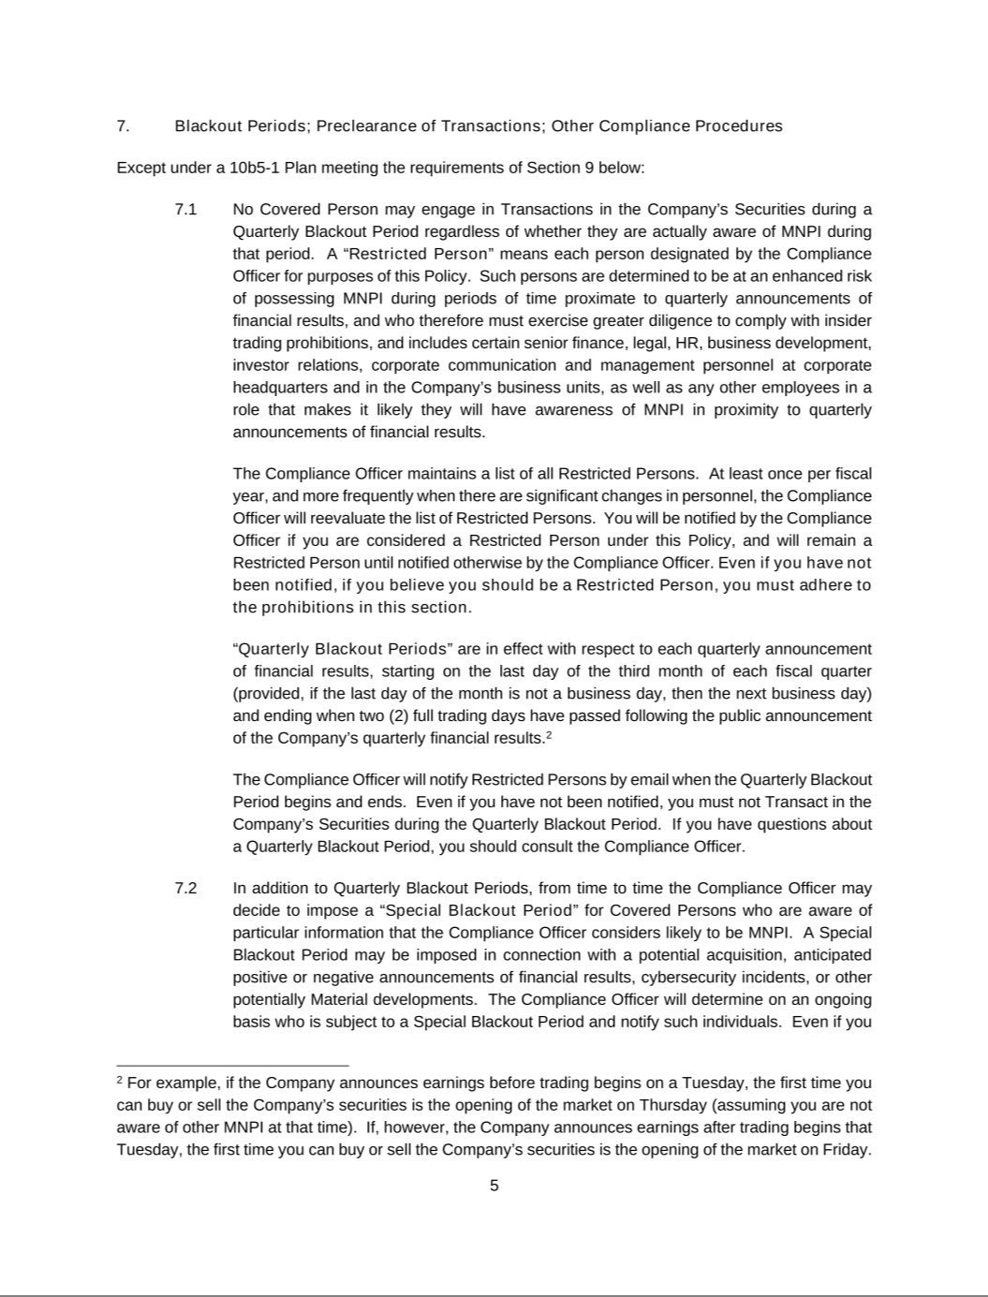

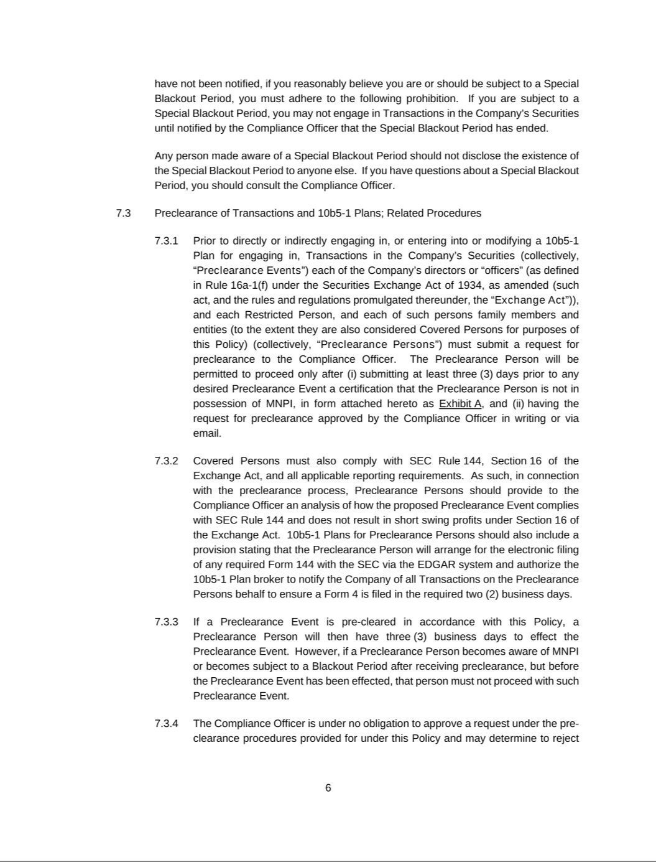

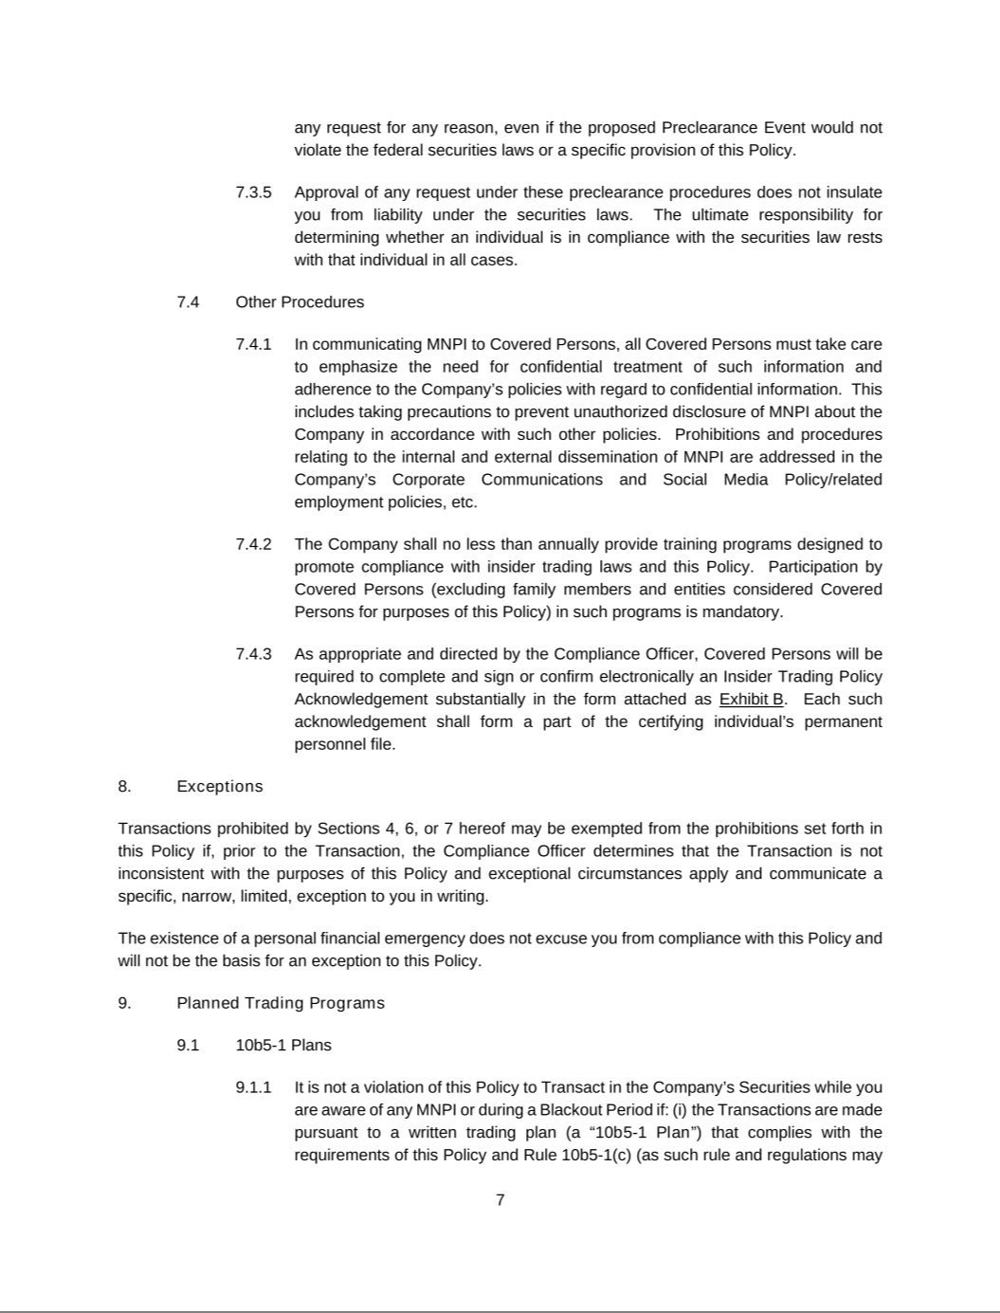

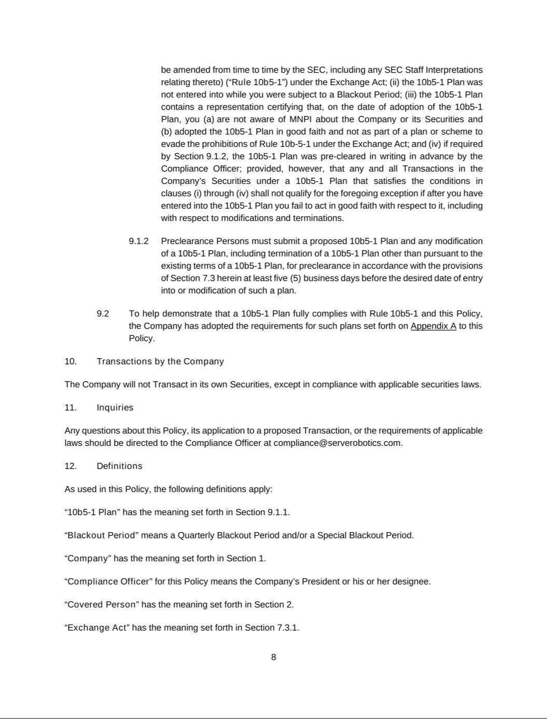

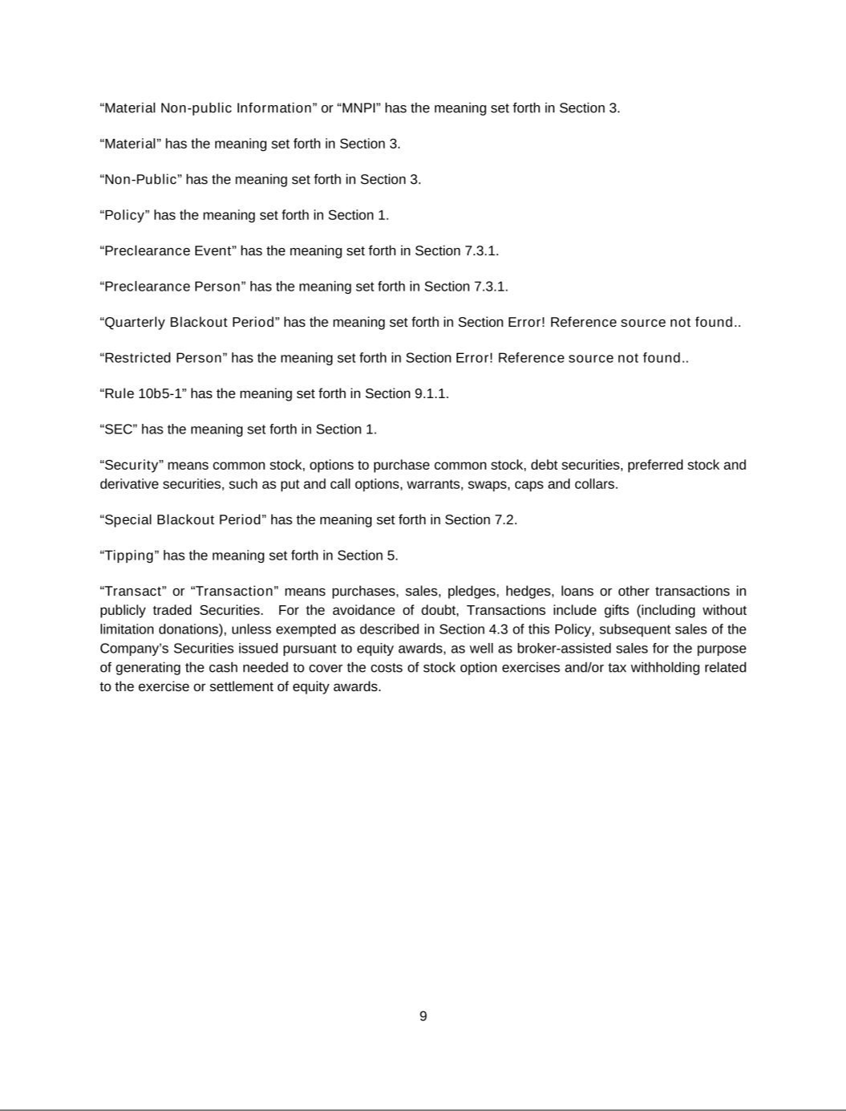

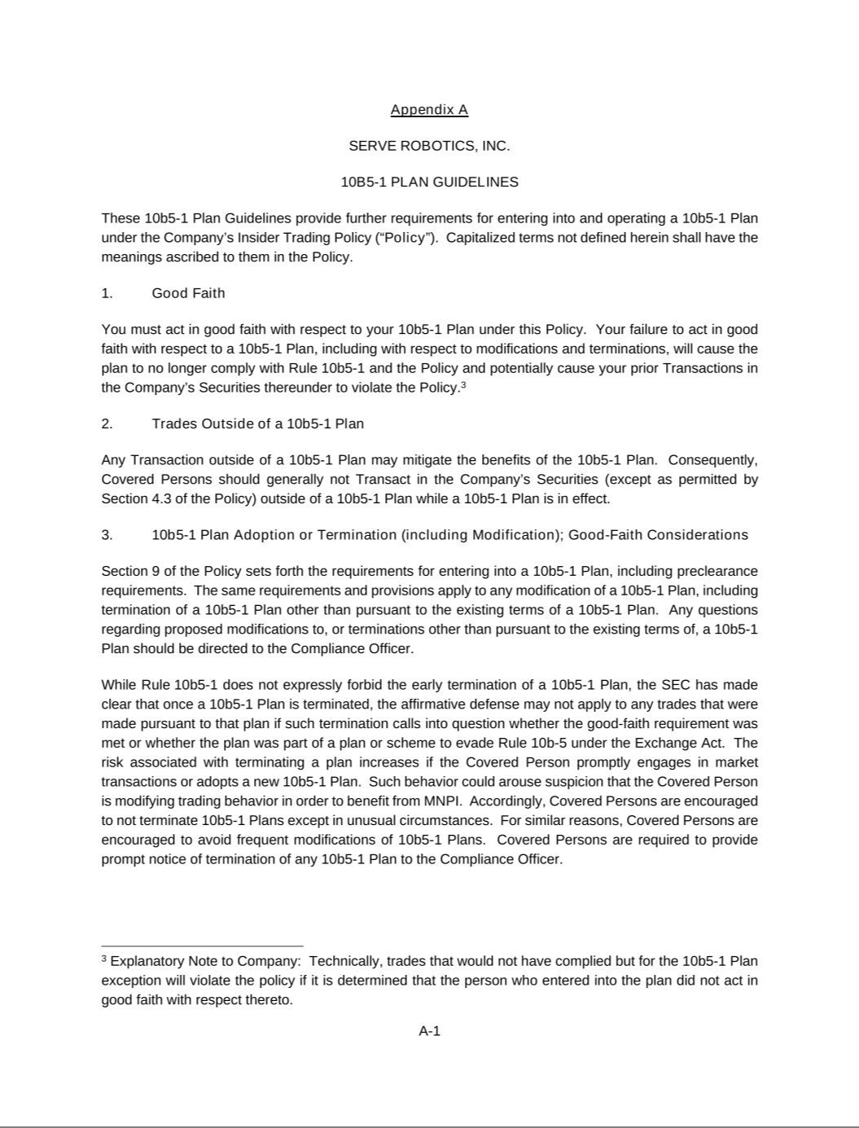

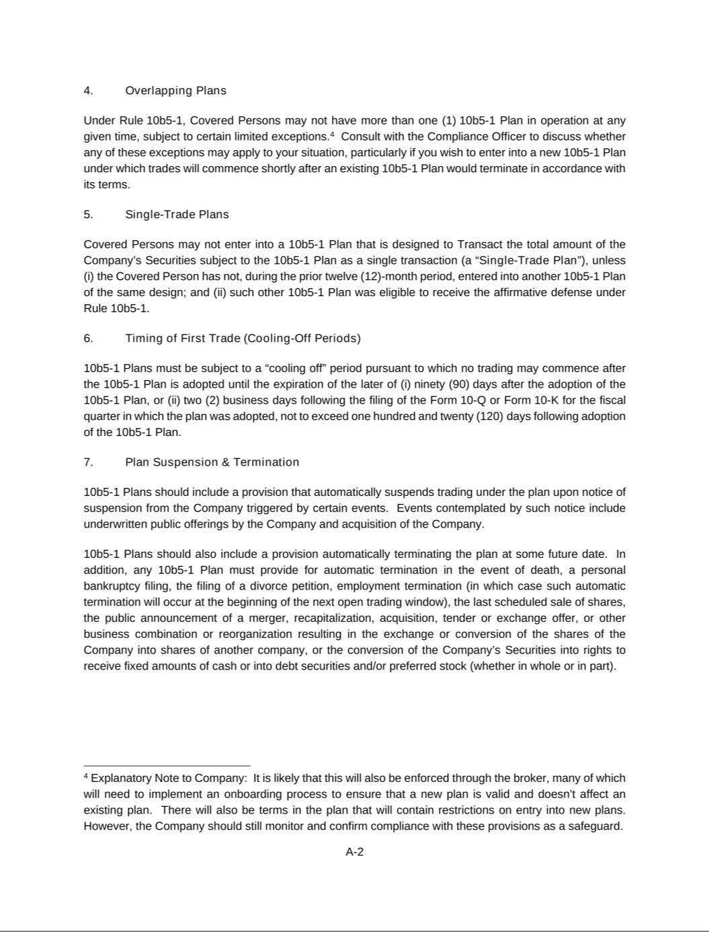



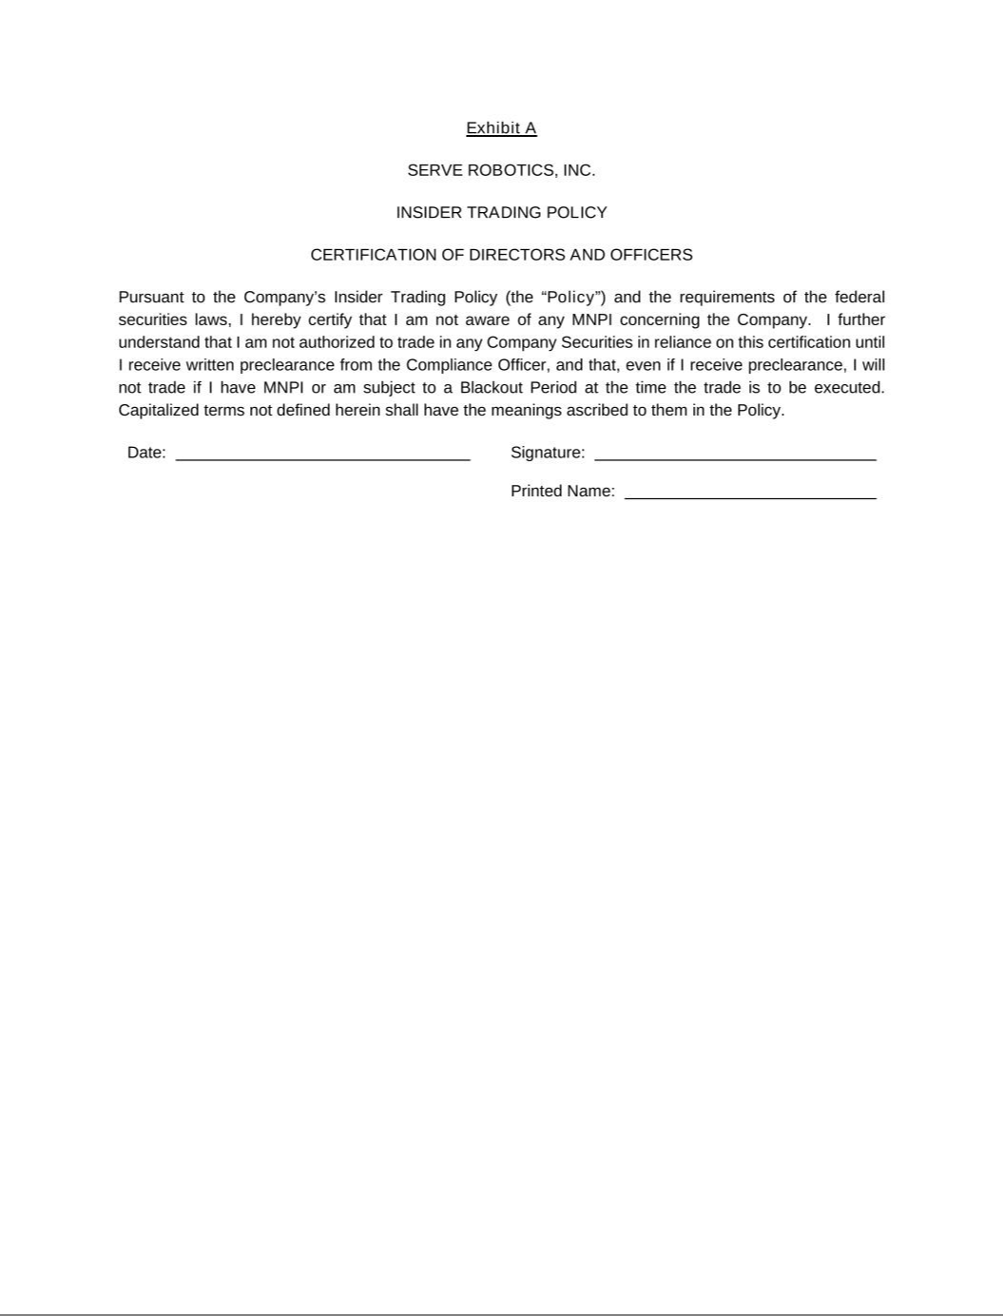

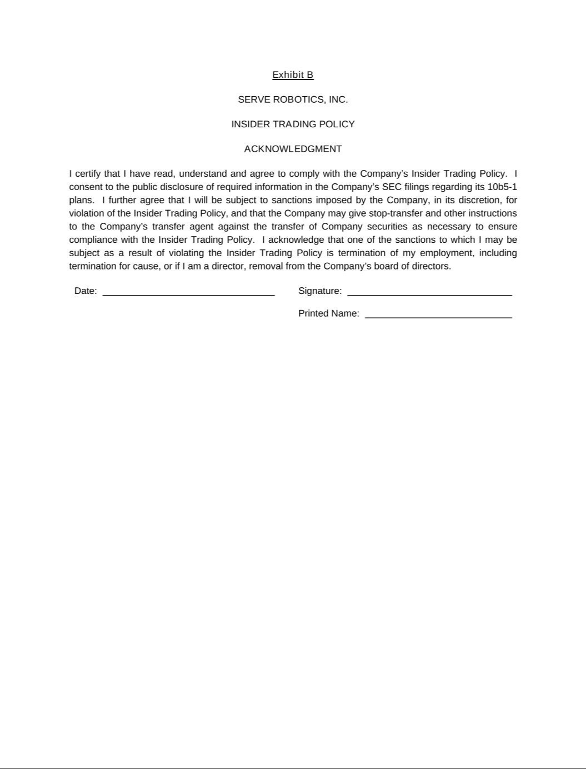

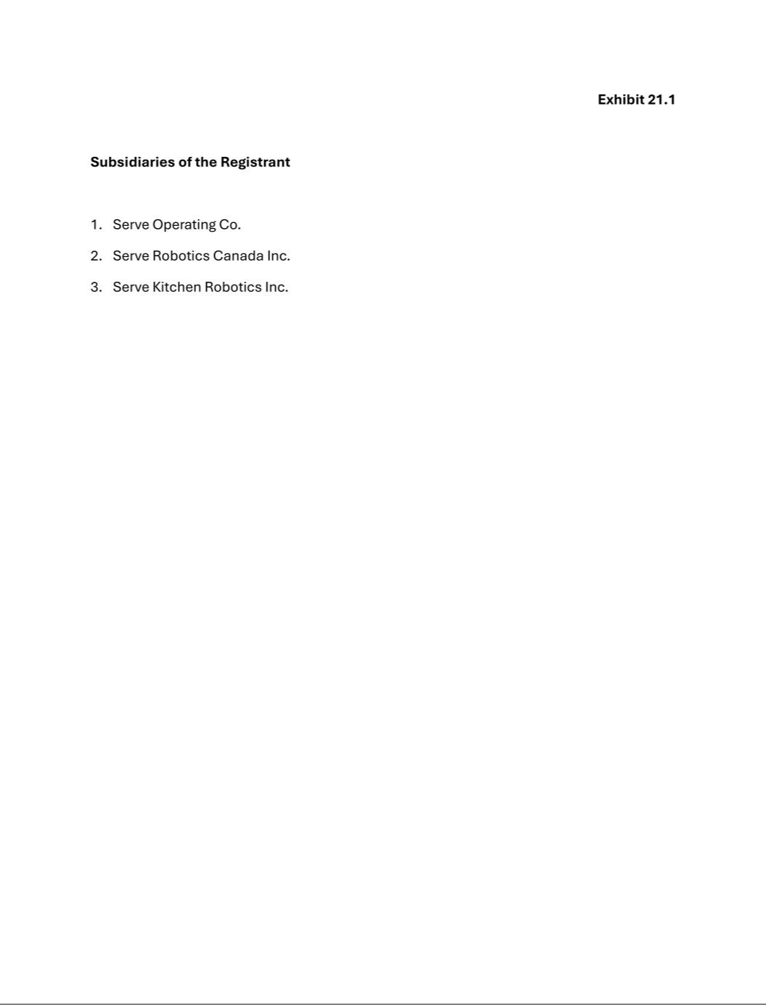

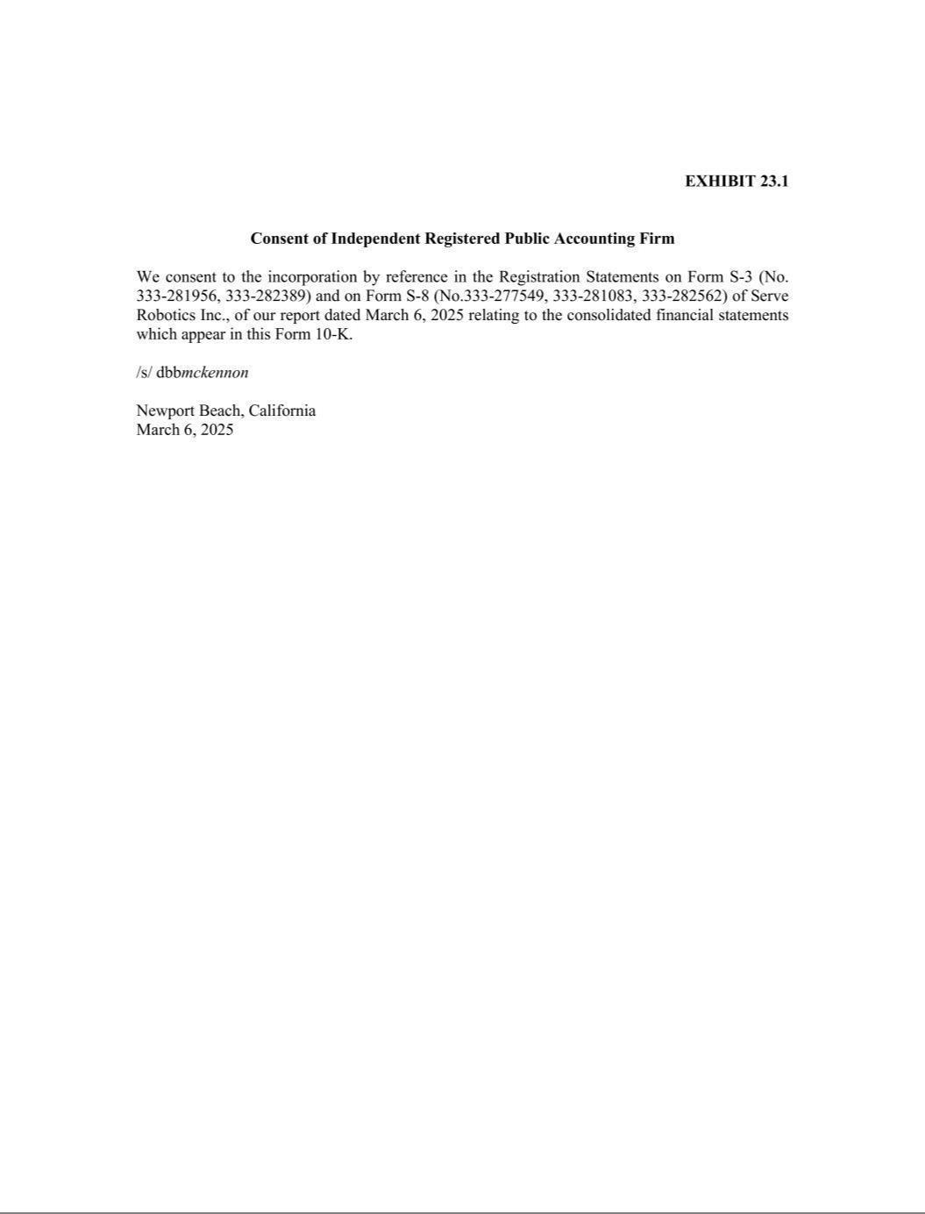

Exhibit 31.1

Certification of Principal Executive Officer Pursuant to Exchange Act Rule 13a-14(a)/15d-14(a) as Adopted

Pursuant to Section 302 of the Sarbanes-Oxley Act of 2002

I, Ali Kashani, certify that:

- I have reviewed this Annual Report on Form 10-K of Serve Robotics Inc.;

- Based on my knowledge, this report does not contain any untrue statement of a material fact or omit to state a material fact necessary to make the statements made, in light of the circumstances under which such statements were made, not misleading with respect to the period covered by this report;

- Based on my knowledge, the financial statements, and other financial information included in this report, fairly present in all material respects the financial condition, results of operations and cash flows of the registrant as of, and for, the periods presented in this report;

- The registrant’s other certifying officer(s) and I are responsible for establishing and maintaining disclosure controls and procedures (as defined in Exchange Act Rules 13a-15(e) and 15-d-15(e)) and internal control over financial reporting (as defined in Exchange Act Rules 13a-15(f) and 15d-15(f)) for the registrant and have:

  - Designed such disclosure controls and procedures, or caused such disclosure controls and procedures to be designed under our supervision, to ensure that material information relating to the registrant, including its consolidated subsidiaries, is made known to us by others within those entities, particularly during the period in which this report is being prepared;

  - Designed such internal control over financial reporting, or caused such internal control over financial reporting to be designed under our supervision, to provide reasonable assurance regarding the reliability of financial reporting and the preparation of financial statements for external purposes in accordance with generally accepted accounting principles;

  - Evaluated the effectiveness of the registrant’s disclosure controls and procedures and presented in this report our conclusions about the effectiveness of the disclosure controls and procedures, as of the end of the period covered by this report based on such evaluation; and

  - Disclosed in this report any change in the registrant’s internal control over financial reporting that occurred during the registrant’s most recent fiscal quarter (the registrant’s fourth fiscal quarter in the case of an annual report) that has materially affected, or is reasonably likely to materially affect, the registrant’s internal control over financial reporting; and

- The registrant’s other certifying officer(s) and I have disclosed, based on our most recent evaluation of internal control over financial reporting, to the registrant’s auditors and the audit committee of the registrant’s board of directors (or persons performing the equivalent functions):

  - All significant deficiencies and material weaknesses in the design or operation of internal control over financial reporting which are reasonably likely to adversely affect the registrant’s ability to record, process, summarize and report financial information; and

  - Any fraud, whether or not material, that involves management or other employees who have a significant role in the registrant’s internal control over financial reporting.

Date: March 6, 2025 /s/ Ali Kashani

Ali Kashani

Chief Executive Officer

(Principal Executive Officer)

Exhibit 31.2

Certification of Principal Financial Officer Pursuant to Exchange Act Rule 13a-14(a)/15d-14(a) as Adopted

Pursuant to Section 302 of the Sarbanes-Oxley Act of 2002

I, Brian Read, certify that:

- I have reviewed this Annual Report on Form 10-K of Serve Robotics Inc.;

- Based on my knowledge, this report does not contain any untrue statement of a material fact or omit to state a material fact necessary to make the statements made, in light of the circumstances under which such statements were made, not misleading with respect to the period covered by this report;

- Based on my knowledge, the financial statements, and other financial information included in this report, fairly present in all material respects the financial condition, results of operations and cash flows of the registrant as of, and for, the periods presented in this report;

- The registrant’s other certifying officer(s) and I are responsible for establishing and maintaining disclosure controls and procedures (as defined in Exchange Act Rules 13a-15(e) and 15-d-15(e)) and internal control over financial reporting (as defined in Exchange Act Rules 13a-15(f) and 15d-15(f)) for the registrant and have:

  - Designed such disclosure controls and procedures, or caused such disclosure controls and procedures to be designed under our supervision, to ensure that material information relating to the registrant, including its consolidated subsidiaries, is made known to us by others within those entities, particularly during the period in which this report is being prepared;

  - Designed such internal control over financial reporting, or caused such internal control over financial reporting to be designed under our supervision, to provide reasonable assurance regarding the reliability of financial reporting and the preparation of financial statements for external purposes in accordance with generally accepted accounting principles;

  - Evaluated the effectiveness of the registrant’s disclosure controls and procedures and presented in this report our conclusions about the effectiveness of the disclosure controls and procedures, as of the end of the period covered by this report based on such evaluation; and

  - Disclosed in this report any change in the registrant’s internal control over financial reporting that occurred during the registrant’s most recent fiscal quarter (the registrant’s fourth fiscal quarter in the case of an annual report) that has materially affected, or is reasonably likely to materially affect, the registrant’s internal control over financial reporting; and

- The registrant’s other certifying officer(s) and I have disclosed, based on our most recent evaluation of internal control over financial reporting, to the registrant’s auditors and the audit committee of the registrant’s board of directors (or persons performing the equivalent functions):

  - All significant deficiencies and material weaknesses in the design or operation of internal control over financial reporting which are reasonably likely to adversely affect the registrant’s ability to record, process, summarize and report financial information; and

  - Any fraud, whether or not material, that involves management or other employees who have a significant role in the registrant’s internal control over financial reporting.

Date: March 6, 2025 /s/ Brian Read

Brian Read

Chief Financial Officer

(Principal Financial and Accounting Officer)

Exhibit 32.1

Certification of Principal Executive Officer Pursuant to 18 U.S.C. Section 1350 as Adopted Pursuant

to Section 906 of the Sarbanes-Oxley Act of 2002

In connection with the Quarterly Report of Serve Robotics Inc. (the “Company”) on Form 10-K for the year ended December 31, 2024, as filed with the Securities and Exchange Commission (the “Report”), I, Ali Kashani, Chief Executive Officer (Principal Executive Officer) of the Company, hereby certify as of the date hereof, solely for purposes of Title 18, Chapter 63, Section 1350 of the United States Code, that to the best of my knowledge:

- The Report fully complies with the requirements of Section 13(a) or 15(d), as applicable, of the Securities Exchange Act of 1934, and

- The information contained in the Report fairly presents, in all material respects, the financial condition and results of operations of the Company at the dates and for the periods indicated.

Date: March 6, 2025 /s/ Ali Kashani

Ali Kashani

Chief Executive Officer

(Principal Executive Officer)

Exhibit 32.2

Certification of Principal Executive Officer Pursuant to 18 U.S.C. Section 1350 as Adopted Pursuant

to Section 906 of the Sarbanes-Oxley Act of 2002

In connection with the Quarterly Report of Serve Robotics Inc. (the “Company”) on Form 10-K for the year ended December 31, 2024, as filed with the Securities and Exchange Commission (the “Report”), I, Brian Read, Chief Financial Officer (Principal Financial and Accounting Officer) of the Company, hereby certify as of the date hereof, solely for purposes of Title 18, Chapter 63, Section 1350 of the United States Code, that to the best of my knowledge:

- The Report fully complies with the requirements of Section 13(a) or 15(d), as applicable, of the Securities Exchange Act of 1934, and

- The information contained in the Report fairly presents, in all material respects, the financial condition and results of operations of the Company at the dates and for the periods indicated.

Date: March 6, 2025 /s/ Brian Read

Brian Read

Chief Financial Officer

(Principal Financial and Accounting Officer)

