UNITED STATES
SECURITIES AND EXCHANGE COMMISSION
Washington, D.C. 20549
FORM 8-K
CURRENT REPORT
Pursuant to Section 13 or 15(d) of the Securities Exchange Act of 1934
Date of Report (Date of earliest event reported): August 13, 2024

SERVE ROBOTICS INC.
(Exact Name of Registrant as Specified in Charter)
Delaware |  |  |  |  |  | 000-56237 |  |  |  |  |  | 85-3844872
(State or Other Jurisdiction  of Incorporation) |  |  |  |  |  | (Commission File Number) |  |  |  |  |  | (IRS Employer  Identification No.)
730 Broadway  Redwood City, CA |  |  |  |  |  | 94063
(Address of Principal Executive Offices) |  |  |  |  |  | (Zip Code)
(818) 860-1352
(Registrant’s telephone number, including area code)
N/A
(Former Name or Former Address, if Changed Since Last Report)
Check the appropriate box below if the Form 8-K filing is intended to simultaneously satisfy the filing obligation of the registrant under any of the following provisions:
☐ Written communications pursuant to Rule 425 under the Securities Act (17 CFR 230.425)
☐ Soliciting material pursuant to Rule 14a-12 under the Exchange Act (17 CFR 240.14a-12)
☐ Pre-commencement communications pursuant to Rule 14d-2(b) under the Exchange Act (17 CFR 240.14d-2(b))
☐ Pre-commencement communications pursuant to Rule 13e-4(c) under the Exchange Act (17 CFR 240.13e-4(c))
Securities registered pursuant to Section 12(b) of the Act:
Title of each class |  |  |  |  |  | Trading Symbol(s) |  |  |  |  |  | Name of each exchange on which registered
Common Stock, par value $0.0001 per share |  |  |  |  |  | SERV |  |  |  |  |  | The Nasdaq Capital Market
Indicate by check mark whether the registrant is an emerging growth company as defined in Rule 405 of the Securities Act of 1933 (§230.405 of this chapter) or Rule 12b-2 of the Securities Exchange Act of 1934 (§240.12b-2 of this chapter).
Emerging growth company ☒
If an emerging growth company, indicate by check mark if the registrant has elected not to use the extended transition period for complying with any new or revised financial accounting standards provided pursuant to Section 13(a) of the Exchange Act. ☐

Item 2.02. Results of Operations and Financial Condition.
On August 13, 2024, Serve Robotics Inc. (the “Company”) announced its financial results for the three months ended June 30, 2024. The full text of the press release issued in connection with the announcement is furnished as Exhibit 99.1 to this Current Report on Form 8-K.

Item 7.01. Regulation FD Disclosure.
On August 13, 2024, the Company made available on its website a revised Company investor presentation. A copy of the presentation is furnished as Exhibit 99.2 to this Current Report on Form 8-K.
The information in this Form 8-K (including Exhibits 99.1 and 99.2) shall not be deemed “filed” for purposes of Section 18 of the Securities Exchange Act of 1934, as amended (the “Exchange Act”), or otherwise subject to the liabilities of that section, nor shall it be deemed incorporated by reference in any filing under the Securities Act of 1933, as amended, or the Exchange Act, except as expressly set forth by specific reference in such a filing.

Item 9.01 Financial Statements and Exhibits.
(d)List of Exhibits.
Exhibit  Number |  |  |  |  |  | Description
99.1 |  |  |  |  |  | Press release, dated August 13, 2024
99.2 |  |  |  |  |  | Investor Presentation, dated August 2024
104 |  |  |  |  |  | Cover Page Interactive Data File (embedded within the Inline XBRL document)

1

SIGNATURES
Pursuant to the requirements of the Securities Exchange Act of 1934, the registrant has duly caused this report to be signed on its behalf by the undersigned hereunto duly authorized.
 |  |  | Serve Robotics Inc.
Dated: August 13, 2024 |  |  | /s/ Ali Kashani
 |  |  | Ali Kashani
 |  |  | Chief Executive Officer and Director

2
Exhibit 99.1
Serve Robotics Announces Second Quarter 2024 Results
•Manufacturing activities commenced on 2,000-robot fleet deployment following entry into manufacturing agreement with Magna and amendment to lidar supply agreement with Ouster
•Cash position bolstered by proceeds of $40 million equity offering, as well as post-quarter $15 million private placement transaction
SAN FRANCISCO, August 13, 2024 — Serve Robotics Inc. (the “Company” or “Serve”) (Nasdaq: SERV), a leading autonomous sidewalk delivery company, today announced financial results for the second quarter 2024 ended June 30, 2024.
"We are pleased to report another strong quarter, extending our 30-month track record of double-digit month-over-month growth and improvements in key operational metrics," said Dr. Ali Kashani, Serve's Co-founder and CEO. "This quarter, we expanded into Koreatown in Los Angeles, signed important agreements with Magna International Inc. ("Magna") and expanded on our supply agreement with Ouster Inc. ("Ouster"), and appointed our Chief Hardware & Manufacturing Officer to spearhead our fleet expansion efforts. I am particularly pleased to announce that Serve has completed the design of our third-generation robot. Looking ahead, we are focused on executing Serve's fleet expansion plan to deploy at least 250 additional robots in Los Angeles by the end of Q1 2025. We believe our continued execution of this plan through year end 2025 will position Serve to deploy all 2,000 robots under our Uber Eats agreement, which at full utilization is expected to generate $60 to $80 million in run-rate revenue annually."
Second Quarter 2024 and Recent Highlights
•Public Offering & Follow-on Transaction: On April 18, 2024, Serve completed a successful public equity offering, which generated $40.0 million in gross proceeds, and through which Serve's common stock began trading on The Nasdaq Capital Market under the ticker symbol “SERV”. Post quarter-end, the company also completed a private placement transaction with gross proceeds of $15.0 million.
•Operational Performance: Serve averaged 385 daily supply hours during the second quarter 2024, a 106% increase year-over-year and a 28% increase quarter-over-quarter. The Company also achieved an 85% increase in daily active robots year-over-year and a 23% increase quarter-over-quarter.
•Los Angeles Expansion: In June 2024, Serve announced the expansion of its delivery operations into Koreatown and began onboarding new local merchants through its partnership with Uber Eats. The coverage expansion represents execution of Serve's long-term plan to broaden its geographic reach in Los Angeles and across the U.S.
•Manufacturing activities commenced following Magna and Ouster agreements: In the second quarter Serve commenced manufacturing activities on its 2,000-robot fleet, led by Euan Abraham, the Company's newly promoted Chief Hardware & Manufacturing Officer. Serve also entered into a purchase and production agreement with Magna, under which Magna will become the contract manufacturer of Serve's delivery robots, and signed an amendment expanding its supply agreement with Ouster to equip its next-generation robots with upgraded sensors for enhanced performance.
Second Quarter Financial Highlights
•Second quarter revenue was $0.47 million, including $0.30 million of software service revenue derived from the Company’s software services agreement with Magna. As forecasted, Serve's services contract with Magna was significantly completed during the second quarter, and the Company does not anticipate material software services revenue in Q3 2024.
•As of June 30, 2024, the Company had $28.8 million of cash and cash equivalents.

•As of June 30, 2024, the Company had 36.5 million shares of common stock outstanding, and 42.6 million shares outstanding on a fully diluted basis. Following the Company’s July 2024 private placement, the Company had approximately 48.2 million shares outstanding on a fully diluted basis.
Quarterly Conference Call
Company management will host a conference call and webcast today at 2:00 p.m. PT / 5:00 p.m. ET to discuss the financial results and provide a corporate update. A live webcast and replay can be accessed from the investor relations page of Serve's website at investors.serverobotics.com.
Individuals interested in listening to the conference call may do so by dialing (646) 968-2525 and referencing conference ID#: 1640108.

About Serve

Serve develops advanced, AI-powered, low-emissions sidewalk delivery robots that endeavor to make delivery sustainable and economical. Spun off from Uber in 2021 as an independent company, Serve has completed tens of thousands of deliveries for enterprise partners such as Uber Eats and 7-Eleven. Serve has scalable multi-year contracts, including a signed agreement to deploy up to 2,000 delivery robots on the Uber Eats platform across multiple U.S. markets.

For further information about Serve (Nasdaq: SERV), please visit www.serverobotics.com or follow us on social media via X (Twitter), Instagram, or LinkedIn @serverobotics.
2
Supplemental Financial Information
The key metrics and financial tables outlined below are metrics that provide management with additional understanding of the drivers of business performance and the Company’s ability to deliver stockholder return. Investors should not place undue reliance on these metrics as indicators of future or expected results. The Company’s presentation of these metrics may differ from similarly titled metrics presented by other companies and therefore comparability may be limited.
Table 1: Key Metrics
 |  |  | Three Months Ended |  |  |  |  |  |  |  |  |  |  |  |  |  |  |  |  |  | Six Months Ended
 |  |  | June 30, 2024 |  |  |  |  |  | March 31, 2024 |  |  |  |  |  | June 30, 2023 |  |  |  |  |  | June 30, 2024 |  |  |  |  |  | June 30, 2023
Key Metrics |  |  | (Unaudited) |  |  |  |  |  | (Unaudited) |  |  |  |  |  | (Unaudited) |  |  |  |  |  | (Unaudited) |  |  |  |  |  | (Unaudited)
Daily Active Robots (1) |  |  | 48 |  |  |  |  |  | 39 |  |  |  |  |  | 23 |  |  |  |  |  | 44 |  |  |  |  |  | 25
Daily Supply Hours (2) |  |  | 385 |  |  |  |  |  | 300 |  |  |  |  |  | 152 |  |  |  |  |  | 342 |  |  |  |  |  | 169
(1)Daily Active Robots: The Company defines daily active robots as the average number of robots performing daily deliveries during the period.
(2)Daily Supply Hours: The Company defines daily supply hours as the average number of hours the Company’s robots are ready to accept offers and perform daily deliveries during the period.

Table 2: Revenue
 |  |  | Three Months Ended |  |  |  |  |  |  |  |  |  |  |  |  |  |  |  |  |  | Six Months Ended
 |  |  | June 30, 2024 |  |  |  |  |  | March 31, 2024 |  |  |  |  |  | June 30, 2023 |  |  |  |  |  | June 30, 2024 |  |  |  |  |  | June 30, 2023
Revenue |  |  | (Unaudited) |  |  |  |  |  | (Unaudited) |  |  |  |  |  | (Unaudited) |  |  |  |  |  | (Unaudited) |  |  |  |  |  | (Unaudited)
Software services |  |  | $ | 296,035 |  |  |  |  | $ | 851,101 |  |  |  |  | $ | - |  |  |  |  | $ | 1,147,136 |  |  |  |  | $ | -
Delivery services |  |  | 75,540 |  |  |  |  |  | 51,760 |  |  |  |  |  | 32,467 |  |  |  |  |  | 127,300 |  |  |  |  |  | 57,719
Branding fees |  |  | 96,800 |  |  |  |  |  | 43,850 |  |  |  |  |  | 29,542 |  |  |  |  |  | 140,650 |  |  |  |  |  | 44,542
 |  |  | $ | 468,375 |  |  |  |  | $ | 946,711 |  |  |  |  | $ | 62,009 |  |  |  |  | $ | 1,415,086 |  |  |  |  | $ | 102,261
Forward Looking Statements
This press release contains “forward-looking statements,” within the meaning of Section 27A of the Securities Act of 1933, Section 21E of the Securities Exchange Act of 1934 and the Private Securities Litigation Reform Act of 1995. Forward-looking statements may be identified by the context of the statement and generally arise when we or our management are discussing our beliefs, estimates or expectations. Such statements generally include the words “believes,” “plans,” “intends,” “targets,” “may,” “could,” “should,” “will,” “expects,” “estimates,” “suggests,” “anticipates,” “outlook,” “continues,” or similar expressions. These statements are not historical facts or guarantees of future performance, but represent management’s belief at the time the statements were made regarding future events which are subject to certain risks, uncertainties and other factors, many of which are outside of our control. Actual results and outcomes may differ materially from what is expressed or forecast in such forward-looking statements. Forward-looking statements include, without limitation, statements regarding the Company’s partnership with Magna, timing of the Company’s robot deployment, the Company’s ability to expand to additional markets, and the Company’s timing and ability to scale to commercial production.
The forward-looking statements contained in this release are also subject to other risks and uncertainties, including those more fully described in our filings with the Securities and Exchange Commission (“SEC”), including in the sections entitled “Risk Factors” and “Management’s Discussion and Analysis of Financial Condition and Results of Operations’’ in our Annual Report on Form 10-K for the year ended December 31, 2023, our Quarterly Report on Form 10-Q for the three months ended June 30, 2024 that will be filed following this earnings release, and in our subsequent SEC filings. We can give no assurance that the plans, intentions, expectations or strategies as reflected in or suggested by those forward-looking
3
statements will be attained or achieved. The forward-looking statements in this release are based on information available to us as of the date hereof, and we disclaim any obligation to update any forward-looking statements, except as required by law. These forward-looking statements should not be relied upon as representing our views as of any date subsequent to the date of this press release.

Contacts

Aduke Thelwell, Head of Communications & Investor Relations
Serve Robotics
aduke.thelwell@serverobotics.com
347-464-8510

Investor Relations
investor.relations@serverobotics.com

4
Serve Robotics Inc.
Unaudited Condensed Consolidated Balance Sheets
As of June 30, 2024 and December 31, 2023
(unaudited)
 |  |  | June 30,  2024 |  |  |  |  |  | December 31,  2023
ASSETS
Current assets:
Cash |  |  | 28,780,034 |  |  |  |  |  | $ | 6,756
Accounts receivable |  |  | 93,132 |  |  |  |  |  | 2,955
Inventory |  |  | 709,289 |  |  |  |  |  | 774,349
Prepaid expenses |  |  | 1,119,995 |  |  |  |  |  | 676,969
Escrow Receivable |  |  | 180,000 |  |  |  |  |  | -
Total current assets |  |  | 30,882,450 |  |  |  |  |  | 1,461,029
Property and equipment, net |  |  | 819,244 |  |  |  |  |  | 48,422
Right of use asset |  |  | 552,143 |  |  |  |  |  | 782,439
Deposits |  |  | 512,659 |  |  |  |  |  | 512,659
Total assets |  |  | 32,766,496 |  |  |  |  |  | $ | 2,804,549
LIABILITIES AND STOCKHOLDERS’ EQUITY (DEFICIT)
Current liabilities:
Accounts payable |  |  | 1,387,559 |  |  |  |  |  | $ | 2,050,605
Accrued liabilities |  |  | 46,079 |  |  |  |  |  | 255,849
Deferred revenue |  |  | 52,863 |  |  |  |  |  | -
Note payable, current |  |  | 750,000 |  |  |  |  |  | 1,000,000
Note payable - related party |  |  | — |  |  |  |  |  | 70,000
Right of use liability, current portion |  |  | 413,800 |  |  |  |  |  | 496,963
Lease liability, current portion |  |  | 1,617,224 |  |  |  |  |  | 2,363,807
Total current liabilities |  |  | 4,267,525 |  |  |  |  |  | 6,237,224
Note payable, net of current portion |  |  | — |  |  |  |  |  | 230,933
Restricted stock award liability |  |  | — |  |  |  |  |  | 158,617
Right of use liability |  |  | 35,230 |  |  |  |  |  | 211,181
Total liabilities |  |  | 4,302,755 |  |  |  |  |  | 6,837,955
Stockholders’ equity (deficit):
Preferred stock, $0.0001 par value, 10,000,000 shares authorized, no shares issued or outstanding as of both June 30, 2024 and December 31, 2023 |  |  | — |  |  |  |  |  | -
Common stock, $0.0001 par value; 300,000,000 shares authorized, 36,642,064 and 24,832,814 shares issued and 36,529,574 and 24,508,795 shares outstanding as of both June 30, 2024 and December 31, 2023 |  |  | 3,651 |  |  |  |  |  | 2,450
Additional paid-in capital |  |  | 114,869,809 |  |  |  |  |  | 64,468,141
Subscription receivable |  |  | — |  |  |  |  |  | (169,616)
Accumulated deficit |  |  | (86,409,719) |  |  |  |  |  | (68,334,381)
Total stockholders’ equity (deficit) |  |  | 28,463,741 |  |  |  |  |  | (4,033,406)
Total liabilities and stockholders’ equity (deficit) |  |  | $ | 32,766,496 |  |  |  |  | $ | 2,804,549

5
Serve Robotics Inc.
Unaudited Condensed Consolidated Statements of Operations
For the Three and Six Months Ended June 30, 2024 and 2023; and Three Months Ended March 31, 2024
(unaudited)
 |  |  | Three Month Ended |  |  |  |  |  |  |  |  |  |  |  |  |  |  |  |  |  | Six Months Ended
 |  |  | June 30, 2024 |  |  |  |  |  | March 31, 2024 |  |  |  |  |  | June 30, 2023 |  |  |  |  |  | June 30, 2024 |  |  |  |  |  | June 30, 2023
Revenues |  |  | $ | 468,375 |  |  |  |  | $ | 946,711 |  |  |  |  | $ | 62,009 |  |  |  |  | $ | 1,415,086 |  |  |  |  | $ | 102,261
Cost of revenues |  |  | 326,013 |  |  |  |  |  | 352,438 |  |  |  |  |  | 391,367 |  |  |  |  |  | 678,451 |  |  |  |  |  | 758,628
Gross profit (loss) |  |  | 142,362 |  |  |  |  |  | 594,273 |  |  |  |  |  | (329,358) |  |  |  |  |  | 736,635 |  |  |  |  |  | (656,367)
Operating expenses:
General and administrative |  |  | 1,873,320 |  |  |  |  |  | 1,008,071 |  |  |  |  |  | 970,819 |  |  |  |  |  | 2,881,391 |  |  |  |  |  | 1,986,806
Operations |  |  | 871,211 |  |  |  |  |  | 540,974 |  |  |  |  |  | 592,648 |  |  |  |  |  | 1,412,185 |  |  |  |  |  | 1,114,335
Research and development |  |  | 5,787,906 |  |  |  |  |  | 6,638,441 |  |  |  |  |  | 2,125,685 |  |  |  |  |  | 12,426,347 |  |  |  |  |  | 4,208,634
Sales and marketing |  |  | 165,612 |  |  |  |  |  | 118,236 |  |  |  |  |  | 83,136 |  |  |  |  |  | 283,848 |  |  |  |  |  | 362,718
Total operating expenses |  |  | 8,698,049 |  |  |  |  |  | 8,305,722 |  |  |  |  |  | 3,772,288 |  |  |  |  |  | 17,003,771 |  |  |  |  |  | 7,672,493
Loss from operations |  |  | (8,555,687) |  |  |  |  |  | (7,711,449) |  |  |  |  |  | (4,101,646) |  |  |  |  |  | (16,267,136) |  |  |  |  |  | (8,328,860)
Other income (expense), net:
Interest expense, net |  |  | (260,120) |  |  |  |  |  | (1,326,522) |  |  |  |  |  | (496,862) |  |  |  |  |  | (1,586,642) |  |  |  |  |  | (538,606)
Change in fair value of derivative liability |  |  | (221,560) |  |  |  |  |  | - |  |  |  |  |  | - |  |  |  |  |  | (221,560) |  |  |  |  |  | -
Change in fair value of simple agreements for future equity |  |  | - |  |  |  |  |  | - |  |  |  |  |  | (367,748) |  |  |  |  |  | - |  |  |  |  |  | (1,236,912)
Total other income (expense), net |  |  | (481,680) |  |  |  |  |  | (1,326,522) |  |  |  |  |  | (864,610) |  |  |  |  |  | (1,808,202) |  |  |  |  |  | (1,775,518)
Provision for income taxes |  |  | - |  |  |  |  |  | - |  |  |  |  |  | - |  |  |  |  |  | - |  |  |  |  |  | -
Net loss |  |  | $ | (9,037,367) |  |  |  |  | $ | (9,037,971) |  |  |  |  | $ | (4,966,256) |  |  |  |  | $ | (18,075,338) |  |  |  |  | $ | (10,104,378)
Weighted average common shares outstanding - basic and diluted |  |  | 33,795,009 |  |  |  |  |  | 24,556,343 |  |  |  |  |  | 6,678,372 |  |  |  |  |  | 29,176,370 |  |  |  |  |  | 6,678,372
Net loss per common share - basic and diluted |  |  | $ | (0.27) |  |  |  |  | $ | (0.37) |  |  |  |  | $ | (0.74) |  |  |  |  | $ | (0.62) |  |  |  |  | $ | (1.51)

6
Serve Robotics Inc.
Unaudited Condensed Consolidated Statements of Cash Flows
For the Six Months Ended June 30, 2024 and 2023
(unaudited)
Six Months Ended
June 30,
 |  |  | 2024 |  |  |  |  |  | 2023
Cash flows from operating activities:
Net loss |  |  | $ | (18,075,338) |  |  |  |  | $ | (10,104,378)
Adjustments to reconcile net loss to net cash used in operating activities:
Depreciation |  |  | 27,500 |  |  |  |  |  | 931,279
Stock-based compensation |  |  | 7,735,469 |  |  |  |  |  | 200,872
Amortization of debt discount |  |  | 1,677,942 |  |  |  |  |  | 466,706
Loss on conversion of note payable |  |  | 221,560 |  |  |  |  |  | -
Change in fair value of simple agreements for future equity |  |  | - |  |  |  |  |  | 1,236,912
Interest on recourse loan |  |  | - |  |  |  |  |  | (2,504)
Changes in operating assets and liabilities:
Accounts receivable |  |  | (90,177) |  |  |  |  |  | 23,697
Inventory |  |  | 65,060 |  |  |  |  |  | (4,704)
Prepaid expenses |  |  | (443,026) |  |  |  |  |  | 16,253
Escrow receivable |  |  | (180,000) |  |  |  |  |  | -
Accounts payable |  |  | (663,046) |  |  |  |  |  | 704,870
Accrued liabilities |  |  | (120,231) |  |  |  |  |  | (36,045)
Deferred revenue |  |  | 52,863 |  |  |  |  |  | -
Right of use liabilities, net |  |  | (28,818) |  |  |  |  |  | (23,163)
Net cash used in operating activities |  |  | (9,820,242) |  |  |  |  |  | (6,590,205)
Cash flows from investing activities:
Purchase of property and equipment |  |  | (798,322) |  |  |  |  |  | -
Net cash used in investing activities |  |  | (798,322) |  |  |  |  |  | -
Cash flows from financing activities:
Proceeds from simple agreement for future equity |  |  | - |  |  |  |  |  | 2,666,953
Proceeds from convertible notes payable |  |  | 4,844,625 |  |  |  |  |  | 2,798,410
Proceeds from note payable, related party |  |  | - |  |  |  |  |  | 399,000
Exercise of warrants |  |  | 5,907 |  |  |  |  |  | -
Exercise of options |  |  | 8,757 |  |  |  |  |  | -
Proceeds from issuance of common stock pursuant to offering, net of offering costs |  |  | 35,849,136 |  |  |  |  |  | -
Repayments of note payable |  |  | (500,000) |  |  |  |  |  | (500,000)
Repayments of notes payable, related party |  |  | (70,000) |  |  |  |  |  | -
Deferred offering costs |  |  | - |  |  |  |  |  | (352,617)
Repayment of lease liability financing |  |  | (746,583) |  |  |  |  |  | (1,118,348)
Net cash provided by financing activities |  |  | 39,391,842 |  |  |  |  |  | 3,893,398
Net change in cash and cash equivalents |  |  | 28,773,278 |  |  |  |  |  | (2,696,807)
Cash and cash equivalents at beginning of period |  |  | 6,756 |  |  |  |  |  | 2,715,719
Cash and cash equivalents at end of period |  |  | $ | 28,780,034 |  |  |  |  | $ | 18,912

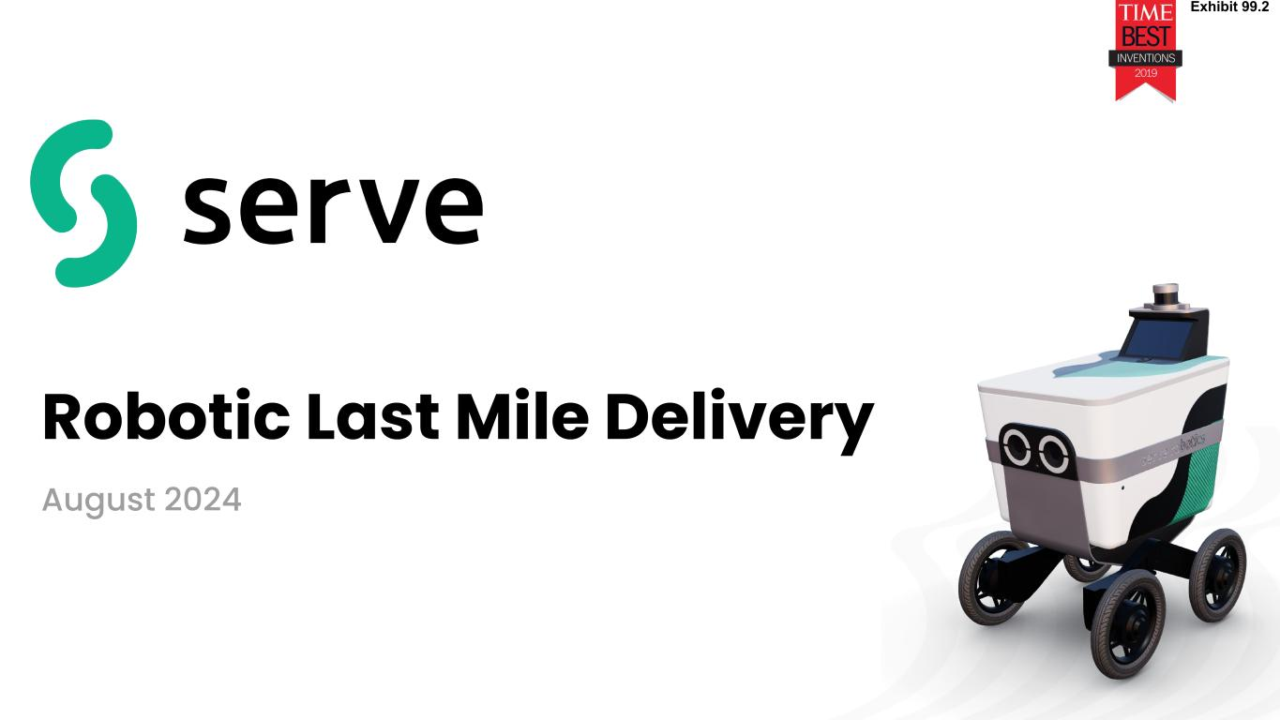
7
Robotic Last Mile Delivery August 2024 Exhibit 99.2

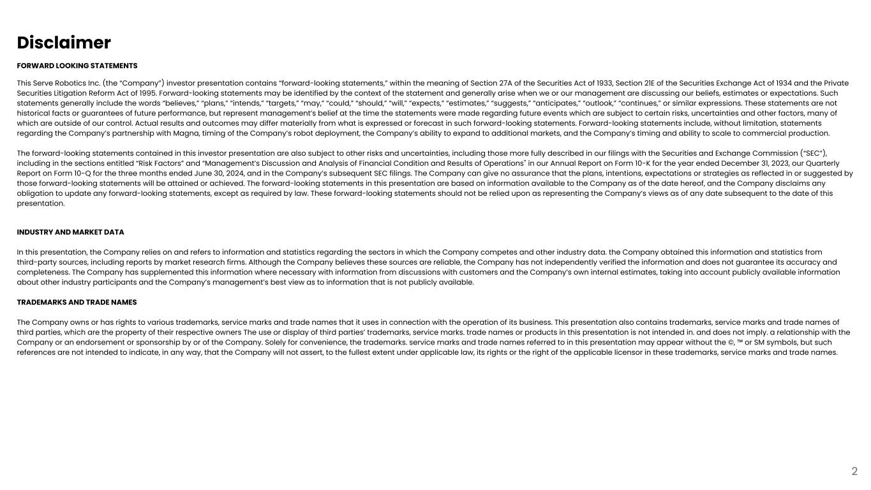
Disclaimer FORWARD LOOKING STATEMENTS This Serve Robotics Inc. (the “Company”) investor presentation contains “forward-looking statements,” within the meaning of Section 27A of the Securities Act of 1933, Section 21E of the Securities Exchange Act of 1934 and the Private Securities Litigation Reform Act of 1995. Forward-looking statements may be identified by the context of the statement and generally arise when we or our management are discussing our beliefs, estimates or expectations. Such statements generally include the words “believes,” “plans,” “intends,” “targets,” “may,” “could,” “should,” “will,” “expects,” “estimates,” “suggests,” “anticipates,” “outlook,” “continues,” or similar expressions. These statements are not historical facts or guarantees of future performance, but represent management’s belief at the time the statements were made regarding future events which are subject to certain risks, uncertainties and other factors, many of which are outside of our control. Actual results and outcomes may differ materially from what is expressed or forecast in such forward-looking statements. Forward-looking statements include, without limitation, statements regarding the Company’s partnership with Magna, timing of the Company’s robot deployment, the Company’s ability to expand to additional markets, and the Company’s timing and ability to scale to commercial production. The forward-looking statements contained in this investor presentation are also subject to other risks and uncertainties, including those more fully described in our filings with the Securities and Exchange Commission (“SEC”), including in the sections entitled “Risk Factors” and “Management’s Discussion and Analysis of Financial Condition and Results of Operations'' in our Annual Report on Form 10-K for the year ended December 31, 2023, our Quarterly Report on Form 10-Q for the three months ended June 30, 2024, and in the Company’s subsequent SEC filings. The Company can give no assurance that the plans, intentions, expectations or strategies as reflected in or suggested by those forward-looking statements will be attained or achieved. The forward-looking statements in this presentation are based on information available to the Company as of the date hereof, and the Company disclaims any obligation to update any forward-looking statements, except as required by law. These forward-looking statements should not be relied upon as representing the Company’s views as of any date subsequent to the date of this presentation. INDUSTRY AND MARKET DATA In this presentation, the Company relies on and refers to information and statistics regarding the sectors in which the Company competes and other industry data. the Company obtained this information and statistics from third-party sources, including reports by market research firms. Although the Company believes these sources are reliable, the Company has not independently verified the information and does not guarantee its accuracy and completeness. The Company has supplemented this information where necessary with information from discussions with customers and the Company’s own internal estimates, taking into account publicly available information about other industry participants and the Company’s management’s best view as to information that is not publicly available. TRADEMARKS AND TRADE NAMES The Company owns or has rights to various trademarks, service marks and trade names that it uses in connection with the operation of its business. This presentation also contains trademarks, service marks and trade names of third parties, which are the property of their respective owners The use or display of third parties’ trademarks, service marks. trade names or products in this presentation is not intended in. and does not imply. a relationship with the Company or an endorsement or sponsorship by or of the Company. Solely for convenience, the trademarks. service marks and trade names referred to in this presentation may appear without the ©, ™ or SM symbols, but such references are not intended to indicate, in any way, that the Company will not assert, to the fullest extent under applicable law, its rights or the right of the applicable licensor in these trademarks, service marks and trade names. 2

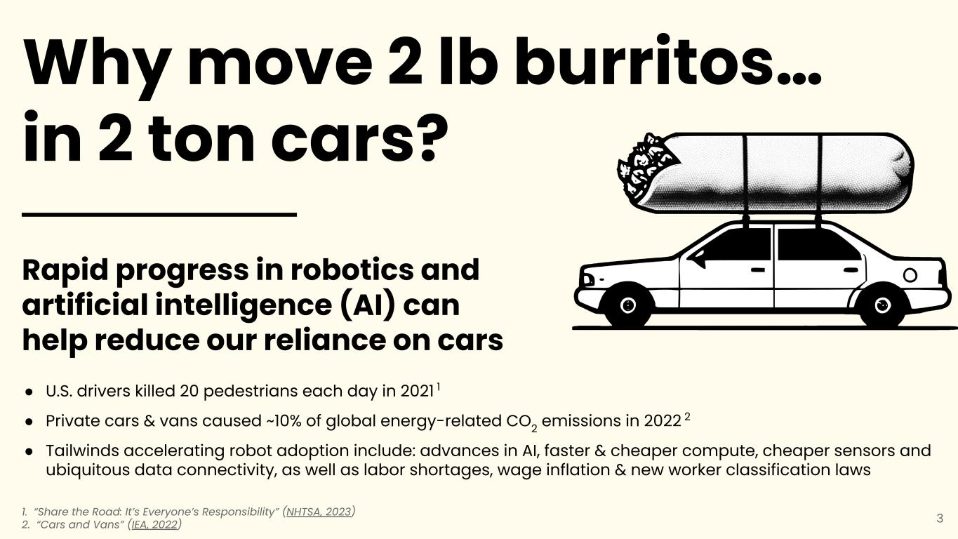
Rapid progress in robotics and artificial intelligence (AI) can help reduce our reliance on cars ● U.S. drivers killed 20 pedestrians each day in 2021 1 ● Private cars & vans caused ~10% of global energy-related CO2 emissions in 2022 2 ● Tailwinds accelerating robot adoption include: advances in AI, faster & cheaper compute, cheaper sensors and ubiquitous data connectivity, as well as labor shortages, wage inflation & new worker classification laws 1. “Share the Road: It’s Everyone’s Responsibility” (NHTSA, 2023) 2. “Cars and Vans” (IEA, 2022) Why move 2 lb burritos… in 2 ton cars? 3

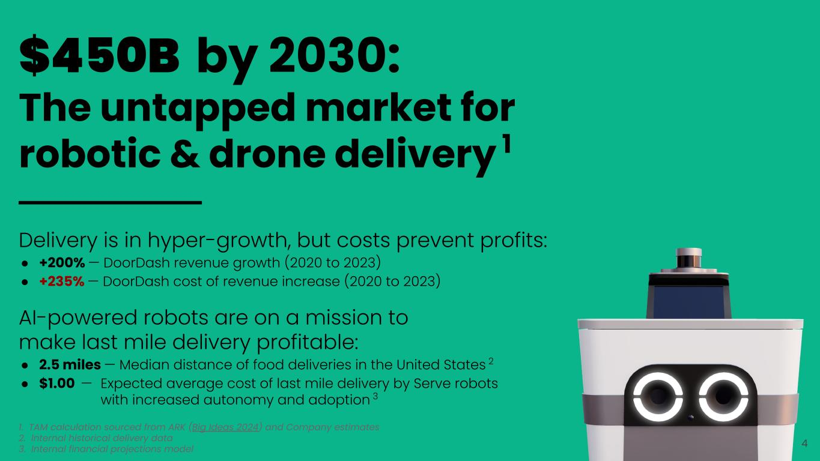
$450B by 2030: The untapped market for robotic & drone delivery 1 1. TAM calculation sourced from ARK (Big Ideas 2024) and Company estimates 2. Internal historical delivery data 3. Internal financial projections model Delivery is in hyper-growth, but costs prevent profits: ● +200% — DoorDash revenue growth (2020 to 2023) ● +235% — DoorDash cost of revenue increase (2020 to 2023) AI-powered robots are on a mission to make last mile delivery profitable: ● 2.5 miles — Median distance of food deliveries in the United States 2 ● $1.00 — Expected average cost of last mile delivery by Serve robots with increased autonomy and adoption 3 4

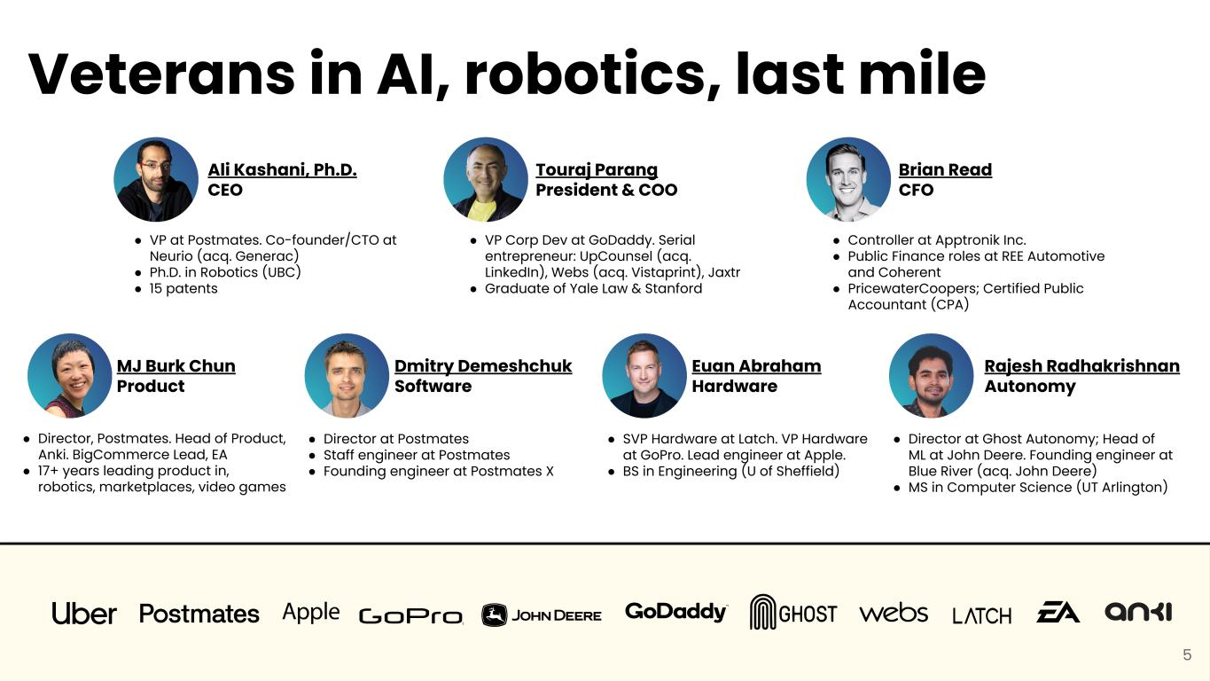
Veterans in AI, robotics, last mile ● VP at Postmates. Co-founder/CTO at Neurio (acq. Generac) ● Ph.D. in Robotics (UBC) ● 15 patents Ali Kashani, Ph.D. CEO ● Director at Postmates ● Staff engineer at Postmates ● Founding engineer at Postmates X Dmitry Demeshchuk Software ● Director, Postmates. Head of Product, Anki. BigCommerce Lead, EA ● 17+ years leading product in, robotics, marketplaces, video games MJ Burk Chun Product ● VP Corp Dev at GoDaddy. Serial entrepreneur: UpCounsel (acq. LinkedIn), Webs (acq. Vistaprint), Jaxtr ● Graduate of Yale Law & Stanford Touraj Parang President & COO ● SVP Hardware at Latch. VP Hardware at GoPro. Lead engineer at Apple. ● BS in Engineering (U of Sheffield) Euan Abraham Hardware Brian Read CFO ● Controller at Apptronik Inc. ● Public Finance roles at REE Automotive and Coherent ● PricewaterCoopers; Certified Public Accountant (CPA) 5 Rajesh Radhakrishnan Autonomy ● Director at Ghost Autonomy; Head of ML at John Deere. Founding engineer at Blue River (acq. John Deere) ● MS in Computer Science (UT Arlington) Rajesh Radhakrishnan Autonomy ● Director at Ghost Autonomy; Head of ML at John Deere. Founding engineer at Blue River (acq. John Deere) ● MS in Computer Science (UT Arlington)

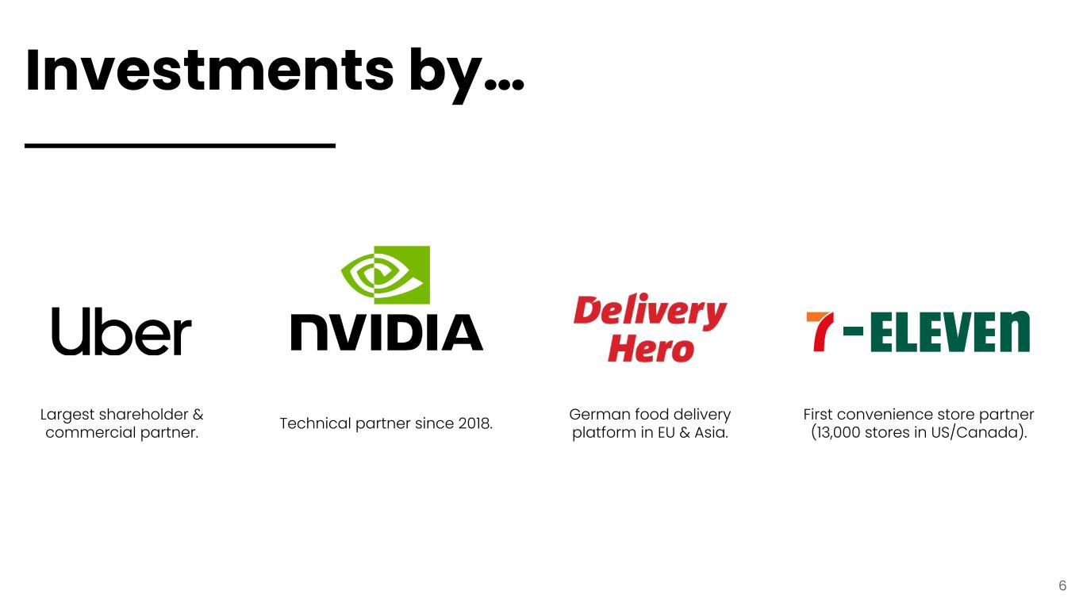
Investments by… 6 Technical partner since 2018.Largest shareholder & commercial partner. German food delivery platform in EU & Asia. First convenience store partner (13,000 stores in US/Canada).

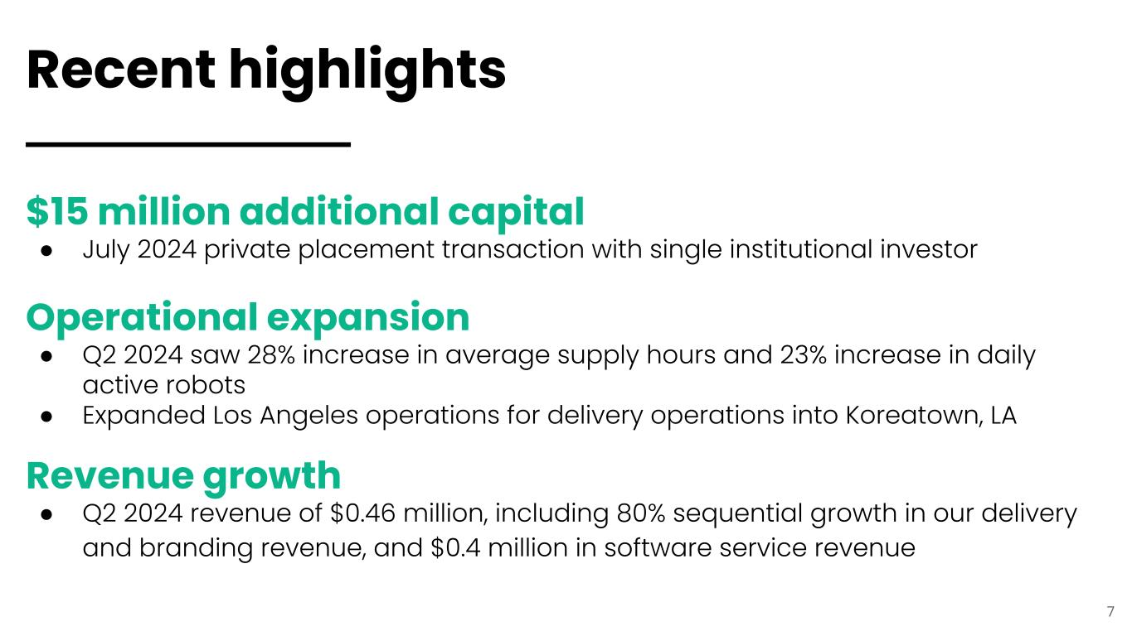
Recent highlights 7 $15 million additional capital ● July 2024 private placement transaction with single institutional investor Operational expansion ● Q2 2024 saw 28% increase in average supply hours and 23% increase in daily active robots ● Expanded Los Angeles operations for delivery operations into Koreatown, LA Revenue growth ● Q2 2024 revenue of $0.46 million, including 80% sequential growth in our delivery and branding revenue, and $0.4 million in software service revenue

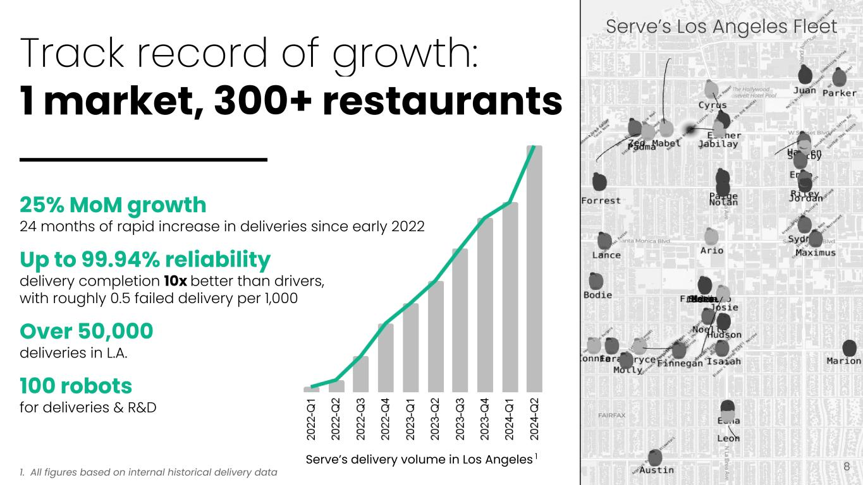
Track record of growth: 1 market, 300+ restaurants 8 25% MoM growth 24 months of rapid increase in deliveries since early 2022 Up to 99.94% reliability delivery completion 10x better than drivers, with roughly 0.5 failed delivery per 1,000 Over 50,000 deliveries in L.A. 100 robots for deliveries & R&D Serve’s delivery volume in Los Angeles 1 1. All figures based on internal historical delivery data Serve’s Los Angeles Fleet

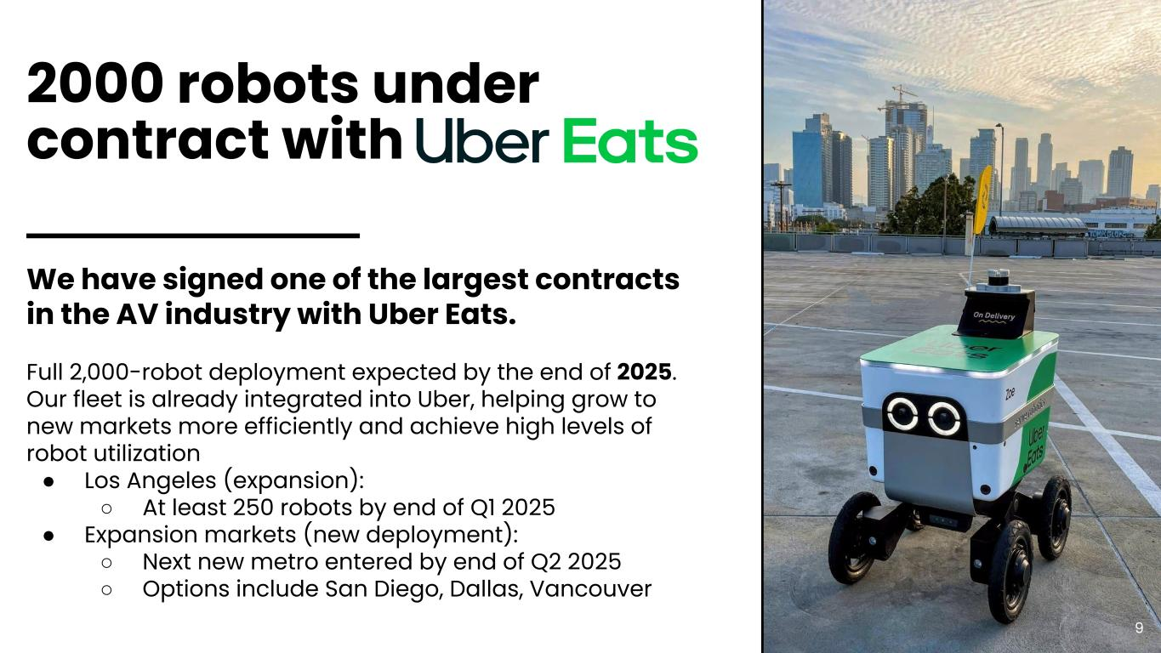
2000 robots under contract with 9 We have signed one of the largest contracts in the AV industry with Uber Eats. Full 2,000-robot deployment expected by the end of 2025. Our fleet is already integrated into Uber, helping grow to new markets more efficiently and achieve high levels of robot utilization ● Los Angeles (expansion): ○ At least 250 robots by end of Q1 2025 ● Expansion markets (new deployment): ○ Next new metro entered by end of Q2 2025 ○ Options include San Diego, Dallas, Vancouver

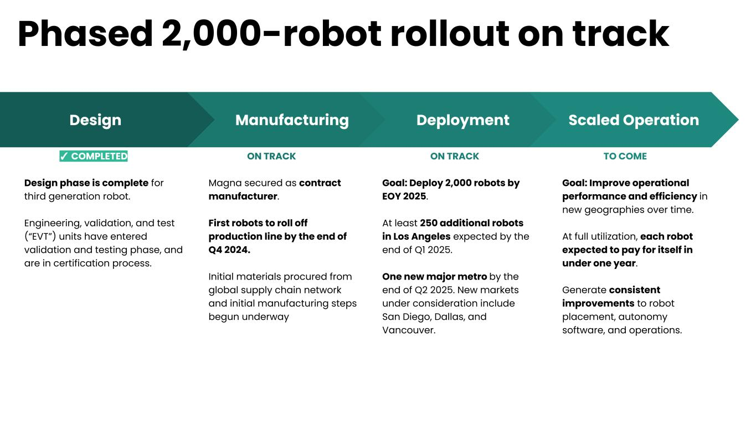
Design Design phase is complete for third generation robot. Engineering, validation, and test (“EVT”) units have entered validation and testing phase, and are in certification process. Manufacturing Magna secured as contract manufacturer. First robots to roll off production line by the end of Q4 2024. Initial materials procured from global supply chain network and initial manufacturing steps begun underway Deployment Goal: Deploy 2,000 robots by EOY 2025. At least 250 additional robots in Los Angeles expected by the end of Q1 2025. One new major metro by the end of Q2 2025. New markets under consideration include San Diego, Dallas, and Vancouver. Scaled Operation Goal: Improve operational performance and efficiency in new geographies over time. At full utilization, each robot expected to pay for itself in under one year. Generate consistent improvements to robot placement, autonomy software, and operations. Phased 2,000-robot rollout on track ✓ COMPLETED ON TRACK ON TRACK TO COME

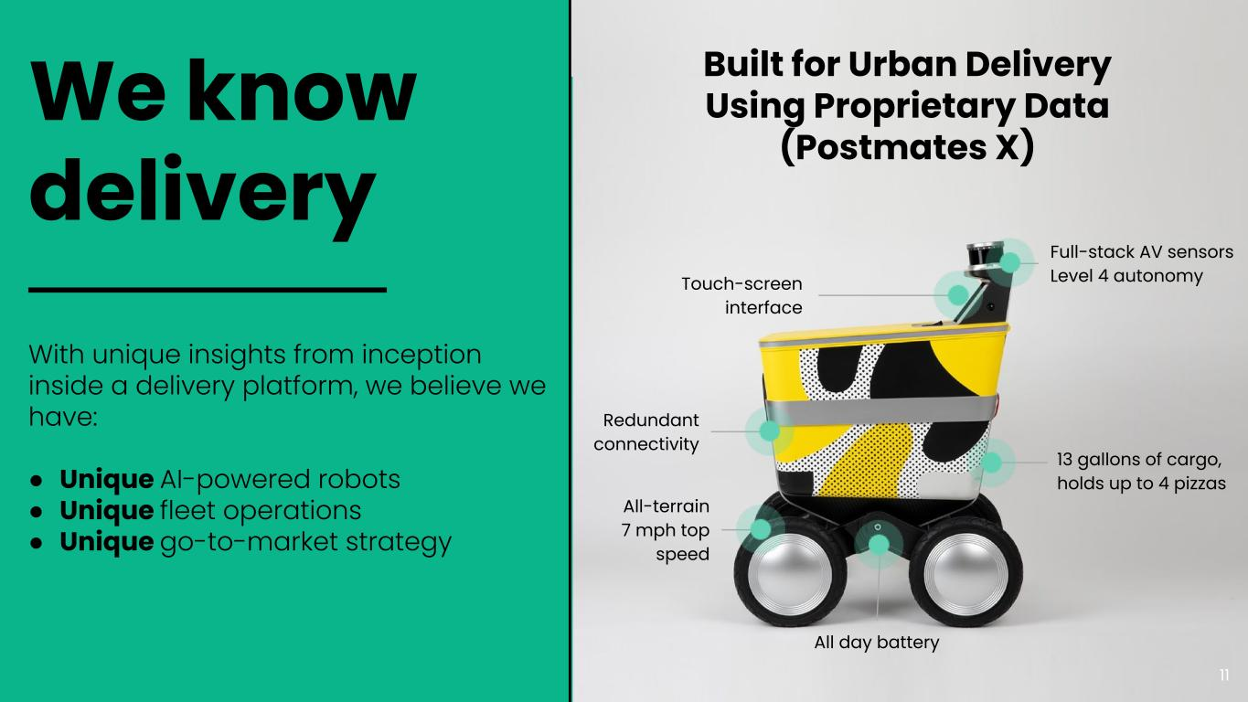
We know delivery With unique insights from inception inside a delivery platform, we believe we have: ● Unique AI-powered robots ● Unique fleet operations ● Unique go-to-market strategy All-terrain 7 mph top speed 13 gallons of cargo, holds up to 4 pizzas All day battery Touch-screen interface Full-stack AV sensors Level 4 autonomy Redundant connectivity Built for Urban Delivery Using Proprietary Data (Postmates X) 11

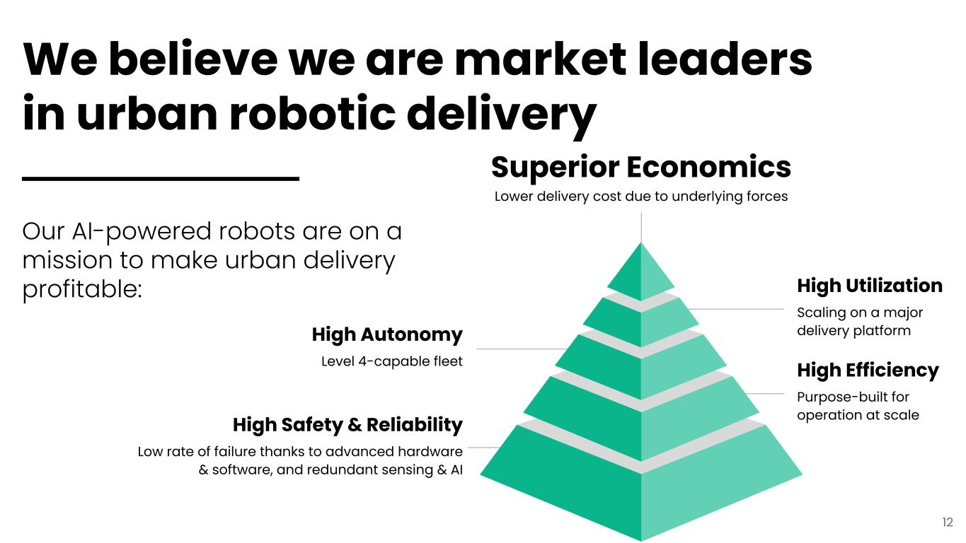
High Safety & Reliability Low rate of failure thanks to advanced hardware & software, and redundant sensing & AI Superior Economics Lower delivery cost due to underlying forces High Autonomy Level 4-capable fleet High Utilization Scaling on a major delivery platform High Efficiency Purpose-built for operation at scale We believe we are market leaders in urban robotic delivery Our AI-powered robots are on a mission to make urban delivery profitable: 12

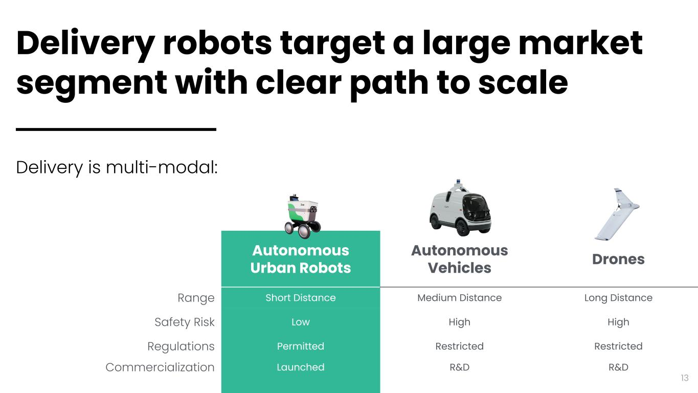
Autonomous Urban Robots Autonomous Vehicles Drones Range Short Distance Medium Distance Long Distance Safety Risk Low High High Regulations Permitted Restricted Restricted Commercialization Launched R&D R&D Delivery robots target a large market segment with clear path to scale Delivery is multi-modal: 13

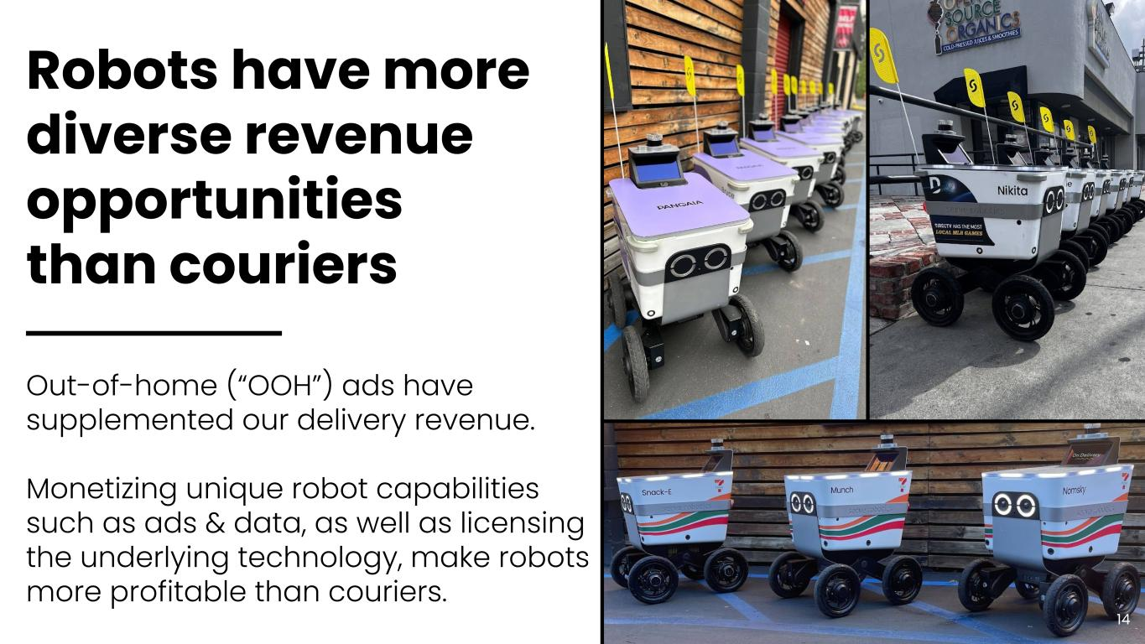
Robots have more diverse revenue opportunities than couriers Out-of-home (“OOH”) ads have supplemented our delivery revenue. Monetizing unique robot capabilities such as ads & data, as well as licensing the underlying technology, make robots more profitable than couriers. 14

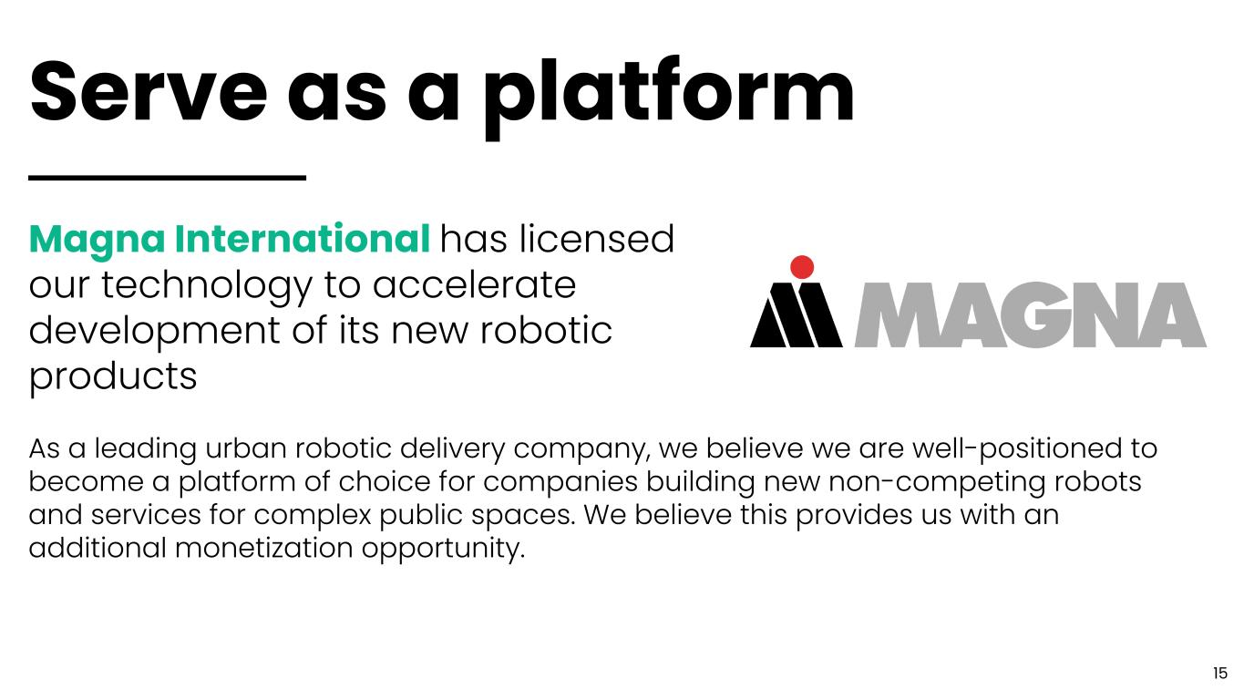
Serve as a platform Magna International has licensed our technology to accelerate development of its new robotic products As a leading urban robotic delivery company, we believe we are well-positioned to become a platform of choice for companies building new non-competing robots and services for complex public spaces. We believe this provides us with an additional monetization opportunity. 15

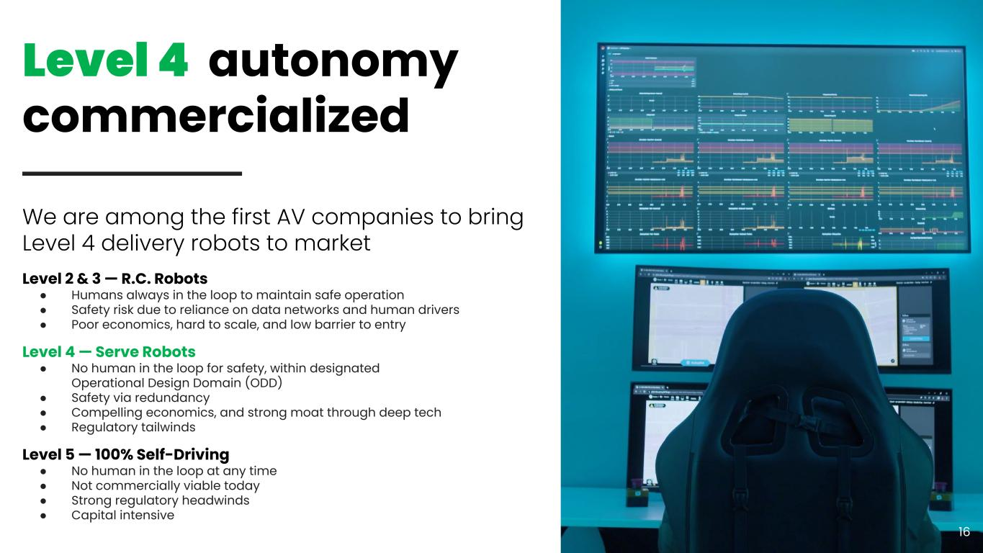
We are among the first AV companies to bring Level 4 delivery robots to market Level 2 & 3 — R.C. Robots ● Humans always in the loop to maintain safe operation ● Safety risk due to reliance on data networks and human drivers ● Poor economics, hard to scale, and low barrier to entry Level 4 — Serve Robots ● No human in the loop for safety, within designated Operational Design Domain (ODD) ● Safety via redundancy ● Compelling economics, and strong moat through deep tech ● Regulatory tailwinds Level 5 — 100% Self-Driving ● No human in the loop at any time ● Not commercially viable today ● Strong regulatory headwinds ● Capital intensive Level 4 autonomy commercialized 16

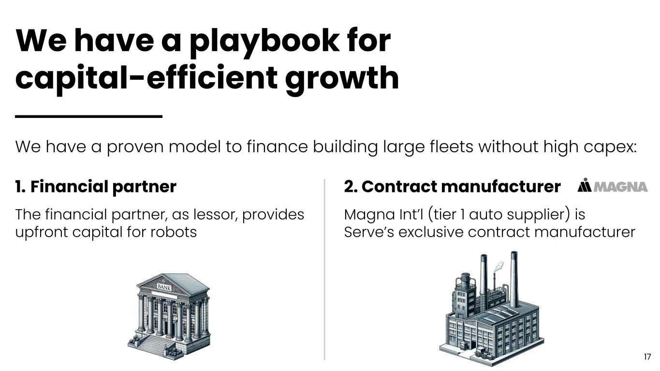
We have a playbook for capital-efficient growth We have a proven model to finance building large fleets without high capex: 1. Financial partner The financial partner, as lessor, provides upfront capital for robots 2. Contract manufacturer Magna Int’l (tier 1 auto supplier) is Serve’s exclusive contract manufacturer 17

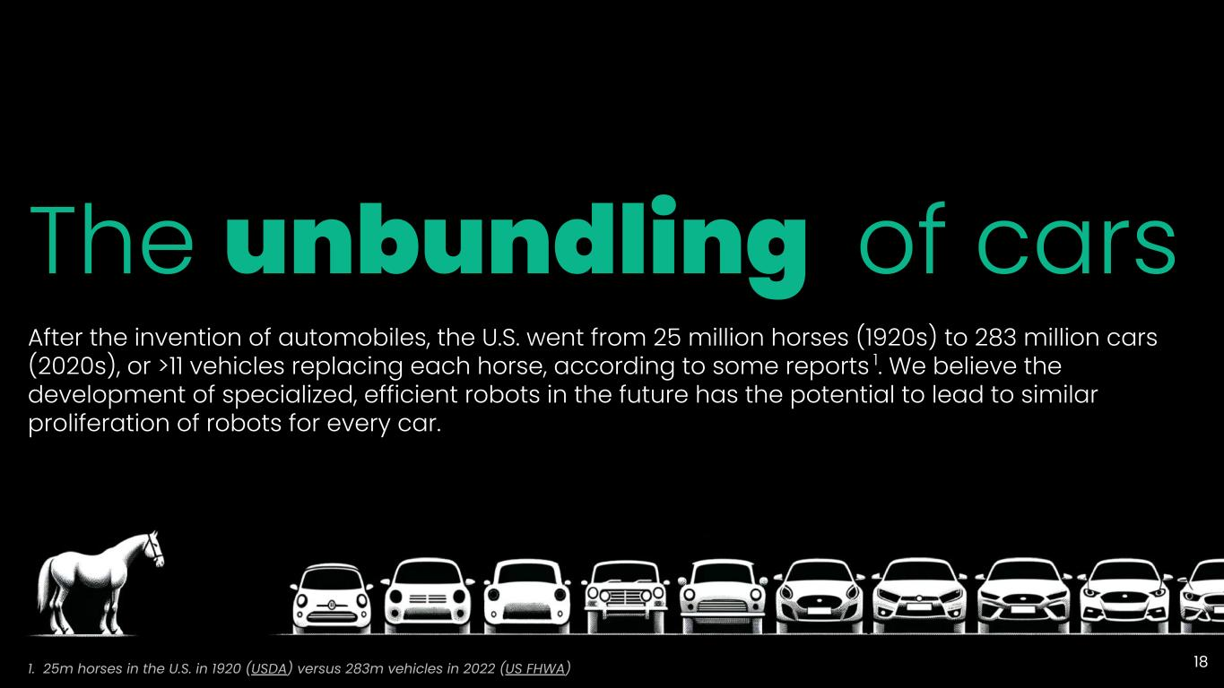
The unbundling of cars After the invention of automobiles, the U.S. went from 25 million horses (1920s) to 283 million cars (2020s), or >11 vehicles replacing each horse, according to some reports 1. We believe the development of specialized, efficient robots in the future has the potential to lead to similar proliferation of robots for every car. 1. 25m horses in the U.S. in 1920 (USDA) versus 283m vehicles in 2022 (US FHWA) 18

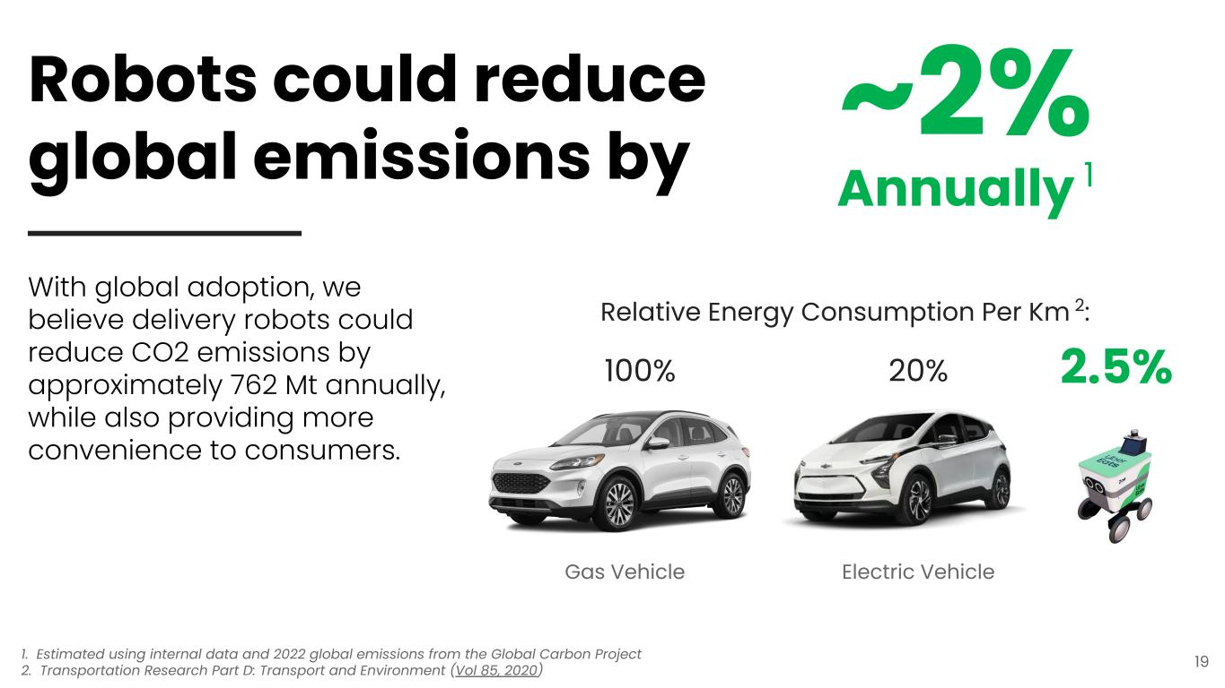
2.5% 100% Gas Vehicle 20% Electric Vehicle Relative Energy Consumption Per Km 2: With global adoption, we believe delivery robots could reduce CO2 emissions by approximately 762 Mt annually, while also providing more convenience to consumers. 19 Robots could reduce global emissions by ~2% Annually 1 1. Estimated using internal data and 2022 global emissions from the Global Carbon Project 2. Transportation Research Part D: Transport and Environment (Vol 85, 2020)

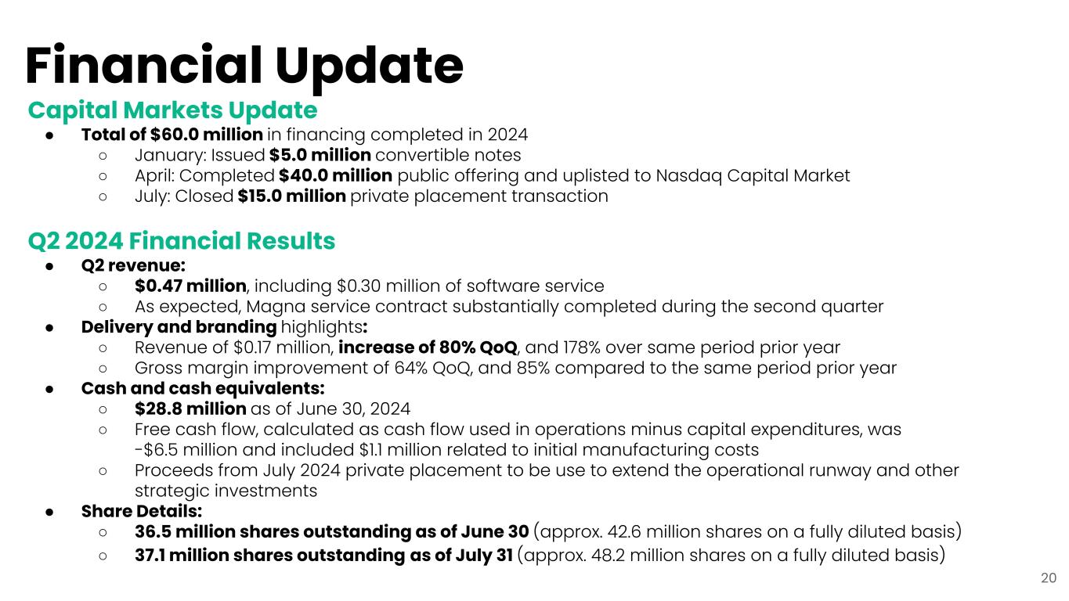
Capital Markets Update ● Total of $60.0 million in financing completed in 2024 ○ January: Issued $5.0 million convertible notes ○ April: Completed $40.0 million public offering and uplisted to Nasdaq Capital Market ○ July: Closed $15.0 million private placement transaction Q2 2024 Financial Results ● Q2 revenue: ○ $0.47 million, including $0.30 million of software service ○ As expected, Magna service contract substantially completed during the second quarter ● Delivery and branding highlights: ○ Revenue of $0.17 million, increase of 80% QoQ, and 178% over same period prior year ○ Gross margin improvement of 64% QoQ, and 85% compared to the same period prior year ● Cash and cash equivalents: ○ $28.8 million as of June 30, 2024 ○ Free cash flow, calculated as cash flow used in operations minus capital expenditures, was -$6.5 million and included $1.1 million related to initial manufacturing costs ○ Proceeds from July 2024 private placement to be use to extend the operational runway and other strategic investments ● Share Details: ○ 36.5 million shares outstanding as of June 30 (approx. 42.6 million shares on a fully diluted basis) ○ 37.1 million shares outstanding as of July 31 (approx. 48.2 million shares on a fully diluted basis) Financial Update 20


Thank you!

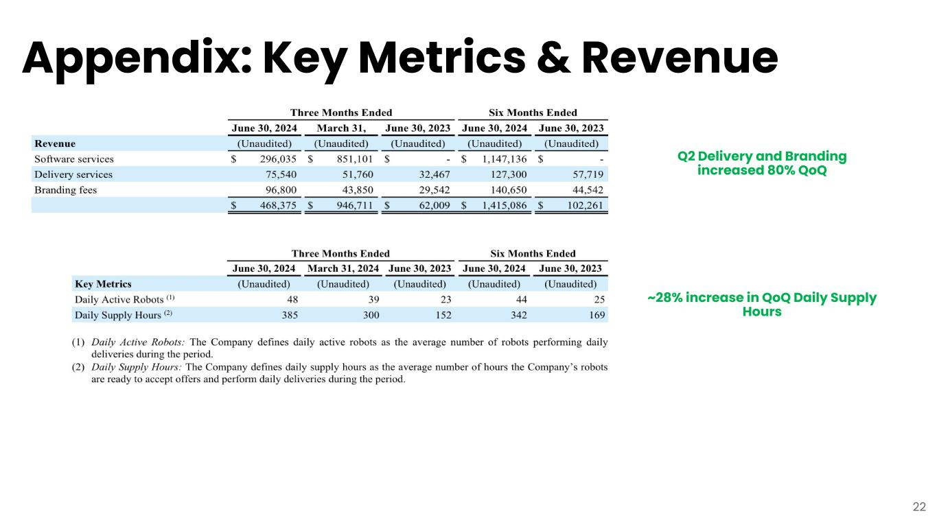
Appendix: Key Metrics & Revenue 22 ~28% increase in QoQ Daily Supply Hours Q2 Delivery and Branding increased 80% QoQ

